POEM TX Paper 1
2026-06-03

Main Analysis Tables and Figures

Table 1
(This is the older version)
 | Overall | By Condition
Characteristic | N = 187,328¹ | Diabetes  N = 88,155¹ | Hypertension  N = 127,196¹
Birth Outcome
LB | 185,894 (99%) | 87,444 (99%) | 126,176 (99%)
SB | 1,434 (0.8%) | 711 (0.8%) | 1,020 (0.8%)
Year
2019 | 34,963 (19%) | 16,561 (19%) | 23,316 (18%)
2020 | 38,875 (21%) | 18,642 (21%) | 26,031 (20%)
2021 | 41,232 (22%) | 19,730 (22%) | 27,725 (22%)
2022 | 43,391 (23%) | 20,102 (23%) | 29,926 (24%)
2023 | 28,867 (15%) | 13,120 (15%) | 20,198 (16%)
Race/Ethnicity
American Indian or Alaskan | 449 (0.2%) | 208 (0.2%) | 310 (0.2%)
Asian, Pacific Islander | 3,428 (1.8%) | 2,507 (2.8%) | 1,380 (1.1%)
Black, non-Hispanic | 38,362 (20%) | 12,402 (14%) | 31,309 (25%)
Hispanic | 97,241 (52%) | 53,348 (61%) | 59,525 (47%)
Unknown/Other | 8,591 (4.6%) | 3,612 (4.1%) | 6,238 (4.9%)
White, non-Hispanic | 39,257 (21%) | 16,078 (18%) | 28,434 (22%)
Age Group
19-24 | 53,379 (28%) | 18,707 (21%) | 39,650 (31%)
25-34 | 101,790 (54%) | 50,230 (57%) | 67,020 (53%)
35-44 | 31,674 (17%) | 18,906 (21%) | 20,201 (16%)
45-55 | 485 (0.3%) | 312 (0.4%) | 325 (0.3%)
Index No Transfusion Weight | 27 (19, 41) | 26 (18, 38) | 33 (24, 45)
Preexisting Diabetes | 28,711 (15%) | 28,711 (33%) | 12,793 (10%)
Gestational Diabetes | 82,194 (44%) | 82,194 (93%) | 25,550 (20%)
Chronic Hypertension | 57,509 (31%) | 16,778 (19%) | 57,509 (45%)
Gestational Hypertension | 92,407 (49%) | 18,091 (21%) | 92,407 (73%)
Preeclampsia | 13,632 (7.3%) | 4,608 (5.2%) | 13,632 (11%)
Pulmonary Hypertension | 390 (0.2%) | 97 (0.1%) | 390 (0.3%)
¹n (%); Median (Q1, Q3)

Pre Post

This is the newer version with pre and post
Characteristic | Diabetes - Pre  N = 16,561¹ | Diabetes - FFCRA  N = 43,166¹ | Hypertension - Pre  N = 23,316¹ | Hypertension - FFCRA  N = 60,893¹
Birth Outcome
LB | 16,454 (99%) | 42,822 (99%) | 23,147 (99%) | 60,419 (99%)
SB | 107 (0.6%) | 344 (0.8%) | 169 (0.7%) | 474 (0.8%)
Year
2019 | 16,561 (100%) | 0 (0%) | 23,316 (100%) | 0 (0%)
2020 | 0 (0%) | 18,642 (43%) | 0 (0%) | 26,031 (43%)
2021 | 0 (0%) | 19,730 (46%) | 0 (0%) | 27,725 (46%)
2022 | 0 (0%) | 4,794 (11%) | 0 (0%) | 7,137 (12%)
Race/Ethnicity
American Indian or Alaskan | 39 (0.2%) | 99 (0.2%) | 41 (0.2%) | 144 (0.2%)
Asian, Pacific Islander | 441 (2.7%) | 1,238 (2.9%) | 209 (0.9%) | 637 (1.0%)
Black, non-Hispanic | 2,443 (15%) | 6,048 (14%) | 5,919 (25%) | 15,053 (25%)
Hispanic | 9,883 (60%) | 26,133 (61%) | 10,420 (45%) | 28,473 (47%)
Unknown/Other | 606 (3.7%) | 1,683 (3.9%) | 1,075 (4.6%) | 2,757 (4.5%)
White, non-Hispanic | 3,149 (19%) | 7,965 (18%) | 5,652 (24%) | 13,829 (23%)
Age Group
19-24 | 3,735 (23%) | 9,388 (22%) | 7,682 (33%) | 19,163 (31%)
25-34 | 9,271 (56%) | 24,505 (57%) | 11,940 (51%) | 31,932 (52%)
35-44 | 3,491 (21%) | 9,115 (21%) | 3,632 (16%) | 9,644 (16%)
45-55 | 64 (0.4%) | 158 (0.4%) | 62 (0.3%) | 154 (0.3%)
Index No Transfusion Weight | 23 (14, 35) | 26 (18, 38) | 30 (21, 42) | 33 (24, 45)
Preexisting Diabetes | 5,277 (32%) | 13,794 (32%) | 2,192 (9.4%) | 6,055 (9.9%)
Gestational Diabetes | 15,459 (93%) | 40,398 (94%) | 4,525 (19%) | 12,533 (21%)
Chronic Hypertension | 2,916 (18%) | 8,014 (19%) | 10,251 (44%) | 27,256 (45%)
Gestational Hypertension | 3,166 (19%) | 8,904 (21%) | 17,017 (73%) | 44,618 (73%)
Preeclampsia | 769 (4.6%) | 2,219 (5.1%) | 2,435 (10%) | 6,478 (11%)
Pulmonary Hypertension | 16 (<0.1%) | 43 (<0.1%) | 85 (0.4%) | 181 (0.3%)
¹n (%); Median (Q1, Q3)

Multiple Post Periods
Characteristic | Diabetes - Pre  N = 16,561¹ | Diabetes - FFCRA  N = 43,166¹ | Diabetes - Unwinding  N = 28,428¹ | Hypertension - Pre  N = 23,316¹ | Hypertension - FFCRA  N = 60,893¹ | Hypertension - Unwinding  N = 42,987¹
Birth Outcome
LB | 16,454 (99%) | 42,822 (99%) | 28,168 (99%) | 23,147 (99%) | 60,419 (99%) | 42,610 (99%)
SB | 107 (0.6%) | 344 (0.8%) | 260 (0.9%) | 169 (0.7%) | 474 (0.8%) | 377 (0.9%)
Year
2019 | 16,561 (100%) | 0 (0%) | 0 (0%) | 23,316 (100%) | 0 (0%) | 0 (0%)
2020 | 0 (0%) | 18,642 (43%) | 0 (0%) | 0 (0%) | 26,031 (43%) | 0 (0%)
2021 | 0 (0%) | 19,730 (46%) | 0 (0%) | 0 (0%) | 27,725 (46%) | 0 (0%)
2022 | 0 (0%) | 4,794 (11%) | 15,308 (54%) | 0 (0%) | 7,137 (12%) | 22,789 (53%)
2023 | 0 (0%) | 0 (0%) | 13,120 (46%) | 0 (0%) | 0 (0%) | 20,198 (47%)
Race/Ethnicity
American Indian or Alaskan | 39 (0.2%) | 99 (0.2%) | 70 (0.2%) | 41 (0.2%) | 144 (0.2%) | 125 (0.3%)
Asian, Pacific Islander | 441 (2.7%) | 1,238 (2.9%) | 828 (2.9%) | 209 (0.9%) | 637 (1.0%) | 534 (1.2%)
Black, non-Hispanic | 2,443 (15%) | 6,048 (14%) | 3,911 (14%) | 5,919 (25%) | 15,053 (25%) | 10,337 (24%)
Hispanic | 9,883 (60%) | 26,133 (61%) | 17,332 (61%) | 10,420 (45%) | 28,473 (47%) | 20,632 (48%)
Unknown/Other | 606 (3.7%) | 1,683 (3.9%) | 1,323 (4.7%) | 1,075 (4.6%) | 2,757 (4.5%) | 2,406 (5.6%)
White, non-Hispanic | 3,149 (19%) | 7,965 (18%) | 4,964 (17%) | 5,652 (24%) | 13,829 (23%) | 8,953 (21%)
Age Group
19-24 | 3,735 (23%) | 9,388 (22%) | 5,584 (20%) | 7,682 (33%) | 19,163 (31%) | 12,805 (30%)
25-34 | 9,271 (56%) | 24,505 (57%) | 16,454 (58%) | 11,940 (51%) | 31,932 (52%) | 23,148 (54%)
35-44 | 3,491 (21%) | 9,115 (21%) | 6,300 (22%) | 3,632 (16%) | 9,644 (16%) | 6,925 (16%)
45-55 | 64 (0.4%) | 158 (0.4%) | 90 (0.3%) | 62 (0.3%) | 154 (0.3%) | 109 (0.3%)
Index No Transfusion Weight | 23 (14, 35) | 26 (18, 38) | 26 (19, 40) | 30 (21, 42) | 33 (24, 45) | 33 (25, 47)
Preexisting Diabetes | 5,277 (32%) | 13,794 (32%) | 9,640 (34%) | 2,192 (9.4%) | 6,055 (9.9%) | 4,546 (11%)
Gestational Diabetes | 15,459 (93%) | 40,398 (94%) | 26,337 (93%) | 4,525 (19%) | 12,533 (21%) | 8,492 (20%)
Chronic Hypertension | 2,916 (18%) | 8,014 (19%) | 5,848 (21%) | 10,251 (44%) | 27,256 (45%) | 20,002 (47%)
Gestational Hypertension | 3,166 (19%) | 8,904 (21%) | 6,021 (21%) | 17,017 (73%) | 44,618 (73%) | 30,772 (72%)
Preeclampsia | 769 (4.6%) | 2,219 (5.1%) | 1,620 (5.7%) | 2,435 (10%) | 6,478 (11%) | 4,719 (11%)
Pulmonary Hypertension | 16 (<0.1%) | 43 (<0.1%) | 38 (0.1%) | 85 (0.4%) | 181 (0.3%) | 124 (0.3%)
¹n (%); Median (Q1, Q3)

Figure 1: Biweekly graphs based on anchor date: outpatient utilization
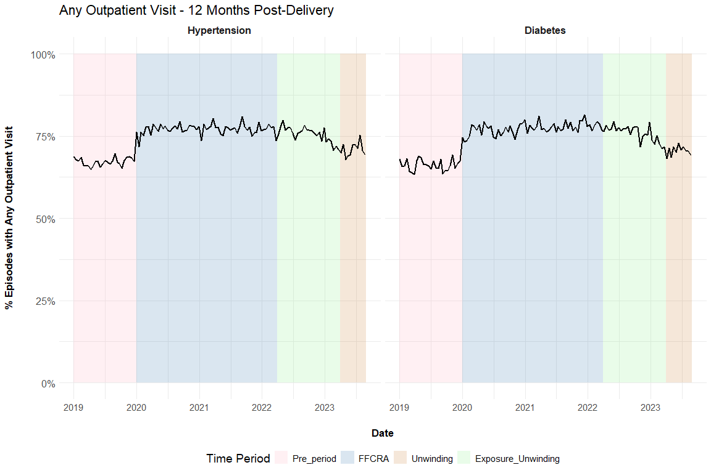

Figure 2: Biweekly graphs based on anchor date: diabetes screening
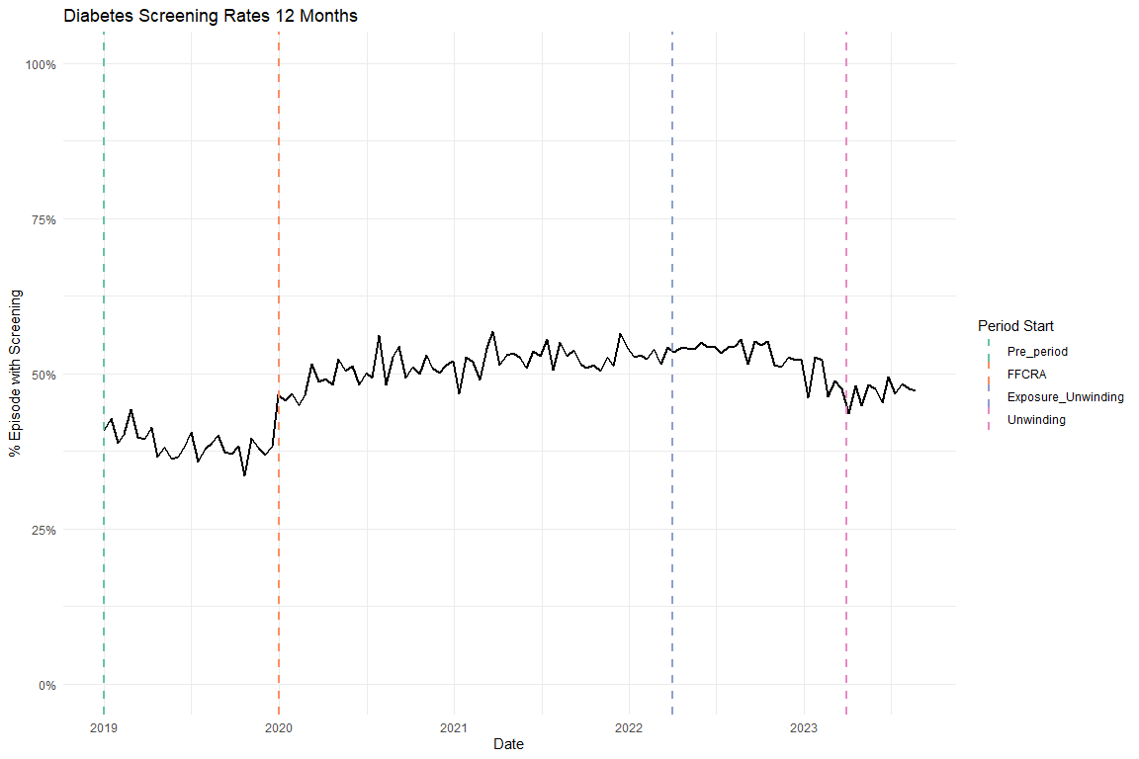

Figure 3: Biweekly graphs based on anchor date: hypertensive medication
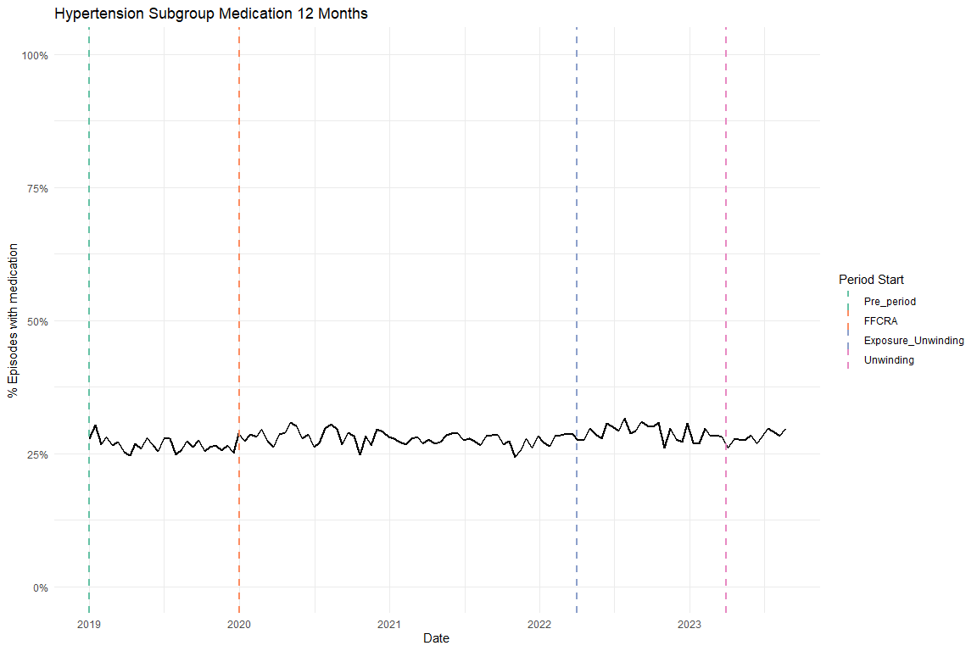

Table 2: ITS results of all utilization outcomes, adjusted, main coefficients only
Diabetes cohort
Characteristic |  | Diabetes Screening Beta | 95% CI |  | Any outpatient utilization Beta |  | 95% CI
Pre-trend |  | -0.003 | -0.004, -0.002 |  | -0.001 |  | -0.002, 0.000
Level Change, FFCRA |  | 0.131 | 0.114, 0.149 |  | 0.104 |  | 0.089, 0.120
Level Change, Exposure to Unwinding |  | 0.152 | 0.127, 0.176 |  | 0.108 |  | 0.086, 0.130
Trend Change, FFCRA |  | 0.003 | 0.002, 0.004 |  | 0.001 |  | 0.000, 0.002
Trend Change, Exposure to Unwinding |  | -0.003 | -0.004, -0.003 |  | -0.003 |  | -0.003, -0.002
Abbreviation: CI = Confidence Interval
Hypertension cohort
Characteristic | Antihypertensive medication Beta |  |  | 95% CI |  | Any outpatient utilization Beta |  | 95% CI
Pre-trend | -0.002 |  |  | -0.003, -0.001 |  | -0.001 |  | -0.001, 0.000
Level Change, FFCRA | 0.036 |  |  | 0.023, 0.049 |  | 0.099 |  | 0.086, 0.113
Level Change, Exposure to Unwinding | 0.055 |  |  | 0.037, 0.073 |  | 0.109 |  | 0.091, 0.128
Trend Change, FFCRA | 0.002 |  |  | 0.001, 0.002 |  | 0.001 |  | 0.000, 0.001
Trend Change, Exposure to Unwinding | 0.000 |  |  | 0.000, 0.000 |  | -0.002 |  | -0.003, -0.002
Abbreviation: CI = Confidence Interval

Table 3: ITS results for average outpatient visit count (Negative Binomial, IRR), adjusted
Diabetes cohort
Characteristic | Avg Outpatient Visits IRR | 95% CI
Pre-trend | 0.997 | 0.994, 0.999
Level Change, FFCRA | 1.610 | 1.539, 1.685
Level Change, Exposure to Unwinding | 1.730 | 1.626, 1.841
Trend Change, FFCRA | 1.004 | 1.001, 1.007
Trend Change, Exposure to Unwinding | 0.988 | 0.987, 0.990
Abbreviations: CI = Confidence Interval, IRR = Incidence Rate Ratio
Hypertension cohort
Characteristic | Avg Outpatient Visits IRR | 95% CI
Pre-trend | 0.998 | 0.996, 1.000
Level Change, FFCRA | 1.551 | 1.493, 1.611
Level Change, Exposure to Unwinding | 1.619 | 1.537, 1.705
Trend Change, FFCRA | 1.001 | 0.999, 1.004
Trend Change, Exposure to Unwinding | 0.991 | 0.990, 0.993
Abbreviations: CI = Confidence Interval, IRR = Incidence Rate Ratio

Table 4: ITS results for any outpatient utilization by time window (0-60 days and 61 days-12 months), adjusted
Diabetes cohort
Characteristic | Any Outpatient (0-60 days) Beta |  | 95% CI |  |  | Any Outpatient (61 days-12 mo) Beta | 95% CI
Pre-trend | -0.002 |  | -0.003, -0.001 |  |  | -0.001 | -0.002, 0.000
Level Change, FFCRA | 0.010 |  | -0.007, 0.028 |  |  | 0.238 | 0.221, 0.256
Level Change, Exposure to Unwinding | -0.012 |  | -0.037, 0.013 |  |  | 0.270 | 0.246, 0.295
Trend Change, FFCRA | 0.002 |  | 0.001, 0.004 |  |  | 0.001 | 0.000, 0.002
Trend Change, Exposure to Unwinding | -0.001 |  | -0.001, 0.000 |  |  | -0.005 | -0.006, -0.005
Abbreviation: CI = Confidence Interval
Hypertension cohort
Characteristic |  | Any Outpatient (0-60 days) Beta |  | 95% CI | Any Outpatient (61 days-12 mo) Beta |  | 95% CI
Pre-trend |  | -0.001 |  | -0.002, 0.000 | 0.000 |  | -0.001, 0.001
Level Change, FFCRA |  | 0.012 |  | -0.003, 0.027 | 0.219 |  | 0.204, 0.233
Level Change, Exposure to Unwinding |  | 0.010 |  | -0.010, 0.031 | 0.243 |  | 0.222, 0.263
Trend Change, FFCRA |  | 0.001 |  | 0.000, 0.002 | 0.000 |  | -0.001, 0.001
Trend Change, Exposure to Unwinding |  | 0.000 |  | -0.001, 0.000 | -0.004 |  | -0.005, -0.004
Abbreviation: CI = Confidence Interval

Supplemental Figures

Flowchart
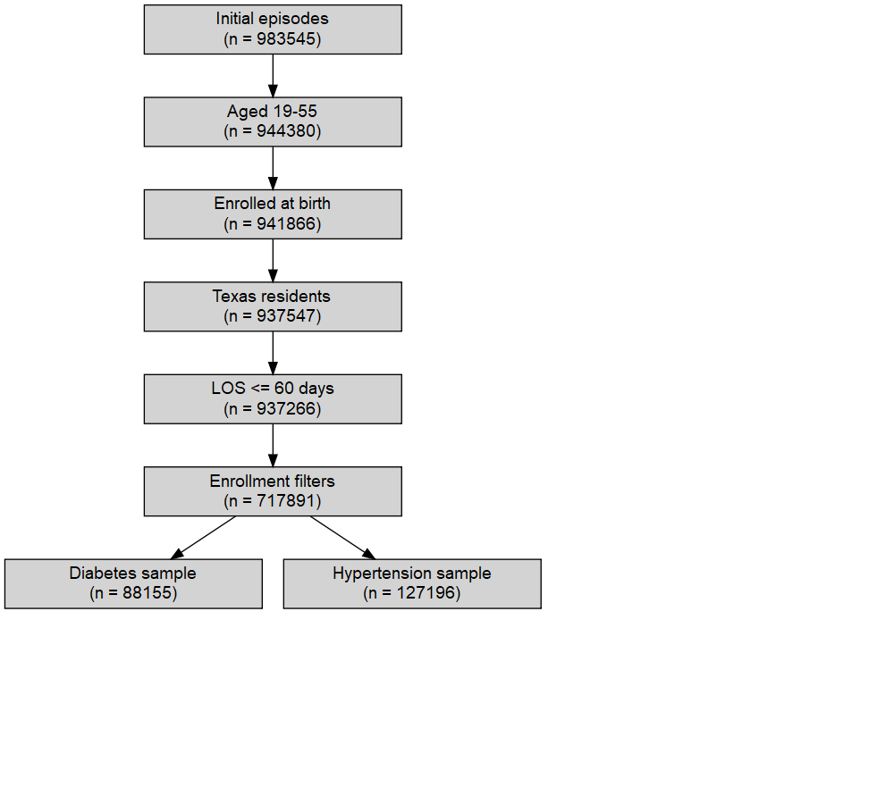
Flowchart counts
-------------------------------------------------
Step n
-------------------------------------------------
Initial episodes (time-filtered) 983545
Aged 19-55 944380
Enrolled at birth 941866
Texas residents 937547
LOS <= 60 days 937266
Final cohort (enrollment filters) 717891
Diabetes sample 88155
Hypertension sample 127196
-------------------------------------------------

Enrollment
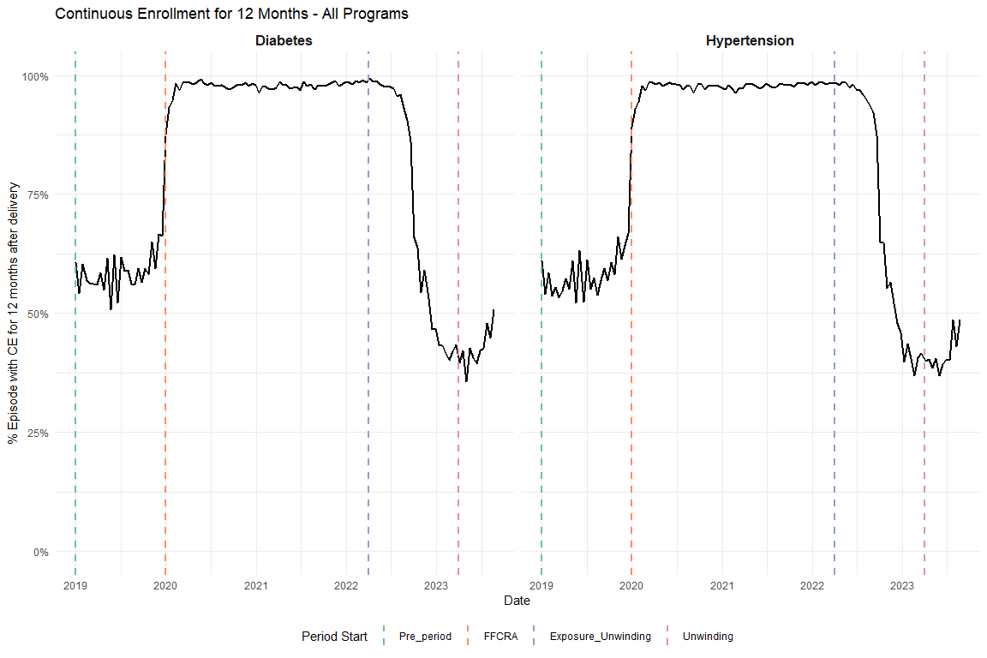
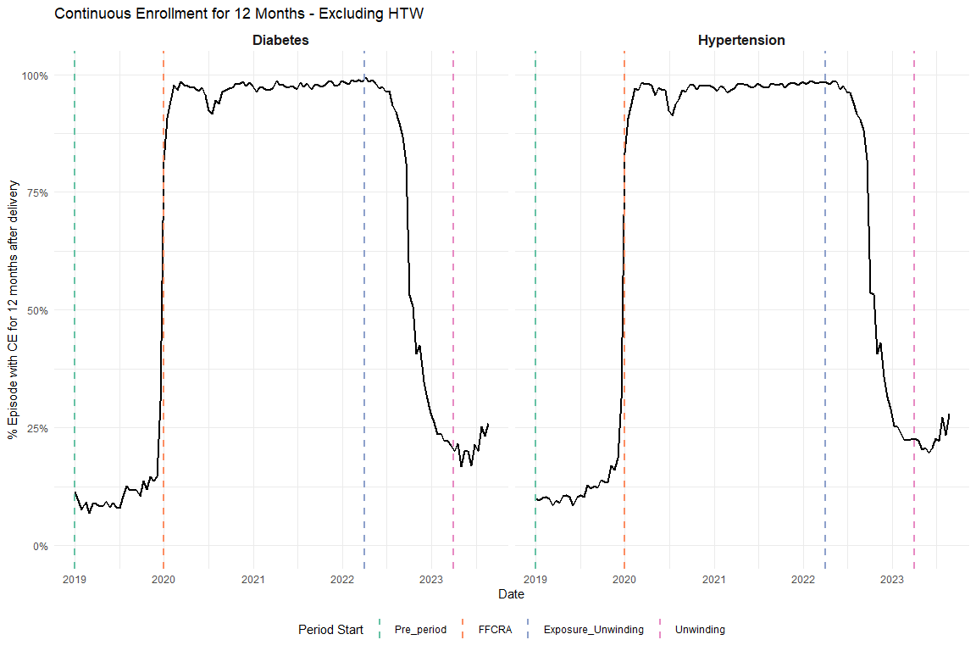
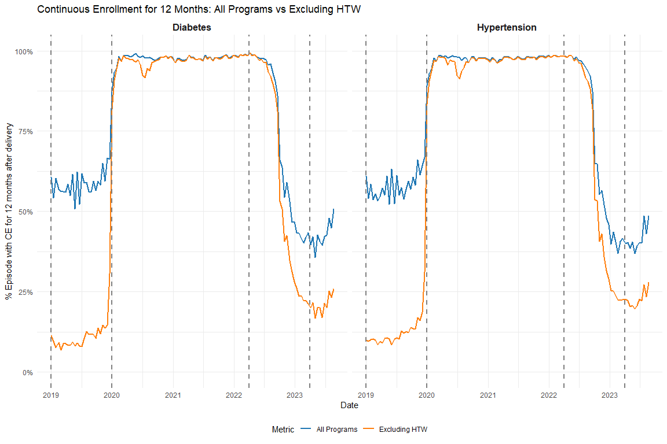

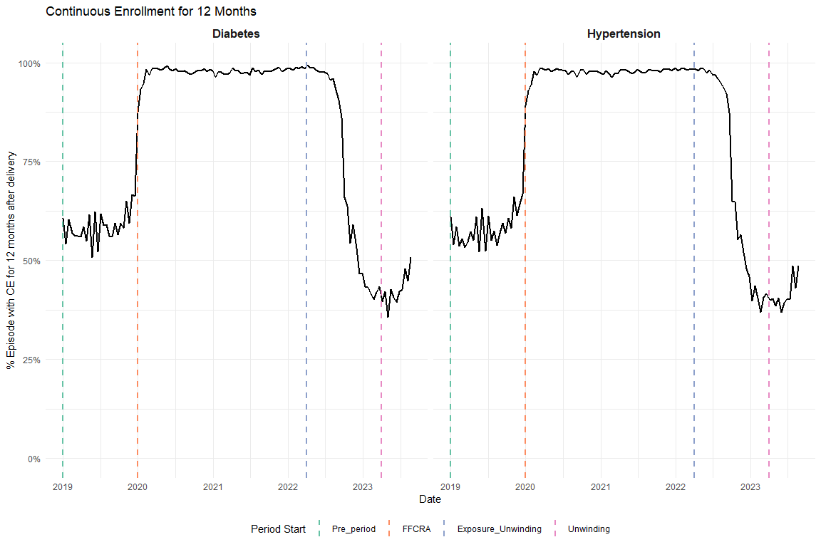

OGT vs A1C
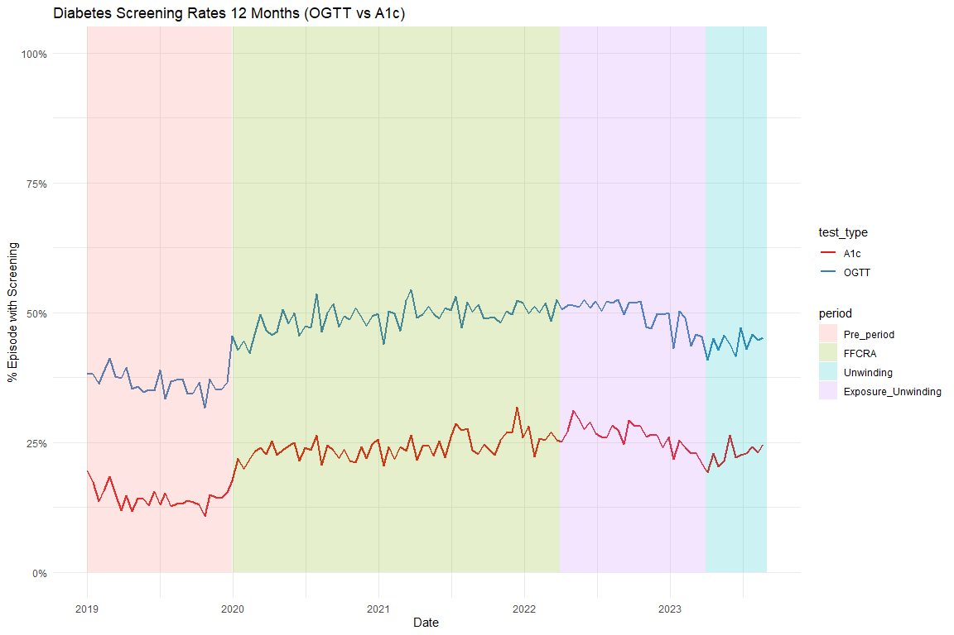

Average Visits per Person
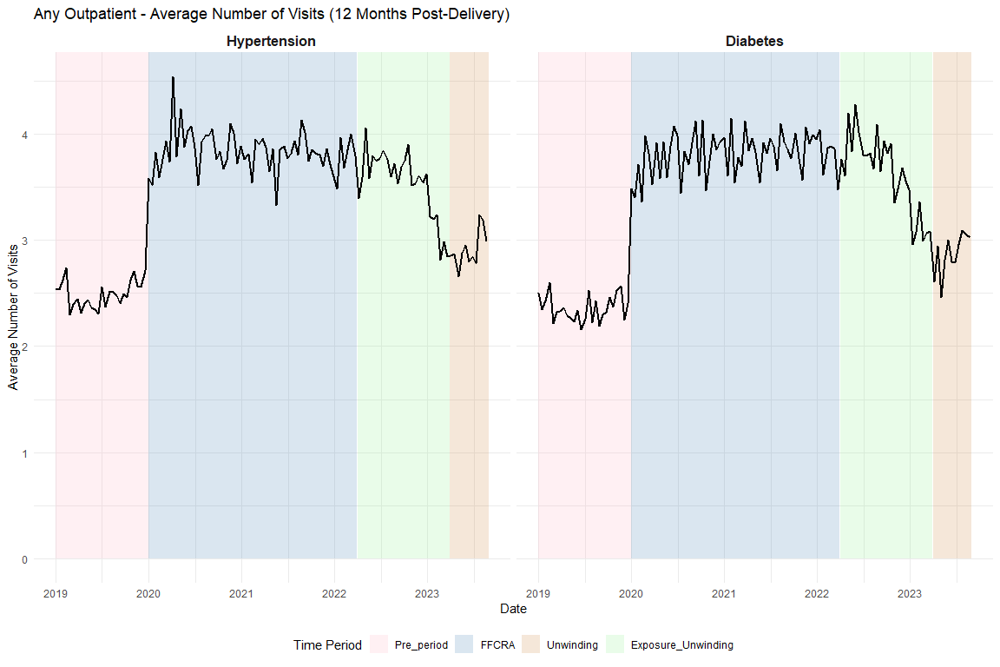

Supplemental Tables

Share of Visits for outpatient
This is based on the chart in the appendix we got the categories from
type_care | share_of_visits
Other acute or chronic illness only | 58.2
Contraceptive management only | 10.3
Mental/behavioral health care only | 9.7
Postpartum evaluation only | 8.4
Preventive/well care only | 7.7
Postpartum & Contraceptive | 3.3
Preventive/well & Contraceptive | 1.0
Contraceptive & Mental/behavioral health care | 0.5
Postpartum & mental/behavioral health care | 0.3
Preventive/well & mental/behavioral health | 0.2
Other combination | 0.2
Postpartum & Preventive/well | 0.1

Full ITS Results

Diabetes Screening
Unadjusted
Characteristic | Beta | 95% CI | p-value
(Intercept) | 0.4052 | 0.3896, 0.4207 | <0.001
t | -0.0015 | -0.0026, -0.0005 | 0.004
period_FFCRA | 0.1234 | 0.1054, 0.1413 | <0.001
period_Exposure_Unwinding | 0.1438 | 0.1186, 0.1690 | <0.001
t_after_FFCRA | 0.0024 | 0.0013, 0.0035 | <0.001
t_after_Exposure | -0.0035 | -0.0041, -0.0029 | <0.001
Abbreviation: CI = Confidence Interval
Adjusted
Characteristic | Beta | 95% CI | p-value
(Intercept) | 0.2863 | 0.2634, 0.3092 | <0.001
t | -0.0027 | -0.0037, -0.0016 | <0.001
period_FFCRA | 0.1313 | 0.1136, 0.1490 | <0.001
period_Exposure_Unwinding | 0.1516 | 0.1268, 0.1764 | <0.001
t_after_FFCRA | 0.0034 | 0.0024, 0.0045 | <0.001
t_after_Exposure | -0.0035 | -0.0041, -0.0029 | <0.001
Age | 0.0002 | -0.0004, 0.0007 | 0.60
Index No Transfusion Weight | 0.0047 | 0.0045, 0.0048 | <0.001
Abbreviation: CI = Confidence Interval

Diabetes Outpatient
Unadjusted
Characteristic | Beta | 95% CI | p-value
(Intercept) | 0.6624 | 0.6488, 0.6761 | <0.001
t | -0.0001 | -0.0010, 0.0008 | 0.90
period_FFCRA | 0.0984 | 0.0827, 0.1141 | <0.001
period_Exposure_Unwinding | 0.1025 | 0.0805, 0.1246 | <0.001
t_after_FFCRA | 0.0005 | -0.0004, 0.0015 | 0.26
t_after_Exposure | -0.0030 | -0.0035, -0.0025 | <0.001
Abbreviation: CI = Confidence Interval
Adjusted
Characteristic | Beta | 95% CI | p-value
(Intercept) | 0.6149 | 0.5947, 0.6351 | <0.001
t | -0.0008 | -0.0017, 0.0000 | 0.064
period_FFCRA | 0.1042 | 0.0886, 0.1198 | <0.001
period_Exposure_Unwinding | 0.1082 | 0.0864, 0.1301 | <0.001
t_after_FFCRA | 0.0013 | 0.0003, 0.0022 | 0.008
t_after_Exposure | -0.0029 | -0.0035, -0.0024 | <0.001
Age | -0.0009 | -0.0014, -0.0004 | <0.001
Index No Transfusion Weight | 0.0031 | 0.0029, 0.0032 | <0.001
Abbreviation: CI = Confidence Interval

HTN Medication
Unadjusted
Characteristic | Beta | 95% CI | p-value
(Intercept) | 0.2737 | 0.2621, 0.2854 | <0.001
t | -0.0006 | -0.0014, 0.0002 | 0.12
period_FFCRA | 0.0270 | 0.0134, 0.0406 | <0.001
period_Exposure_Unwinding | 0.0467 | 0.0278, 0.0656 | <0.001
t_after_FFCRA | 0.0004 | -0.0004, 0.0012 | 0.31
t_after_Exposure | -0.0001 | -0.0006, 0.0003 | 0.66
Abbreviation: CI = Confidence Interval
Adjusted
Characteristic | Beta | 95% CI | p-value
(Intercept) | -0.3078 | -0.3237, -0.2919 | <0.001
t | -0.0020 | -0.0028, -0.0013 | <0.001
period_FFCRA | 0.0359 | 0.0230, 0.0487 | <0.001
period_Exposure_Unwinding | 0.0550 | 0.0372, 0.0728 | <0.001
t_after_FFCRA | 0.0016 | 0.0009, 0.0024 | <0.001
t_after_Exposure | 0.0000 | -0.0004, 0.0004 | 0.94
Age | 0.0141 | 0.0137, 0.0145 | <0.001
Index No Transfusion Weight | 0.0061 | 0.0060, 0.0062 | <0.001
Abbreviation: CI = Confidence Interval

HTN Outpatient
Unadjusted
Characteristic | Beta | 95% CI | p-value
(Intercept) | 0.6669 | 0.6556, 0.6782 | <0.001
t | 0.0004 | -0.0004, 0.0011 | 0.31
period_FFCRA | 0.0915 | 0.0783, 0.1047 | <0.001
period_Exposure_Unwinding | 0.1020 | 0.0836, 0.1203 | <0.001
t_after_FFCRA | -0.0003 | -0.0011, 0.0005 | 0.46
t_after_Exposure | -0.0023 | -0.0028, -0.0019 | <0.001
Abbreviation: CI = Confidence Interval
Adjusted
Characteristic | Beta | 95% CI | p-value
(Intercept) | 0.5869 | 0.5707, 0.6031 | <0.001
t | -0.0005 | -0.0013, 0.0002 | 0.16
period_FFCRA | 0.0994 | 0.0863, 0.1125 | <0.001
period_Exposure_Unwinding | 0.1095 | 0.0913, 0.1277 | <0.001
t_after_FFCRA | 0.0005 | -0.0002, 0.0013 | 0.17
t_after_Exposure | -0.0022 | -0.0027, -0.0018 | <0.001
Age | -0.0005 | -0.0009, -0.0001 | 0.017
Index No Transfusion Weight | 0.0031 | 0.0030, 0.0033 | <0.001
Abbreviation: CI = Confidence Interval

Average Outpatient Visit Count – Negative Binomial, IRR (total_visit_days_12)

Diabetes Visit Count
Unadjusted
Characteristic | IRR | 95% CI | p-value
(Intercept) | 2.3438 | 2.2504, 2.4410 | <0.001
t | 1.0003 | 0.9976, 1.0030 | 0.83
period_FFCRA | 1.5822 | 1.5108, 1.6571 | <0.001
period_Exposure_Unwinding | 1.6914 | 1.5869, 1.8027 | <0.001
t_after_FFCRA | 1.0005 | 0.9977, 1.0032 | 0.74
t_after_Exposure | 0.9883 | 0.9867, 0.9898 | <0.001
Abbreviations: CI = Confidence Interval, IRR = Incidence Rate Ratio
Adjusted
Characteristic | IRR | 95% CI | p-value
(Intercept) | 1.5937 | 1.5035, 1.6894 | <0.001
t | 0.9966 | 0.9940, 0.9993 | 0.012
period_FFCRA | 1.6099 | 1.5386, 1.6845 | <0.001
period_Exposure_Unwinding | 1.7302 | 1.6256, 1.8415 | <0.001
t_after_FFCRA | 1.0039 | 1.0012, 1.0066 | 0.005
t_after_Exposure | 0.9880 | 0.9866, 0.9895 | <0.001
Age | 1.0003 | 0.9989, 1.0017 | 0.72
Index No Transfusion Weight | 1.0144 | 1.0140, 1.0148 | <0.001
Abbreviations: CI = Confidence Interval, IRR = Incidence Rate Ratio

HTN Visit Count
Unadjusted
Characteristic | IRR | 95% CI | p-value
(Intercept) | 2.4264 | 2.3466, 2.5089 | <0.001
t | 1.0021 | 0.9999, 1.0043 | 0.066
period_FFCRA | 1.5121 | 1.4549, 1.5717 | <0.001
period_Exposure_Unwinding | 1.5795 | 1.4981, 1.6653 | <0.001
t_after_FFCRA | 0.9976 | 0.9953, 0.9999 | 0.039
t_after_Exposure | 0.9913 | 0.9900, 0.9925 | <0.001
Abbreviations: CI = Confidence Interval, IRR = Incidence Rate Ratio
Adjusted
Characteristic | IRR | 95% CI | p-value
(Intercept) | 1.3783 | 1.3153, 1.4443 | <0.001
t | 0.9980 | 0.9958, 1.0001 | 0.066
period_FFCRA | 1.5510 | 1.4933, 1.6109 | <0.001
period_Exposure_Unwinding | 1.6186 | 1.5368, 1.7047 | <0.001
t_after_FFCRA | 1.0014 | 0.9991, 1.0036 | 0.23
t_after_Exposure | 0.9915 | 0.9903, 0.9927 | <0.001
Age | 1.0049 | 1.0037, 1.0060 | <0.001
Index No Transfusion Weight | 1.0136 | 1.0132, 1.0139 | <0.001
Abbreviations: CI = Confidence Interval, IRR = Incidence Rate Ratio

HEDIS Postpartum Visits

Diabetes Postpartum Visits
Unadjusted
Characteristic | Beta | 95% CI | p-value
(Intercept) | 0.7827 | 0.7701, 0.7953 | <0.001
t | 0.0003 | -0.0006, 0.0011 | 0.51
period_FFCRA | 0.0055 | -0.0090, 0.0200 | 0.46
period_Exposure_Unwinding | 0.0150 | -0.0054, 0.0353 | 0.15
t_after_FFCRA | 0.0000 | -0.0009, 0.0008 | 0.92
t_after_Exposure | -0.0012 | -0.0017, -0.0007 | <0.001
Abbreviation: CI = Confidence Interval
Adjusted
Characteristic | Beta | 95% CI | p-value
(Intercept) | 0.7894 | 0.7706, 0.8081 | <0.001
t | 0.0000 | -0.0008, 0.0008 | 0.98
period_FFCRA | 0.0078 | -0.0067, 0.0223 | 0.29
period_Exposure_Unwinding | 0.0172 | -0.0031, 0.0375 | 0.10
t_after_FFCRA | 0.0002 | -0.0006, 0.0011 | 0.61
t_after_Exposure | -0.0012 | -0.0017, -0.0007 | <0.001
Age | -0.0011 | -0.0015, -0.0006 | <0.001
Index No Transfusion Weight | 0.0010 | 0.0009, 0.0012 | <0.001
Abbreviation: CI = Confidence Interval

HTN Postpartum Visits
Unadjusted
Characteristic | Beta | 95% CI | p-value
(Intercept) | 0.7668 | 0.7562, 0.7775 | <0.001
t | 0.0005 | -0.0002, 0.0012 | 0.16
period_FFCRA | -0.0021 | -0.0146, 0.0104 | 0.74
period_Exposure_Unwinding | -0.0010 | -0.0184, 0.0164 | 0.91
t_after_FFCRA | -0.0003 | -0.0010, 0.0005 | 0.47
t_after_Exposure | -0.0008 | -0.0012, -0.0004 | <0.001
Abbreviation: CI = Confidence Interval
Adjusted
Characteristic | Beta | 95% CI | p-value
(Intercept) | 0.7918 | 0.7763, 0.8073 | <0.001
t | 0.0001 | -0.0006, 0.0008 | 0.74
period_FFCRA | 0.0016 | -0.0109, 0.0141 | 0.80
period_Exposure_Unwinding | 0.0026 | -0.0148, 0.0199 | 0.77
t_after_FFCRA | 0.0001 | -0.0006, 0.0008 | 0.80
t_after_Exposure | -0.0008 | -0.0012, -0.0003 | <0.001
Age | -0.0021 | -0.0025, -0.0017 | <0.001
Index No Transfusion Weight | 0.0012 | 0.0010, 0.0013 | <0.001
Abbreviation: CI = Confidence Interval

Sensitivity Analyses

Diabetes Subgroup Exclude Pre-existing

Graph
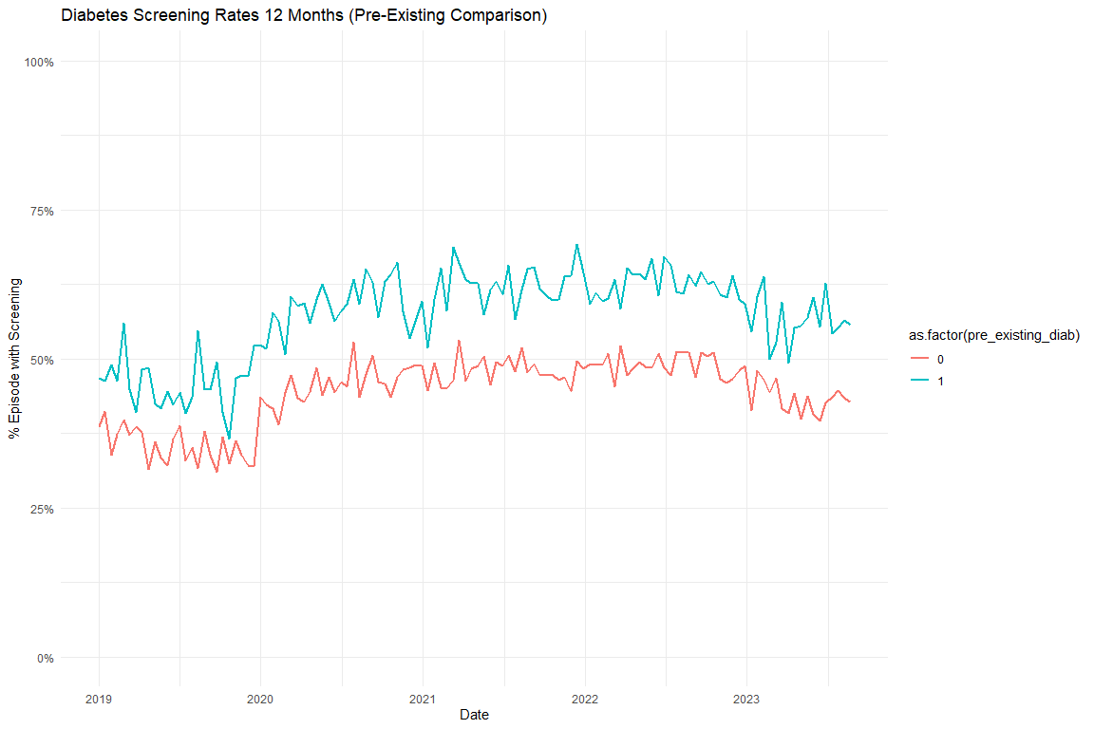

Models

Diabetes Screening Unadjusted
 | Full Sample | Excluding Pre-Existing Diabetes
Characteristic | Beta¹ | Beta¹
(Intercept) | 0.405*** | 0.379***
t | -0.002** | -0.002***
period_FFCRA | 0.123*** | 0.121***
period_Exposure_Unwinding | 0.144*** | 0.136***
t_after_FFCRA | 0.002*** | 0.003***
t_after_Exposure | -0.004*** | -0.003***
¹*p<0.05; **p<0.01; ***p<0.001

Diabetes Screening Adjusted
 | Full Sample | Excluding Pre-Existing Diabetes
Characteristic | Beta¹ | Beta¹
(Intercept) | 0.286*** | 0.306***
t | -0.003*** | -0.003***
period_FFCRA | 0.131*** | 0.129***
period_Exposure_Unwinding | 0.152*** | 0.144***
t_after_FFCRA | 0.003*** | 0.004***
t_after_Exposure | -0.003*** | -0.003***
Age | 0.000 | -0.001
Index No Transfusion Weight | 0.005*** | 0.004***
¹*p<0.05; **p<0.01; ***p<0.001

Diabetes Subgroup Test Type Graphs
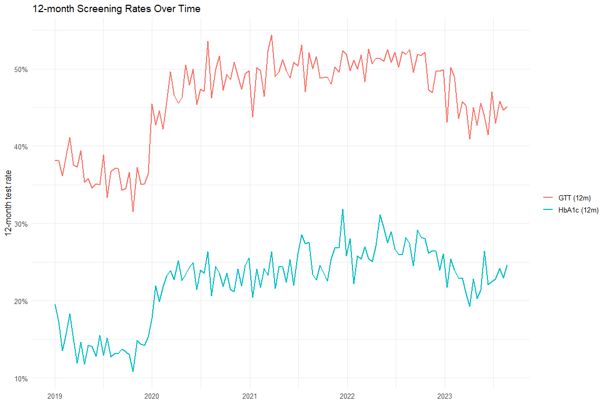

Diabetes Test Type Models
 | Overall (Unadj) | Overall (Adj) | HbA1c (Unadj) | HbA1c (Adj) | GTT (Unadj) | GTT (Adj)
Characteristic | Beta¹ | Beta¹ | Beta¹ | Beta¹ | Beta¹ | Beta¹
(Intercept) | 0.405*** | 0.286*** | 0.155*** | -0.031** | 0.380*** | 0.265***
t | -0.002** | -0.003*** | -0.001* | -0.002*** | -0.001* | -0.002***
period_FFCRA | 0.123*** | 0.131*** | 0.091*** | 0.095*** | 0.122*** | 0.130***
period_Exposure_Unwinding | 0.144*** | 0.152*** | 0.116*** | 0.120*** | 0.141*** | 0.149***
t_after_FFCRA | 0.002*** | 0.003*** | 0.002*** | 0.002*** | 0.002*** | 0.003***
t_after_Exposure | -0.004*** | -0.003*** | -0.003*** | -0.003*** | -0.004*** | -0.003***
Age |  | 0.000 |  | 0.003*** |  | 0.000
Index No Transfusion Weight |  | 0.005*** |  | 0.003*** |  | 0.005***
¹*p<0.05; **p<0.01; ***p<0.001

Excluding COVID
[1] "diab_screen_unadj_excluded_reidx"
[1] "diab_screen_adj_excluded_reidx"
[1] "diab_any_outpatient_unadj_excluded_reidx"
[1] "diab_any_outpatient_adj_excluded_reidx"
[1] "htn_med_unadj_excluded_reidx"
[1] "htn_med_adj_excluded_reidx"
[1] "htn_any_outpatient_unadj_excluded_reidx"
[1] "htn_any_outpatient_adj_excluded_reidx"
 | Original - Unadj | Excluded COVID - Unadj | Original - Adj | Excluded COVID - Adj
Characteristic | Beta¹ | Beta¹ | Beta¹ | Beta¹
(Intercept) | 0.405*** | 0.411*** | 0.286*** | 0.294***
t | -0.002** | 0.001 | -0.003*** | 0.001
period_FFCRA | 0.123*** | 0.088*** | 0.131*** | 0.061***
period_Exposure_Unwinding | 0.144*** | 0.114*** | 0.152*** | 0.090***
t_after_FFCRA | 0.002*** | 0.000 | 0.003*** | -0.001
t_after_Exposure | -0.004*** | -0.003*** | -0.003*** | -0.003***
Age |  |  | 0.000 | 0.000
Index No Transfusion Weight |  |  | 0.005*** | 0.005***
¹*p<0.05; **p<0.01; ***p<0.001
 | Original - Unadj | Excluded COVID - Unadj | Original - Adj | Excluded COVID - Adj
Characteristic | Beta¹ | Beta¹ | Beta¹ | Beta¹
(Intercept) | 0.662*** | 0.661*** | 0.615*** | 0.618***
t | 0.000 | 0.000 | -0.001 | 0.000
period_FFCRA | 0.098*** | 0.101*** | 0.104*** | 0.084***
period_Exposure_Unwinding | 0.103*** | 0.105*** | 0.108*** | 0.089***
t_after_FFCRA | 0.001 | 0.000 | 0.001** | 0.000
t_after_Exposure | -0.003*** | -0.003*** | -0.003*** | -0.003***
Age |  |  | -0.001*** | -0.001***
Index No Transfusion Weight |  |  | 0.003*** | 0.003***
¹*p<0.05; **p<0.01; ***p<0.001
 | Original - Unadj | Excluded COVID - Unadj | Original - Adj | Excluded COVID - Adj
Characteristic | Beta¹ | Beta¹ | Beta¹ | Beta¹
(Intercept) | 0.274*** | 0.280*** | -0.308*** | -0.290***
t | -0.001 | -0.001* | -0.002*** | -0.001**
period_FFCRA | 0.027*** | 0.015 | 0.036*** | -0.017
period_Exposure_Unwinding | 0.047*** | 0.031** | 0.055*** | 0.002
t_after_FFCRA | 0.000 | 0.001 | 0.002*** | 0.001
t_after_Exposure | 0.000 | 0.000 | 0.000 | 0.000
Age |  |  | 0.014*** | 0.014***
Index No Transfusion Weight |  |  | 0.006*** | 0.006***
¹*p<0.05; **p<0.01; ***p<0.001
 | Original - Unadj | Excluded COVID - Unadj | Original - Adj | Excluded COVID - Adj
Characteristic | Beta¹ | Beta¹ | Beta¹ | Beta¹
(Intercept) | 0.667*** | 0.675*** | 0.587*** | 0.601***
t | 0.000 | 0.000 | -0.001 | 0.000
period_FFCRA | 0.091*** | 0.100*** | 0.099*** | 0.082***
period_Exposure_Unwinding | 0.102*** | 0.113*** | 0.109*** | 0.096***
t_after_FFCRA | 0.000 | 0.000 | 0.001 | 0.000
t_after_Exposure | -0.002*** | -0.002*** | -0.002*** | -0.002***
Age |  |  | 0.000* | -0.001*
Index No Transfusion Weight |  |  | 0.003*** | 0.003***
¹*p<0.05; **p<0.01; ***p<0.001

Other Break Analysis

Percent Change in DSHS Numbers
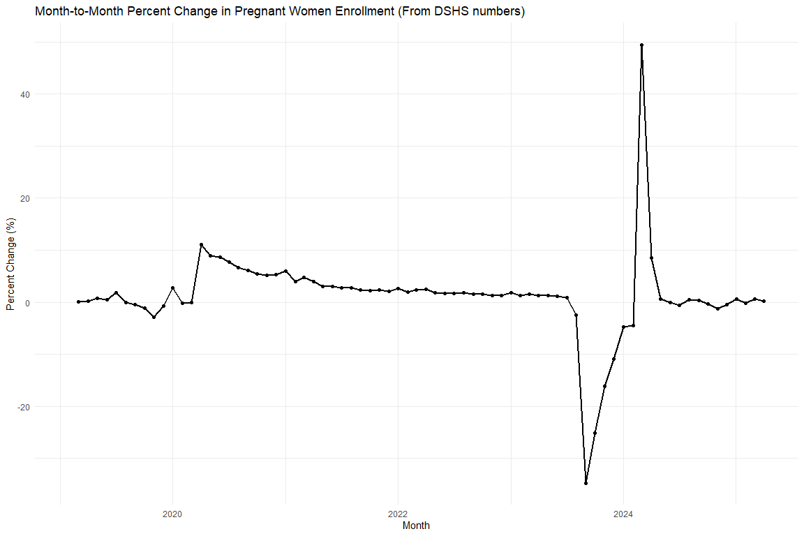
Month | Pregnant Women (Count) | Percent Change (%)
2023-01-01 | 476,205 | 1.77%
2023-02-01 | 482,037 | 1.22%
2023-03-01 | 489,284 | 1.50%
2023-04-01 | 495,541 | 1.28%
2023-05-01 | 501,614 | 1.23%
2023-06-01 | 507,057 | 1.09%
2023-07-01 | 511,183 | 0.81%
2023-08-01 | 498,392 | -2.50%
2023-09-01 | 325,121 | -34.77%
2023-10-01 | 243,231 | -25.19%
2023-11-01 | 204,057 | -16.11%
2023-12-01 | 181,646 | -10.98%
2024-01-01 | 173,116 | -4.70%
2024-02-01 | 165,441 | -4.43%
2024-03-01 | 247,371 | 49.52%
2024-04-01 | 268,508 | 8.54%
2024-05-01 | 269,962 | 0.54%
2024-06-01 | 269,712 | -0.09%

Change in CE (from cohort)
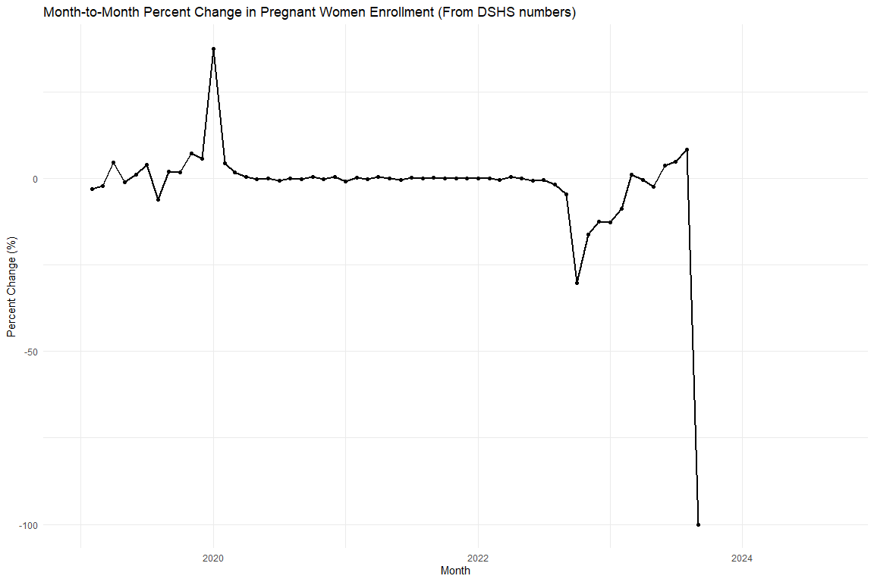
Month | CE After 12 (Level, %) | MoM Change (%)
2019-01-01 | 58.65%
2019-02-01 | 56.90% | -2.99%
2019-03-01 | 55.71% | -2.09%
2019-04-01 | 58.26% | 4.58%
2019-05-01 | 57.69% | -0.97%
2019-06-01 | 58.29% | 1.04%
2019-07-01 | 60.55% | 3.86%
2019-08-01 | 56.78% | -6.22%
2019-09-01 | 57.94% | 2.04%
2019-10-01 | 58.95% | 1.75%
2019-11-01 | 63.24% | 7.28%
2019-12-01 | 66.85% | 5.70%
2020-01-01 | 91.98% | 37.59%
2020-02-01 | 96.13% | 4.51%
2020-03-01 | 97.88% | 1.83%
2020-04-01 | 98.25% | 0.38%
2020-05-01 | 98.11% | -0.15%
2020-06-01 | 98.19% | 0.08%
2020-07-01 | 97.56% | -0.64%
2020-08-01 | 97.56% | 0.00%
2020-09-01 | 97.37% | -0.19%
2020-10-01 | 97.78% | 0.42%
2020-11-01 | 97.58% | -0.20%
2020-12-01 | 97.99% | 0.42%
2021-01-01 | 97.22% | -0.78%
2021-02-01 | 97.38% | 0.16%
2021-03-01 | 97.24% | -0.14%
2021-04-01 | 97.78% | 0.55%
2021-05-01 | 97.91% | 0.13%
2021-06-01 | 97.52% | -0.39%
2021-07-01 | 97.76% | 0.24%
2021-08-01 | 97.75% | -0.02%
2021-09-01 | 98.02% | 0.28%
2021-10-01 | 98.14% | 0.12%
2021-11-01 | 98.15% | 0.01%
2021-12-01 | 98.27% | 0.12%
2022-01-01 | 98.40% | 0.13%
2022-02-01 | 98.44% | 0.04%
2022-03-01 | 98.14% | -0.31%
2022-04-01 | 98.51% | 0.38%
2022-05-01 | 98.45% | -0.06%
2022-06-01 | 97.74% | -0.72%
2022-07-01 | 97.28% | -0.47%
2022-08-01 | 95.56% | -1.77%
2022-09-01 | 91.20% | -4.56%
2022-10-01 | 63.57% | -30.30%
2022-11-01 | 53.32% | -16.12%
2022-12-01 | 46.67% | -12.47%
2023-01-01 | 40.74% | -12.70%
2023-02-01 | 37.19% | -8.72%
2023-03-01 | 37.61% | 1.14%
2023-04-01 | 37.46% | -0.41%
2023-05-01 | 36.53% | -2.48%
2023-06-01 | 37.87% | 3.68%
2023-07-01 | 39.75% | 4.95%
2023-08-01 | 43.10% | 8.43%
2023-09-01 | 0.00% | -100.00%

Scratch (check predicted values)
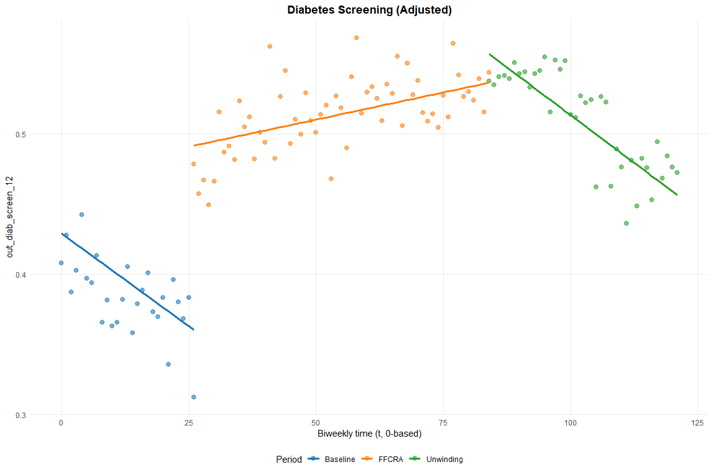

Export Excel

