POEM TX Paper 2 (APCD Data) - Mental Health
2026-03-09

Cohort (Before Filtering to Mental Health)
Right now, APCD data goes until Aug 2025, so filtered anchor dates for 1 year before then. This will soon be updated to include more data, though. At this point, it is not filtered to “Regular” Medicaid.
Characteristic | N = 1,053,542¹
Mental Health Sample | 138,737 (13%)
Birth Outcome
LB | 1,046,367 (99%)
SB | 7,175 (0.7%)
Year
2019 | 189,522 (18%)
2020 | 186,347 (18%)
2021 | 184,435 (18%)
2022 | 192,551 (18%)
2023 | 185,053 (18%)
2024 | 115,634 (11%)
Age Group
19-24 | 357,222 (34%)
25-34 | 553,993 (53%)
35-44 | 140,403 (13%)
45-55 | 1,924 (0.2%)
Enrollment Category
Emergency | 240,278 (23%)
Healthy Texas Women | 42 (<0.1%)
Other | 36 (<0.1%)
Regular | 797,227 (76%)
Three months prior | 4,131 (0.4%)
Unknown | 11,828 (1.1%)
Anxiety and fear-related disorders | 85,411 (8.1%)
Depressive disorders | 74,869 (7.1%)
Suicidal ideation/attempt/self-harm | 3,867 (0.4%)
Schizophrenia spectrum/psychotic disorders | 4,180 (0.4%)
Trauma- and stressor-related disorders | 23,708 (2.3%)
Bipolar and related disorders | 20,460 (1.9%)
Neurodevelopmental disorders | 56 (<0.1%)
Other disorders | 10,540 (1.0%)
Continuously enrolled 12 months post-delivery | 609,930 (58%)
Enrolled at 12 months post-delivery | 714,996 (68%)
MH prescription (0-12 months) | 77,339 (7.3%)
Therapy session (0-12 months) | 29,497 (2.8%)
¹n (%)

MH Sub Cohort

Table 1
Characteristic | N = 138,737¹
Birth Outcome
LB | 137,609 (99%)
SB | 1,128 (0.8%)
Year
2019 | 19,116 (14%)
2020 | 23,727 (17%)
2021 | 26,792 (19%)
2022 | 26,783 (19%)
2023 | 26,189 (19%)
2024 | 16,130 (12%)
Age Group
19-24 | 47,779 (34%)
25-34 | 73,152 (53%)
35-44 | 17,608 (13%)
45-55 | 198 (0.1%)
Enrollment Category
Emergency | 12,280 (8.9%)
Healthy Texas Women | 6 (<0.1%)
Other | 6 (<0.1%)
Regular | 125,417 (90%)
Three months prior | 477 (0.3%)
Unknown | 551 (0.4%)
Anxiety and fear-related disorders | 85,411 (62%)
Depressive disorders | 74,869 (54%)
Suicidal ideation/attempt/self-harm | 3,867 (2.8%)
Schizophrenia spectrum/psychotic disorders | 4,180 (3.0%)
Trauma- and stressor-related disorders | 23,708 (17%)
Bipolar and related disorders | 20,460 (15%)
Neurodevelopmental disorders | 56 (<0.1%)
Other disorders | 10,540 (7.6%)
Continuously enrolled 12 months post-delivery | 95,947 (69%)
Enrolled at 12 months post-delivery | 108,158 (78%)
MH prescription (0-12 months) | 37,001 (27%)
Therapy session (0-12 months) | 16,096 (12%)
¹n (%)

Figure 1: MH Prescriptions 0-12 Months Postpartum
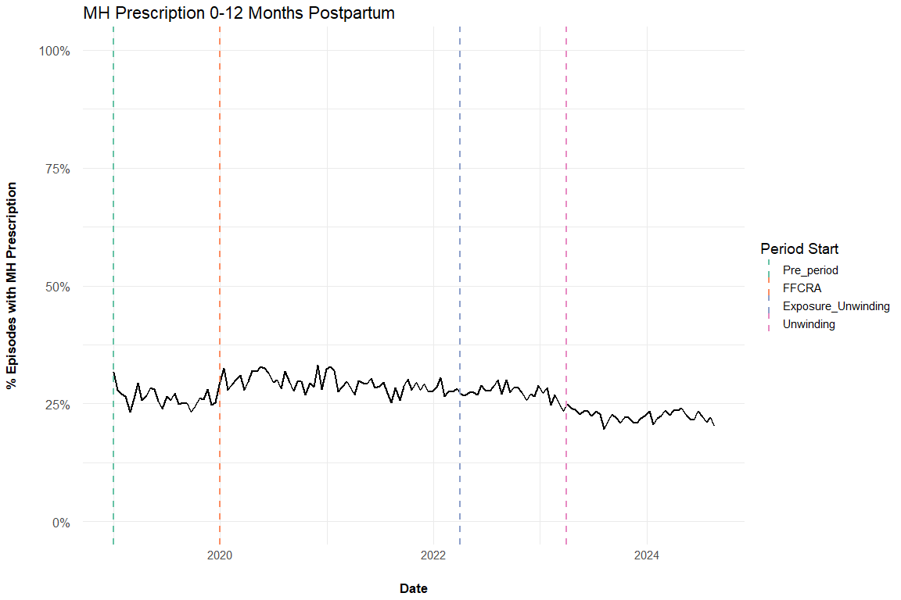
Figure 1

Figure 2: Therapy Sessions 0-12 Months Postpartum
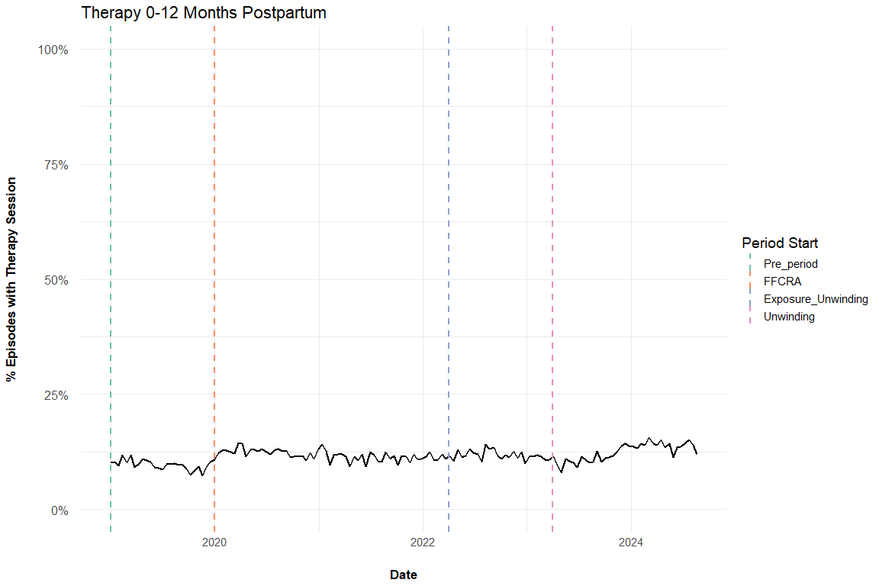
Figure 2

Supplemental Figures

Enrollment
This looks different than our other one, but it’s probably because it still has those on “Emergency” Medicaid for their delivery
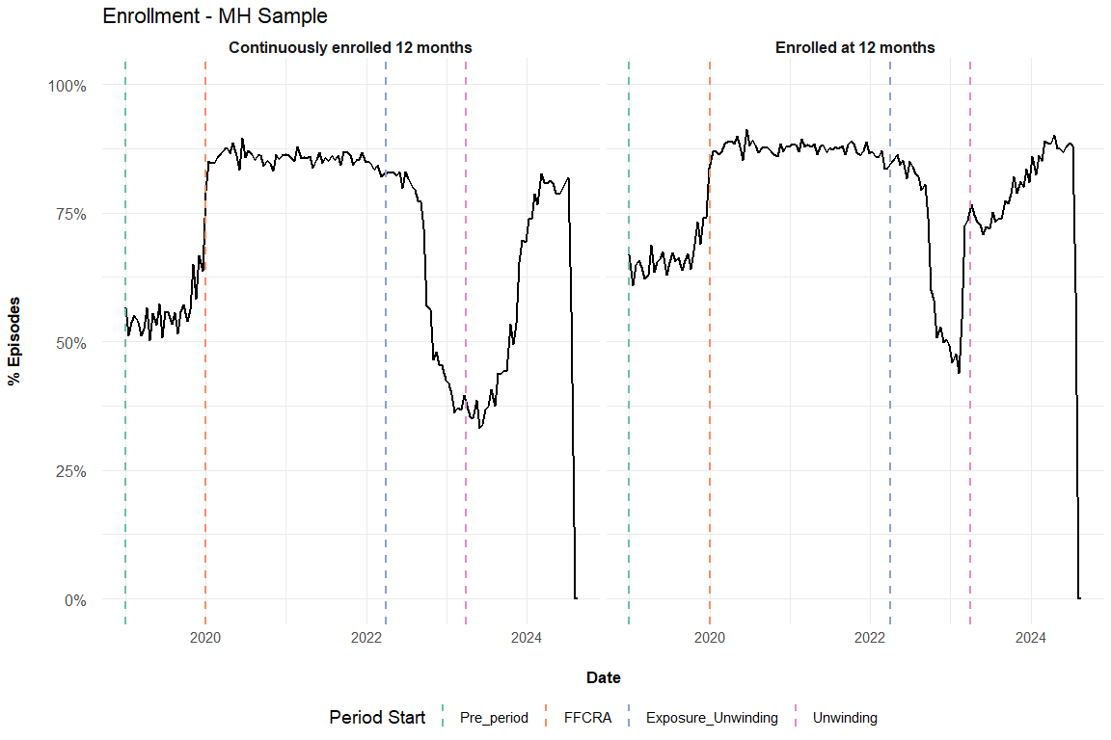
Figure 3

