POEM TX Paper 2 (APCD Data) - Mental Health
2026-03-23

Cohort (Before Filtering to Mental Health)
Right now, APCD data goes until Aug 2025, so filtered anchor dates for 1 year before then. This will soon be updated to include more data, though. At this point, it is not filtered to “Regular” Medicaid.
Characteristic | N = 1,053,542¹
Mental Health Sample | 138,737 (13%)
Birth Outcome
LB | 1,046,367 (99%)
SB | 7,175 (0.7%)
Year
2019 | 189,522 (18%)
2020 | 186,347 (18%)
2021 | 184,435 (18%)
2022 | 192,551 (18%)
2023 | 185,053 (18%)
2024 | 115,634 (11%)
Age Group
19-24 | 357,222 (34%)
25-34 | 553,993 (53%)
35-44 | 140,403 (13%)
45-55 | 1,924 (0.2%)
Enrollment Category
Emergency | 240,278 (23%)
Healthy Texas Women | 42 (<0.1%)
Other | 36 (<0.1%)
Regular | 797,227 (76%)
Three months prior | 4,131 (0.4%)
Unknown | 11,828 (1.1%)
¹n (%)

Diagnoses & Outcomes by Mental Health Sample
Characteristic | Overall (No Prior MH), N = 914,805¹ | MH Subgroup, N = 138,737¹
Prior: Anxiety and fear-related disorders | 0 (0%) | 85,411 (62%)
Prior: Depressive disorders | 0 (0%) | 74,869 (54%)
Prior: Suicidal ideation/attempt/self-harm | 0 (0%) | 3,867 (2.8%)
Prior: Schizophrenia spectrum/psychotic disorders | 0 (0%) | 4,180 (3.0%)
Prior: Trauma- and stressor-related disorders | 0 (0%) | 23,708 (17%)
Prior: Bipolar and related disorders | 0 (0%) | 20,460 (15%)
Prior: Neurodevelopmental disorders | 0 (0%) | 56 (<0.1%)
Prior: Other disorders | 0 (0%) | 10,540 (7.6%)
Postpartum: Any MH diagnosis (0-12 months) | 77,500 (8.5%) | 63,129 (46%)
Postpartum: Anxiety and fear-related disorders | 36,423 (4.0%) | 38,820 (28%)
Postpartum: Depressive disorders | 29,290 (3.2%) | 34,336 (25%)
Postpartum: Suicidal ideation/attempt/self-harm | 2,882 (0.3%) | 3,244 (2.3%)
Postpartum: Schizophrenia spectrum/psychotic disorders | 1,359 (0.1%) | 3,182 (2.3%)
Postpartum: Trauma- and stressor-related disorders | 15,097 (1.7%) | 17,038 (12%)
Postpartum: Bipolar and related disorders | 5,485 (0.6%) | 13,812 (10.0%)
Postpartum: Neurodevelopmental disorders | 29 (<0.1%) | 33 (<0.1%)
Postpartum: Other disorders | 27,371 (3.0%) | 15,806 (11%)
Continuously enrolled 12 months post-delivery | 513,983 (56%) | 95,947 (69%)
Enrolled at 12 months post-delivery | 606,838 (66%) | 108,158 (78%)
MH prescription (0-12 months) | 40,338 (4.4%) | 37,001 (27%)
Therapy session (0-12 months) | 13,401 (1.5%) | 16,096 (12%)
¹n (%)

Outcome Graphs

MH Prescriptions 0-12 Months Postpartum
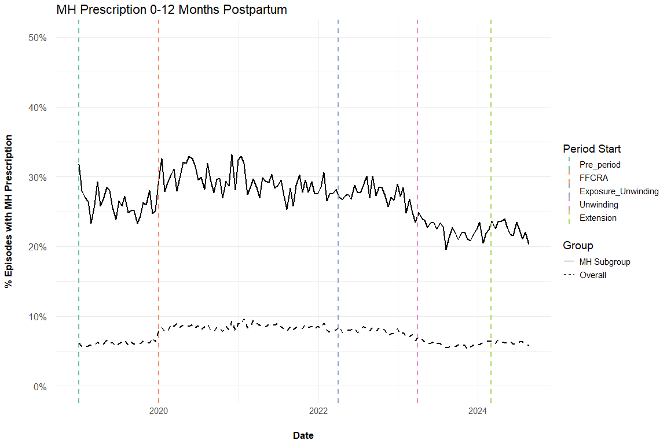

Therapy Sessions 0-12 Months Postpartum
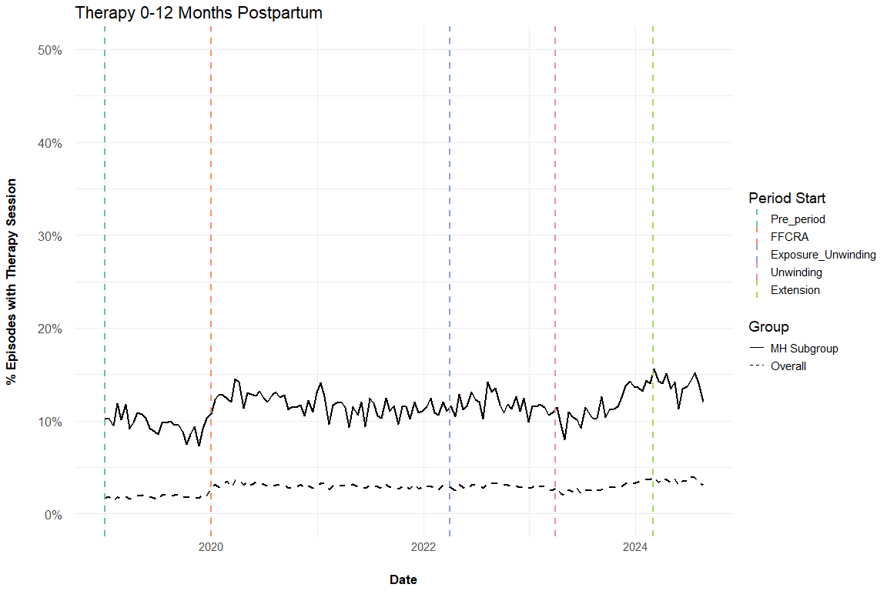

Therapy & MH Prescriptions by Time Period

Overall
Characteristic | 1. Pre, N = 189,522¹ | 2. FFCRA, N = 416,693¹ | 3. Exposure to Unwinding, N = 360,347¹ | 4. Extension onwards, N = 86,449¹
Therapy session (0-12 months) | 3,454 (1.8%) | 12,534 (3.0%) | 10,402 (2.9%) | 3,079 (3.6%)
MH prescription (0-12 months) | 11,585 (6.1%) | 35,261 (8.5%) | 25,068 (7.0%) | 5,390 (6.2%)
¹n (%)

MH Sample
Characteristic | 1. Pre, N = 19,116¹ | 2. FFCRA, N = 56,908¹ | 3. Exposure to Unwinding, N = 50,659¹ | 4. Extension onwards, N = 11,972¹
Therapy session (0-12 months) | 1,821 (9.5%) | 6,685 (12%) | 5,906 (12%) | 1,667 (14%)
MH prescription (0-12 months) | 4,975 (26%) | 16,634 (29%) | 12,677 (25%) | 2,697 (23%)
¹n (%)

Changelog:
- 3/23/2026: Added derived (non-overlapping) time period variable. Added Table 3: therapy & MH prescriptions stratified by time period.
- 3/17/2026: Added “Extension” time period (starting March 1, 2024). Added DX after delivery too
- 3/10/2026: Added postpartum MH DX outcomes and clarified language on prior labels.

