POEM TX Paper 1
2025-10-16

Main Analysis Tables and Figures

Table 1
 | Overall | By Condition
Characteristic | N = 187,329¹ | Diabetes, N = 88,155¹ | Hypertension, N = 127,197¹
Birth Outcome
LB | 185,895 (99%) | 87,444 (99%) | 126,177 (99%)
SB | 1,434 (0.8%) | 711 (0.8%) | 1,020 (0.8%)
Year
2019 | 34,963 (19%) | 16,561 (19%) | 23,316 (18%)
2020 | 38,875 (21%) | 18,642 (21%) | 26,031 (20%)
2021 | 41,232 (22%) | 19,730 (22%) | 27,725 (22%)
2022 | 43,391 (23%) | 20,102 (23%) | 29,926 (24%)
2023 | 28,868 (15%) | 13,120 (15%) | 20,199 (16%)
Race/Ethnicity
American Indian or Alaskan | 449 (0.2%) | 208 (0.2%) | 310 (0.2%)
Asian, Pacific Islander | 3,428 (1.8%) | 2,507 (2.8%) | 1,380 (1.1%)
Black, non-Hispanic | 38,362 (20%) | 12,402 (14%) | 31,309 (25%)
Hispanic | 97,241 (52%) | 53,348 (61%) | 59,525 (47%)
Unknown/Other | 8,591 (4.6%) | 3,612 (4.1%) | 6,238 (4.9%)
White, non-Hispanic | 39,258 (21%) | 16,078 (18%) | 28,435 (22%)
Age Group
19-24 | 53,380 (28%) | 18,707 (21%) | 39,651 (31%)
25-34 | 101,790 (54%) | 50,230 (57%) | 67,020 (53%)
35-44 | 31,674 (17%) | 18,906 (21%) | 20,201 (16%)
45-55 | 485 (0.3%) | 312 (0.4%) | 325 (0.3%)
Index No Transfusion Weight | 12 (12, 19) | 12 (12, 19) | 12 (12, 19)
¹n (%); Median (IQR)

Figure 1: Biweekly graphs based on anchor date: outpatient utilization
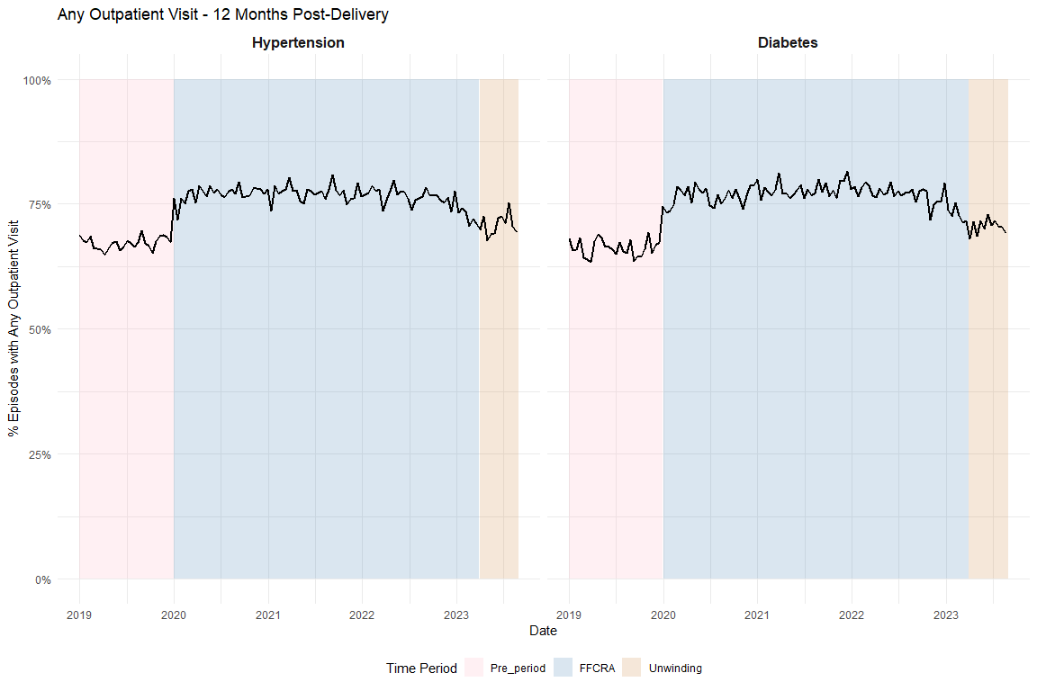

Figure 2: Biweekly graphs based on anchor date: diabetes screening
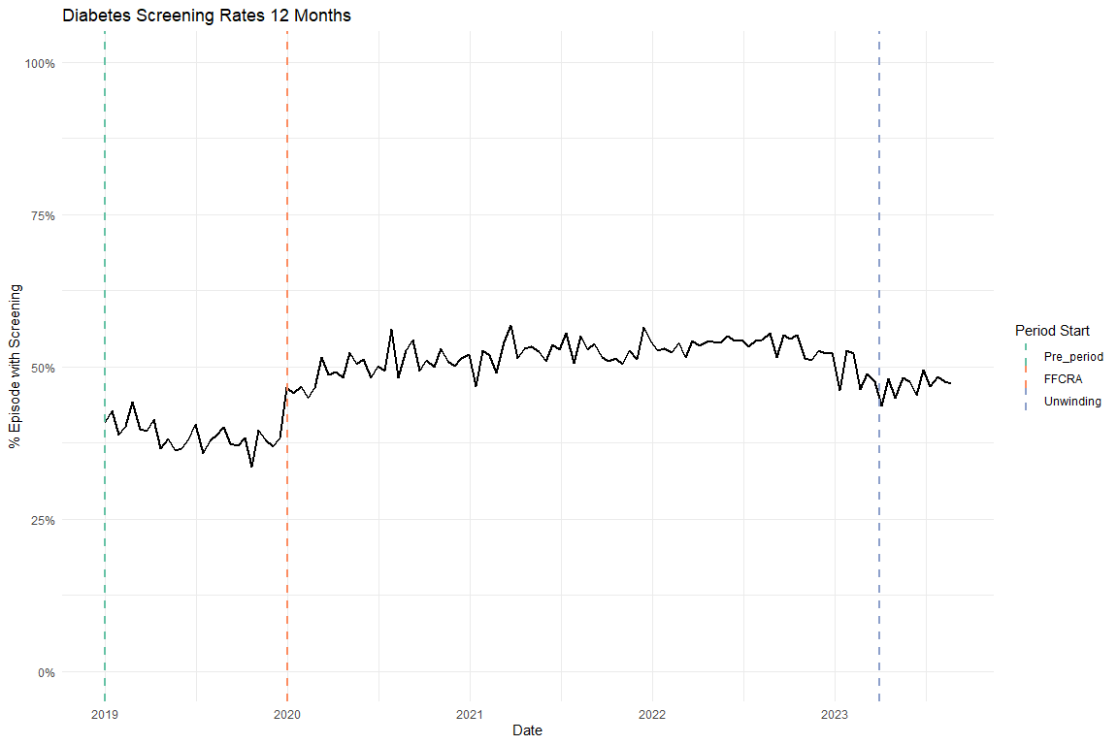

Figure 3: Biweekly graphs based on anchor date: hypertensive medication
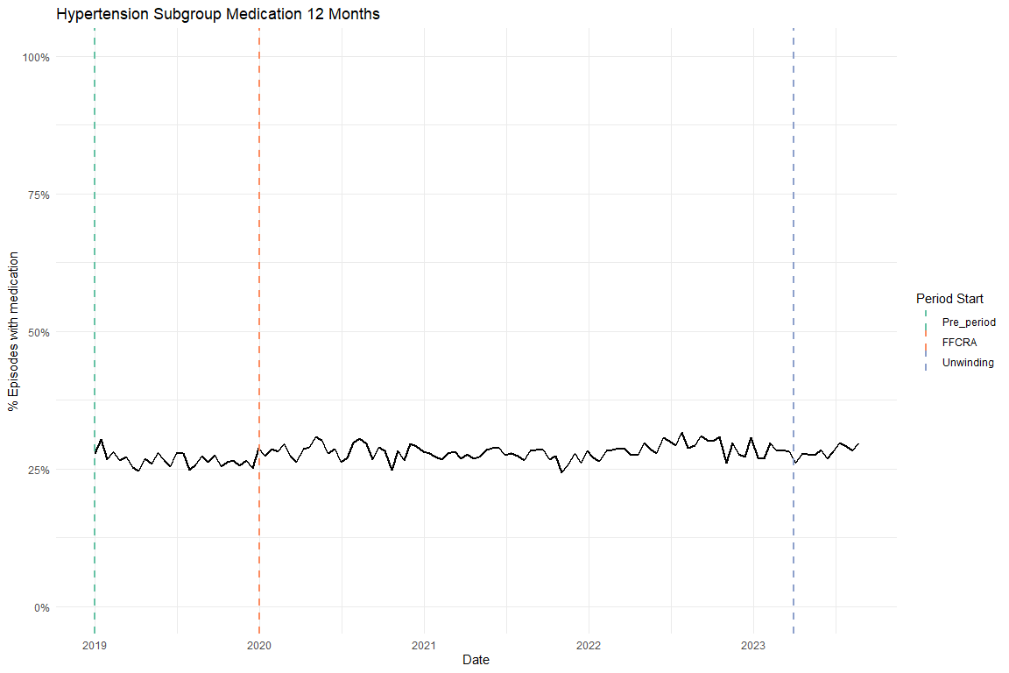

Table 2: ITS results of all utilization outcomes, adjusted, main coefficients only
Diabetes cohort
Characteristic | Diabetes Screening Beta | 95% CI¹ | Any outpatient utilization Beta | 95% CI¹
Pre-trend | -0.002 | -0.003, -0.001 | -0.001 | -0.002, 0.000
Level Change, FFCRA | 0.072 | 0.052, 0.092 | 0.105 | 0.087, 0.122
Level Change, Unwinding | -0.199 | -0.591, 0.193 | -0.030 | -0.374, 0.313
Trend Change, FFCRA | 0.003 | 0.002, 0.004 | 0.000 | 0.000, 0.001
Trend Change, Unwinding | 0.004 | 0.001, 0.008 | 0.001 | -0.002, 0.004
¹CI = Confidence Interval
Hypertension cohort
Characteristic | Antihypertensive medication Beta | 95% CI¹ | Any outpatient utilization Beta | 95% CI¹
Pre-trend | -0.001 | -0.002, -0.001 | 0.000 | -0.001, 0.000
Level Change, FFCRA | -0.011 | -0.026, 0.004 | 0.105 | 0.091, 0.120
Level Change, Unwinding | -0.343 | -0.625, -0.062 | -0.208 | -0.489, 0.072
Trend Change, FFCRA | 0.001 | 0.001, 0.002 | 0.000 | -0.001, 0.001
Trend Change, Unwinding | 0.004 | 0.002, 0.007 | 0.002 | 0.000, 0.005
¹CI = Confidence Interval

Supplemental Figures

Flowchart
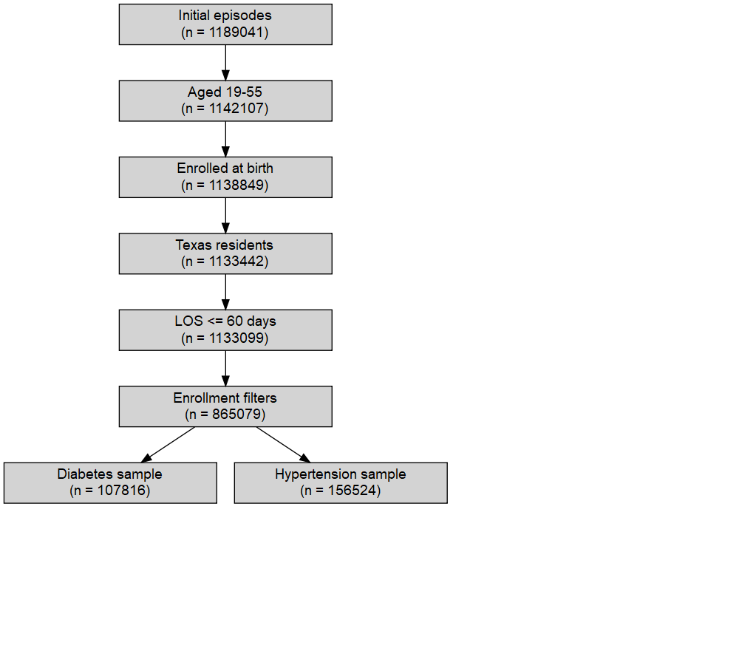

Enrollment
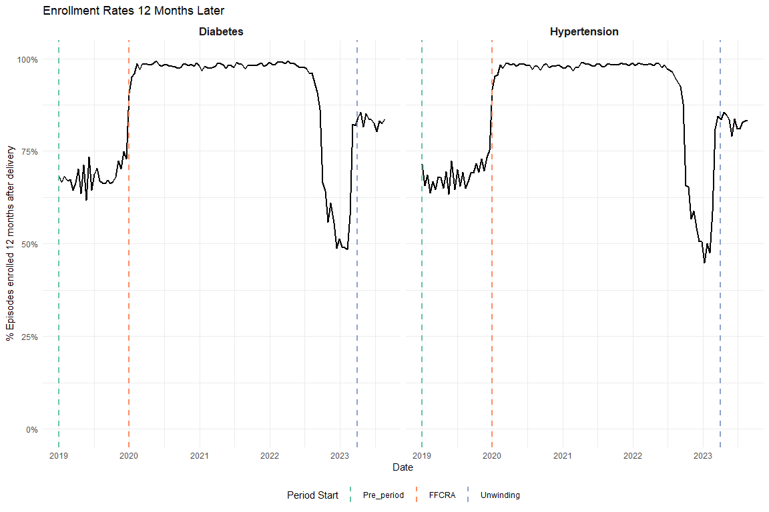

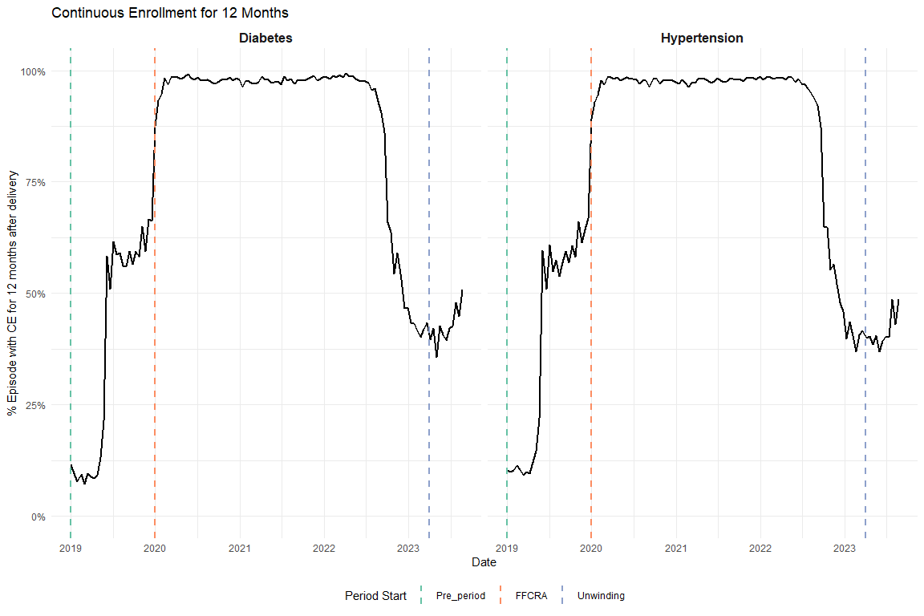

Average Visits per Person
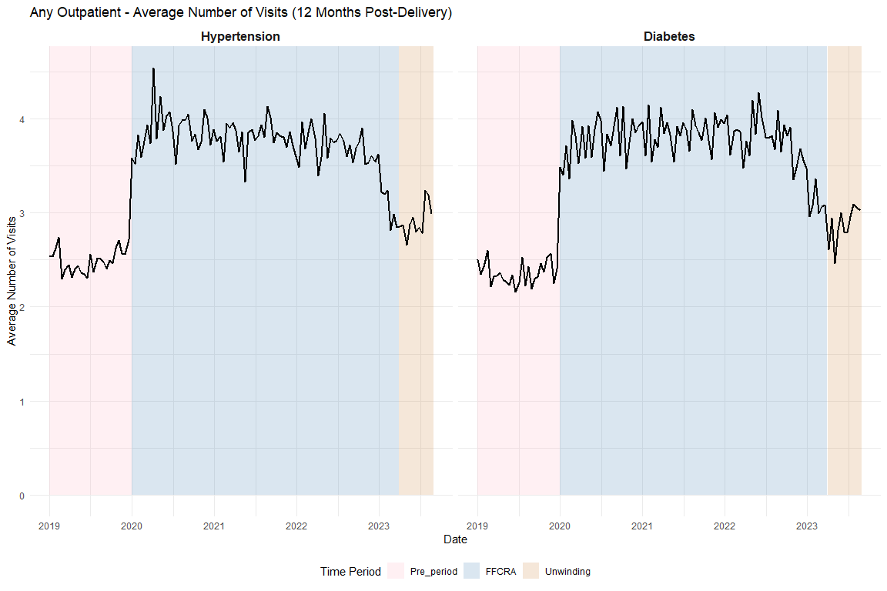

Supplemental Tables

Full ITS Results

Diabetes Screening
Unadjusted
Characteristic | Beta | 95% CI¹ | p-value
(Intercept) | 0.4067 | 0.3902, 0.4232 | <0.001
biweekly_counter | -0.0015 | -0.0026, -0.0005 | 0.004
period_FFCRA | 0.0844 | 0.0641, 0.1047 | <0.001
period_Unwinding | -0.1353 | -0.5301, 0.2595 | 0.50
biweekly_counter * period_FFCRA | 0.0019 | 0.0009, 0.0030 | <0.001
biweekly_counter * period_Unwinding | 0.0032 | -0.0003, 0.0068 | 0.072
¹CI = Confidence Interval
Adjusted
Characteristic | Beta | 95% CI¹ | p-value
(Intercept) | 0.2816 | 0.2577, 0.3056 | <0.001
biweekly_counter | -0.0023 | -0.0033, -0.0012 | <0.001
period_FFCRA | 0.0718 | 0.0516, 0.0920 | <0.001
period_Unwinding | -0.1992 | -0.5910, 0.1926 | 0.32
Age | 0.0005 | -0.0001, 0.0011 | 0.081
Index No Transfusion Weight | 0.0087 | 0.0083, 0.0092 | <0.001
biweekly_counter * period_FFCRA | 0.0026 | 0.0016, 0.0036 | <0.001
biweekly_counter * period_Unwinding | 0.0044 | 0.0009, 0.0078 | 0.015
¹CI = Confidence Interval

Diabetes Outpatient
Unadjusted
Characteristic | Beta | 95% CI¹ | p-value
(Intercept) | 0.6625 | 0.6481, 0.6769 | <0.001
biweekly_counter | -0.0001 | -0.0010, 0.0008 | 0.90
period_FFCRA | 0.1149 | 0.0972, 0.1327 | <0.001
period_Unwinding | 0.0168 | -0.3285, 0.3622 | 0.92
biweekly_counter * period_FFCRA | -0.0001 | -0.0010, 0.0008 | 0.89
biweekly_counter * period_Unwinding | 0.0003 | -0.0028, 0.0034 | 0.86
¹CI = Confidence Interval
Adjusted
Characteristic | Beta | 95% CI¹ | p-value
(Intercept) | 0.6040 | 0.5830, 0.6250 | <0.001
biweekly_counter | -0.0006 | -0.0015, 0.0002 | 0.16
period_FFCRA | 0.1047 | 0.0870, 0.1223 | <0.001
period_Unwinding | -0.0302 | -0.3737, 0.3133 | 0.86
Age | -0.0008 | -0.0013, -0.0003 | 0.002
Index No Transfusion Weight | 0.0066 | 0.0061, 0.0070 | <0.001
biweekly_counter * period_FFCRA | 0.0005 | -0.0004, 0.0014 | 0.28
biweekly_counter * period_Unwinding | 0.0012 | -0.0019, 0.0042 | 0.46
¹CI = Confidence Interval

HTN Medication
Unadjusted
Characteristic | Beta | 95% CI¹ | p-value
(Intercept) | 0.2744 | 0.2621, 0.2867 | <0.001
biweekly_counter | -0.0006 | -0.0014, 0.0002 | 0.12
period_FFCRA | 0.0012 | -0.0140, 0.0164 | 0.88
period_Unwinding | -0.2938 | -0.5848, -0.0028 | 0.048
biweekly_counter * period_FFCRA | 0.0007 | -0.0001, 0.0015 | 0.074
biweekly_counter * period_Unwinding | 0.0032 | 0.0006, 0.0058 | 0.016
¹CI = Confidence Interval
Adjusted
Characteristic | Beta | 95% CI¹ | p-value
(Intercept) | -0.2613 | -0.2781, -0.2445 | <0.001
biweekly_counter | -0.0013 | -0.0020, -0.0005 | <0.001
period_FFCRA | -0.0108 | -0.0255, 0.0039 | 0.15
period_Unwinding | -0.3434 | -0.6248, -0.0621 | 0.017
Age | 0.0154 | 0.0150, 0.0158 | <0.001
Index No Transfusion Weight | 0.0082 | 0.0078, 0.0085 | <0.001
biweekly_counter * period_FFCRA | 0.0013 | 0.0005, 0.0020 | <0.001
biweekly_counter * period_Unwinding | 0.0041 | 0.0015, 0.0066 | 0.002
¹CI = Confidence Interval

HTN Outpatient
Unadjusted
Characteristic | Beta | 95% CI¹ | p-value
(Intercept) | 0.6665 | 0.6546, 0.6784 | <0.001
biweekly_counter | 0.0004 | -0.0004, 0.0011 | 0.31
period_FFCRA | 0.1190 | 0.1043, 0.1338 | <0.001
period_Unwinding | -0.1921 | -0.4745, 0.0903 | 0.18
biweekly_counter * period_FFCRA | -0.0007 | -0.0014, 0.0001 | 0.086
biweekly_counter * period_Unwinding | 0.0016 | -0.0009, 0.0041 | 0.21
¹CI = Confidence Interval
Adjusted
Characteristic | Beta | 95% CI¹ | p-value
(Intercept) | 0.5944 | 0.5777, 0.6111 | <0.001
biweekly_counter | -0.0004 | -0.0012, 0.0003 | 0.27
period_FFCRA | 0.1055 | 0.0908, 0.1202 | <0.001
period_Unwinding | -0.2084 | -0.4892, 0.0724 | 0.15
Age | -0.0002 | -0.0006, 0.0002 | 0.42
Index No Transfusion Weight | 0.0063 | 0.0060, 0.0066 | <0.001
biweekly_counter * period_FFCRA | 0.0001 | -0.0006, 0.0009 | 0.76
biweekly_counter * period_Unwinding | 0.0024 | -0.0001, 0.0049 | 0.058
¹CI = Confidence Interval

HEDIS Postpartum Visits

Diabetes Postpartum Visits
Unadjusted
Characteristic | Beta | 95% CI¹ | p-value
(Intercept) | 0.7824 | 0.7691, 0.7957 | <0.001
biweekly_counter | 0.0003 | -0.0006, 0.0011 | 0.51
period_FFCRA | 0.0123 | -0.0040, 0.0287 | 0.14
period_Unwinding | 0.0994 | -0.2192, 0.4179 | 0.54
biweekly_counter * period_FFCRA | -0.0002 | -0.0010, 0.0007 | 0.73
biweekly_counter * period_Unwinding | -0.0011 | -0.0040, 0.0017 | 0.44
¹CI = Confidence Interval
Adjusted
Characteristic | Beta | 95% CI¹ | p-value
(Intercept) | 0.7655 | 0.7461, 0.7849 | <0.001
biweekly_counter | -0.0001 | -0.0010, 0.0007 | 0.73
period_FFCRA | 0.0050 | -0.0114, 0.0213 | 0.55
period_Unwinding | 0.0687 | -0.2490, 0.3863 | 0.67
Age | -0.0013 | -0.0017, -0.0008 | <0.001
Index No Transfusion Weight | 0.0044 | 0.0040, 0.0048 | <0.001
biweekly_counter * period_FFCRA | 0.0003 | -0.0006, 0.0011 | 0.55
biweekly_counter * period_Unwinding | -0.0005 | -0.0034, 0.0023 | 0.72
¹CI = Confidence Interval

HTN Postpartum Visits
Unadjusted
Characteristic | Beta | 95% CI¹ | p-value
(Intercept) | 0.7663 | 0.7550, 0.7776 | <0.001
biweekly_counter | 0.0005 | -0.0002, 0.0012 | 0.16
period_FFCRA | 0.0145 | 0.0005, 0.0285 | 0.042
period_Unwinding | 0.1765 | -0.0914, 0.4443 | 0.20
biweekly_counter * period_FFCRA | -0.0004 | -0.0012, 0.0003 | 0.22
biweekly_counter * period_Unwinding | -0.0019 | -0.0043, 0.0005 | 0.11
¹CI = Confidence Interval
Adjusted
Characteristic | Beta | 95% CI¹ | p-value
(Intercept) | 0.7770 | 0.7611, 0.7929 | <0.001
biweekly_counter | -0.0001 | -0.0009, 0.0006 | 0.69
period_FFCRA | 0.0038 | -0.0102, 0.0177 | 0.60
period_Unwinding | 0.1686 | -0.0982, 0.4354 | 0.22
Age | -0.0024 | -0.0028, -0.0020 | <0.001
Index No Transfusion Weight | 0.0047 | 0.0043, 0.0050 | <0.001
biweekly_counter * period_FFCRA | 0.0002 | -0.0005, 0.0009 | 0.60
biweekly_counter * period_Unwinding | -0.0013 | -0.0037, 0.0011 | 0.28
¹CI = Confidence Interval

Sensitivity Analyses

Diabetes Subgroup Exclude Pre-existing

Graph
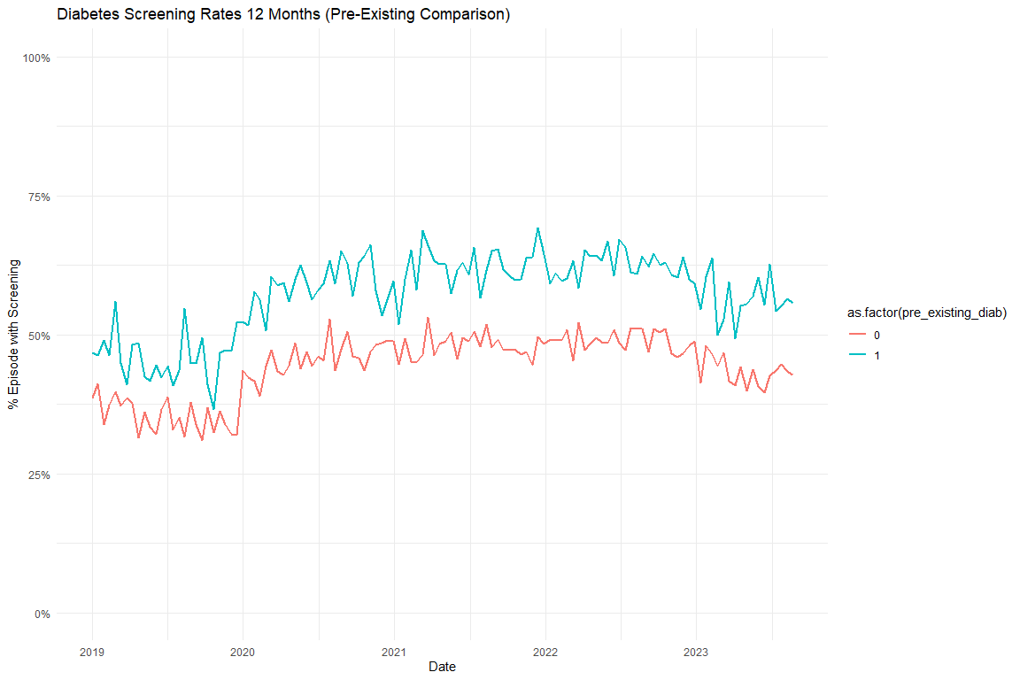

Models

Diabetes Screening Unadjusted
 | Full Sample | Excluding Pre-Existing Diabetes
Characteristic | Beta¹ | Beta¹
(Intercept) | 0.407*** | 0.381***
biweekly_counter | -0.002** | -0.002***
period_FFCRA | 0.084*** | 0.069***
period_Unwinding | -0.135 | -0.090
biweekly_counter * period_FFCRA | 0.002*** | 0.002***
biweekly_counter * period_Unwinding | 0.003 | 0.003
¹*p<0.05; **p<0.01; ***p<0.001

Diabetes Screening Adjusted
 | Full Sample | Excluding Pre-Existing Diabetes
Characteristic | Beta¹ | Beta¹
(Intercept) | 0.282*** | 0.314***
biweekly_counter | -0.002*** | -0.003***
period_FFCRA | 0.072*** | 0.057***
period_Unwinding | -0.199 | -0.139
Age | 0.001 | 0.000
Index No Transfusion Weight | 0.009*** | 0.007***
biweekly_counter * period_FFCRA | 0.003*** | 0.003***
biweekly_counter * period_Unwinding | 0.004* | 0.004
¹*p<0.05; **p<0.01; ***p<0.001

Diabetes Subgroup Test Type Graphs
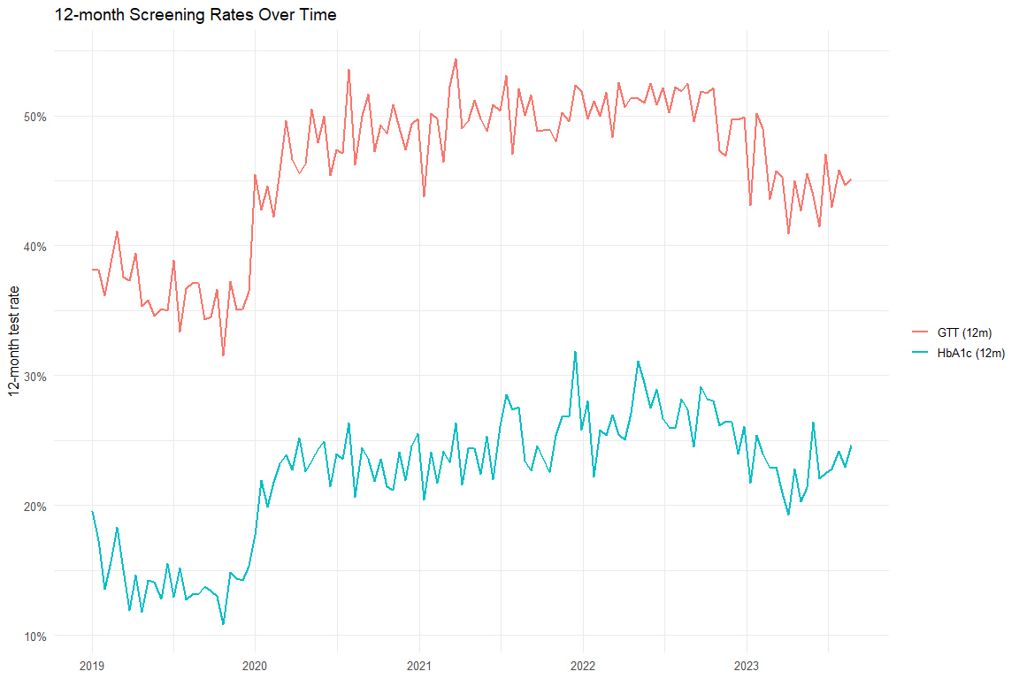

Diabetes Test Type Models
 | Overall (Unadj) | Overall (Adj) | HbA1c (Unadj) | HbA1c (Adj) | GTT (Unadj) | GTT (Adj)
Characteristic | Beta¹ | Beta¹ | Beta¹ | Beta¹ | Beta¹ | Beta¹
(Intercept) | 0.407*** | 0.282*** | 0.156*** | -0.044*** | 0.382*** | 0.262***
biweekly_counter | -0.002** | -0.002*** | -0.001* | -0.002*** | -0.001* | -0.002***
period_FFCRA | 0.084*** | 0.072*** | 0.056*** | 0.047*** | 0.092*** | 0.080***
period_Unwinding | -0.135 | -0.199 | -0.295 | -0.352* | -0.120 | -0.182
biweekly_counter * period_FFCRA | 0.002*** | 0.003*** | 0.002*** | 0.002*** | 0.002** | 0.002***
biweekly_counter * period_Unwinding | 0.003 | 0.004* | 0.004** | 0.005*** | 0.003 | 0.004*
Age |  | 0.001 |  | 0.004*** |  | 0.000
Index No Transfusion Weight |  | 0.009*** |  | 0.008*** |  | 0.009***
¹*p<0.05; **p<0.01; ***p<0.001

Excluding COVID
[1] "diab_screen_unadj_excluded_reidx"
[1] "diab_screen_adj_excluded_reidx"
[1] "diab_any_outpatient_unadj_excluded_reidx"
[1] "diab_any_outpatient_adj_excluded_reidx"
[1] "htn_med_unadj_excluded_reidx"
[1] "htn_med_adj_excluded_reidx"
[1] "htn_any_outpatient_unadj_excluded_reidx"
[1] "htn_any_outpatient_adj_excluded_reidx"
 | Original - Unadj | Excluded COVID - Unadj | Original - Adj | Excluded COVID - Adj
Characteristic | Beta¹ | Beta¹ | Beta¹ | Beta¹
(Intercept) | 0.407*** | 0.404*** | 0.282*** | 0.316***
biweekly_counter | -0.002** | 0.003 | -0.002*** | -0.009
period_FFCRA | 0.084*** | 0.110*** | 0.072*** | 0.053*
period_Unwinding | -0.135 | -0.074 | -0.199 | -0.169
biweekly_counter * period_FFCRA | 0.002*** | -0.002 | 0.003*** | 0.009
biweekly_counter * period_Unwinding | 0.003 | -0.001 | 0.004* | 0.011
Age |  |  | 0.001 | 0.001
Index No Transfusion Weight |  |  | 0.009*** | 0.009***
¹*p<0.05; **p<0.01; ***p<0.001
 | Original - Unadj | Excluded COVID - Unadj | Original - Adj | Excluded COVID - Adj
Characteristic | Beta¹ | Beta¹ | Beta¹ | Beta¹
(Intercept) | 0.663*** | 0.681*** | 0.604*** | 0.654***
biweekly_counter | 0.000 | -0.006 | -0.001 | -0.014**
period_FFCRA | 0.115*** | 0.099*** | 0.105*** | 0.057**
period_Unwinding | 0.017 | -0.008 | -0.030 | -0.076
biweekly_counter * period_FFCRA | 0.000 | 0.005 | 0.000 | 0.014**
biweekly_counter * period_Unwinding | 0.000 | 0.006 | 0.001 | 0.015**
Age |  |  | -0.001** | -0.001**
Index No Transfusion Weight |  |  | 0.007*** | 0.007***
¹*p<0.05; **p<0.01; ***p<0.001
 | Original - Unadj | Excluded COVID - Unadj | Original - Adj | Excluded COVID - Adj
Characteristic | Beta¹ | Beta¹ | Beta¹ | Beta¹
(Intercept) | 0.274*** | 0.291*** | -0.261*** | -0.210***
biweekly_counter | -0.001 | -0.004 | -0.001*** | -0.011**
period_FFCRA | 0.001 | -0.014 | -0.011 | -0.056***
period_Unwinding | -0.294* | -0.265* | -0.343* | -0.338**
biweekly_counter * period_FFCRA | 0.001 | 0.004 | 0.001*** | 0.011**
biweekly_counter * period_Unwinding | 0.003* | 0.007 | 0.004** | 0.014**
Age |  |  | 0.015*** | 0.015***
Index No Transfusion Weight |  |  | 0.008*** | 0.008***
¹*p<0.05; **p<0.01; ***p<0.001
 | Original - Unadj | Excluded COVID - Unadj | Original - Adj | Excluded COVID - Adj
Characteristic | Beta¹ | Beta¹ | Beta¹ | Beta¹
(Intercept) | 0.666*** | 0.694*** | 0.594*** | 0.653***
biweekly_counter | 0.000 | -0.006 | 0.000 | -0.014***
period_FFCRA | 0.119*** | 0.092*** | 0.105*** | 0.048**
period_Unwinding | -0.192 | -0.176 | -0.208 | -0.221*
biweekly_counter * period_FFCRA | -0.001 | 0.005 | 0.000 | 0.014**
biweekly_counter * period_Unwinding | 0.002 | 0.008 | 0.002 | 0.016***
Age |  |  | 0.000 | 0.000
Index No Transfusion Weight |  |  | 0.006*** | 0.006***
¹*p<0.05; **p<0.01; ***p<0.001

MH (Scratch)
