POEM TX Paper 1 (APCD Data)
2026-01-15

Main Analysis Tables and Figures

Table 1
 | Overall | By Condition
Characteristic | N = 226,654¹ | Diabetes, N = 113,721¹ | Hypertension, N = 146,279¹
outcome_type
LB | 225,252 (99%) | 113,032 (99%) | 145,277 (99%)
SB | 1,402 (0.6%) | 689 (0.6%) | 1,002 (0.7%)
anchor_year
2019 | 43,610 (19%) | 22,393 (20%) | 27,230 (19%)
2020 | 47,255 (21%) | 24,403 (21%) | 29,787 (20%)
2021 | 49,314 (22%) | 25,065 (22%) | 31,613 (22%)
2022 | 52,413 (23%) | 25,603 (23%) | 34,685 (24%)
2023 | 34,062 (15%) | 16,257 (14%) | 22,964 (16%)
age_group
19-24 | 57,002 (25%) | 20,154 (18%) | 42,049 (29%)
25-34 | 121,279 (54%) | 62,650 (55%) | 76,186 (52%)
35-44 | 47,540 (21%) | 30,366 (27%) | 27,528 (19%)
45-55 | 833 (0.4%) | 551 (0.5%) | 516 (0.4%)
no_transfusion_weight | 12 (12, 19) | 12 (12, 19) | 12 (12, 19)
¹n (%); Median (IQR)

Figure 1: Biweekly graphs based on anchor date: outpatient utilization
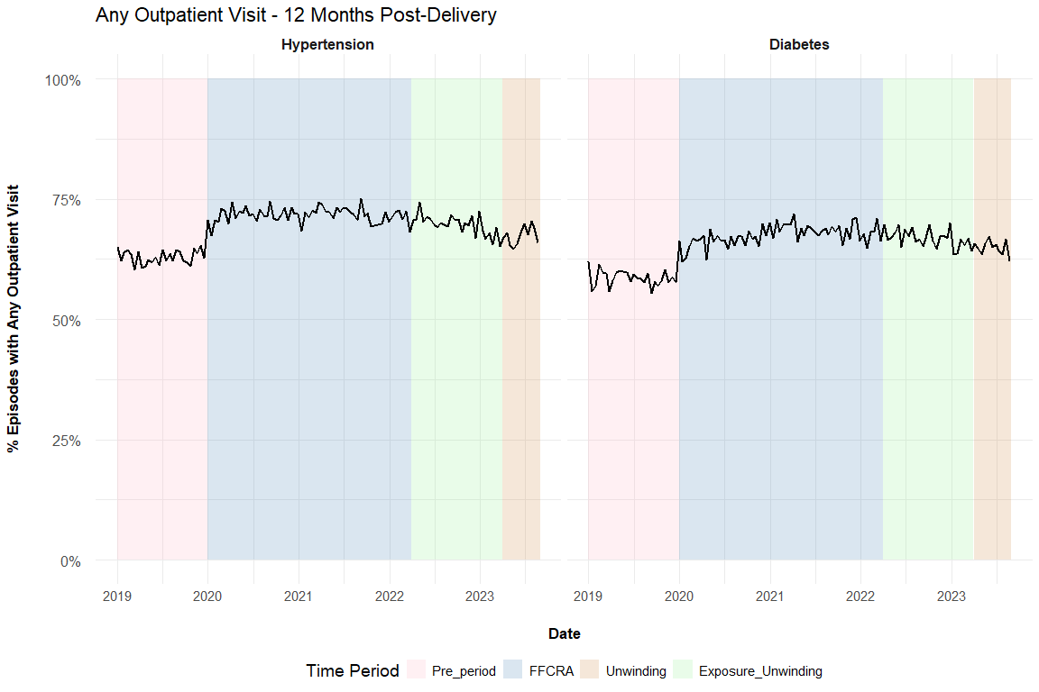

Figure 2: Biweekly graphs based on anchor date: diabetes screening
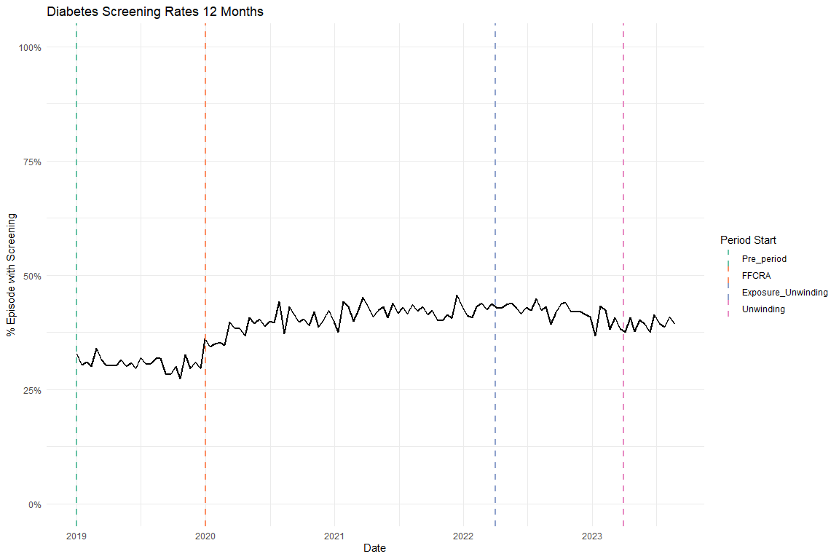

Figure 3: Biweekly graphs based on anchor date: hypertensive medication
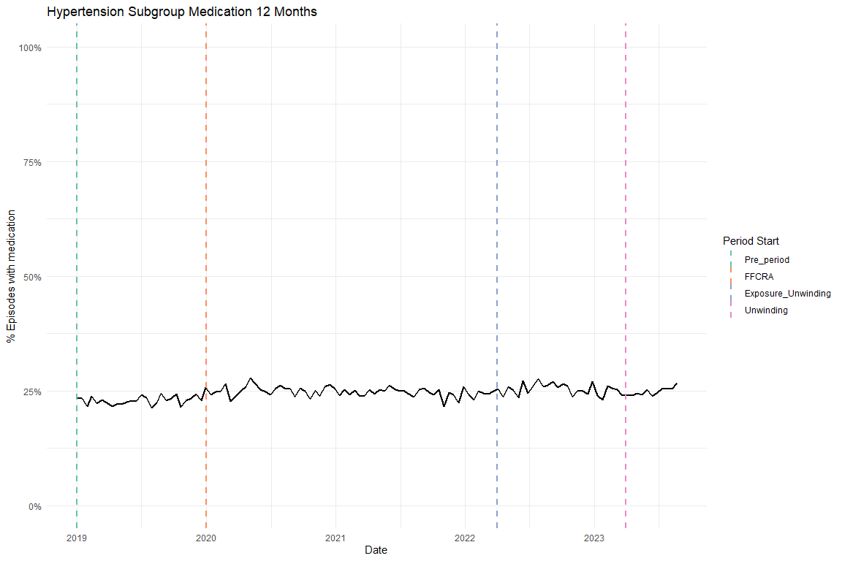

Table 2: ITS results of all utilization outcomes, adjusted, main coefficients only
Diabetes cohort
Characteristic | Diabetes Screening Beta | 95% CI¹ | Any outpatient utilization Beta | 95% CI¹
Pre-trend | -0.002 | -0.003, -0.001 | -0.002 | -0.002, -0.001
Level Change, FFCRA | 0.091 | 0.076, 0.106 | 0.089 | 0.074, 0.103
Level Change, Exposure to Unwinding | 0.092 | 0.071, 0.113 | 0.082 | 0.061, 0.103
Trend Change, FFCRA | 0.003 | 0.002, 0.004 | 0.002 | 0.001, 0.003
Trend Change, Exposure to Unwinding | -0.002 | -0.003, -0.002 | -0.002 | -0.002, -0.001
¹CI = Confidence Interval
Hypertension cohort
Characteristic | Antihypertensive medication Beta | 95% CI¹ | Any outpatient utilization Beta | 95% CI¹
Pre-trend | 0.000 | -0.001, 0.000 | -0.001 | -0.002, 0.000
Level Change, FFCRA | 0.027 | 0.015, 0.039 | 0.096 | 0.083, 0.109
Level Change, Exposure to Unwinding | 0.039 | 0.023, 0.056 | 0.094 | 0.076, 0.112
Trend Change, FFCRA | 0.000 | -0.001, 0.001 | 0.001 | 0.000, 0.001
Trend Change, Exposure to Unwinding | 0.000 | 0.000, 0.000 | -0.001 | -0.002, -0.001
¹CI = Confidence Interval

Supplemental Figures

Flowchart

Enrollment
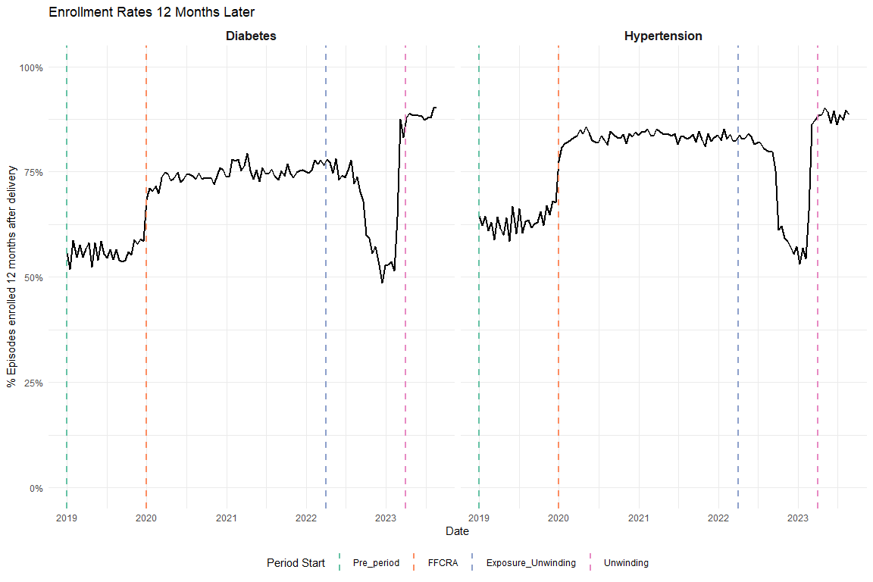

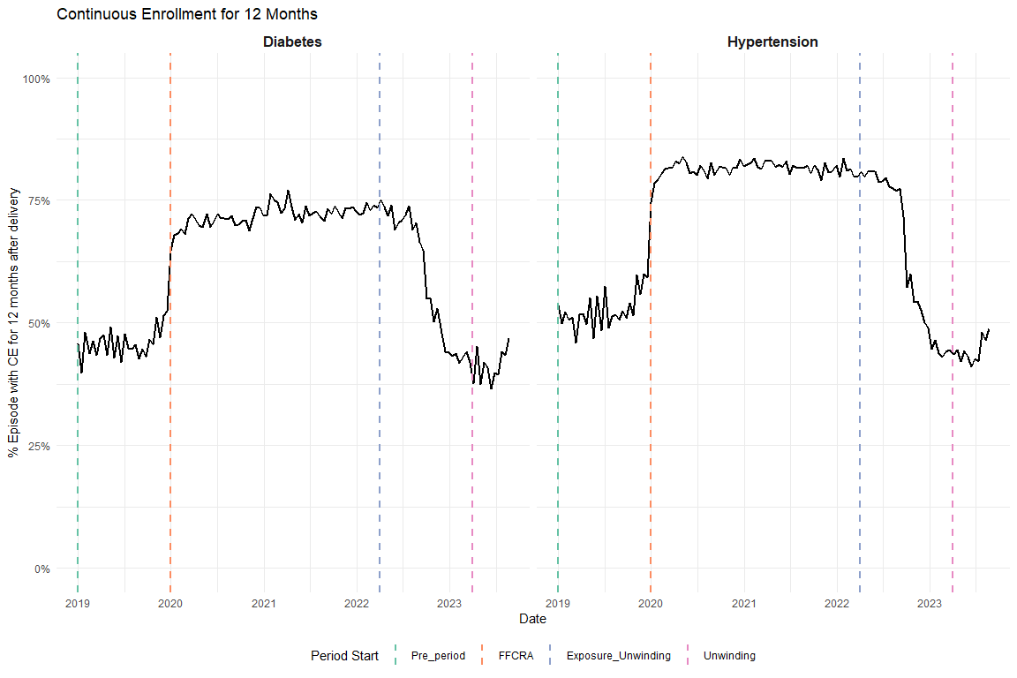

OGT vs A1C
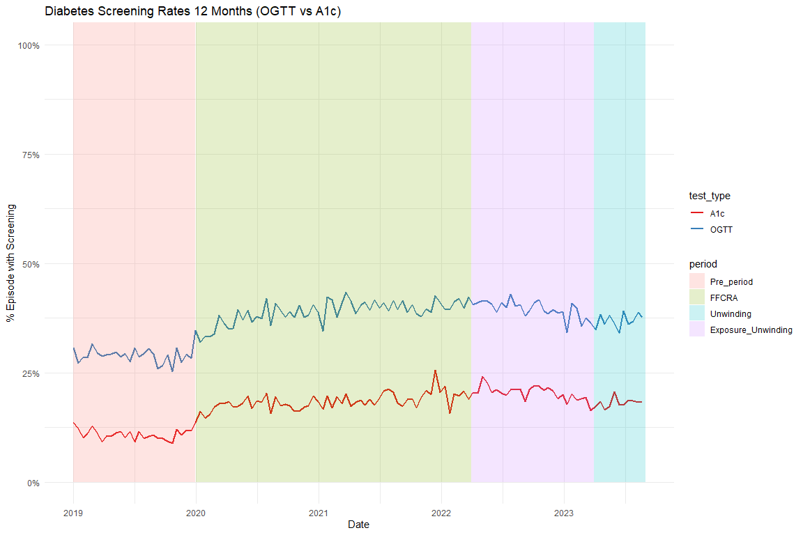

Average Visits per Person
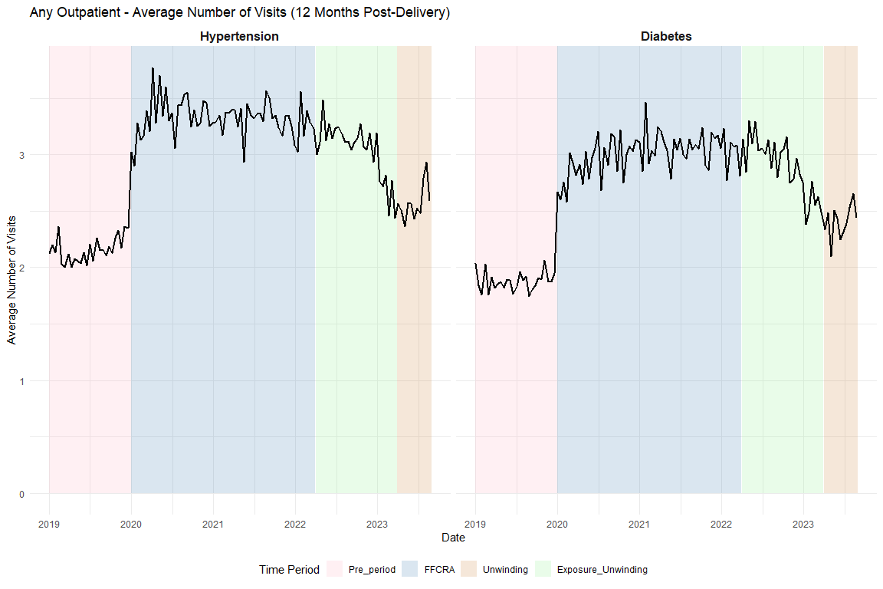

Supplemental Tables

Full ITS Results

Diabetes Screening
Unadjusted
Characteristic | Beta | 95% CI¹ | p-value
(Intercept) | 0.3142 | 0.3011, 0.3273 | <0.001
t | -0.0007 | -0.0015, 0.0002 | 0.13
period_FFCRA | 0.0823 | 0.0671, 0.0974 | <0.001
period_Exposure_Unwinding | 0.0808 | 0.0593, 0.1023 | <0.001
t_after_FFCRA | 0.0017 | 0.0008, 0.0026 | <0.001
t_after_Exposure | -0.0023 | -0.0028, -0.0018 | <0.001
¹CI = Confidence Interval
Adjusted
Characteristic | Beta | 95% CI¹ | p-value
(Intercept) | 0.4318 | 0.4119, 0.4517 | <0.001
t | -0.0017 | -0.0026, -0.0009 | <0.001
period_FFCRA | 0.0914 | 0.0764, 0.1064 | <0.001
period_Exposure_Unwinding | 0.0920 | 0.0707, 0.1134 | <0.001
t_after_FFCRA | 0.0027 | 0.0018, 0.0036 | <0.001
t_after_Exposure | -0.0022 | -0.0028, -0.0017 | <0.001
age | -0.0071 | -0.0076, -0.0067 | <0.001
no_transfusion_weight | 0.0084 | 0.0079, 0.0088 | <0.001
¹CI = Confidence Interval

Diabetes Outpatient
Unadjusted
Characteristic | Beta | 95% CI¹ | p-value
(Intercept) | 0.5917 | 0.5790, 0.6045 | <0.001
t | -0.0005 | -0.0013, 0.0003 | 0.25
period_FFCRA | 0.0800 | 0.0652, 0.0948 | <0.001
period_Exposure_Unwinding | 0.0710 | 0.0500, 0.0921 | <0.001
t_after_FFCRA | 0.0011 | 0.0002, 0.0019 | 0.018
t_after_Exposure | -0.0016 | -0.0021, -0.0011 | <0.001
¹CI = Confidence Interval
Adjusted
Characteristic | Beta | 95% CI¹ | p-value
(Intercept) | 0.7148 | 0.6953, 0.7343 | <0.001
t | -0.0015 | -0.0023, -0.0007 | <0.001
period_FFCRA | 0.0888 | 0.0741, 0.1035 | <0.001
period_Exposure_Unwinding | 0.0818 | 0.0610, 0.1027 | <0.001
t_after_FFCRA | 0.0020 | 0.0011, 0.0029 | <0.001
t_after_Exposure | -0.0015 | -0.0021, -0.0010 | <0.001
age | -0.0071 | -0.0076, -0.0066 | <0.001
no_transfusion_weight | 0.0078 | 0.0074, 0.0082 | <0.001
¹CI = Confidence Interval

HTN Medication
Unadjusted
Characteristic | Beta | 95% CI¹ | p-value
(Intercept) | 0.2245 | 0.2141, 0.2348 | <0.001
t | 0.0003 | -0.0004, 0.0010 | 0.37
period_FFCRA | 0.0205 | 0.0084, 0.0327 | <0.001
period_Exposure_Unwinding | 0.0325 | 0.0156, 0.0493 | <0.001
t_after_FFCRA | -0.0005 | -0.0012, 0.0002 | 0.18
t_after_Exposure | 0.0000 | -0.0004, 0.0004 | 0.97
¹CI = Confidence Interval
Adjusted
Characteristic | Beta | 95% CI¹ | p-value
(Intercept) | -0.1928 | -0.2074, -0.1781 | <0.001
t | -0.0004 | -0.0011, 0.0002 | 0.19
period_FFCRA | 0.0270 | 0.0151, 0.0388 | <0.001
period_Exposure_Unwinding | 0.0393 | 0.0229, 0.0558 | <0.001
t_after_FFCRA | 0.0002 | -0.0005, 0.0009 | 0.59
t_after_Exposure | 0.0001 | -0.0003, 0.0005 | 0.77
age | 0.0110 | 0.0106, 0.0113 | <0.001
no_transfusion_weight | 0.0081 | 0.0078, 0.0084 | <0.001
¹CI = Confidence Interval

HTN Outpatient
Unadjusted
Characteristic | Beta | 95% CI¹ | p-value
(Intercept) | 0.6258 | 0.6147, 0.6369 | <0.001
t | 0.0003 | -0.0005, 0.0010 | 0.45
period_FFCRA | 0.0850 | 0.0721, 0.0980 | <0.001
period_Exposure_Unwinding | 0.0822 | 0.0641, 0.1002 | <0.001
t_after_FFCRA | -0.0003 | -0.0011, 0.0004 | 0.40
t_after_Exposure | -0.0012 | -0.0016, -0.0007 | <0.001
¹CI = Confidence Interval
Adjusted
Characteristic | Beta | 95% CI¹ | p-value
(Intercept) | 0.6633 | 0.6473, 0.6792 | <0.001
t | -0.0008 | -0.0015, 0.0000 | 0.038
period_FFCRA | 0.0959 | 0.0830, 0.1088 | <0.001
period_Exposure_Unwinding | 0.0943 | 0.0763, 0.1122 | <0.001
t_after_FFCRA | 0.0007 | -0.0001, 0.0014 | 0.078
t_after_Exposure | -0.0011 | -0.0015, -0.0007 | <0.001
age | -0.0043 | -0.0047, -0.0039 | <0.001
no_transfusion_weight | 0.0071 | 0.0068, 0.0075 | <0.001
¹CI = Confidence Interval

HEDIS Postpartum Visits

Diabetes Postpartum Visits
Unadjusted
Characteristic | Beta | 95% CI¹ | p-value
(Intercept) | 0.6968 | 0.6847, 0.7089 | <0.001
t | 0.0002 | -0.0006, 0.0010 | 0.62
period_FFCRA | 0.0055 | -0.0085, 0.0195 | 0.44
period_Exposure_Unwinding | 0.0027 | -0.0173, 0.0226 | 0.79
t_after_FFCRA | 0.0002 | -0.0006, 0.0011 | 0.58
t_after_Exposure | -0.0004 | -0.0009, 0.0001 | 0.10
¹CI = Confidence Interval
Adjusted
Characteristic | Beta | 95% CI¹ | p-value
(Intercept) | 0.8772 | 0.8587, 0.8957 | <0.001
t | -0.0005 | -0.0013, 0.0003 | 0.20
period_FFCRA | 0.0122 | -0.0017, 0.0261 | 0.086
period_Exposure_Unwinding | 0.0108 | -0.0090, 0.0306 | 0.28
t_after_FFCRA | 0.0009 | 0.0001, 0.0017 | 0.029
t_after_Exposure | -0.0004 | -0.0009, 0.0001 | 0.15
age | -0.0076 | -0.0080, -0.0072 | <0.001
no_transfusion_weight | 0.0045 | 0.0041, 0.0049 | <0.001
¹CI = Confidence Interval

HTN Postpartum Visits
Unadjusted
Characteristic | Beta | 95% CI¹ | p-value
(Intercept) | 0.7119 | 0.7012, 0.7226 | <0.001
t | 0.0004 | -0.0003, 0.0011 | 0.32
period_FFCRA | 0.0044 | -0.0081, 0.0170 | 0.49
period_Exposure_Unwinding | -0.0117 | -0.0291, 0.0058 | 0.19
t_after_FFCRA | -0.0002 | -0.0009, 0.0006 | 0.69
t_after_Exposure | 0.0000 | -0.0004, 0.0004 | >0.99
¹CI = Confidence Interval
Adjusted
Characteristic | Beta | 95% CI¹ | p-value
(Intercept) | 0.8362 | 0.8208, 0.8516 | <0.001
t | -0.0005 | -0.0012, 0.0002 | 0.14
period_FFCRA | 0.0140 | 0.0015, 0.0264 | 0.028
period_Exposure_Unwinding | -0.0011 | -0.0184, 0.0163 | 0.91
t_after_FFCRA | 0.0007 | 0.0000, 0.0014 | 0.056
t_after_Exposure | 0.0001 | -0.0004, 0.0005 | 0.80
age | -0.0066 | -0.0069, -0.0062 | <0.001
no_transfusion_weight | 0.0054 | 0.0051, 0.0057 | <0.001
¹CI = Confidence Interval

Event Study
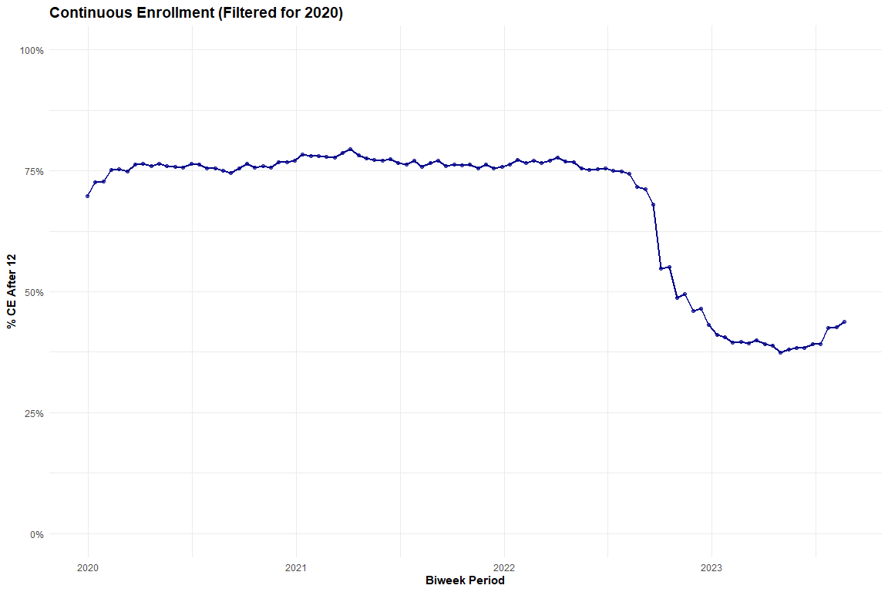
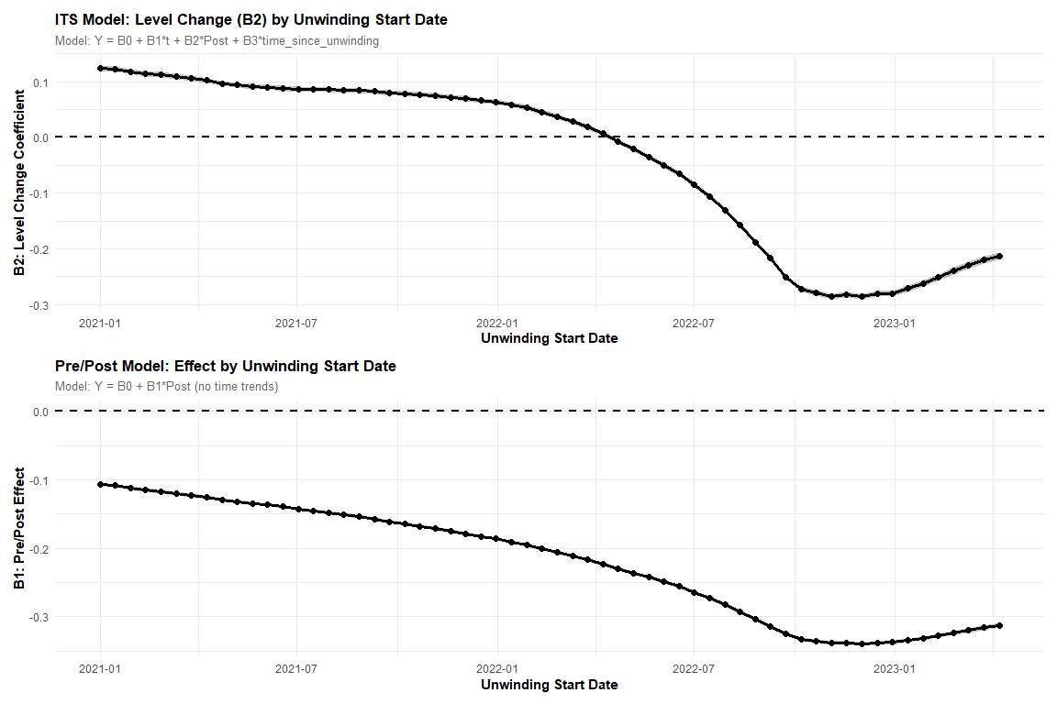

Sensitivity Analyses

Diabetes Subgroup Exclude Pre-existing

Graph
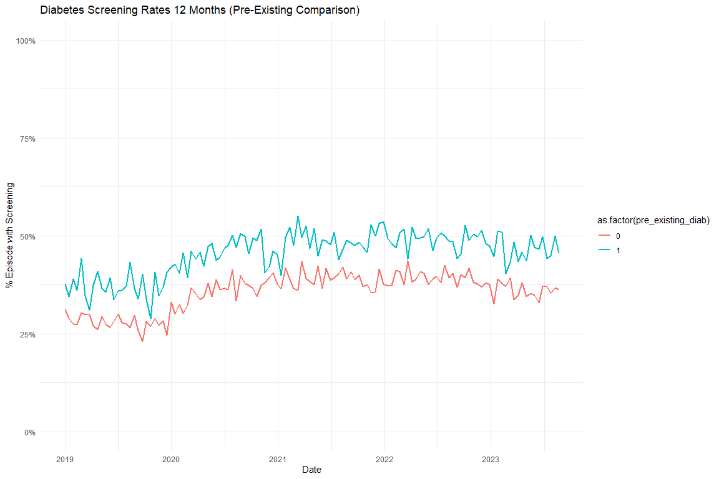

Models

Diabetes Screening Unadjusted
 | Full Sample | Excluding Pre-Existing Diabetes
Characteristic | Beta¹ | Beta¹
(Intercept) | 0.314*** | 0.291***
t | -0.001 | -0.001*
period_FFCRA | 0.082*** | 0.083***
period_Exposure_Unwinding | 0.081*** | 0.081***
t_after_FFCRA | 0.002*** | 0.002***
t_after_Exposure | -0.002*** | -0.002***
¹*p<0.05; **p<0.01; ***p<0.001

Diabetes Screening Adjusted
 | Full Sample | Excluding Pre-Existing Diabetes
Characteristic | Beta¹ | Beta¹
(Intercept) | 0.432*** | 0.433***
t | -0.002*** | -0.002***
period_FFCRA | 0.091*** | 0.091***
period_Exposure_Unwinding | 0.092*** | 0.090***
t_after_FFCRA | 0.003*** | 0.003***
t_after_Exposure | -0.002*** | -0.002***
age | -0.007*** | -0.007***
no_transfusion_weight | 0.008*** | 0.006***
¹*p<0.05; **p<0.01; ***p<0.001

Diabetes Subgroup Test Type Graphs
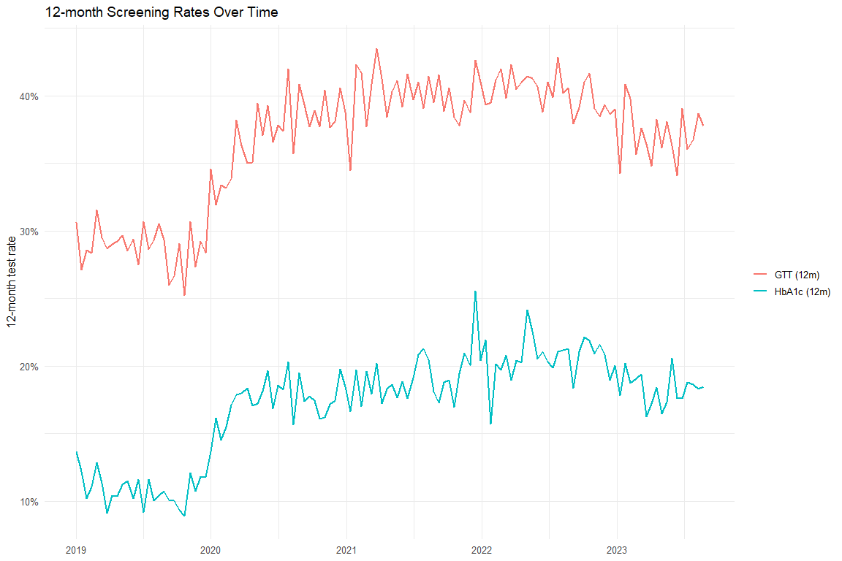

Diabetes Test Type Models
 | Overall (Unadj) | Overall (Adj) | HbA1c (Unadj) | HbA1c (Adj) | GTT (Unadj) | GTT (Adj)
Characteristic | Beta¹ | Beta¹ | Beta¹ | Beta¹ | Beta¹ | Beta¹
(Intercept) | 0.314*** | 0.432*** | 0.113*** | 0.075*** | 0.294*** | 0.407***
t | -0.001 | -0.002*** | 0.000 | -0.001** | -0.001 | -0.002***
period_FFCRA | 0.082*** | 0.091*** | 0.062*** | 0.067*** | 0.081*** | 0.090***
period_Exposure_Unwinding | 0.081*** | 0.092*** | 0.077*** | 0.084*** | 0.077*** | 0.088***
t_after_FFCRA | 0.002*** | 0.003*** | 0.001** | 0.002*** | 0.001** | 0.002***
t_after_Exposure | -0.002*** | -0.002*** | -0.002*** | -0.002*** | -0.002*** | -0.002***
age |  | -0.007*** |  | -0.001*** |  | -0.007***
no_transfusion_weight |  | 0.008*** |  | 0.007*** |  | 0.008***
¹*p<0.05; **p<0.01; ***p<0.001

Excluding COVID
[1] "diab_screen_unadj_excluded_reidx"
[1] "diab_screen_adj_excluded_reidx"
[1] "diab_any_outpatient_unadj_excluded_reidx"
[1] "diab_any_outpatient_adj_excluded_reidx"
[1] "htn_med_unadj_excluded_reidx"
[1] "htn_med_adj_excluded_reidx"
[1] "htn_any_outpatient_unadj_excluded_reidx"
[1] "htn_any_outpatient_adj_excluded_reidx"
 | Original - Unadj | Excluded COVID - Unadj | Original - Adj | Excluded COVID - Adj
Characteristic | Beta¹ | Beta¹ | Beta¹ | Beta¹
(Intercept) | 0.314*** | 0.312*** | 0.432*** | 0.444***
t | -0.001 | 0.001** | -0.002*** | 0.001*
period_FFCRA | 0.082*** | 0.073*** | 0.091*** | 0.051***
period_Exposure_Unwinding | 0.081*** | 0.081*** | 0.092*** | 0.061***
t_after_FFCRA | 0.002*** | -0.001 | 0.003*** | -0.001
t_after_Exposure | -0.002*** | -0.002*** | -0.002*** | -0.002***
age |  |  | -0.007*** | -0.008***
no_transfusion_weight |  |  | 0.008*** | 0.009***
¹*p<0.05; **p<0.01; ***p<0.001
 | Original - Unadj | Excluded COVID - Unadj | Original - Adj | Excluded COVID - Adj
Characteristic | Beta¹ | Beta¹ | Beta¹ | Beta¹
(Intercept) | 0.592*** | 0.589*** | 0.715*** | 0.725***
t | 0.000 | 0.002*** | -0.002*** | 0.002***
period_FFCRA | 0.080*** | 0.053*** | 0.089*** | 0.033**
period_Exposure_Unwinding | 0.071*** | 0.057*** | 0.082*** | 0.038**
t_after_FFCRA | 0.001* | -0.002*** | 0.002*** | -0.002**
t_after_Exposure | -0.002*** | -0.001 | -0.002*** | -0.001*
age |  |  | -0.007*** | -0.007***
no_transfusion_weight |  |  | 0.008*** | 0.008***
¹*p<0.05; **p<0.01; ***p<0.001
 | Original - Unadj | Excluded COVID - Unadj | Original - Adj | Excluded COVID - Adj
Characteristic | Beta¹ | Beta¹ | Beta¹ | Beta¹
(Intercept) | 0.224*** | 0.230*** | -0.193*** | -0.181***
t | 0.000 | 0.000 | 0.000 | -0.001*
period_FFCRA | 0.021*** | 0.030*** | 0.027*** | 0.014
period_Exposure_Unwinding | 0.032*** | 0.041*** | 0.039*** | 0.027**
t_after_FFCRA | 0.000 | 0.000 | 0.000 | 0.000
t_after_Exposure | 0.000 | 0.000 | 0.000 | 0.000
age |  |  | 0.011*** | 0.011***
no_transfusion_weight |  |  | 0.008*** | 0.008***
¹*p<0.05; **p<0.01; ***p<0.001
 | Original - Unadj | Excluded COVID - Unadj | Original - Adj | Excluded COVID - Adj
Characteristic | Beta¹ | Beta¹ | Beta¹ | Beta¹
(Intercept) | 0.626*** | 0.634*** | 0.663*** | 0.680***
t | 0.000 | 0.000 | -0.001* | 0.000
period_FFCRA | 0.085*** | 0.082*** | 0.096*** | 0.064***
period_Exposure_Unwinding | 0.082*** | 0.085*** | 0.094*** | 0.068***
t_after_FFCRA | 0.000 | -0.001 | 0.001 | -0.001
t_after_Exposure | -0.001*** | -0.001* | -0.001*** | -0.001*
age |  |  | -0.004*** | -0.005***
no_transfusion_weight |  |  | 0.007*** | 0.007***
¹*p<0.05; **p<0.01; ***p<0.001

Other Break Analysis

Percent Change in DSHS Numbers
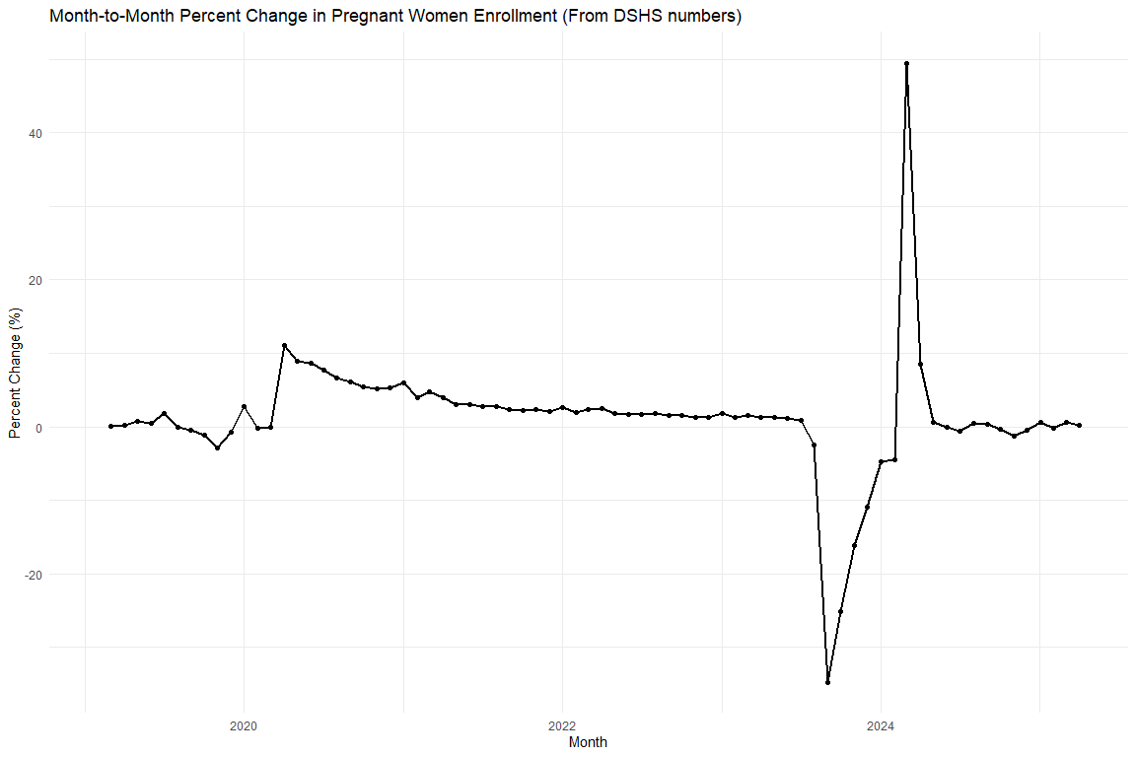
Month-to-Month Percent Change in Pregnant Women Enrollment (Jan 2023 - Jun 2024)
Month | Pregnant Women (Count) | Percent Change (%)
2023-01-01 | 476,205 | 1.77%
2023-02-01 | 482,037 | 1.22%
2023-03-01 | 489,284 | 1.50%
2023-04-01 | 495,541 | 1.28%
2023-05-01 | 501,614 | 1.23%
2023-06-01 | 507,057 | 1.09%
2023-07-01 | 511,183 | 0.81%
2023-08-01 | 498,392 | -2.50%
2023-09-01 | 325,121 | -34.77%
2023-10-01 | 243,231 | -25.19%
2023-11-01 | 204,057 | -16.11%
2023-12-01 | 181,646 | -10.98%
2024-01-01 | 173,116 | -4.70%
2024-02-01 | 165,441 | -4.43%
2024-03-01 | 247,371 | 49.52%
2024-04-01 | 268,508 | 8.54%
2024-05-01 | 269,962 | 0.54%
2024-06-01 | 269,712 | -0.09%

Change in CE (from cohort)
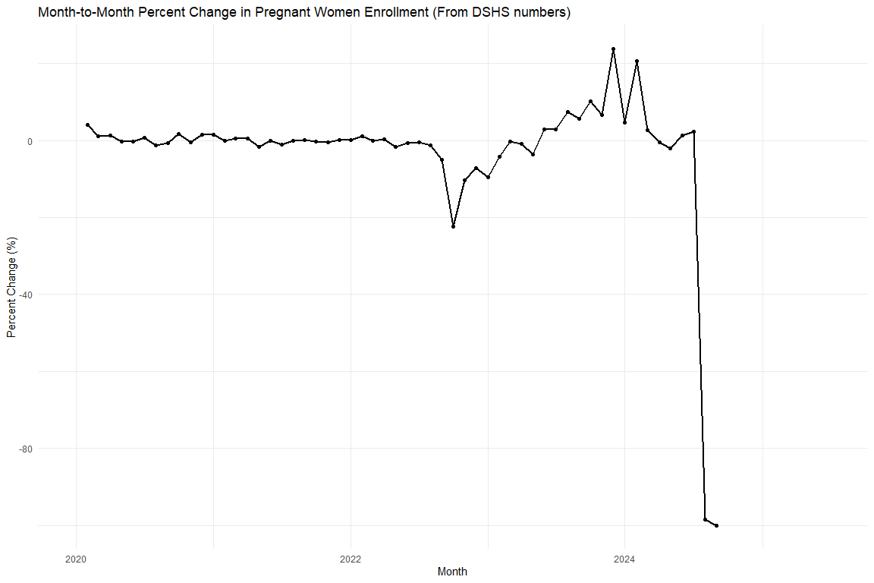
Monthly CE After 12 Rate and Month-over-Month Change
Month | CE After 12 (Level, %) | MoM Change (%)
2022-01-01 | 76.19% | 0.22%
2022-02-01 | 77.05% | 1.13%
2022-03-01 | 77.06% | 0.02%
2022-04-01 | 77.28% | 0.28%
2022-05-01 | 75.96% | -1.71%
2022-06-01 | 75.49% | -0.61%
2022-07-01 | 75.17% | -0.43%
2022-08-01 | 74.26% | -1.22%
2022-09-01 | 70.56% | -4.97%
2022-10-01 | 54.84% | -22.28%
2022-11-01 | 49.22% | -10.26%
2022-12-01 | 45.73% | -7.08%
2023-01-01 | 41.36% | -9.56%
2023-02-01 | 39.61% | -4.24%
2023-03-01 | 39.47% | -0.35%
2023-04-01 | 39.17% | -0.76%
2023-05-01 | 37.72% | -3.68%
2023-06-01 | 38.83% | 2.94%
2023-07-01 | 39.94% | 2.85%
2023-08-01 | 42.93% | 7.49%
2023-09-01 | 45.37% | 5.69%

Scratch (check predicted values)
