POEM TX Paper 1
2026-02-05

Main Analysis Tables and Figures

Table 1
(This is the older version)
 | Overall | By Condition
Characteristic | N = 187,329¹ | Diabetes, N = 88,155¹ | Hypertension, N = 127,197¹
Birth Outcome
LB | 185,895 (99%) | 87,444 (99%) | 126,177 (99%)
SB | 1,434 (0.8%) | 711 (0.8%) | 1,020 (0.8%)
Year
2019 | 34,963 (19%) | 16,561 (19%) | 23,316 (18%)
2020 | 38,875 (21%) | 18,642 (21%) | 26,031 (20%)
2021 | 41,232 (22%) | 19,730 (22%) | 27,725 (22%)
2022 | 43,391 (23%) | 20,102 (23%) | 29,926 (24%)
2023 | 28,868 (15%) | 13,120 (15%) | 20,199 (16%)
Race/Ethnicity
American Indian or Alaskan | 449 (0.2%) | 208 (0.2%) | 310 (0.2%)
Asian, Pacific Islander | 3,428 (1.8%) | 2,507 (2.8%) | 1,380 (1.1%)
Black, non-Hispanic | 38,362 (20%) | 12,402 (14%) | 31,309 (25%)
Hispanic | 97,241 (52%) | 53,348 (61%) | 59,525 (47%)
Unknown/Other | 8,591 (4.6%) | 3,612 (4.1%) | 6,238 (4.9%)
White, non-Hispanic | 39,258 (21%) | 16,078 (18%) | 28,435 (22%)
Age Group
19-24 | 53,380 (28%) | 18,707 (21%) | 39,651 (31%)
25-34 | 101,790 (54%) | 50,230 (57%) | 67,020 (53%)
35-44 | 31,674 (17%) | 18,906 (21%) | 20,201 (16%)
45-55 | 485 (0.3%) | 312 (0.4%) | 325 (0.3%)
Index No Transfusion Weight | 12 (12, 19) | 12 (12, 19) | 12 (12, 19)
¹n (%); Median (IQR)

This is the newer version with pre and post
Characteristic | Diabetes - Pre, N = 16,561¹ | Diabetes - FFCRA, N = 43,166¹ | Hypertension - Pre, N = 23,316¹ | Hypertension - FFCRA, N = 60,893¹
Birth Outcome
LB | 16,454 (99%) | 42,822 (99%) | 23,147 (99%) | 60,419 (99%)
SB | 107 (0.6%) | 344 (0.8%) | 169 (0.7%) | 474 (0.8%)
Year
2019 | 16,561 (100%) | 0 (0%) | 23,316 (100%) | 0 (0%)
2020 | 0 (0%) | 18,642 (43%) | 0 (0%) | 26,031 (43%)
2021 | 0 (0%) | 19,730 (46%) | 0 (0%) | 27,725 (46%)
2022 | 0 (0%) | 4,794 (11%) | 0 (0%) | 7,137 (12%)
Race/Ethnicity
American Indian or Alaskan | 39 (0.2%) | 99 (0.2%) | 41 (0.2%) | 144 (0.2%)
Asian, Pacific Islander | 441 (2.7%) | 1,238 (2.9%) | 209 (0.9%) | 637 (1.0%)
Black, non-Hispanic | 2,443 (15%) | 6,048 (14%) | 5,919 (25%) | 15,053 (25%)
Hispanic | 9,883 (60%) | 26,133 (61%) | 10,420 (45%) | 28,473 (47%)
Unknown/Other | 606 (3.7%) | 1,683 (3.9%) | 1,075 (4.6%) | 2,757 (4.5%)
White, non-Hispanic | 3,149 (19%) | 7,965 (18%) | 5,652 (24%) | 13,829 (23%)
Age Group
19-24 | 3,735 (23%) | 9,388 (22%) | 7,682 (33%) | 19,163 (31%)
25-34 | 9,271 (56%) | 24,505 (57%) | 11,940 (51%) | 31,932 (52%)
35-44 | 3,491 (21%) | 9,115 (21%) | 3,632 (16%) | 9,644 (16%)
45-55 | 64 (0.4%) | 158 (0.4%) | 62 (0.3%) | 154 (0.3%)
Index No Transfusion Weight | 12 (12, 19) | 12 (12, 19) | 12 (12, 19) | 12 (12, 19)
¹n (%); Median (IQR)

Multiple Post Periods
Characteristic | Diabetes - Pre, N = 16,561¹ | Diabetes - FFCRA, N = 43,166¹ | Diabetes - Unwinding, N = 28,428¹ | Hypertension - Pre, N = 23,316¹ | Hypertension - FFCRA, N = 60,893¹ | Hypertension - Unwinding, N = 42,988¹
Birth Outcome
LB | 16,454 (99%) | 42,822 (99%) | 28,168 (99%) | 23,147 (99%) | 60,419 (99%) | 42,611 (99%)
SB | 107 (0.6%) | 344 (0.8%) | 260 (0.9%) | 169 (0.7%) | 474 (0.8%) | 377 (0.9%)
Year
2019 | 16,561 (100%) | 0 (0%) | 0 (0%) | 23,316 (100%) | 0 (0%) | 0 (0%)
2020 | 0 (0%) | 18,642 (43%) | 0 (0%) | 0 (0%) | 26,031 (43%) | 0 (0%)
2021 | 0 (0%) | 19,730 (46%) | 0 (0%) | 0 (0%) | 27,725 (46%) | 0 (0%)
2022 | 0 (0%) | 4,794 (11%) | 15,308 (54%) | 0 (0%) | 7,137 (12%) | 22,789 (53%)
2023 | 0 (0%) | 0 (0%) | 13,120 (46%) | 0 (0%) | 0 (0%) | 20,199 (47%)
Race/Ethnicity
American Indian or Alaskan | 39 (0.2%) | 99 (0.2%) | 70 (0.2%) | 41 (0.2%) | 144 (0.2%) | 125 (0.3%)
Asian, Pacific Islander | 441 (2.7%) | 1,238 (2.9%) | 828 (2.9%) | 209 (0.9%) | 637 (1.0%) | 534 (1.2%)
Black, non-Hispanic | 2,443 (15%) | 6,048 (14%) | 3,911 (14%) | 5,919 (25%) | 15,053 (25%) | 10,337 (24%)
Hispanic | 9,883 (60%) | 26,133 (61%) | 17,332 (61%) | 10,420 (45%) | 28,473 (47%) | 20,632 (48%)
Unknown/Other | 606 (3.7%) | 1,683 (3.9%) | 1,323 (4.7%) | 1,075 (4.6%) | 2,757 (4.5%) | 2,406 (5.6%)
White, non-Hispanic | 3,149 (19%) | 7,965 (18%) | 4,964 (17%) | 5,652 (24%) | 13,829 (23%) | 8,954 (21%)
Age Group
19-24 | 3,735 (23%) | 9,388 (22%) | 5,584 (20%) | 7,682 (33%) | 19,163 (31%) | 12,806 (30%)
25-34 | 9,271 (56%) | 24,505 (57%) | 16,454 (58%) | 11,940 (51%) | 31,932 (52%) | 23,148 (54%)
35-44 | 3,491 (21%) | 9,115 (21%) | 6,300 (22%) | 3,632 (16%) | 9,644 (16%) | 6,925 (16%)
45-55 | 64 (0.4%) | 158 (0.4%) | 90 (0.3%) | 62 (0.3%) | 154 (0.3%) | 109 (0.3%)
Index No Transfusion Weight | 12 (12, 19) | 12 (12, 19) | 12 (12, 19) | 12 (12, 19) | 12 (12, 19) | 12 (12, 19)
¹n (%); Median (IQR)

Figure 1: Biweekly graphs based on anchor date: outpatient utilization
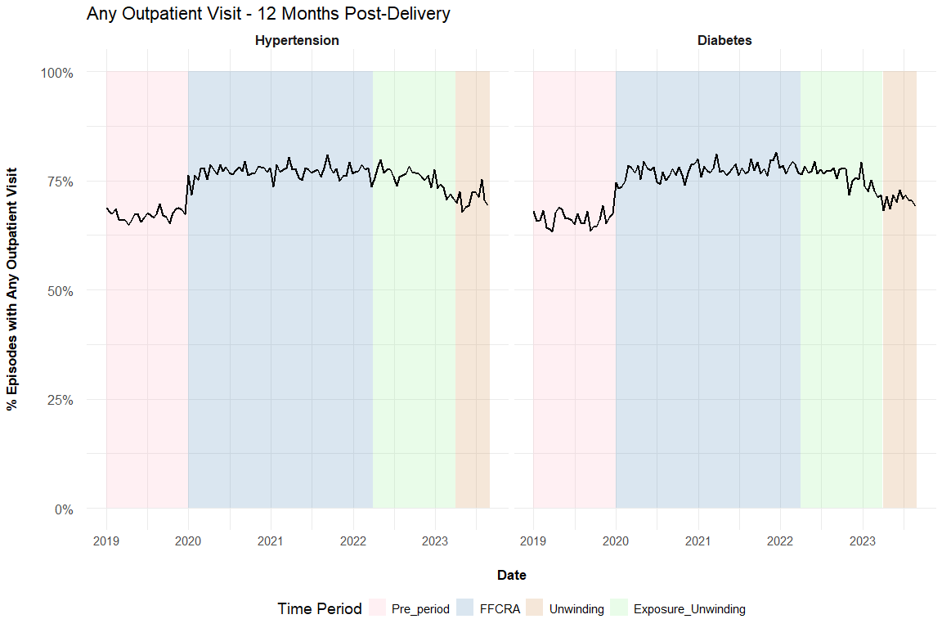

Figure 2: Biweekly graphs based on anchor date: diabetes screening
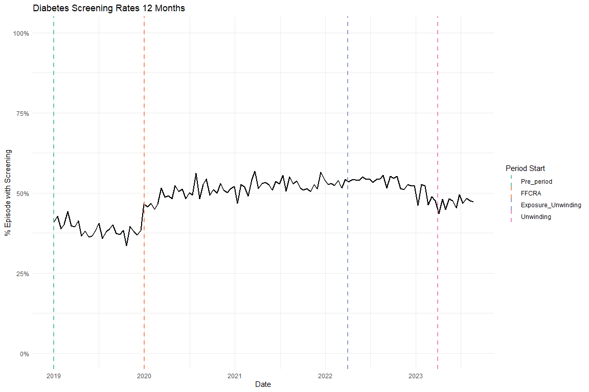

Figure 3: Biweekly graphs based on anchor date: hypertensive medication
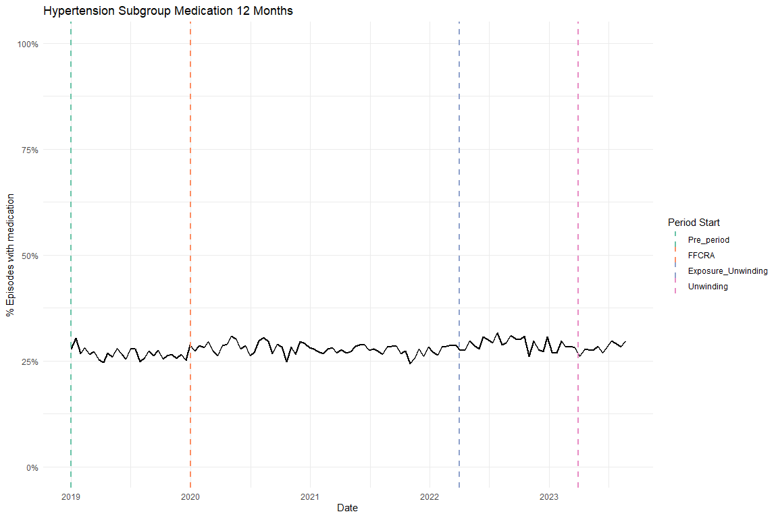

Table 2: ITS results of all utilization outcomes, adjusted, main coefficients only
Diabetes cohort
Characteristic | Diabetes Screening Beta | 95% CI¹ | Any outpatient utilization Beta | 95% CI¹
Pre-trend | -0.002 | -0.003, -0.001 | -0.001 | -0.002, 0.000
Level Change, FFCRA | 0.130 | 0.112, 0.147 | 0.104 | 0.088, 0.119
Level Change, Exposure to Unwinding | 0.152 | 0.127, 0.177 | 0.109 | 0.087, 0.131
Trend Change, FFCRA | 0.003 | 0.002, 0.004 | 0.001 | 0.000, 0.002
Trend Change, Exposure to Unwinding | -0.004 | -0.004, -0.003 | -0.003 | -0.004, -0.002
¹CI = Confidence Interval
Hypertension cohort
Characteristic | Antihypertensive medication Beta | 95% CI¹ | Any outpatient utilization Beta | 95% CI¹
Pre-trend | -0.001 | -0.002, -0.001 | 0.000 | -0.001, 0.000
Level Change, FFCRA | 0.031 | 0.018, 0.044 | 0.100 | 0.087, 0.113
Level Change, Exposure to Unwinding | 0.052 | 0.034, 0.070 | 0.111 | 0.093, 0.129
Trend Change, FFCRA | 0.001 | 0.000, 0.002 | 0.000 | 0.000, 0.001
Trend Change, Exposure to Unwinding | 0.000 | -0.001, 0.000 | -0.002 | -0.003, -0.002
¹CI = Confidence Interval

Supplemental Figures

Flowchart
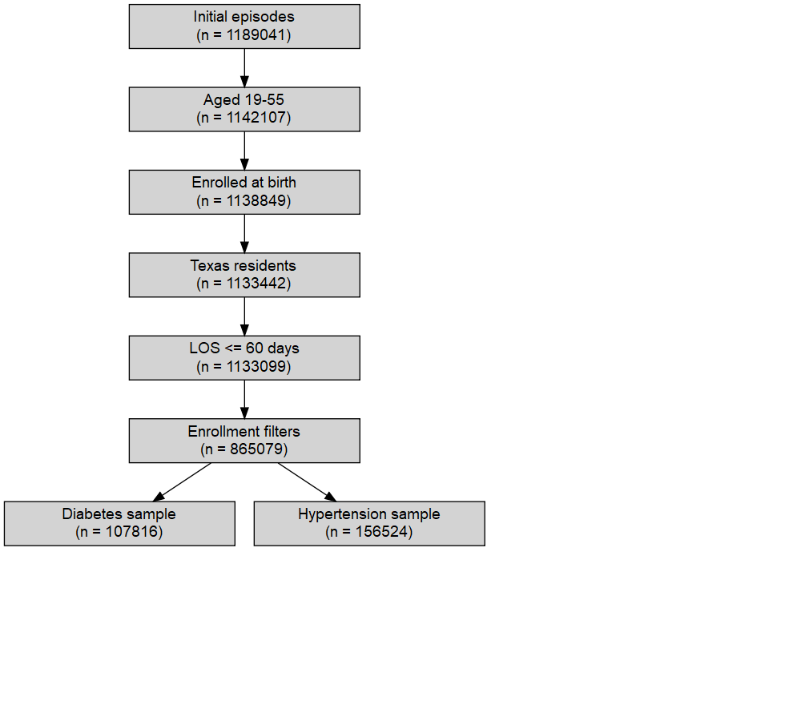

Enrollment
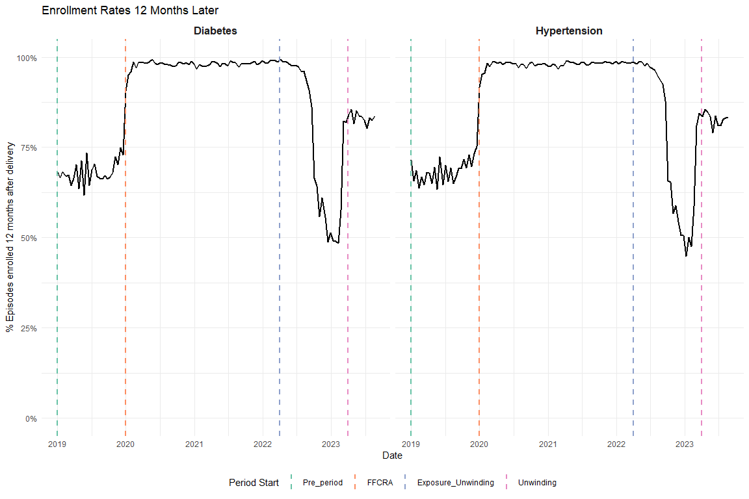

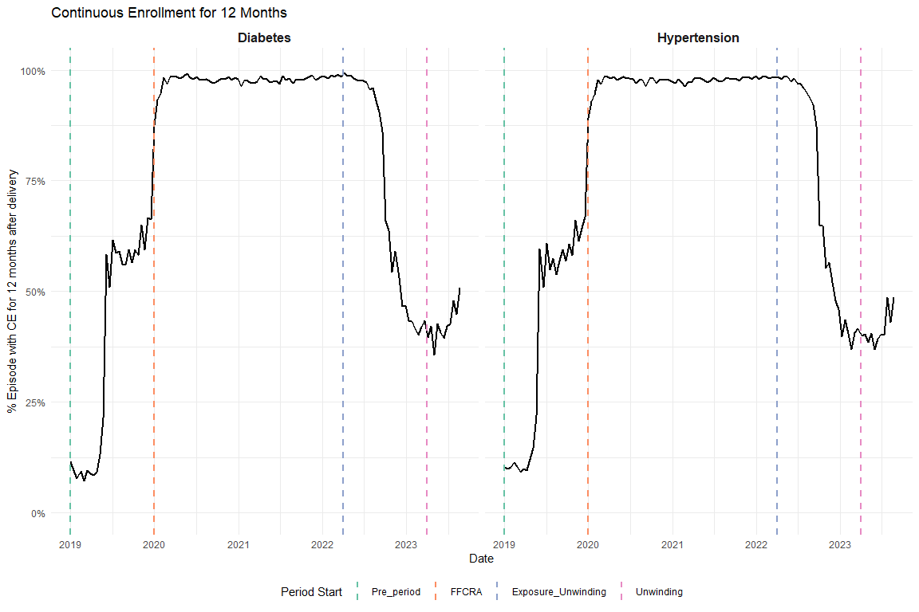

OGT vs A1C
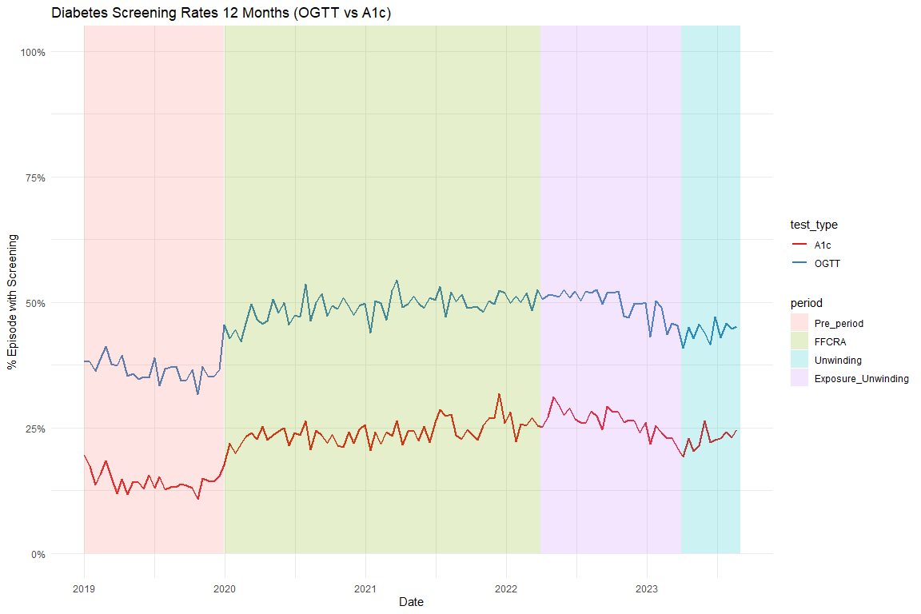

Average Visits per Person
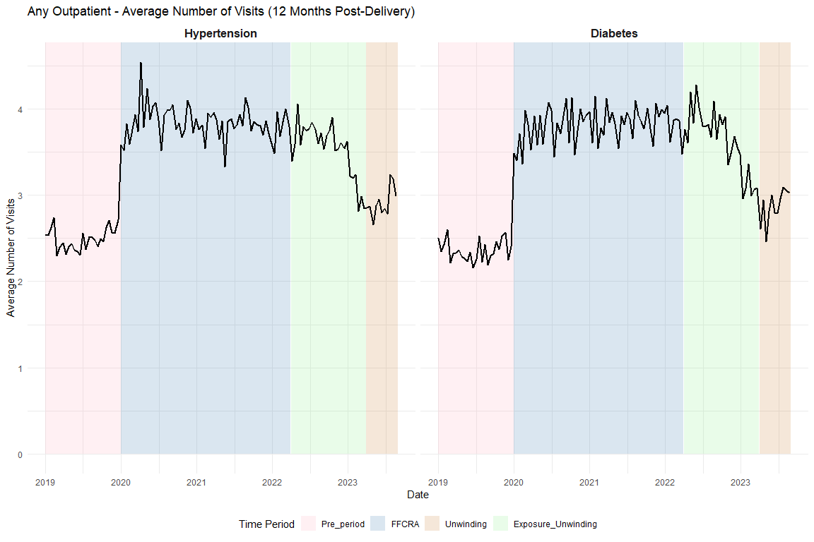

Supplemental Tables

Full ITS Results

Diabetes Screening
Unadjusted
Characteristic | Beta | 95% CI¹ | p-value
(Intercept) | 0.4052 | 0.3896, 0.4207 | <0.001
t | -0.0015 | -0.0026, -0.0005 | 0.004
period_FFCRA | 0.1234 | 0.1054, 0.1413 | <0.001
period_Exposure_Unwinding | 0.1438 | 0.1186, 0.1690 | <0.001
t_after_FFCRA | 0.0024 | 0.0013, 0.0035 | <0.001
t_after_Exposure | -0.0035 | -0.0041, -0.0029 | <0.001
¹CI = Confidence Interval
Adjusted
Characteristic | Beta | 95% CI¹ | p-value
(Intercept) | 0.2794 | 0.2561, 0.3027 | <0.001
t | -0.0023 | -0.0033, -0.0012 | <0.001
period_FFCRA | 0.1296 | 0.1118, 0.1474 | <0.001
period_Exposure_Unwinding | 0.1516 | 0.1266, 0.1766 | <0.001
t_after_FFCRA | 0.0031 | 0.0020, 0.0041 | <0.001
t_after_Exposure | -0.0035 | -0.0041, -0.0029 | <0.001
Age | 0.0005 | -0.0001, 0.0011 | 0.079
Index No Transfusion Weight | 0.0087 | 0.0083, 0.0092 | <0.001
¹CI = Confidence Interval

Diabetes Outpatient
Unadjusted
Characteristic | Beta | 95% CI¹ | p-value
(Intercept) | 0.6624 | 0.6488, 0.6761 | <0.001
t | -0.0001 | -0.0010, 0.0008 | 0.90
period_FFCRA | 0.0984 | 0.0827, 0.1141 | <0.001
period_Exposure_Unwinding | 0.1025 | 0.0805, 0.1246 | <0.001
t_after_FFCRA | 0.0005 | -0.0004, 0.0015 | 0.26
t_after_Exposure | -0.0030 | -0.0035, -0.0025 | <0.001
¹CI = Confidence Interval
Adjusted
Characteristic | Beta | 95% CI¹ | p-value
(Intercept) | 0.6033 | 0.5829, 0.6238 | <0.001
t | -0.0006 | -0.0015, 0.0002 | 0.16
period_FFCRA | 0.1037 | 0.0881, 0.1193 | <0.001
period_Exposure_Unwinding | 0.1090 | 0.0871, 0.1309 | <0.001
t_after_FFCRA | 0.0011 | 0.0001, 0.0020 | 0.024
t_after_Exposure | -0.0030 | -0.0035, -0.0024 | <0.001
Age | -0.0008 | -0.0013, -0.0003 | 0.002
Index No Transfusion Weight | 0.0066 | 0.0061, 0.0070 | <0.001
¹CI = Confidence Interval

HTN Medication
Unadjusted
Characteristic | Beta | 95% CI¹ | p-value
(Intercept) | 0.2737 | 0.2621, 0.2854 | <0.001
t | -0.0006 | -0.0014, 0.0002 | 0.12
period_FFCRA | 0.0270 | 0.0134, 0.0406 | <0.001
period_Exposure_Unwinding | 0.0467 | 0.0278, 0.0656 | <0.001
t_after_FFCRA | 0.0004 | -0.0004, 0.0012 | 0.31
t_after_Exposure | -0.0001 | -0.0006, 0.0003 | 0.65
¹CI = Confidence Interval
Adjusted
Characteristic | Beta | 95% CI¹ | p-value
(Intercept) | -0.2625 | -0.2788, -0.2462 | <0.001
t | -0.0013 | -0.0020, -0.0005 | <0.001
period_FFCRA | 0.0310 | 0.0179, 0.0442 | <0.001
period_Exposure_Unwinding | 0.0521 | 0.0338, 0.0704 | <0.001
t_after_FFCRA | 0.0010 | 0.0002, 0.0017 | 0.016
t_after_Exposure | -0.0001 | -0.0005, 0.0003 | 0.63
Age | 0.0154 | 0.0150, 0.0158 | <0.001
Index No Transfusion Weight | 0.0082 | 0.0079, 0.0085 | <0.001
¹CI = Confidence Interval

HTN Outpatient
Unadjusted
Characteristic | Beta | 95% CI¹ | p-value
(Intercept) | 0.6669 | 0.6556, 0.6782 | <0.001
t | 0.0004 | -0.0004, 0.0011 | 0.31
period_FFCRA | 0.0915 | 0.0783, 0.1047 | <0.001
period_Exposure_Unwinding | 0.1020 | 0.0836, 0.1203 | <0.001
t_after_FFCRA | -0.0003 | -0.0011, 0.0005 | 0.46
t_after_Exposure | -0.0023 | -0.0028, -0.0019 | <0.001
¹CI = Confidence Interval
Adjusted
Characteristic | Beta | 95% CI¹ | p-value
(Intercept) | 0.5941 | 0.5778, 0.6103 | <0.001
t | -0.0004 | -0.0012, 0.0003 | 0.27
period_FFCRA | 0.0999 | 0.0867, 0.1130 | <0.001
period_Exposure_Unwinding | 0.1112 | 0.0930, 0.1294 | <0.001
t_after_FFCRA | 0.0005 | -0.0003, 0.0012 | 0.25
t_after_Exposure | -0.0023 | -0.0027, -0.0018 | <0.001
Age | -0.0002 | -0.0006, 0.0002 | 0.42
Index No Transfusion Weight | 0.0063 | 0.0060, 0.0066 | <0.001
¹CI = Confidence Interval

HEDIS Postpartum Visits

Diabetes Postpartum Visits
Unadjusted
Characteristic | Beta | 95% CI¹ | p-value
(Intercept) | 0.7827 | 0.7701, 0.7953 | <0.001
t | 0.0003 | -0.0006, 0.0011 | 0.51
period_FFCRA | 0.0055 | -0.0090, 0.0200 | 0.46
period_Exposure_Unwinding | 0.0150 | -0.0054, 0.0353 | 0.15
t_after_FFCRA | 0.0000 | -0.0009, 0.0008 | 0.92
t_after_Exposure | -0.0012 | -0.0017, -0.0007 | <0.001
¹CI = Confidence Interval
Adjusted
Characteristic | Beta | 95% CI¹ | p-value
(Intercept) | 0.7654 | 0.7465, 0.7843 | <0.001
t | -0.0001 | -0.0010, 0.0007 | 0.73
period_FFCRA | 0.0094 | -0.0050, 0.0239 | 0.20
period_Exposure_Unwinding | 0.0197 | -0.0006, 0.0400 | 0.057
t_after_FFCRA | 0.0003 | -0.0005, 0.0012 | 0.43
t_after_Exposure | -0.0012 | -0.0017, -0.0007 | <0.001
Age | -0.0013 | -0.0017, -0.0008 | <0.001
Index No Transfusion Weight | 0.0044 | 0.0040, 0.0048 | <0.001
¹CI = Confidence Interval

HTN Postpartum Visits
Unadjusted
Characteristic | Beta | 95% CI¹ | p-value
(Intercept) | 0.7668 | 0.7562, 0.7775 | <0.001
t | 0.0005 | -0.0002, 0.0012 | 0.16
period_FFCRA | -0.0021 | -0.0146, 0.0104 | 0.74
period_Exposure_Unwinding | -0.0010 | -0.0184, 0.0164 | 0.91
t_after_FFCRA | -0.0003 | -0.0010, 0.0005 | 0.47
t_after_Exposure | -0.0008 | -0.0012, -0.0004 | <0.001
¹CI = Confidence Interval
Adjusted
Characteristic | Beta | 95% CI¹ | p-value
(Intercept) | 0.7768 | 0.7613, 0.7923 | <0.001
t | -0.0001 | -0.0009, 0.0006 | 0.69
period_FFCRA | 0.0050 | -0.0075, 0.0175 | 0.43
period_Exposure_Unwinding | 0.0067 | -0.0106, 0.0241 | 0.45
t_after_FFCRA | 0.0003 | -0.0004, 0.0011 | 0.36
t_after_Exposure | -0.0008 | -0.0012, -0.0003 | <0.001
Age | -0.0024 | -0.0028, -0.0020 | <0.001
Index No Transfusion Weight | 0.0046 | 0.0043, 0.0050 | <0.001
¹CI = Confidence Interval

Sensitivity Analyses

Diabetes Subgroup Exclude Pre-existing

Graph
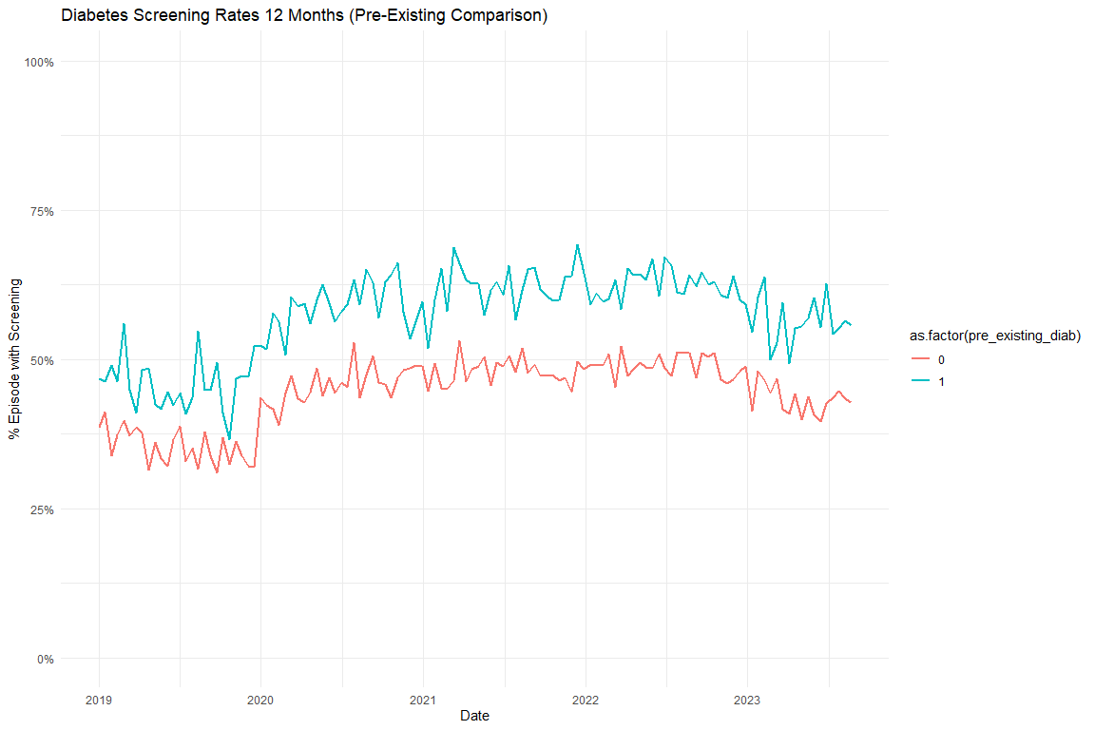

Models

Diabetes Screening Unadjusted
 | Full Sample | Excluding Pre-Existing Diabetes
Characteristic | Beta¹ | Beta¹
(Intercept) | 0.405*** | 0.379***
t | -0.002** | -0.002***
period_FFCRA | 0.123*** | 0.121***
period_Exposure_Unwinding | 0.144*** | 0.136***
t_after_FFCRA | 0.002*** | 0.003***
t_after_Exposure | -0.004*** | -0.003***
¹*p<0.05; **p<0.01; ***p<0.001

Diabetes Screening Adjusted
 | Full Sample | Excluding Pre-Existing Diabetes
Characteristic | Beta¹ | Beta¹
(Intercept) | 0.279*** | 0.311***
t | -0.002*** | -0.003***
period_FFCRA | 0.130*** | 0.126***
period_Exposure_Unwinding | 0.152*** | 0.142***
t_after_FFCRA | 0.003*** | 0.004***
t_after_Exposure | -0.004*** | -0.003***
Age | 0.001 | 0.000
Index No Transfusion Weight | 0.009*** | 0.007***
¹*p<0.05; **p<0.01; ***p<0.001

Diabetes Subgroup Test Type Graphs
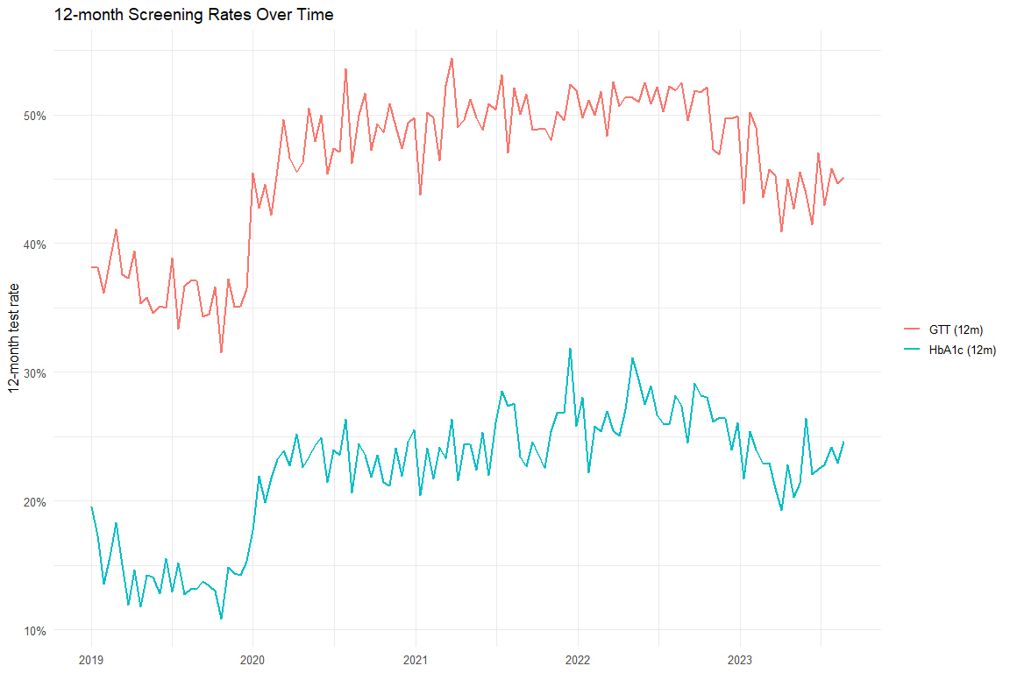

Diabetes Test Type Models
 | Overall (Unadj) | Overall (Adj) | HbA1c (Unadj) | HbA1c (Adj) | GTT (Unadj) | GTT (Adj)
Characteristic | Beta¹ | Beta¹ | Beta¹ | Beta¹ | Beta¹ | Beta¹
(Intercept) | 0.405*** | 0.279*** | 0.155*** | -0.046*** | 0.380*** | 0.260***
t | -0.002** | -0.002*** | -0.001* | -0.002*** | -0.001* | -0.002***
period_FFCRA | 0.123*** | 0.130*** | 0.091*** | 0.094*** | 0.122*** | 0.128***
period_Exposure_Unwinding | 0.144*** | 0.152*** | 0.116*** | 0.121*** | 0.141*** | 0.149***
t_after_FFCRA | 0.002*** | 0.003*** | 0.002*** | 0.002*** | 0.002*** | 0.003***
t_after_Exposure | -0.004*** | -0.004*** | -0.003*** | -0.003*** | -0.004*** | -0.004***
Age |  | 0.001 |  | 0.004*** |  | 0.000
Index No Transfusion Weight |  | 0.009*** |  | 0.008*** |  | 0.009***
¹*p<0.05; **p<0.01; ***p<0.001

Excluding COVID
[1] "diab_screen_unadj_excluded_reidx"
[1] "diab_screen_adj_excluded_reidx"
[1] "diab_any_outpatient_unadj_excluded_reidx"
[1] "diab_any_outpatient_adj_excluded_reidx"
[1] "htn_med_unadj_excluded_reidx"
[1] "htn_med_adj_excluded_reidx"
[1] "htn_any_outpatient_unadj_excluded_reidx"
[1] "htn_any_outpatient_adj_excluded_reidx"
 | Original - Unadj | Excluded COVID - Unadj | Original - Adj | Excluded COVID - Adj
Characteristic | Beta¹ | Beta¹ | Beta¹ | Beta¹
(Intercept) | 0.405*** | 0.411*** | 0.279*** | 0.285***
t | -0.002** | 0.001 | -0.002*** | 0.001
period_FFCRA | 0.123*** | 0.088*** | 0.130*** | 0.072***
period_Exposure_Unwinding | 0.144*** | 0.114*** | 0.152*** | 0.100***
t_after_FFCRA | 0.002*** | 0.000 | 0.003*** | 0.000
t_after_Exposure | -0.004*** | -0.003*** | -0.004*** | -0.003***
Age |  |  | 0.001 | 0.001
Index No Transfusion Weight |  |  | 0.009*** | 0.009***
¹*p<0.05; **p<0.01; ***p<0.001
 | Original - Unadj | Excluded COVID - Unadj | Original - Adj | Excluded COVID - Adj
Characteristic | Beta¹ | Beta¹ | Beta¹ | Beta¹
(Intercept) | 0.662*** | 0.661*** | 0.603*** | 0.607***
t | 0.000 | 0.000 | -0.001 | 0.000
period_FFCRA | 0.098*** | 0.101*** | 0.104*** | 0.089***
period_Exposure_Unwinding | 0.103*** | 0.105*** | 0.109*** | 0.094***
t_after_FFCRA | 0.001 | 0.000 | 0.001* | 0.000
t_after_Exposure | -0.003*** | -0.003*** | -0.003*** | -0.003***
Age |  |  | -0.001** | -0.001**
Index No Transfusion Weight |  |  | 0.007*** | 0.007***
¹*p<0.05; **p<0.01; ***p<0.001
 | Original - Unadj | Excluded COVID - Unadj | Original - Adj | Excluded COVID - Adj
Characteristic | Beta¹ | Beta¹ | Beta¹ | Beta¹
(Intercept) | 0.274*** | 0.280*** | -0.263*** | -0.246***
t | -0.001 | -0.001* | -0.001*** | -0.001*
period_FFCRA | 0.027*** | 0.015 | 0.031*** | -0.001
period_Exposure_Unwinding | 0.047*** | 0.031** | 0.052*** | 0.018
t_after_FFCRA | 0.000 | 0.001 | 0.001* | 0.001
t_after_Exposure | 0.000 | 0.000 | 0.000 | 0.000
Age |  |  | 0.015*** | 0.015***
Index No Transfusion Weight |  |  | 0.008*** | 0.008***
¹*p<0.05; **p<0.01; ***p<0.001
 | Original - Unadj | Excluded COVID - Unadj | Original - Adj | Excluded COVID - Adj
Characteristic | Beta¹ | Beta¹ | Beta¹ | Beta¹
(Intercept) | 0.667*** | 0.675*** | 0.594*** | 0.607***
t | 0.000 | 0.000 | 0.000 | 0.000
period_FFCRA | 0.091*** | 0.100*** | 0.100*** | 0.085***
period_Exposure_Unwinding | 0.102*** | 0.113*** | 0.111*** | 0.100***
t_after_FFCRA | 0.000 | 0.000 | 0.000 | 0.000
t_after_Exposure | -0.002*** | -0.002*** | -0.002*** | -0.002***
Age |  |  | 0.000 | 0.000
Index No Transfusion Weight |  |  | 0.006*** | 0.006***
¹*p<0.05; **p<0.01; ***p<0.001

Other Break Analysis

Percent Change in DSHS Numbers
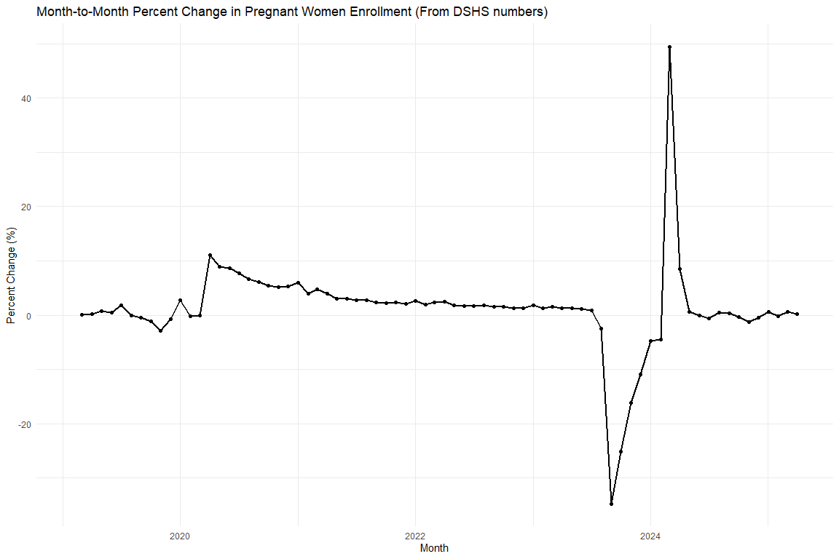
Month-to-Month Percent Change in Pregnant Women Enrollment (Jan 2023 - Jun 2024)
Month | Pregnant Women (Count) | Percent Change (%)
2023-01-01 | 476,205 | 1.77%
2023-02-01 | 482,037 | 1.22%
2023-03-01 | 489,284 | 1.50%
2023-04-01 | 495,541 | 1.28%
2023-05-01 | 501,614 | 1.23%
2023-06-01 | 507,057 | 1.09%
2023-07-01 | 511,183 | 0.81%
2023-08-01 | 498,392 | -2.50%
2023-09-01 | 325,121 | -34.77%
2023-10-01 | 243,231 | -25.19%
2023-11-01 | 204,057 | -16.11%
2023-12-01 | 181,646 | -10.98%
2024-01-01 | 173,116 | -4.70%
2024-02-01 | 165,441 | -4.43%
2024-03-01 | 247,371 | 49.52%
2024-04-01 | 268,508 | 8.54%
2024-05-01 | 269,962 | 0.54%
2024-06-01 | 269,712 | -0.09%

Change in CE (from cohort)
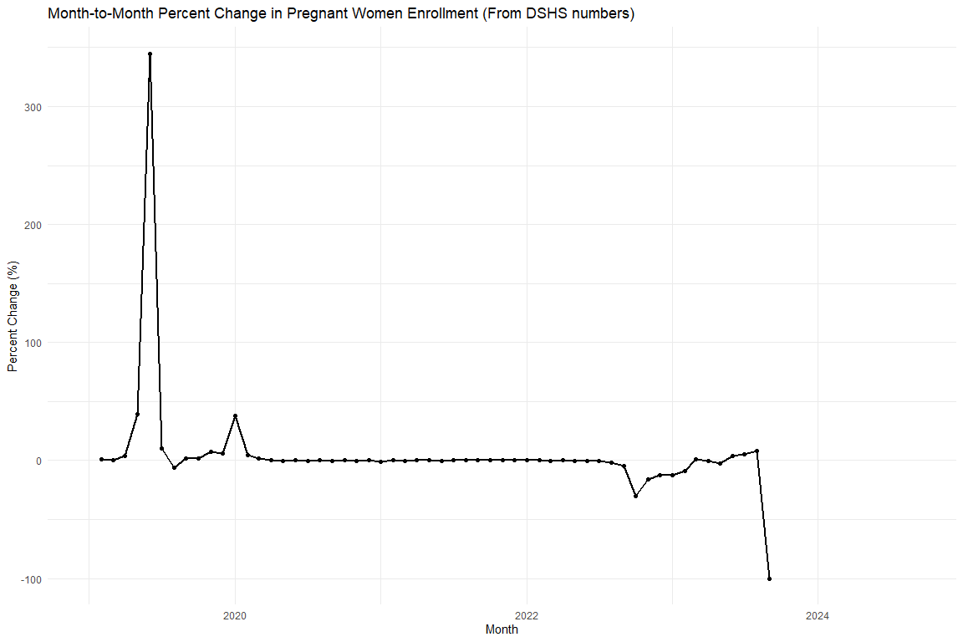
Monthly CE After 12 Rate and Month-over-Month Change
Month | CE After 12 (Level, %) | MoM Change (%)
2019-01-01 | 8.38%
2019-02-01 | 8.49% | 1.20%
2019-03-01 | 8.49% | 0.09%
2019-04-01 | 8.83% | 3.96%
2019-05-01 | 12.30% | 39.26%
2019-06-01 | 54.71% | 344.97%
2019-07-01 | 60.31% | 10.23%
2019-08-01 | 56.78% | -5.85%
2019-09-01 | 57.94% | 2.04%
2019-10-01 | 58.95% | 1.75%
2019-11-01 | 63.24% | 7.28%
2019-12-01 | 66.85% | 5.70%
2020-01-01 | 91.98% | 37.59%
2020-02-01 | 96.13% | 4.51%
2020-03-01 | 97.88% | 1.83%
2020-04-01 | 98.25% | 0.38%
2020-05-01 | 98.11% | -0.15%
2020-06-01 | 98.19% | 0.08%
2020-07-01 | 97.56% | -0.64%
2020-08-01 | 97.56% | 0.00%
2020-09-01 | 97.37% | -0.19%
2020-10-01 | 97.78% | 0.42%
2020-11-01 | 97.58% | -0.20%
2020-12-01 | 97.99% | 0.42%
2021-01-01 | 97.22% | -0.78%
2021-02-01 | 97.38% | 0.16%
2021-03-01 | 97.24% | -0.14%
2021-04-01 | 97.78% | 0.55%
2021-05-01 | 97.91% | 0.13%
2021-06-01 | 97.52% | -0.39%
2021-07-01 | 97.76% | 0.24%
2021-08-01 | 97.75% | -0.02%
2021-09-01 | 98.02% | 0.28%
2021-10-01 | 98.14% | 0.12%
2021-11-01 | 98.15% | 0.01%
2021-12-01 | 98.27% | 0.12%
2022-01-01 | 98.40% | 0.13%
2022-02-01 | 98.44% | 0.04%
2022-03-01 | 98.14% | -0.31%
2022-04-01 | 98.51% | 0.38%
2022-05-01 | 98.45% | -0.06%
2022-06-01 | 97.74% | -0.72%
2022-07-01 | 97.28% | -0.47%
2022-08-01 | 95.56% | -1.77%
2022-09-01 | 91.20% | -4.56%
2022-10-01 | 63.57% | -30.30%
2022-11-01 | 53.32% | -16.12%
2022-12-01 | 46.67% | -12.47%
2023-01-01 | 40.74% | -12.70%
2023-02-01 | 37.19% | -8.72%
2023-03-01 | 37.61% | 1.14%
2023-04-01 | 37.46% | -0.41%
2023-05-01 | 36.53% | -2.48%
2023-06-01 | 37.87% | 3.68%
2023-07-01 | 39.75% | 4.95%
2023-08-01 | 43.10% | 8.43%
2023-09-01 | 0.00% | -100.00%

Scratch (check predicted values)
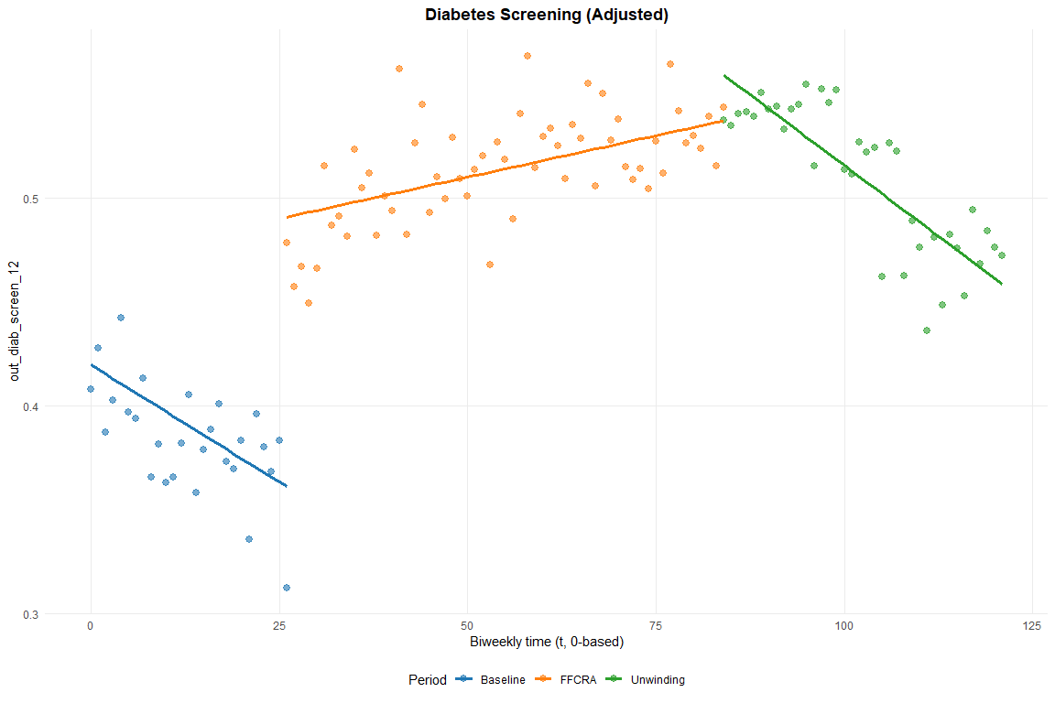

Export Excel

