POEM TX MH Cohort Explore
2026-02-04

Risk Group
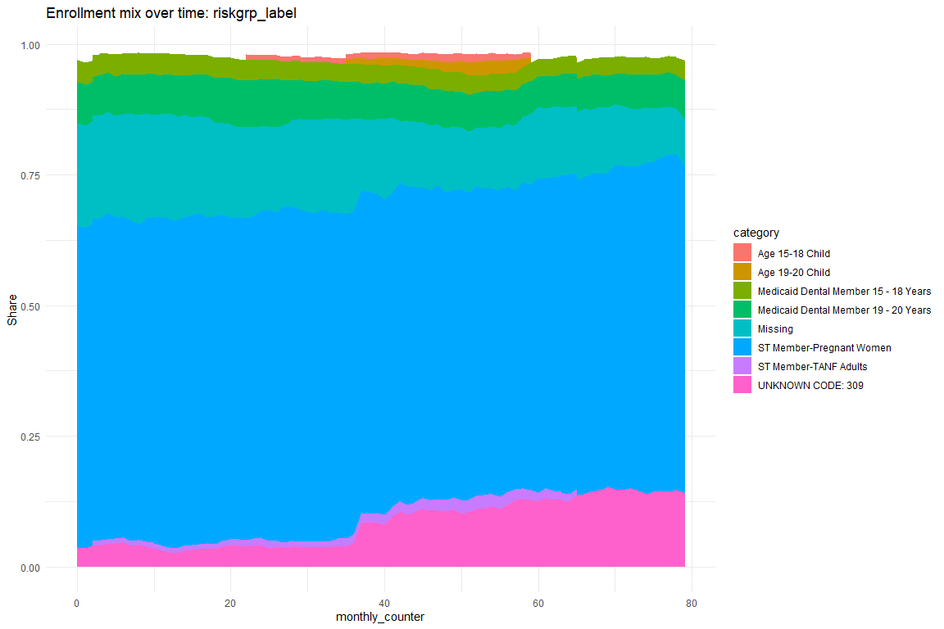

ME_TP
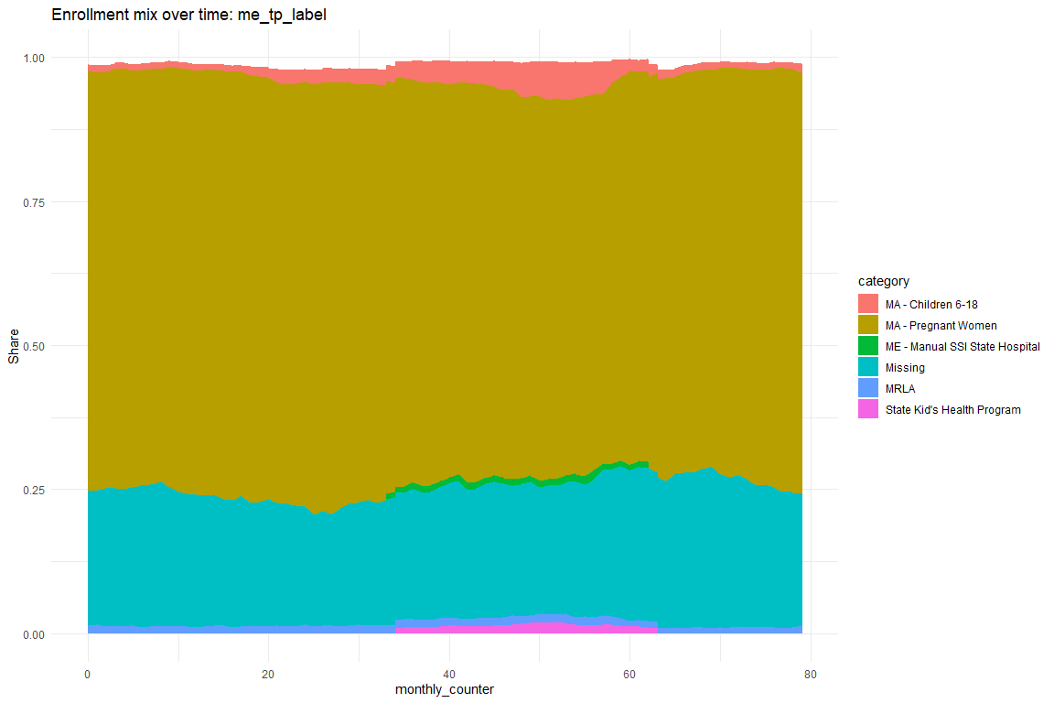

ME_CODE
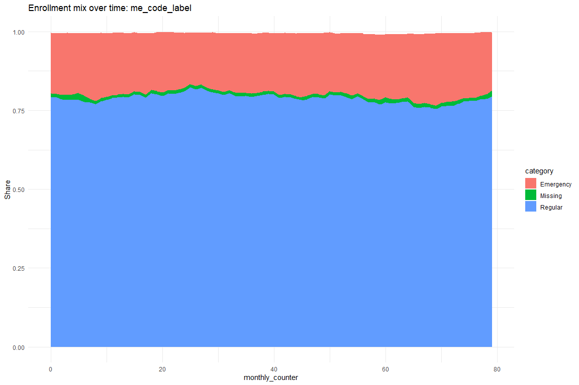

Table Version
Characteristic | N = 1,538,452¹
age | 26 (21, 31)
me_code_plot
1929(b) Base plan 20 MAO client | 24 (<0.1%)
Emergency | 301,119 (20%)
Healthy Texas Women | 2,195 (0.1%)
ICF-MR | 1 (<0.1%)
Institutional regular (CATS 1, 3 or 4) (BP16 or 17) | 1 (<0.1%)
Missing | 16,576 (1.1%)
Pregnancy for TP42 cases (Presumptive eligibility) | 51 (<0.1%)
QMD coverage (Medicare only) | 185 (<0.1%)
Regular | 1,212,598 (79%)
Three months prior | 5,702 (0.4%)
riskgrp_plot
Age 15-18 Child | 12,516 (0.8%)
Age 19-20 Child | 11,602 (0.8%)
Foster Care - Member <= 21 Years Old | 1,727 (0.1%)
Medicaid Dental Member 15 - 18 Years | 55,446 (3.6%)
Medicaid Dental Member 19 - 20 Years | 111,199 (7.2%)
Medicaid Dental Member 6 - 14 Years | 1,241 (<0.1%)
Missing | 233,078 (15%)
Other | 4,614 (0.3%)
SP Member - Dual Eligible Community | 1,395 (<0.1%)
SP Member - Non-Medicare Community | 9,190 (0.6%)
ST Member- AA/PCA | 1,464 (<0.1%)
ST Member-Pregnant Women | 943,562 (61%)
ST Member-TANF Adults | 19,968 (1.3%)
STAR Kids - Age 15-20 Child | 4,311 (0.3%)
UNKNOWN CODE: 309 | 125,981 (8.2%)
UNKNOWN CODE: 310 | 1,158 (<0.1%)
me_tp_plot
MA - Children 1-5 | 348 (<0.1%)
MA - Children 6-18 | 39,828 (2.6%)
MA - FFCC | 3,554 (0.2%)
MA - MBCC | 67 (<0.1%)
MA - Newborn Children | 1,230 (<0.1%)
MA - Pregnant Women | 1,086,337 (71%)
ME - Grandfathered LTC | 58 (<0.1%)
ME - Manual SSI State Hospital | 11,380 (0.7%)
ME - Manual SSI State School | 500 (<0.1%)
ME - SSI Chest Hospital | 2,627 (0.2%)
ME - SSI State Group Home | 296 (<0.1%)
Missing | 360,535 (23%)
MRLA | 19,306 (1.3%)
Other | 122 (<0.1%)
PCA Medicaid - Federal Match - With Cash | 252 (<0.1%)
State Kid's Health Program | 12,012 (0.8%)
¹Median (IQR); n (%)

By Time
Characteristic | Exposure, N = 344,262¹ | FFCRA, N = 530,875¹ | Other/NA, N = 421,902¹ | Pre, N = 241,413¹
age | 26 (21, 31) | 26 (21, 30) | 26 (22, 31) | 25 (21, 30)
me_code_plot
1929(b) Base plan 20 MAO client | 0 (0%) | 10 (<0.1%) | 8 (<0.1%) | 6 (<0.1%)
Emergency | 66,541 (19%) | 97,700 (18%) | 88,753 (21%) | 48,125 (20%)
Healthy Texas Women | 755 (0.2%) | 758 (0.1%) | 520 (0.1%) | 162 (<0.1%)
ICF-MR | 0 (0%) | 1 (<0.1%) | 0 (0%) | 0 (0%)
Institutional regular (CATS 1, 3 or 4) (BP16 or 17) | 0 (0%) | 1 (<0.1%) | 0 (0%) | 0 (0%)
Missing | 3,281 (1.0%) | 4,772 (0.9%) | 5,269 (1.2%) | 3,254 (1.3%)
Pregnancy for TP42 cases (Presumptive eligibility) | 4 (<0.1%) | 19 (<0.1%) | 19 (<0.1%) | 9 (<0.1%)
QMD coverage (Medicare only) | 33 (<0.1%) | 69 (<0.1%) | 39 (<0.1%) | 44 (<0.1%)
Regular | 272,625 (79%) | 425,819 (80%) | 325,270 (77%) | 188,884 (78%)
Three months prior | 1,023 (0.3%) | 1,726 (0.3%) | 2,024 (0.5%) | 929 (0.4%)
riskgrp_plot
Age 15-18 Child | 4,369 (1.3%) | 4,240 (0.8%) | 2,813 (0.7%) | 1,094 (0.5%)
Age 19-20 Child | 6,517 (1.9%) | 2,913 (0.5%) | 2,060 (0.5%) | 112 (<0.1%)
Foster Care - Member <= 21 Years Old | 478 (0.1%) | 632 (0.1%) | 373 (<0.1%) | 244 (0.1%)
Medicaid Dental Member 15 - 18 Years | 11,994 (3.5%) | 19,714 (3.7%) | 13,985 (3.3%) | 9,753 (4.0%)
Medicaid Dental Member 19 - 20 Years | 23,772 (6.9%) | 42,397 (8.0%) | 26,590 (6.3%) | 18,440 (7.6%)
Medicaid Dental Member 6 - 14 Years | 301 (<0.1%) | 448 (<0.1%) | 318 (<0.1%) | 174 (<0.1%)
Missing | 42,581 (12%) | 92,214 (17%) | 50,320 (12%) | 47,963 (20%)
Other | 1,015 (0.3%) | 1,863 (0.4%) | 862 (0.2%) | 874 (0.4%)
SP Member - Dual Eligible Community | 324 (<0.1%) | 555 (0.1%) | 360 (<0.1%) | 156 (<0.1%)
SP Member - Non-Medicare Community | 2,196 (0.6%) | 3,188 (0.6%) | 2,326 (0.6%) | 1,480 (0.6%)
ST Member- AA/PCA | 632 (0.2%) | 412 (<0.1%) | 350 (<0.1%) | 70 (<0.1%)
ST Member-Pregnant Women | 204,931 (60%) | 332,252 (63%) | 257,518 (61%) | 148,861 (62%)
ST Member-TANF Adults | 7,552 (2.2%) | 6,269 (1.2%) | 4,336 (1.0%) | 1,811 (0.8%)
STAR Kids - Age 15-20 Child | 1,145 (0.3%) | 1,581 (0.3%) | 947 (0.2%) | 638 (0.3%)
UNKNOWN CODE: 309 | 36,266 (11%) | 21,867 (4.1%) | 58,376 (14%) | 9,472 (3.9%)
UNKNOWN CODE: 310 | 189 (<0.1%) | 330 (<0.1%) | 368 (<0.1%) | 271 (0.1%)
me_tp_plot
MA - Children 1-5 | 56 (<0.1%) | 148 (<0.1%) | 105 (<0.1%) | 39 (<0.1%)
MA - Children 6-18 | 17,860 (5.2%) | 12,134 (2.3%) | 7,603 (1.8%) | 2,231 (0.9%)
MA - FFCC | 812 (0.2%) | 1,253 (0.2%) | 942 (0.2%) | 547 (0.2%)
MA - MBCC | 21 (<0.1%) | 28 (<0.1%) | 13 (<0.1%) | 5 (<0.1%)
MA - Newborn Children | 173 (<0.1%) | 567 (0.1%) | 151 (<0.1%) | 339 (0.1%)
MA - Pregnant Women | 230,638 (67%) | 386,723 (73%) | 293,577 (70%) | 175,399 (73%)
ME - Grandfathered LTC | 9 (<0.1%) | 24 (<0.1%) | 12 (<0.1%) | 13 (<0.1%)
ME - Manual SSI State Hospital | 4,057 (1.2%) | 3,977 (0.7%) | 2,065 (0.5%) | 1,281 (0.5%)
ME - Manual SSI State School | 216 (<0.1%) | 171 (<0.1%) | 68 (<0.1%) | 45 (<0.1%)
ME - SSI Chest Hospital | 1,123 (0.3%) | 778 (0.1%) | 594 (0.1%) | 132 (<0.1%)
ME - SSI State Group Home | 72 (<0.1%) | 112 (<0.1%) | 70 (<0.1%) | 42 (<0.1%)
Missing | 79,062 (23%) | 114,556 (22%) | 109,134 (26%) | 57,783 (24%)
MRLA | 4,824 (1.4%) | 6,884 (1.3%) | 4,552 (1.1%) | 3,046 (1.3%)
Other | 38 (<0.1%) | 36 (<0.1%) | 40 (<0.1%) | 8 (<0.1%)
PCA Medicaid - Federal Match - With Cash | 110 (<0.1%) | 50 (<0.1%) | 74 (<0.1%) | 18 (<0.1%)
State Kid's Health Program | 5,191 (1.5%) | 3,434 (0.6%) | 2,902 (0.7%) | 485 (0.2%)
¹Median (IQR); n (%)

Filter for MH
Characteristic | Exposure, N = 51,456¹ | FFCRA, N = 76,885¹ | Other/NA, N = 64,401¹ | Pre, N = 25,953¹
age | 26.0 (21.0, 31.0) | 25.0 (21.0, 30.0) | 26.0 (21.0, 31.0) | 25.0 (21.0, 30.0)
me_code_plot
1929(b) Base plan 20 MAO client | 0 (0%) | 8 (<0.1%) | 5 (<0.1%) | 4 (<0.1%)
Emergency | 3,829 (7.4%) | 5,275 (6.9%) | 5,880 (9.1%) | 1,897 (7.3%)
Healthy Texas Women | 98 (0.2%) | 84 (0.1%) | 90 (0.1%) | 19 (<0.1%)
Institutional regular (CATS 1, 3 or 4) (BP16 or 17) | 0 (0%) | 1 (<0.1%) | 0 (0%) | 0 (0%)
Missing | 191 (0.4%) | 295 (0.4%) | 358 (0.6%) | 140 (0.5%)
Pregnancy for TP42 cases (Presumptive eligibility) | 1 (<0.1%) | 4 (<0.1%) | 2 (<0.1%) | 1 (<0.1%)
QMD coverage (Medicare only) | 15 (<0.1%) | 33 (<0.1%) | 17 (<0.1%) | 20 (<0.1%)
Regular | 47,209 (92%) | 70,990 (92%) | 57,774 (90%) | 23,778 (92%)
Three months prior | 113 (0.2%) | 195 (0.3%) | 275 (0.4%) | 94 (0.4%)
riskgrp_plot
Age 15-18 Child | 808 (1.6%) | 691 (0.9%) | 566 (0.9%) | 135 (0.5%)
Age 19-20 Child | 1,147 (2.2%) | 575 (0.7%) | 420 (0.7%) | 8 (<0.1%)
Foster Care - Member <= 21 Years Old | 221 (0.4%) | 348 (0.5%) | 226 (0.4%) | 116 (0.4%)
Medicaid Dental Member 15 - 18 Years | 2,351 (4.6%) | 3,460 (4.5%) | 2,835 (4.4%) | 1,272 (4.9%)
Medicaid Dental Member 19 - 20 Years | 3,839 (7.5%) | 6,541 (8.5%) | 4,365 (6.8%) | 2,114 (8.1%)
Medicaid Dental Member 6 - 14 Years | 75 (0.1%) | 105 (0.1%) | 100 (0.2%) | 26 (0.1%)
Missing | 3,054 (5.9%) | 5,659 (7.4%) | 4,451 (6.9%) | 2,327 (9.0%)
Other | 234 (0.5%) | 363 (0.5%) | 216 (0.3%) | 124 (0.5%)
SP Member - Dual Eligible Community | 154 (0.3%) | 327 (0.4%) | 187 (0.3%) | 87 (0.3%)
SP Member - Non-Medicare Community | 1,081 (2.1%) | 1,685 (2.2%) | 1,214 (1.9%) | 682 (2.6%)
ST Member- AA/PCA | 202 (0.4%) | 129 (0.2%) | 112 (0.2%) | 15 (<0.1%)
ST Member-Pregnant Women | 33,706 (66%) | 53,131 (69%) | 44,352 (69%) | 17,914 (69%)
ST Member-TANF Adults | 1,908 (3.7%) | 1,722 (2.2%) | 1,054 (1.6%) | 397 (1.5%)
STAR Kids - Age 15-20 Child | 557 (1.1%) | 763 (1.0%) | 460 (0.7%) | 267 (1.0%)
UNKNOWN CODE: 309 | 2,107 (4.1%) | 1,369 (1.8%) | 3,810 (5.9%) | 452 (1.7%)
UNKNOWN CODE: 310 | 12 (<0.1%) | 17 (<0.1%) | 33 (<0.1%) | 17 (<0.1%)
me_tp_plot
MA - Children 1-5 | 4 (<0.1%) | 8 (<0.1%) | 6 (<0.1%) | 4 (<0.1%)
MA - Children 6-18 | 3,046 (5.9%) | 1,911 (2.5%) | 1,477 (2.3%) | 276 (1.1%)
MA - FFCC | 339 (0.7%) | 509 (0.7%) | 440 (0.7%) | 177 (0.7%)
MA - MBCC | 5 (<0.1%) | 10 (<0.1%) | 6 (<0.1%) | 2 (<0.1%)
MA - Newborn Children | 0 (0%) | 8 (<0.1%) | 1 (<0.1%) | 1 (<0.1%)
MA - Pregnant Women | 37,779 (73%) | 61,468 (80%) | 50,446 (78%) | 20,911 (81%)
ME - Grandfathered LTC | 3 (<0.1%) | 13 (<0.1%) | 7 (<0.1%) | 2 (<0.1%)
ME - Manual SSI State Hospital | 963 (1.9%) | 1,012 (1.3%) | 450 (0.7%) | 214 (0.8%)
ME - Manual SSI State School | 87 (0.2%) | 91 (0.1%) | 38 (<0.1%) | 25 (<0.1%)
ME - SSI Chest Hospital | 366 (0.7%) | 244 (0.3%) | 196 (0.3%) | 38 (0.1%)
ME - SSI State Group Home | 44 (<0.1%) | 94 (0.1%) | 56 (<0.1%) | 33 (0.1%)
Missing | 5,175 (10%) | 7,070 (9.2%) | 8,306 (13%) | 2,806 (11%)
MRLA | 2,387 (4.6%) | 3,533 (4.6%) | 2,322 (3.6%) | 1,360 (5.2%)
Other | 14 (<0.1%) | 16 (<0.1%) | 8 (<0.1%) | 5 (<0.1%)
PCA Medicaid - Federal Match - With Cash | 34 (<0.1%) | 17 (<0.1%) | 30 (<0.1%) | 0 (0%)
State Kid's Health Program | 1,210 (2.4%) | 881 (1.1%) | 612 (1.0%) | 99 (0.4%)
¹Median (IQR); n (%)

