Homework 3, TSCI 5050
Alex F. Bokov, bokov@uthscsa.edu

Student Name:_______Yuanhang Liu__________________________

This homework is graded pass/fail and cooperation is encouraged. Bring the homework (hard-copy) to class, but you can take it back with you and hand it in during the following class if you need more time.

1. Install RSQLite package into your Rstudio (you can use the install.packages('RSQLite') R command)

2. Connect from an Rstudio session to the database you created in HW02 (here we pretend your database is named FOO.db... please modify the below code so that it uses the actual names you chose):
library(RSQLite);
# create a connection object to use in subsequent R commands
con <- dbConnect(drv="SQLite", dbname="FOO.db");
# List the tables in your database.
dbListTables(con);
# Let's say you have a table called called BAR. List its columns.
dbListFields(con,'BAR');
# create a temporary dataframe to hold its contents
dat <- dbGetQuery( con,'select * from BAR' );

3. Choose a numeric column in your data to use as a response (Y) variable and several columns to use as predictor (X) variables. The predictor variables can be any combination of numeric, true/false, or categoric columns. Modify the above select statement so that you are only pulling the variables you need into R. Save this code as a script that you can run whenever you start working with your data.

library(RSQLite);
# create a connection object to use in subsequent R commands
con <- dbConnect(drv=SQLite(), dbname="NeuronExprs.db")
# load csv file into the database
dbWriteTable(conn = con, name = "Exprs", value = "Desktop/Neuron_exprs.csv",
row.names = FALSE, header = TRUE)
# List the tables in your database.
dbListTables(con);
dbListFields(con,'Exprs');
# create a temporary dataframe to hold its contents
dat <- dbGetQuery( con,'select A1BG, A1CF, A26C3 from Exprs' )

4. Fit a linear model to the data (continuing the script in question #2... please modify it to use the actual names of the columns you chose from your data instead of Y, X1, X2, and X3):
dat.lm <- lm(A1BG ~ A1CF + A26C3,data=dat);

Below, copy-paste the output from summary(dat.lm) and the plots from par(mfrow=c(1,2));plot(dat.lm,which=c(1:2)) . Write a brief conclusion about how much each predictor variable affects the response variable, whether or not that effect is significant, and what problems if any the plots reveal.

Call:
lm(formula = A1BG ~ A1CF + A26C3, data = dat)

Residuals:
Min 1Q Median 3Q Max
-0.69458 -0.24366 0.02423 0.19987 0.70328

Coefficients:
Estimate Std. Error t value Pr(>|t|)
(Intercept) 4.62556 1.65922 2.788 0.0117 *
A1CF 0.03129 0.13010 0.240 0.8125
A26C3 0.08706 0.28829 0.302 0.7659
---
Signif. codes: 0 ‘***’ 0.001 ‘**’ 0.01 ‘*’ 0.05 ‘.’ 0.1 ‘ ’ 1

Residual standard error: 0.356 on 19 degrees of freedom
Multiple R-squared: 0.00608, Adjusted R-squared: -0.09854
F-statistic: 0.05812 on 2 and 19 DF, p-value: 0.9437

Seems like there is no significant linear relationship based on the linear model we constructed as shown above. The pvalues for A1CF and A26C3 are both not significant. From the figure below, we can tell from the qq plot that the standardized residuals mostly follow a normal distribution which is the assumption for linear regression.

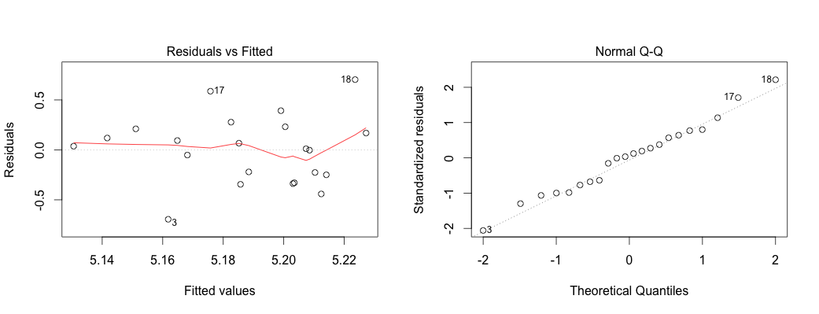

Rather than giving another reading assignment, here are some reading options to choose from. Read as much or as little as you need to in order to answer question 4.
- Brief: http://data.princeton.edu/R/linearModels.html
- Less brief, but still pretty brief: 5.1-5.4 of
http://maths-people.anu.edu.au/~johnm/r/usingR.pdf
- Lengthy, but thoroughly explained: 14.3-14.4 of http://pluto.huji.ac.il/~msby/StatThink/IntroStat.pdf
- More in-depth and theoretical: chapters 3 & 7 from https://cran.r-project.org/doc/contrib/Faraway-PRA.pdf
- And, never forget the built-in documentation: ?lm; ?summary.lm; ?plot.lm

Also, the following may be a useful one-page reference of a lot of R functions and what they do:
http://ww2.coastal.edu/kingw/statistics/R-tutorials/text/function_ref.txt

