Homework 3, TSCI 5050
Alex F. Bokov, bokov@uthscsa.edu

Student Name:_________________________________

This homework is graded pass/fail and cooperation is encouraged. Bring the homework (hard-copy) to class, but you can take it back with you and hand it in during the following class if you need more time.

1. Install RSQLite package into your Rstudio (you can use the install.packages('RSQLite') R command)

2. Connect from an Rstudio session to the database you created in HW02 (here we pretend your database is named FOO.db... please modify the below code so that it uses the actual names you chose):
library(RSQLite);
# create a connection object to use in subsequent R commands
con <- dbConnect(drv="SQLite", dbname="FOO.db");
# List the tables in your database.
dbListTables(con);
# Let's say you have a table called called BAR. List its columns.
dbListFields(con,'BAR');
# create a temporary dataframe to hold its contents
dat <- dbGetQuery( con,'select * from BAR' );

3. Choose a numeric column in your data to use as a response (Y) variable and several columns to use as predictor (X) variables. The predictor variables can be any combination of numeric, true/false, or categoric columns. Modify the above select statement so that you are only pulling the variables you need into R. Save this code as a script that you can run whenever you start working with your data.

4. Fit a linear model to the data (continuing the script in question #2... please modify it to use the actual names of the columns you chose from your data instead of Y, X1, X2, and X3):
dat.lm <- lm(Y~X1+X2+X3,data=dat);

Below, copy-paste the output from summary(dat.lm) and the plots from par(mfrow=c(1,2));plot(dat.lm,which=c(1:2)) . Write a brief conclusion about how much each predictor variable affects the response variable, whether or not that effect is significant, and what problems if any the plots reveal.

Rather than giving another reading assignment, here are some reading options to choose from. Read as much or as little as you need to in order to answer question 4.
- Brief: http://data.princeton.edu/R/linearModels.html
- Less brief, but still pretty brief: 5.1-5.4 of
http://maths-people.anu.edu.au/~johnm/r/usingR.pdf
- Lengthy, but thoroughly explained: 14.3-14.4 of http://pluto.huji.ac.il/~msby/StatThink/IntroStat.pdf
- More in-depth and theoretical: chapters 3 & 7 from https://cran.r-project.org/doc/contrib/Faraway-PRA.pdf
- And, never forget the built-in documentation: ?lm; ?summary.lm; ?plot.lm

Also, the following may be a useful one-page reference of a lot of R functions and what they do:
http://ww2.coastal.edu/kingw/statistics/R-tutorials/text/function_ref.txt

Data generation procedure

50 subjects, age randomly selected from 20-50, sex randomly selected between 0 (female) and 1 (male), BMI was randomly selected with normal distribution with mean of 28.6 (US average). Whether they received a treatment of actual medicine (TRUE) or placebo (FALSE) was also randomly decided.

Pre-treatment blood pressure was assigned as a random distribution around a mean of 130, with the following modifications: if the subject was male, a 0-10 point addition was made. 0.3 to 1 times the subject's BMI minus 25 was added. 0-0.5 times the subject's age-35 was added.

Post-treatment blood pressure was assigned the same way, with the modification that if the treatment was not placebo, the blood pressure was decreased by a value selected randomly from normal distribution around mean 15.

library(RSQLite);
library(DBI);
con <- dbConnect(RSQLite::SQLite(), dbname="Hypothetical_research.db");
dbListTables(con);
dbListFields(con,'results');
dat <- dbGetQuery( con,'select * from results' );

3. For using pre-treatment blood pressure values as the dependent variable:

dat <- dbGetQuery( con,'select age, sex, BMI, pre_BP_mmHg from results' );

For using post-treatment blood pressure values as the dependent variable:

dat <- dbGetQuery( con,'select age, sex, BMI, treatment, post_BP_mmHg from results' );

4. Using pre-treatment blood pressure values

dat.lm <- lm(pre_BP_mmHg~age+sex+BMI,data=dat);

summary(dat.lm); output:

Call:
lm(formula = pre_BP_mmHg ~ age + sex + BMI, data = dat)

Residuals:
Min 1Q Median 3Q Max
-19.8774 -4.4504 -0.9037 3.3349 15.9781

Coefficients:
Estimate Std. Error t value Pr(>|t|)
(Intercept) 97.0428 9.1561 10.599 6.2e-14 ***
age 0.4164 0.1103 3.775 0.000457 ***
sex 8.1812 2.1754 3.761 0.000477 ***
BMI 0.6995 0.3007 2.326 0.024458 *
---
Signif. codes: 0 ‘***’ 0.001 ‘**’ 0.01 ‘*’ 0.05 ‘.’ 0.1 ‘ ’ 1

Residual standard error: 7.479 on 46 degrees of freedom
Multiple R-squared: 0.4661, Adjusted R-squared: 0.4312
F-statistic: 13.38 on 3 and 46 DF, p-value: 2.075e-06

par(mfrow=c(1,2));plot(dat.lm,which=c(1:2)); output
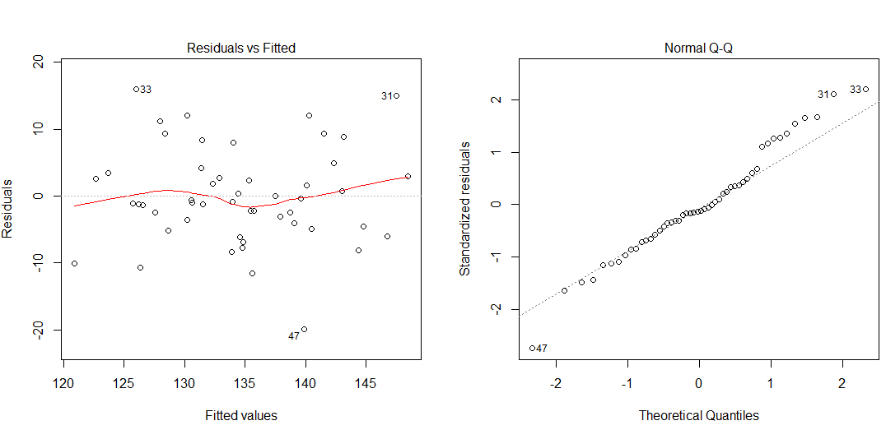
The linear regression correctly determined that age, sex, and BMI were all statistically significant (p < 0.05) factors in the determination of blood pressure. It showed that sex affected blood pressure by approximately 8 mmHg, significantly higher than the average change in blood pressure applied due to sex in the construction of the data, which was 5 mmHg, but not of range of what it theoretically could be, 10 mmHg. The regression shows that BMI has a stronger effect (per unit) than age (per year) on blood pressure, which is consistent with how the data was generated.

The Residuals vs. Fitted graph doesn't show evidence of a non-linear effect in the data, which makes sense because the data was not generated in such a way where that should be the case. The Normal Q-Q graph shows that the residuals are close to normally distributed. The rise near the right side suggests that the data is somewhat right skewed, which might call for some rewriting of the analysis, but in this case (because the data was generated) we already know that the deviation is just sample variance, because all of the other variance in the generation of the data has been accounted for.

