Homework 2, TSCI 5050
Alex F. Bokov, bokov@uthscsa.edu
Due Tuesday, February 16th 20016

Student Name:____You Zhou_____________________________

This homework is graded pass/fail and cooperation is encouraged. Please check the homework into the GitHub repo before the next class, but you can revise and resubmit.

Part 1.
Work through this tutorial... https://www.sqlteaching.com/
Each time you get a “Congrats! That is correct!”, paste the code you used on a separate line below.
SELECT * FROM family_members;
SELECT * FROM family_members WHERE species = 'dog';
SELECT * FROM family_members WHERE salary > 56000;
SELECT * FROM family_members WHERE salary >=55000;
SELECT name, species FROM family_members;
SELECT * FROM friends_of_pickles WHERE height_cm < 45 AND species = 'dog';
SELECT * FROM friends_of_pickles WHERE height_cm < 45 OR species = 'dog';
SELECT * FROM friends_of_pickles WHERE species NOT IN ('cat', 'dog');
SELECT DISTINCT species FROM friends_of_pickles WHERE height_cm >50;
SELECT * FROM friends_of_pickles ORDER BY height_cm DESC;
SELECT * FROM friends_of_pickles ORDER BY height_cm DESC LIMIT 1;
SELECT COUNT(*) FROM friends_of_pickles;
SELECT COUNT(*) FROM friends_of_pickles WHERE species = 'dog';
SELECT SUM(salary) FROM family_members;
SELECT AVG(salary) FROM family_members;
SELECT MAX(salary) FROM family_members;
SELECT MAX(height_cm), species FROM friends_of_pickles GROUP BY species;
SELECT * FROM family_members WHERE salary = (SELECT MAX(salary) FROM family_members);
SELECT * FROM family_members WHERE favorite_book IS NOT NULL
SELECT * FROM celebs_born WHERE birthdate > '1980-09-1';
SELECT character.name, character_actor.actor_name
FROM character
INNER JOIN character_actor
ON character.id = character_actor.character_id;
SELECT character.name, actor.name
FROM character
INNER JOIN character_tv_show
ON character.id = character_tv_show.character_id
INNER JOIN character_actor
ON character_tv_show.character_id = character_actor.character_id
INNER JOIN actor
ON actor.id = character_actor.actor_id;
SELECT character.name, tv_show.name
FROM character
INNER JOIN character_tv_show
ON character.id = character_tv_show.character_id
INNER JOIN tv_show
ON character_tv_show.tv_show_id = tv_show.id WHERE character.name != 'Willow Rosenberg' AND tv_show.name != 'How I Met Your Mother';
SELECT character.name, actor.name
FROM character
LEFT JOIN character_actor
ON character.id = character_actor.character_id
LEFT JOIN actor
ON character_actor.actor_id = actor.id;
SELECT c.name, a.name
FROM character AS c
LEFT JOIN character_actor AS ca
ON c.id = ca. character_id
LEFT JOIN actor AS a
ON ca.actor_id = a.id;
SELECT character.name AS character, actor. name AS actor
FROM character
LEFT JOIN character_actor
ON character.id = character_actor.character_id
LEFT JOIN actor
ON character_actor.actor_id = actor.id;
SELECT r1.name AS employee_name, r2.name AS boss_name
FROM employees AS r1
INNER JOIN employees AS r2
ON r1.boss_id = r2.id;
SELECT * FROM robots WHERE name LIKE "%Robot 20__%";
SELECT *,
CASE WHEN species = 'human' THEN "talk" WHEN species = 'dog' THEN "bark"
ELSE "meow" END AS sound
FROM friends_of_pickles;
SELECT * FROM robots WHERE SUBSTR(location, -2) LIKE 'NY';
SELECT name, COALESCE(tank, gun, sword) as weapon FROM fighters;

Part 2.
Export the data you are using in your own research to a .csv file. Then follow the instructions in “SQLite Data Import.doc” handout (should be in the same directory as this homework).
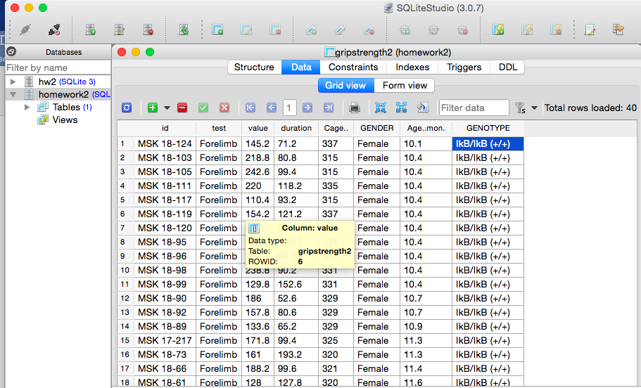
Part 3.
Please answer the following questions. If some questions are impossible to answer with your data, instead of answering try to articulate what about the data makes them impossible to answer.

3.1: How many different groups of subjects (mice, patients, tissue samples, whatever) do you have? What column or columns distinguish the groups from each other? Below this question, try writing a SQL query to count the number of rows belonging to each group, and test your query in SQLiteStudio.
I have two groups of mice. WT and MISR mice. The GENOTYPE colomn distinguish the groups from each other.
SELECT COUNT(GENOTYPE) AS WT_NO FROM gripstrength2
WHERE GENOTYPE='IkB/IkB (+/+)';
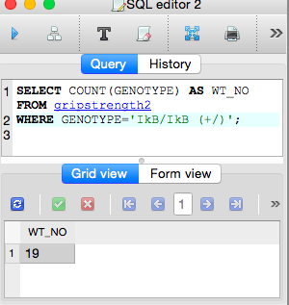
SELECT COUNT(GENOTYPE) AS WT_NO FROM gripstrength2
WHERE GENOTYPE='MISR/IkB (+/+)';
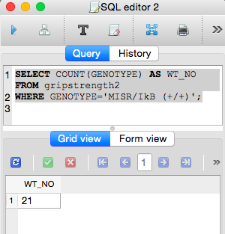

3.2: What column or columns do you consider to be your response (a.k.a. dependent variables)? Below this question, try writing a SQL query to output the average, maximum, and mininum on the columns of your choise, broken up by group (as you described your grouping structure above). Test your query in SQLiteStudio.
The value column I consider is my reponse.
SELECT MAX(value)
FROM gripstrength2
GROUP BY GENOTYPE

SELECT MIN(value)
FROM gripstrength2
GROUP BY GENOTYPE

SELECT AVG(value)
FROM gripstrength2
GROUP BY GENOTYPE

3.3: Is each subject measured only once? If no, when are they measured? Before and after treatment? Over a series of regular followups? Irregular followups? In no particular order, just a bunch of replicate measurements on the same subject?

Yes, the subjects are all measured only once.

3.4: Are some variables in your data only allowed to have a few discrete, predefined values? Which ones are they? Can you think of a SQL query that will help you identify (and maybe even count) typos in these variables that cause them to have disallowed values?
No. The grip strength may very in each individuals so there is no predefined values.

