Aerial 5G Matlab Model - nrSim

User Guide (V1.1)


Documentation Control
Item | Description
Title
Author(s)
Revision
State
Approver list
Reviewer list
Reviewed In

Revision History
Date | Author(s) | Summary of Change
03/01/2021 | Xiangguo Tang | Initial version (V0.1)
06/01/2021 | Xiangguo Tang | Aerial 21-2 release (V1.0)
12/01/2021 | Xiangguo Tang | Aerial 21-4 release (V1.1)  - Add captured sample analysis  - Add UE receiver

TABLE OF CONTENTS

1 Introduction 2
1.1 Purpose and Scope 2
1.2 References 2
2 nrSim Overview 3
2.1 nrSim Architecture 3
2.2 nrSim Features 3
2.2.1 Waveform Compliance Test 4
2.2.2 Test Vector Generation 4
2.2.3 Captured Sample Analysis 5
2.2.4 PHY Performance Simulation 5
3 nrSim Configuration 6
3.1 testAlloc configuration 6
3.2 Carrier and Slot Related Configuration 7
3.3 Chan Configuration 7
3.4 SimCtrl Configuration 7
4 nrSim Usage 10
4.1 Source code and Matlab environment preparation 10
4.2 External Configuration Mode (runSim) 11
4.3 Internal Configuration Mode (runRegression) 11

Introduction

Purpose and Scope

The purpose of this document is to provide an overview and usage guide for Aerial 5G Matlab model – nrSim. The detailed design of nrSim is not covered in this document.

Section 2 describes nrSim architecture and key features. Section 3 lists the important configuration parameters for nrSim. Section 4 provides usage guide to run nrSim in two different configuration modes.

References

- Small Cell Forum, 5G FAPI: PHY API, March 2020
- O-RAN Fronthaul Working Group, Control, User and Synchronization Plan Specification, O-RAN.WG4.CUS.0-v03.00
- 3GPP TS 38.141-1 (V15.4.0): Base Station (BS) conformance testing Part 1: Conducted conformance testing

nrSim Overview

nrSim is a software written in Matlab to serve as a reference model for Aerial cuBB design and verification, which covers from L1/L2 FAPI interface (ref-1) to O-DU/O-RU FH interface (ref-2).

nrSim Architecture

The core of nrSim is the simulation engine nrSimulator.m, which includes Matlab models for gNB transmitter and receiver, MIMO fading channel and UE transmitter and receiver. nrSimulator.m can be called by runSim.m with external configuration mode or by runRegression.m through testPerformance.m and testCompGenTV.m with internal configuration mode.

nrSim Features

To support Aerial cuBB design and verification, nrSim provides four major features: waveform compliance test, test vector generation, captured samples analysis and PHY performance simulation.

Waveform Compliance Test

The purpose of waveform compliance test is to make sure our understanding of 3GPP standards regarding signal waveform generation is correct. It is achieved by checking nrSim generated signal against Matlab 5G Toolbox generated signal.

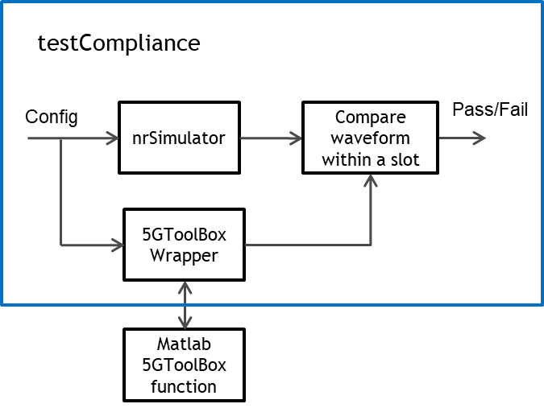

Test Vector Generation

nrSim can generate test vectors for L2/L1 FAPI PDU, cuPHY channel pipeline API parameters, cuPHY channel pipeline output and the compressed samples in a slot.

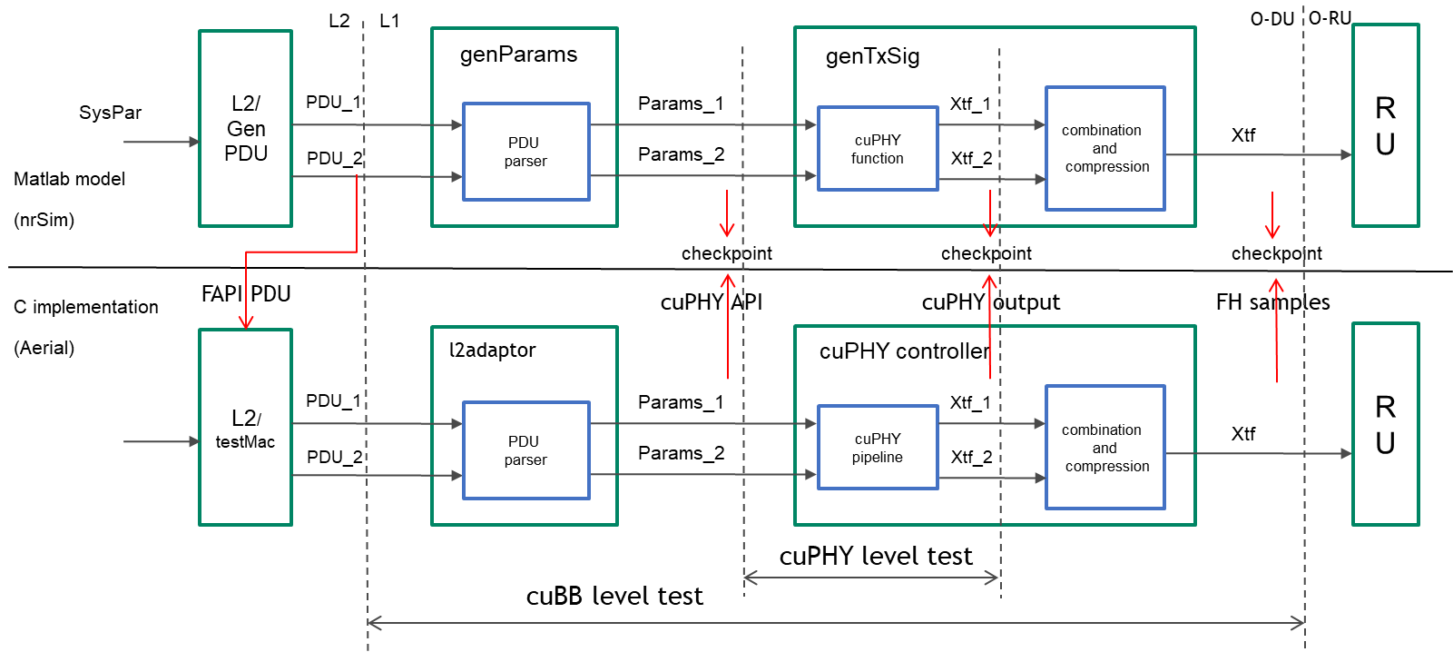

Two types of test vectors will be generated for each test case configuration.
- FAPI test vector including FAPI PDU for all the channels in this slot and FH compressed samples for this slot. There is only one FAPI TV per slot.
- cuPHY test vector including cuPHY parameters and input/output for a cuPHY channel pipeline call. There can be multiple cuPHY TVs per slot.

Captured Sample Analysis

Captured samples from FH (fronthaul) between O-DU and O-RU can be feed into nrSim for RX detection and signal quality analysis. The samples can be compressed or un-compressed.

PHY Performance Simulation

The purpose of this test is to make sure that Aerial PHY performance can meet 3GPP requirement by checking nrSim performance simulation results with the same channel condition and test configuration specified by the 3GPP standard (ref-3).

nrSim Configuration

The input to the simulation engine nrSimulator.m is a single data structure SysPar, which includes all the 3GPP related configurations and simulation control related configurations. The outputs of nrSimulatior include SysPar, UE (array of structures for all UEs) and gNB (structure for gNB).

[SysPar, UE, gNB] = nrSimulator(SysPar)

Matlab functions listed in the table below generate the default configuration for the parameters in SysPar.

Data structure | Field | Description | Matlab function for default configuration
SysPar | testAlloc | Specify DL/UL direction and the number of each type of channels allocated for the slot | initSysPar
 | carrier | Specify carrier level configuration | cfgCarrier
 | ssb | Specify SSB configuration | cfgSsb
 | pdcch | Specify PDCCH channel configuration | cfgPdcch
 | pdsch | Specify PDSCH channel configuration | cfgPdsch
 | csirs | Specify CSIRS channel configuration | cfgCsirs
 | prach | Specify PRACH channel configuration | cfgPrach
 | pucch | Specify PUCCH channel configuration | cfgPucch
 | pusch | Specify PUSCH channel configuration | cfgPusch
 | srs | Specify SRS channel configuration | cfgSrs
 | Chan | Specify MIMO fading channel configuration | cfgChan
 | SimCtrl | Specify Simulation control parameters | cfgSimCtrl

testAlloc configuration

Data structure | Field | Description
testAlloc | dl | Enable DL test
 | ul | Enable UL test
 | ssb | Enable SSB allocation
 | pdcch | Number of PDCCH channels in a slot
 | pdsch | Number of PDSCH channels in a slot
 | csirs | Number of CSIRS channels in a slot
 | prach | Number of PRACH channels in a slot
 | pucch | Number of PUCCH channels in a slot
 | pusch | Number of PUSCH channels in a slot
 | srs | Number of SRS channels in a slot

Carrier and Slot Related Configuration

SysPar definition for 3GPP carrier and slot configuration with each channel is mostly based on SCF-FAPI specification (ref-1).

Chan Configuration

This Chan configuration refers to MIMO fading channel model.

Data structure | Field | Description
Chan | Type | ‘AWGN’, ‘TDLx-xx-xxx’ (3GPP MIMO fading channel)
 | SNR | Channel SNR in dB
 | Delay | Channel propagation delay in second
 | CFO | Carrier frequency offset in Hz
 | Use5Gtoolbox | Use 5GToolbox to generate fading channel model
 | gain | Reserved

SimCtrl Configuration

Data structure | Field | Sub-field | Description
SimCtrl | N_UE |  | Number of UEs
 | N_frame |  | Number of frames per run
 | N_slot_run |  | Number of slots in a frame to run. (0: run all slots in a frame)
 | timeDomainSim |  | Enable time domain simulation (required for applying fading channel model, delay and CFO)
 | prachFalseAlamTest |  | Reserved
 | puschHARQ |  | Reserved
 | plotFigure | tfGrid | Plot time/freq domain signal
 |  | constellation | Plot constellation before and after equalizer
 | genTV | enable | Enable TV generation at gNB side
 |  | enableUE | Enable TV generation at UE side
 |  | tvDirName | Name for TV directory
 |  | cuPHY | Enable cuPHY TV in h5 format
 |  | FAPI | Enable FAPI TV in h5 format
 |  | fhMsgMode | Reserved
 |  | FAPIyaml | Enable FAPI TV in yaml format
 |  | slotIdx | Indices of slots on which TV will be generated
 |  | forceSlotIdxFlag | Force slot index = slotIdx(1) for every slot
 |  | bypassComp | Bypass FH sample compression
 |  | idx | Reserved
 |  | TVname | Prefix for the name of TVs
 |  | polDbg | Reserved
 | oranComp |  | Reserved
 | alg | enableRssiMeas | Enable RSSI measurement for PUSCH
 |  | enableRsrpNvSinrMeas | Enable RSRP, noise cariance and SINR measurement for PUSCH
 |  | enableSinrMeas | Enable SINR measurement for PUSCH
 |  | enableIrc | Enable MMSE-IRC for PUSCH
 |  | enableCfoEstimation | Enable CFO estimation for PUSCH
 |  | enableCfoCorrection | Enable CFO correction for PUSCH
 |  | enableToEstimation | Enable Timing Offset estimation for PUSCH
 |  | enableToCorrection | Enable Timing Offset correction for PUSCH
 |  | TdiMode | Enable time domain CEE interpolation
 | delaySpread |  | Reserved
 | fp16AlgoSel |  | 0: Use half function (Matlab fixed point toolbox required)  1: Use vpf16 function (Matlab fixed point toolbox not required)
 | forceRxZero |  | Reserved
 | useCuphySoftDemapper |  | Reserved
 | checkSrsHestErr |  | Reserved
 | forceCsiPart2Length |  | Reserved
 | capSamp | enable | Enable captured sample analysis
 |  | fileName | Captured sample file name
 |  | isComp | Sample is compressed or not
 | enableUeRx |  | Enable UE RX
 | enableDlTxBf |  | Reserved
 | result |  | Reserved

nrSim Usage

For different test and simulation purpose, nrSim provides two modes to change the configurations and run the Matlab model.
- External configuration mode (runSim): This mode is to use an external configuration file in yaml format to update the parameters. nrSim will read this yaml configuration file and set the SysPar parameters accordingly. It is recommended that non matlab developer uses this mode to generate test vectors or perform captured sample analysis which requires no change to the Matlab code.

- Internal configuration mode (runRegression): This mode is to change the SysPar parameters directly in the Matlab code between initSysPar and nrSimulator. Matlab developer can pre-define a set of configuration used by compliance test, test vector generation and PHY performance simulation. Multiple runs can be performed in this mode with different configurations.

Source code and Matlab environment preparation

Source code:
- https://gitlab-master.nvidia.com/gputelecom/5GModel/-/tree/develop/nr_matlab

Matlab version:
- R2020a or later

Matlab licenses:
- MATLAB
- Communications Toolbox
- DSP System Toolbox
- Signal Processing Toolbox
- Fixed-Point Designer (optional)
  - Call half function to accelerate testing/simulation
  - Can be disabled by setting SimCtrl.fp16AlgoSel = 1
- Parallel Computing Toolbox (optional)
  - Accelerate testing/simulation automatically
- 5G Toolbox
  - Optional for TV generation (disabled by setting Chan.use5Gtoolbox = 0)
  - Required for waveform compliance test, captured sample analysis and performance simulation

Preparation:
- After download the source code, launch Matlab on the directory of nr_matlab and run startup to add all sub-directories into Matlab search path.

External Configuration Mode (runSim)

- Find the yaml configuration template file cfg_template.yaml under nr_matlab. If it is missing, run genCfgTemplate to generate it.
- Use a text editor to change the parameters in the yaml file. Basically cfg_template.yaml is a yaml (text) version of SysPar data structure. Please refer to section 3 for the description of SysPar parameters. After change is done, save it to another file name, for example, cfg_test.yaml.
- Run runSim(cfg_filename, tv_filename) to generate test vector, for example, runSim(‘cfg_test.yaml’, ‘my_test’). nrSim will read cfg_test.yaml file, update SysPar accordingly, run nrSimulator and generate test vector files with name starting with my_test. The generated TV files are stored under the folder named by SysPar.SimCtrl. tvDirName, for example, GPU_test_input.
- Run runSim(cfg_filename, tv_filename, captured_filename) to perform captured sample analysis. The configuration in cfg_filename should match with the configuration of the captured samples in captured_filename.

Notes:
- This mode only supports test vector generation and captured sample analysis. It does not support waveform compliance test and PHY performance test.
- If SimCtrl.plotFigure.tfGrid is set to 1, the time/freq signal in a frame or the specified number of slots in a frame (controlled by N_slot_run) can be plotted to provide visualized channel allocations.
- Non Matlab developer can write script in any language to modify the yaml template file and automatically generate a number of different yaml configuration files for different testing purpose.

Internal Configuration Mode (runRegression)

Instead of updating configuration through the external yaml configuration file case by case, the internal configuration mode changes SysPar parameters directly inside the Matlab code, which allows Matlab developer to define and execute a batch of test cases more efficiently. The main function for this mode is runRegression, which supports a flexible combination of testSet, channelSet and caseSet as the input arguments.

runRegression(testSet, channelSet, caseSet)

 | Values | Value selection
testSet | ‘Compliance’, ‘TestVector’, ‘Performance’, ‘allTests’ | Multiple
channelSet | ‘ssb’, ‘pdcch’, ‘pdsch’, ‘csirs’, ‘dlmix’, ‘allDL’, ‘prach’, ‘pucch’, ‘pusch’, ‘srs’, ‘ulmix’, ‘allUL’, ‘allChannels’ | Multiple
caseSet | ‘full’, ‘compact’, ‘selected’ | Single

Here are some example commands.
- Full regression test for all channels with full caseSet
runRegression({'allTests'}, {'allChannels'}, 'full')
- Test vector generation for all channels with compact caseSet
runRegression({'TestVector'}, {‘allChannels’}, 'compact')
- PHY performance simulation for PRACH channel
runRegression({'Performance'}, {'prach'}, 'full')

The test cases for each channel are defined in the Matlab file testCompGenTV_xxxx.m, where xxxx is the channel name. Matlab developer can modify the Matlab file to create and assign test cases for full set, compact set and selected set.
- full set includes all the test cases which can be generated by nrSim and pass waveform compliance test against 5G Toolbox.
- compact set includes a subset of full set test cases which are supported by cuPHY implementation. TVs from Compact set can be used for nightly CICD regression test.
- selected set includes a subset of compact set test cases which are essential for cuPHY verification. TVs from Selected set can be used for merge request (MR) CICD regression test.

Notes:
- testCompGenTV_dlmix and testCompGenTV_ulmix supports multi-channel multi-slot TV generation without waveform compliance check.
- testPerformance_prach, testPerformance_pusch and testPerformance_pucch support PHY performance test for PRACH (format 0/B4), PUSCH (data/UCI) and PUCCH (format 0/1/2/3).

Below is an example of full regression test summary with Matlab command
runRegression({‘allTests’}, {'allChannels'}, 'full')

