Cloudburst Risk Prediction System
Power BI Dashboard Build Guide | Uttarakhand, India
This document is the step-by-step recipe for assembling the production Power BI dashboard that consumes the dataset produced by the ML pipeline. It covers data import, the data model, recommended DAX measures, page layouts, slicers, and a custom dark theme aligned with the Streamlit GUI.
1. Inputs Provided by the Pipeline
After running the Python pipeline, the following file is the single source of truth for Power BI:
- data/powerbi_dataset.csv - 513 rows, 23 columns, one row per (location x date).
Column reference:
Column | Type | Description
Date | Date | Observation date
Year, Month, MonthName, Season | Calendar | Pre-built calendar attributes
Location | Text | Site name (e.g., 'Kedarnath (Rudraprayag)')
District | Text | Uttarakhand district
Latitude, Longitude | Decimal | Geo coordinates for the map visual
PRECTOT | Decimal | Daily rainfall, mm/day
T2M, RH2M, WS2M | Decimal | Temp (degC), humidity (%), wind speed (m/s)
Rainfall_Intensity | Whole # | Bucket 0-5 (trace ... extreme)
Humidity_Rainfall | Decimal | Interaction feature
Heat_Index | Decimal | Apparent-temperature proxy
Cloudburst | Whole # | Ground-truth label (0 / 1)
Predicted_Probability | Decimal | Model-output probability [0..1]
Predicted_Cloudburst | Whole # | 0/1 at tuned threshold
Risk_Level | Text | Low / Medium / High
2. Importing the Data
2.1 Get Data > Text/CSV
- Open Power BI Desktop and select Home > Get data > Text/CSV.
- Browse to data/powerbi_dataset.csv and click Open.
- In the preview, click Transform Data to open Power Query.
2.2 Power Query cleanup
- Set Date column type = Date.
- Set Latitude / Longitude type = Decimal Number; mark them with Data Category = Latitude / Longitude.
- Set PRECTOT, T2M, RH2M, WS2M, Humidity_Rainfall, Heat_Index, Predicted_Probability = Decimal Number.
- Set Year / Month / Cloudburst / Predicted_Cloudburst / Rainfall_Intensity = Whole Number.
- Right-click MonthName and select Sort By Column > Month so calendar slicers stay ordered.
- Click Close & Apply.
3. Data Model
3.1 Add a calendar table
Create a Date dimension so time intelligence works correctly. Modeling > New table:
Calendar = ADDCOLUMNS (
CALENDAR ( DATE(1990, 1, 1), DATE(2026, 12, 31) ),
"Year", YEAR ( [Date] ),
"Month", MONTH ( [Date] ),
"MonthName", FORMAT ( [Date], "MMM" ),
"Quarter", "Q" & QUARTER ( [Date] ),
"MonthYear", FORMAT ( [Date], "MMM yyyy" )
)
Mark this table as date table (Modeling > Mark as date table > Date).
3.2 Relationships
From | To | Cardinality | Direction
Cloudburst[Date] | Calendar[Date] | Many-to-One | Single
All other dimensions (Location, District, Risk_Level) live inside the fact table for a simple star-shape that is easy to slice.
4. DAX Measures
Create the following measures inside a new measure table called Measures.
Total Events
Total Events = SUM ( cloudburst_dataset[Cloudburst] )
High Risk Areas
High Risk Areas = CALCULATE ( DISTINCTCOUNT ( cloudburst_dataset[Location] ),
cloudburst_dataset[Risk_Level] = "High" )
Avg Rainfall (mm)
Avg Rainfall (mm) = AVERAGE ( cloudburst_dataset[PRECTOT] )
Max Daily Rainfall
Max Daily Rainfall = MAX ( cloudburst_dataset[PRECTOT] )
Predicted Risk Pct
Predicted Risk Pct = AVERAGE ( cloudburst_dataset[Predicted_Probability] ) * 100
Cloudburst Rate
Cloudburst Rate = DIVIDE ( SUM ( cloudburst_dataset[Cloudburst] ),
COUNTROWS ( cloudburst_dataset ) )
Events YoY %
Events YoY % = VAR thisYear = [Total Events]
VAR lastYear = CALCULATE ( [Total Events], DATEADD ( 'Calendar'[Date], -1, YEAR ) )
RETURN DIVIDE ( thisYear - lastYear, lastYear )
Monsoon Events
Monsoon Events = CALCULATE ( [Total Events],
cloudburst_dataset[Season] = "Monsoon" )
5. Report Pages & Visuals
5.1 Page 1 - Executive Overview
Goal: a single glance answer to 'are we at risk?'
- Card: Total Events
- Card: High Risk Areas
- Card: Avg Rainfall (mm)
- Card: Cloudburst Rate (formatted as %)
- Filled Map (visual: Map): Location field on Latitude / Longitude, Bubble size = [Total Events], Colour saturation = [Predicted Risk Pct].
- Stacked column: Year on X, [Total Events] on Y, legend = Risk_Level.
- Slicers (top of page): District, Year, Risk_Level.
5.2 Page 2 - Rainfall vs Cloudbursts
- Scatter chart: PRECTOT (X-axis), RH2M (Y-axis), legend = Cloudburst, size = Predicted_Probability.
- Add a constant line at PRECTOT = 100 mm (Format > Analytics > Constant line).
- Line chart: MonthName (X), [Avg Rainfall (mm)] (line), [Total Events] (column on secondary axis).
5.3 Page 3 - District Risk Analysis
- Matrix visual: Rows = District, Columns = MonthName, Values = [Total Events]. Apply conditional formatting > Background color > rules: 0 = #052035, >5 = #ef4444.
- Donut: Risk_Level vs [Total Events].
- Treemap: Location vs [Total Events] - quickly shows which sites dominate.
5.4 Page 4 - Feature Impact
- Bar chart of feature importances. Use a small Python script visual (or import models/metadata.json into Power BI as a separate table) to plot Feature vs Importance. The columns are exposed in the JSON under feature_importance.
- Decomposition tree: Analyze [Total Events], Explain by District, then Season, then Risk_Level.
6. Slicers, Filters and Theme
6.1 Page-level slicers (recommended on every page)
- District (dropdown).
- Year (between, range slider).
- Risk_Level (tile slicer with the three values).
6.2 Custom theme
View > Themes > Browse for themes - point to powerbi_theme.json shipped alongside this guide.
The palette is calibrated to match the Streamlit GUI:
Token | Hex | Use
Background | #0B1424 | Page canvas
Surface | #10223F | Card backgrounds
Primary | #2563EB | Charts (positive, neutral)
Accent | #06B6D4 | Lines, highlights
Warning | #F59E0B | Medium risk
Danger | #EF4444 | High risk / cloudburst
Success | #10B981 | Low risk
7. Refresh and Operations
- Re-run the pipeline (data_pipeline.py + train_model.py) on a schedule (daily during monsoon, weekly otherwise).
- In Power BI Desktop, hit Home > Refresh after the CSV updates.
- If you publish to the Power BI Service, configure a Personal Gateway pointing at the data/powerbi_dataset.csv path and schedule refresh.
8. Appendix - Sample Visual Reference
The five charts below are produced by visualizations.py and mirror the Power BI visuals - useful both as a visual specification and as a fallback for offline reports.
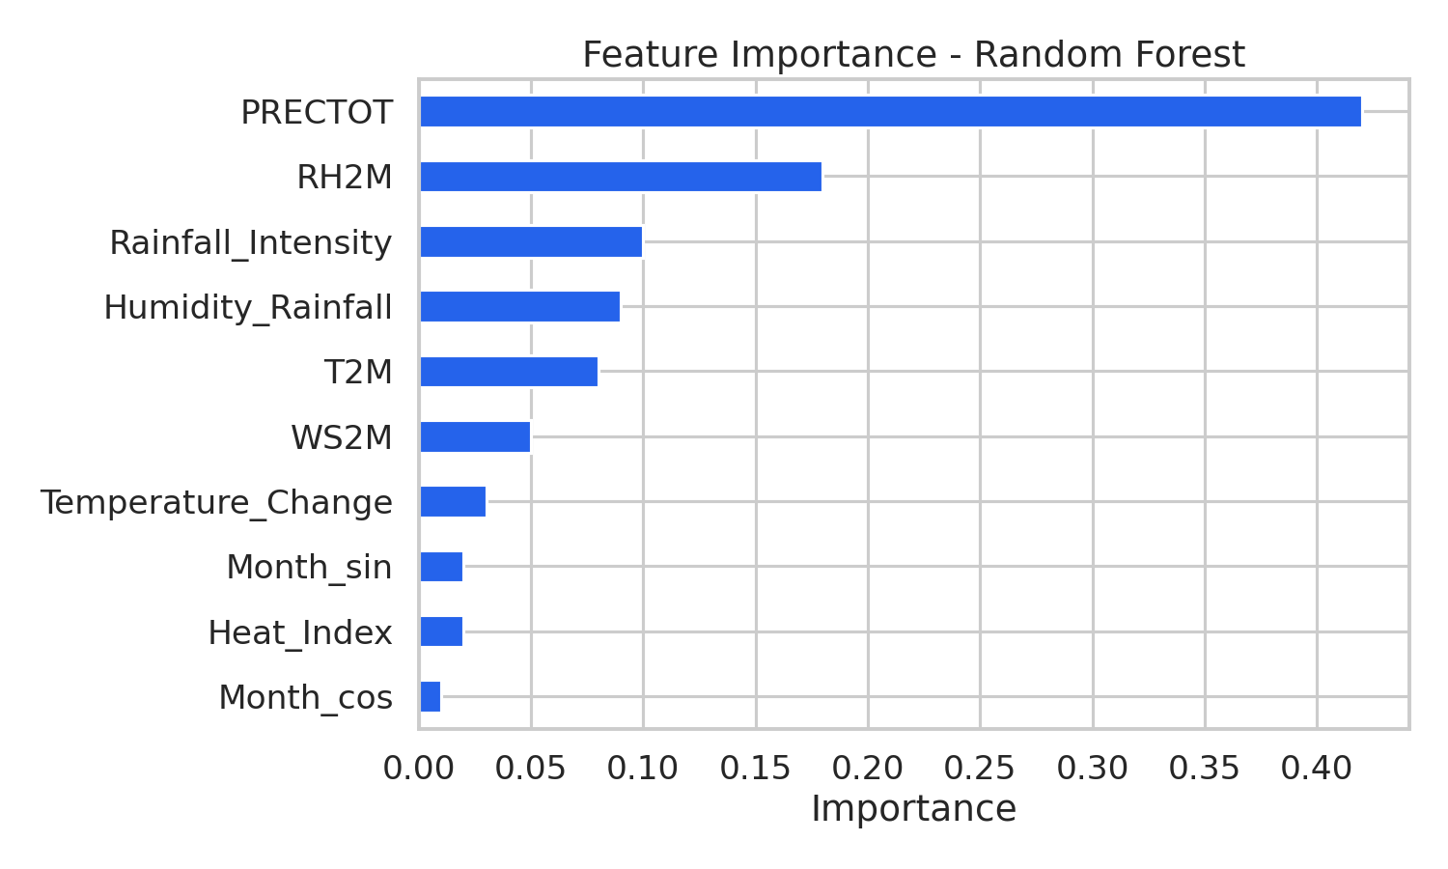
A. Random Forest feature importance.
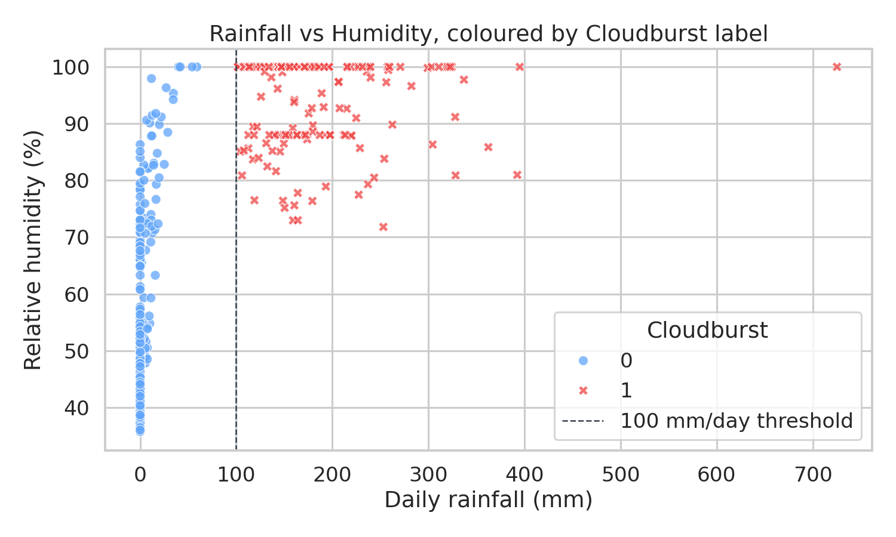
B. Rainfall vs humidity, coloured by label.
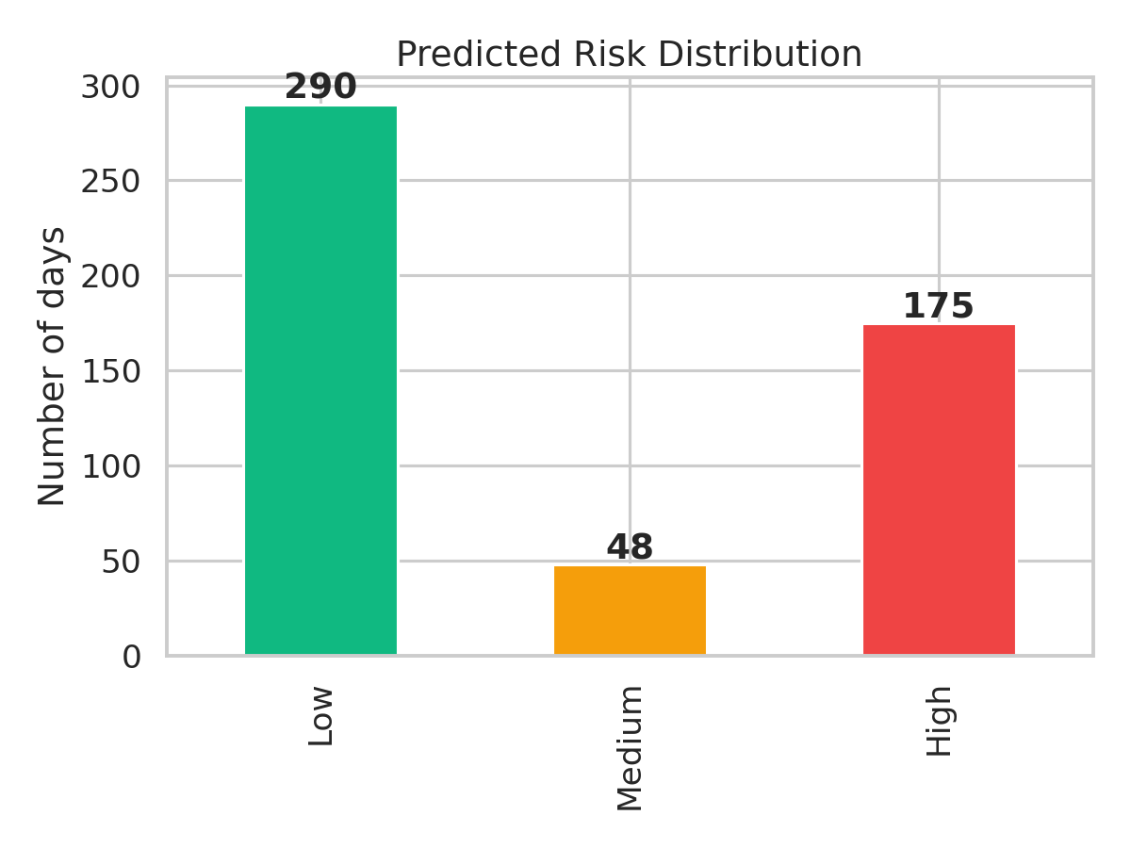
C. Predicted risk distribution.
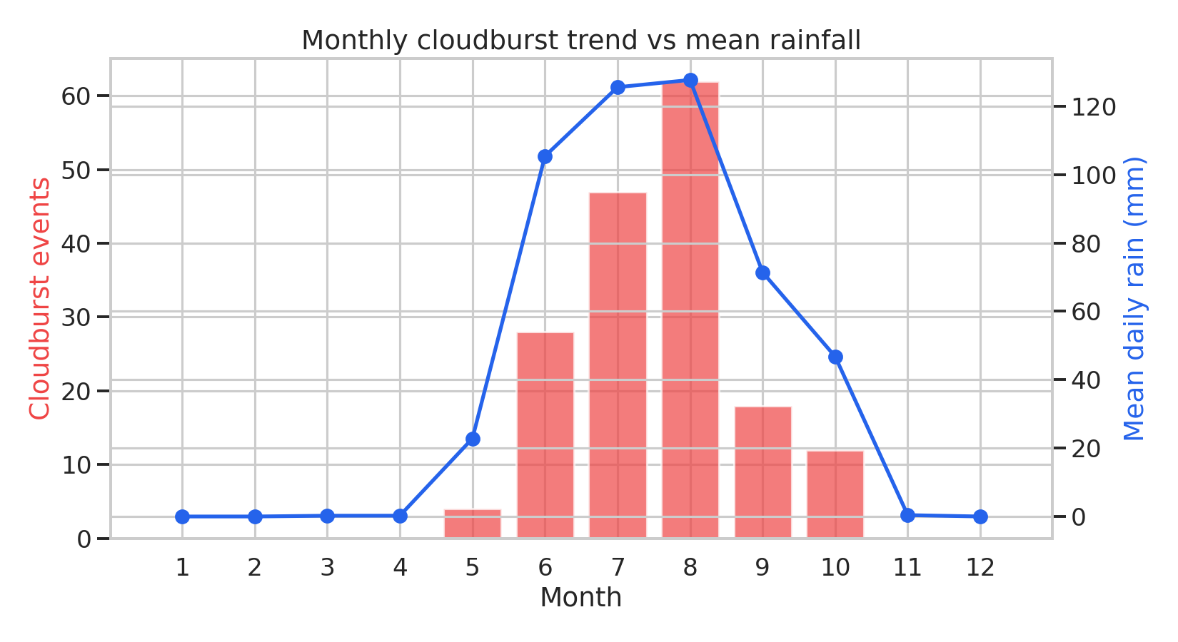
D. Monthly cloudburst trend vs mean rainfall.
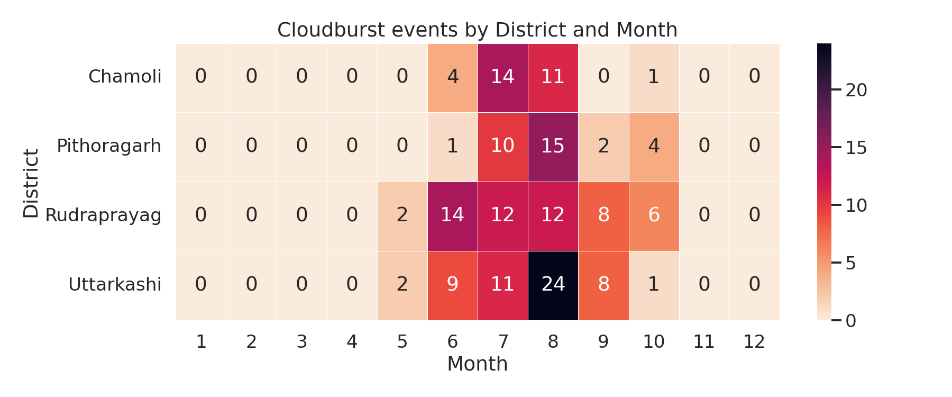
E. Cloudburst events by district & month.

