Project Report on

Interactive Web Design: Landing Page

Submitted

In Partial Fulfillment of

BACHELOR OF COMPUTER APPLICATIONS (BCA)

Submitted by:

Name: Utkarsh Kumar

Roll No: 23/SCA/BCA(CS)/037

Under the Supervision of:

(Dr. Aastha)



School of Computer Applications

Manav Rachna International Institute of Research and Studies (DEEMED TO BE UNIVERSITY)

Sector-43, Aravalli Hills Faridabad— 121001

July 2025

Annexure 2

Declaration

I do hereby declare that this project work entitled “Front end Web-development” submitted by me for the partial fulfillment of the requirement for the award at **BACHLOR OF COMPUTER APPLICATIONS** is a record of my own work. The report embodies the finding based on my study and observation and has not been submitted earlier for the award of any degree or diploma to any Institute or University.

SIGNATURE

Name: Utkarsh Kumar

Roll No: 23/BCA(CS)/037

Date: 18/07/2025

Annexure 3

**Certificate from the Guide**

This is to certify that the project report entitled “Web-development” submitted in partial fulfillment of the degree of **BACHLOR OF COMPUTER APPLICATIONS** to Manav Rachna International Institute of Research and Studies, Faridabad is carried out by Mr. Utkarsh Kumar (Roll No), 23/SCA/BCA(CS)/035 under my guidance.

**Signature of mentor**

Name: Aastha

Date: 18 July 2025

**Head of Department**

Name: Prof. (Dr.) Suhail Javed Quraish

Date:18th July 2025

**ACKNOWLEDGEMENT**

I gratefully acknowledge for the assistance, cooperation, guidance and clarification provided by **Mr.** **Vir Malhotra** during the development of the project. My extreme gratitude to **Dr. Raj Kumar**, Associate Professor & TPO who guided us throughout the project. Without his willing disposition, spirit accommodation, frankness, timely clarification and above all faith in us, this project could not have been completed in due time. His readiness to discuss all important matters at work deserves special attention of.

I would like to extend my sincere gratitude **to Prof. (Dr.) Suhail Javed Quraishi – HOD, Prof. (Dr.) Rashmi Agrawal – Associate Dean and Prof. (Dr.) Brijesh Kumar – Dean** for their valuable teachings and advice. I want to thank all the department faculty members for their cooperation and support. I want to thank non-teaching staff of the department for their cooperation and support.

This opportunity is a big milestone in my career development. I will strive to use gained skills and knowledge in the best possible way, and I will continue to work on their improvement, to attain desired career objectives. I hope to continue cooperation with all of you in the future.

Table of Content

|  |  |  |  |  |
| --- | --- | --- | --- | --- |
| Sno. | Topic | Page no. | Signature | Remarks |
| 1. | Introduction   1. About Organization 2. Aims & Objectives 3. Manpower | 4 - 8 |  |  |
| 2. | System Study   1. Existing System along with limitations 2. Proposed System along with advantages | 9-10 |  |  |
| 3. | Feasibility Study   1. Technical 2. Behavioural 3. Economic | 11 - 13 |  |  |
| 4. | Project Monitoring System   1. Gantt Chart | 14 - 15 |  |  |
| 5. | System Analysis   1. Requirement Specification 2. System Flowcharts 3. DFDs /ERDs (tip to Level 2) | 16-24 |  |  |
| 6. | System Design   1. File/ Data Design | 25-27 |  |  |
| 7. | Input / Output Form Design   1. Screen Design | 28-34 |  |  |

2

|  |  |  |  |  |
| --- | --- | --- | --- | --- |
|  | b) Report Design |  |  |  |
| 8 | System Testing   1. Preparation o1‘Test Data 2. Testing With Live Data 3. Test Cases with results | 35-41 |  |  |
| 9. | System Implementation   1. System Requirements | 42-44 |  |  |
| 10. | Documentation | 45-46 |  |  |
| 11. | Scope of the Project | 47-49 |  |  |

# INTRODUCTION

### About Origination

**Appletree Building Maintenance**, based in Gurgaon, Haryana, is recognized for its commitment to developing future professionals in the infrastructure sector. The company specializes in sand mining and gravel production and offers interns a solid platform to gain industry-relevant experience. On successful completion of tasks, interns receive certificates acknowledging their contributions.

During my internship at **Appletree Building Maintenance**,I worked on two core projects that expanded both my technical knowledge and real-world understanding. The first task involved building a **landing page** for the company using HTML, CSS, and JavaScript. While the company operates in a traditional industry, this project was about enhancing their digital visibility. I focused on a clean, responsive design that clearly presented their services and values to potential clients and partners.

The second project was to develop a to-do list application using HTML, CSS, JavaScript, and Python. Though it sounds simple, it had real utility for the internal team—helping them organize tasks, track progress, and manage daily workflow more efficiently. I handled both front-end and back-end integration, using Python for the backend logic and JavaScript for interactivity. This taught me how basic tech solutions can make a difference even in industries like mining.

The team at **Appletree Building Maintenance** was extremely supportive. Their practical insights into operations, logistics, and project coordination helped me see how technology and traditional industries can work together. I faced challenges, but the collaborative environment pushed me to adapt and solve problems faster, improving both my confidence and skill set.

Overall, this internship was a game-changer. It gave me hands-on experience, boosted my problem-solving abilities, and showed me the real-world impact of tech in non-tech domains. I’m grateful for the chance to be part of Annanya Infratech and excited to carry these learnings into my future work.

**Aim & objectives**

**Task 1: Simple Landing Page using HTML, CSS, and JavaScript**

**AIM:**

To design and develop a simple, responsive, and visually appealing landing page using HTML, CSS, and JavaScript that effectively communicates the intended message and engages users.

### Objectives:

1. **Learn and Apply Web Development Fundamentals:**
   * Understand the structure of HTML documents and create accessible web pages.
   * Use CSS for styling, ensuring an attractive layout across devices.
   * Implement JavaScript to add interactive elements and enhance user experience.

### Create a User-Friendly Interface:

* + Design an intuitive interface guiding users towards desired actions.
  + Integrate fonts, colors, and images harmoniously for an aesthetically pleasing design.

### Implement Responsive Design:

* + Ensure the landing page looks and functions well on various screen sizes and devices.
  + Test across different browsers and devices for compatibility and seamless experience.

### Optimize for Performance and Accessibility:

* + Optimize for fast loading times by minimizing large images and external resources.
  + Follow web accessibility guidelines, implementing features like alt text and keyboard navigation.

### Enhance User Engagement with Interactivity:

* + Use JavaScript for interactive elements, such as form validations and animations.
  + Implement event listeners for immediate feedback to user actions.

### Task 2: To-Do List Application using HTML, CSS, Python, and JavaScript

**AIM:**

To develop a fully functional to-do list application that allows users to create, manage, and track their tasks using a combination of HTML, CSS, Python, and JavaScript.

### Objectives:

1. **Design a User-Friendly Interface:**
   * Create an intuitive interface with HTML and CSS for easy task management.
   * Ensure a responsive layout for a consistent experience across devices.

### Implement Core Functionality:

* + Use JavaScript for front-end logic, including adding, completing, and deleting tasks.
  + Organize tasks by priority or due date for effective management.

### Develop Backend Logic with Python:

* + Use Python for backend logic to store and retrieve tasks.
  + Implement a database or file system for task data persistence.

### Integrate Frontend and Backend:

* + Use AJAX or fetch API for seamless communication between frontend and backend.

### Optimize for Performance and Usability:

* + Ensure fast and responsive application performance.
  + Add helpful features like task filters, search functionality, and notifications.

### Test and Debug:

* + Rigorously test the application to identify and fix bugs.

### Manpower

In the rapidly evolving world of technology, manpower plays a crucial role in web development. Creating a simple landing page and a to-do list application showcases the importance of skilled professionals.

### Developing a Simple Landing Page AIM:

To design and develop a simple, responsive, and visually appealing landing page using HTML, CSS, and JavaScript.

### Objectives:

1. **Web Development Fundamentals:** Skilled developers create semantic and accessible web pages using HTML, CSS, and JavaScript for interactivity.
2. **User-Friendly Interface:** Designers guide users with intuitive and aesthetically pleasing designs.
3. **Responsive Design:** Developers ensure cross-device compatibility.
4. **Performance and Accessibility:** Developers optimize for fast loading times and follow web accessibility guidelines.

### Developing a To-Do List Application AIM:

To develop a fully functional to-do list application using HTML, CSS, Python, and JavaScript.

### Objectives:

1. **User-Friendly Interface:** Designers create intuitive interfaces for easy task management.
2. **Core Functionality:** Developers enable task addition, completion, and deletion using JavaScript.
3. **Backend Development:** Developers ensure data persistence with Python and robust storage solutions.
4. **Frontend and Backend Integration:** Developers ensure real-time synchronization and data security.
5. **Performance and Usability:** Developers optimize for performance and add features like task filters and search functionality.

**Conclusion:** The development of a landing page and a to-do list application underscores the critical role of skilled manpower in web development. Human expertise is vital in creating functional and engaging digital products.

# SYSTEM STUDIES

The system studies for the landing page project encompass a detailed analysis of the existing and proposed systems, focusing on the interactions and data flow between various components. The current system involves manually managing user data, content, and feedback, which is both time-consuming and prone to errors. This inefficiency highlights the need for an automated and streamlined system to enhance user experience and operational efficiency. The proposed system, represented through an Entity-Relationship Diagram (ERD), introduces structured entities such as User, Feedback, and PageContent. The User entity captures essential user information, including UserID, Name, Email, Password, and SignUpDate. The Feedback entity records user interactions with the content, storing details such as FeedbackID, UserID, ContentID, Comment, Rating, and FeedbackDate. The PageContent entity defines the content structure with attributes like ContentID, Title, Body, MediaURL, and PublishDate. By establishing one-to-many relationships between User and Feedback, as well as between PageContent and Feedback, the system ensures accurate tracking of user feedback related to specific content. This automated system not only improves data accuracy but also facilitates comprehensive analysis of user preferences and content performance, ultimately leading to better user engagement and enhanced content management.

### Existing System along with limitations

The existing system for developing web applications such as landing pages and to-do list applications involves standard web technologies like HTML, CSS, JavaScript, and sometimes backend languages like Python. For landing pages, HTML creates the basic structure, CSS ensures visual appeal and responsiveness, and JavaScript adds interactivity, such as animations and form validations. Similarly, to-do list applications use HTML and CSS for the user interface, JavaScript for front-end logic, and Python for backend data handling, with databases or file systems for persistent storage.

However, these systems come with several limitations. Firstly, landing pages often feature static content, limiting user interaction and engagement, while basic to-do list applications may lack advanced features like task prioritization, deadlines, and notifications. Performance issues are another major concern, with large images or unoptimized resources leading to slow loading times, and inefficient backend implementations causing lag in applications. Scalability is also problematic, as basic systems may struggle to handle a large number of users or tasks efficiently, and increased server load can lead to downtime and performance degradation.

Security and data integrity are critical areas where existing systems fall short. Without robust security measures, they are vulnerable to attacks such as SQL injection, cross-site scripting (XSS), and data breaches. Additionally, the lack of proper data backup mechanisms can result in data loss during system failures. User experience is often compromised due to poor accessibility standards, making it difficult for users with disabilities to interact with the system, and inconsistent user interfaces that lead to poor user engagement. Lastly, maintenance and updates pose significant challenges; implementing updates or adding new features can be

complex and time-consuming, and accumulating technical debt over time makes maintenance difficult and increases the risk of system failures. Addressing these limitations is crucial for creating more robust, efficient, and user-friendly web applications.

### Proposed System along with advantages

The proposed system aims to enhance the development of web applications, such as landing pages and to-do list applications, by leveraging advanced web technologies and best practices. For landing pages, the proposed system will use HTML5 for more semantic and structured content, CSS3 for advanced styling techniques, and modern JavaScript (ES6+) features to improve performance and maintainability. Additionally, frameworks and libraries like React or Vue.js will be employed to build dynamic user interfaces. For the to-do list application, the proposed system will utilize HTML5 and CSS3 for a modern and responsive user interface, JavaScript (ES6+) enhanced with frameworks like React or Angular for front-end logic, and Node.js with Express for server-side logic. MongoDB or PostgreSQL will be used for data storage, and RESTful APIs will ensure seamless communication between the front-end and back-end. Furthermore, the system will implement JWT (JSON Web Tokens) for secure user authentication and robust security measures to protect data.

The advantages of the proposed system are significant. It offers enhanced functionality by allowing for more dynamic and interactive content on landing pages and advanced features in the to-do list application, such as task prioritization, deadlines, notifications, and real-time collaboration. Improved performance is another key advantage, achieved through optimized resources and efficient data handling, resulting in faster loading times and reduced lag. The system's architecture is designed for scalability, capable of handling increased user loads and larger datasets efficiently, with cloud integration enabling easy scaling as needed. Security and data integrity are greatly enhanced by implementing modern security practices, including encryption, secure authentication, and regular security audits, alongside robust data backup and recovery solutions.

User experience is significantly improved through adherence to web accessibility standards, ensuring usability for all, including those with disabilities, and using design frameworks to provide a consistent and intuitive user interface. Maintenance and updates are simplified by a modular design approach, making it easier to update and maintain the system, and the use of continuous integration and deployment (CI/CD) automates the deployment process, ensuring quick and reliable updates. In conclusion, the proposed system addresses the limitations of the existing system by leveraging modern technologies and best practices, resulting in enhanced functionality, improved performance, scalability, robust security, better user experience, and easier maintenance and updates, making it well-equipped to meet the demands of modern web applications.

# FEASIBILITY STUDY

The feasibility study for the landing page project evaluates the practicality and viability of the proposed system from multiple perspectives, ensuring that the project is achievable and beneficial. This study includes technical, economic, and behavioural feasibility assessments to comprehensively analyse the project's potential.

### Technical

The technical feasibility of the proposed system for developing web applications, including landing pages and to-do list applications, is highly promising, driven by the availability and maturity of modern web technologies and development practices. The foundation of the system will be built using HTML5, CSS3, and JavaScript (ES6+), which are well-established standards that ensure robust, dynamic, and responsive web interfaces. HTML5 offers a semantic structure that enhances accessibility and search engine optimization, while CSS3 enables advanced styling techniques such as CSS Grid and Flexbox, ensuring the application is visually appealing and responsive across various devices. JavaScript (ES6+) introduces modern features that improve code efficiency and maintainability, making the development process smoother and more efficient.

Advanced frameworks and libraries such as React, Vue.js, and Angular will be employed to build highly interactive and responsive user interfaces. These frameworks are widely adopted in the industry due to their ability to manage complex user interactions and state management efficiently, thereby enhancing user engagement and experience. For the backend, the proposed system will utilize Node.js with Express, which provides a fast, scalable, and efficient environment for server-side development. Node.js is known for its event-driven architecture, which makes it suitable for handling multiple simultaneous connections efficiently.

Data storage and retrieval will be managed using robust databases like MongoDB or PostgreSQL, depending on the specific requirements of the application. MongoDB, a NoSQL database, is known for its flexibility and scalability, making it ideal for applications with large and unstructured data. PostgreSQL, a powerful relational database, offers advanced features like ACID compliance and complex querying capabilities, suitable for applications requiring structured data storage. The integration of RESTful APIs will ensure seamless communication between the front-end and back-end, enabling real-time data exchange and enhancing the overall user experience.

The use of continuous integration and deployment (CI/CD) practices will ensure quick and reliable software delivery, enabling the development team to automate testing and deployment processes and ensure that new code is integrated smoothly into the existing system. Additionally, leveraging cloud services will provide scalability, allowing the application to handle increased user loads and larger datasets efficiently. Cloud platforms such as AWS, Azure, or Google Cloud offer a range of services that can be used to scale the application infrastructure on demand, ensuring high availability and performance.

In conclusion, the technical feasibility of the proposed system is strong, supported by the proven capabilities of modern web technologies and best development practices. The

combination of HTML5, CSS3, JavaScript (ES6+), advanced frameworks and libraries, robust backend technologies, secure authentication mechanisms, modular design, CI/CD practices, and cloud scalability ensures that the proposed system will be robust, efficient, secure, and scalable, capable of meeting the demands of modern web applications.

### Behavioural

The behavioural feasibility of the proposed system for developing web applications, including landing pages and to-do list applications, focuses on ensuring high user acceptance and usability. The system leverages modern web technologies like React and Vue.js to create interactive and responsive interfaces, enhancing user experience. Key points include:

1. User-Centered Design: Incorporates clear navigation, responsive layouts, and accessible content to cater to diverse users, including those with disabilities.
2. Enhanced Productivity: Features like task prioritization, deadlines, notifications, and real- time collaboration improve user productivity and satisfaction.
3. Regular Feedback: Involves users in iterative testing to ensure the system meets their needs and preferences.
4. Training and Support: Provides training and comprehensive resources to facilitate a smooth transition and effective use of the system.
5. Stakeholder Buy-In: Demonstrates the system’s benefits and incorporates stakeholder feedback to ensure continued support.
6. Scalability: Designed for adaptability to future needs and technological advancements.

In conclusion, the behavioural feasibility study indicates that the proposed system is likely to be well-received by users, providing a user-friendly, efficient, and engaging web application experience. By focusing on user-centered design, incorporating advanced features, engaging users throughout the development process, and providing comprehensive training and support, the system aims to meet and exceed user expectations, ensuring its successful adoption and long-term usability.

### Economics

The economic feasibility of the proposed system for developing web applications, including landing pages and to-do list applications, is promising, considering the potential cost savings and benefits. The adoption of modern web technologies like HTML5, CSS3, JavaScript (ES6+), and frameworks such as React or Vue.js can streamline the development process, reducing the time and effort required to create robust, dynamic, and responsive applications. Utilizing open-source technologies and frameworks helps minimize licensing costs, and the use of cloud services for hosting and scalability ensures cost-effective infrastructure management.

The system's modular design allows for incremental development and easy maintenance, which can lead to lower long-term costs by simplifying updates and reducing technical debt. Training and support costs are mitigated through comprehensive documentation and user-friendly design, facilitating quick adoption and reducing the learning curve.

Furthermore, by leveraging automation tools for continuous integration and deployment (CI/CD), the system can reduce operational costs and improve efficiency. The ability to scale resources based on demand ensures that costs are aligned with usage, preventing over- provisioning and waste. Key points include:

* Open-Source Technologies: Minimizes licensing costs and leverages a large community for support and updates.
* Cloud Services: Ensures cost-effective infrastructure management and scalability, allowing for flexible resource allocation based on demand.
* Modular Design: Allows for incremental development and easy maintenance, reducing long- term costs and technical debt.

Additionally, the system can benefit from the cost efficiencies of serverless computing, where billing is based on actual usage rather than pre-allocated capacity. This model helps manage costs more effectively, especially for applications with varying loads. The proposed system's focus on efficiency and optimization in both development and operation phases ensures that the initial investment is well balanced with long-term operational savings.

Overall, the proposed system is economically feasible, providing a cost-effective solution that balances initial investment with long-term benefits. This approach not only reduces upfront and ongoing costs but also ensures a high return on investment by enhancing user satisfaction, productivity, and scalability.

# PROJECT MONITORING SYSTEM

### GANTT CHART

* + Week 1-2: Learn foundational concepts of HTML, CSS, and JavaScript.
  + Week 3-4: Dive into advanced topics such as responsive design, CSS
  + Deliverable: Complete small projects or exercises to demonstrate understanding.

| Planning & Designing |

* + Days 1-2: Gather project requirements, including functional and non-functional requirements.
  + Days 3-4: Create wireframes and mockups using tools like Figma or Adobe XD.
  + Day 5: Finalize UI/UX design based on feedback from stakeholders.

| Frontend Development |

* + Days 1-2: Set up project environment and version control (e.g., Git).
  + Days 3-4: Implement frontend using best practices in HTML/CSS/JavaScript.
  + Day 5: Ensure cross-browser compatibility and responsive design.

| Testing & Refinement |

* + Days 1-2: Conduct unit testing to validate individual components.
  + Days 3-4: Perform integration testing to ensure modules work together.
  + Day 5: User acceptance testing (UAT) and bug fixing.

| Result & Deployment |

* + Days 1-2: Prepare documentation (e.g., user manual, technical documentation).
  + Days 3-4: Deploy application on a staging environment for final testing.
  + Day 5: Go live! Deploy the application on the production environment.

Description Enhancements:

* + Learning Phase (HTML/CSS/JS): Emphasizes a structured approach to learning, progressing from basics to advanced topics with practical exercises to reinforce learning.
  + Planning & Designing: Focuses on thorough requirements gathering and iterative design processes to ensure alignment with stakeholder expectations.
  + Frontend Development: Includes setting up best practices for version control and implementing responsive design techniques for optimal user experience across devices.
  + Result & Deployment: Highlights the importance of comprehensive documentation and a methodical approach to deployment to ensure a successful launch of the application.

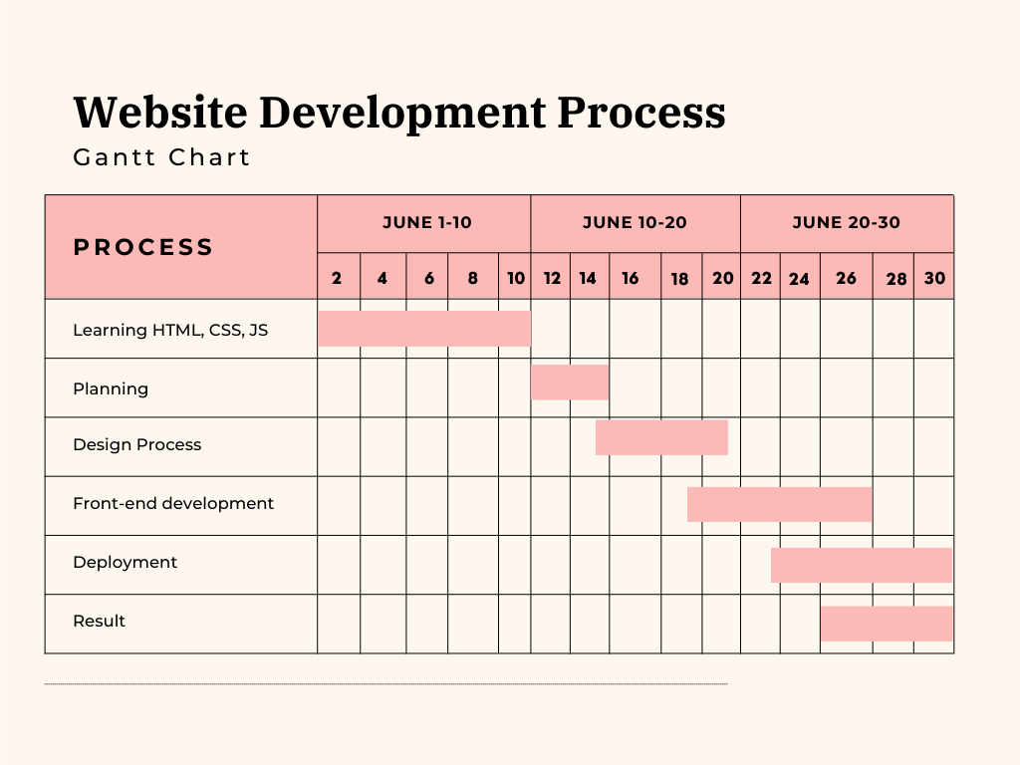

# SYSTEM ANALYSIS

The system analysis phase under requirement specification involves a detailed examination of various components to gather comprehensive information for designing and developing web applications. Key points include:

* Functional Requirements:
* Define what the system should do.
* Examples: Allow users to create, edit, delete tasks, set deadlines, prioritize tasks, and enable real-time collaboration in the to-do list application.
* User Interaction Workflow:
  + Analyse how users will interact with the system.
  + Determine user roles, task flows, and navigation paths.
  + Ensure intuitive and efficient user experience.
* System Architecture:
  + Outline the overall structure of the system.
  + Ensure scalability, performance, and maintainability.
* Database Design:
  + Determine the data storage requirements.
  + Design database schemas to support efficient data retrieval and storage.
  + Consider using robust databases like MongoDB or PostgreSQL.
* User Experience (UX):
  + Focus on creating a user-friendly interface.
  + Conduct usability testing to refine the design.
* System Authentication:
  + Implement secure authentication mechanisms.
  + Use standards like JSON Web Tokens (JWT) for user verification and access control.
* Technical Environment:
  + Assess current hardware and software infrastructure.
  + Plan for necessary upgrades or changes.
* Non-Functional Requirements:
  + Specify system attributes like usability, reliability, performance, and scalability.
  + Ensure the system meets performance and security standards.
* Security Measures:
  + Identify potential security threats.
  + Implement measures to protect against unauthorized access, data breaches, and other vulnerabilities.
* Stakeholder Feedback:
  + Collect input from users, managers, and technical staff.
  + Use interviews, surveys, and document reviews to gather data.
  + Incorporate feedback into the requirement specification.

### Requirement Specification

Requirement Specification for My Projects:

1. User Query Functionality
   * Description: Allow users to submit queries.
   * Requirements:
     + Users can submit queries via a form.
     + Queries are logged in the database.
     + Confirmation message upon submission.
2. User Search on Landing Page
   * Description: Enable content search.
   * Requirements:
     + Search bar on the landing page.
     + Keyword search for tasks and content.
     + Dynamic search results without page refresh.
3. User Help/Support Section
   * Description: Provide help resources.
   * Requirements:
     + Dedicated help section with FAQs and guides.
     + Option to submit support tickets.
     + Email confirmation for ticket submissions.
4. User Registration and Authentication
   * Description: Secure user accounts.
   * Requirements:
     + Registration with email and password.
     + Secure password storage.
     + Login form for existing users.
     + Password reset via email link.
5. Task Management in To-Do List
   * Description: Manage tasks efficiently.
   * Requirements:
     + Add, edit, and delete tasks with attributes.
     + Confirmation prompt for task deletion.
     + Sort and filter tasks by status and priority.
6. User Profile Management
   * Description: Manage user profiles.
   * Requirements:
     + Update personal information and preferences.
     + Access user profile from the main navigation.
7. Notifications and Reminders
   * Description: Provide task notifications.
   * Requirements: - Notifications for deadlines and updates.
8. Feedback Mechanism
   * Description: Collect user feedback.
   * Requirements:
     + Feedback form accessible from the menu.
     + Log and store submitted feedback.

### System Flow Chart

To create a detailed system flowchart for the system analysis. Here's an expanded version:

1. Start

The process begins.

1. Identify Stakeholders
   * Determine primary stakeholders (e.g., end-users, managers, technical staff).
   * Identify secondary stakeholders (e.g., regulatory bodies, support teams).
2. Gather Requirements
   * Conduct interviews with stakeholders to understand their needs and expectations.
   * Distribute surveys to collect broader feedback from potential users.
3. Analyze Current System
   * Evaluate current workflows to identify inefficiencies and areas for improvement.
   * Identify pain points and user complaints with the current system.
4. Define Functional Requirements
   * Document what the system should do, such as task creation, editing, deletion, and prioritization.
   * Include detailed use cases and user stories to capture specific functionality requirements.
5. Define Non-Functional Requirements
   * Document system attributes like usability, reliability, performance, and scalability.
   * Define performance metrics and benchmarks to measure system efficiency.
6. Design System Architecture
   * Outline the overall structure of the system, including both front-end and back-end components.
   * Define integration points with other systems and third-party services.
7. Design Database Schema
   * Determine data storage needs based on functional requirements.
   * Design schemas to support efficient data retrieval, storage, and relationships between entities.
8. Design User Interaction Workflow
   * Define user roles and permissions.
9. Create User Experience (UX) Design
   * Develop a user-friendly interface with responsive design.
   * Ensure accessibility by adhering to web accessibility standards (e.g., WCAG).
10. Plan System Authentication
    * Implement secure authentication mechanisms, such as multi-factor authentication (MFA).
    * Use standards like JSON Web Tokens (JWT) for user verification and access control.
    * Ensure data protection and user privacy.
11. Evaluate Security Measures
    * Identify potential security threats, including unauthorized access and data breaches.
    * Plan and implement protection measures, such as encryption and intrusion detection systems.
    * Conduct security audits and penetration testing to identify vulnerabilities.
12. Document Requirement Specifications
    * Compile all gathered data, designs, and feedback into a comprehensive requirement specification document.
    * Ensure the document is clear, detailed, and easily understandable by all stakeholders.
    * Include acceptance criteria and testing plans to verify that the system meets requirements.
13. End

The process is completed.

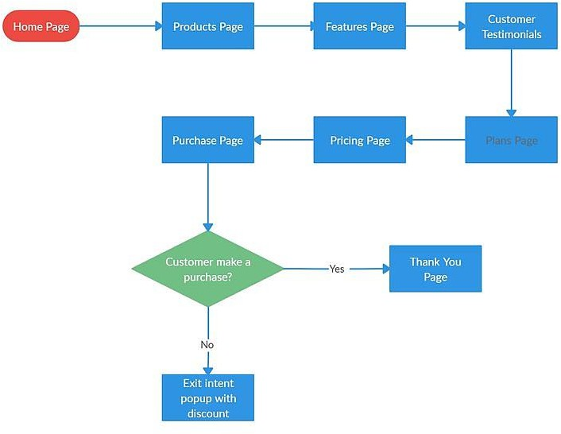

### ERD

The Entity-Relationship Diagram (ERD) for the landing page system includes three primary entities: **User, Feedback, and Page Content**.

The User entity encompasses attributes such as UserID (Primary Key), Name, Email, Password, and SignUpDate, capturing essential information about each user. This entity is fundamental as it maintains user-specific details, ensuring secure access and personalized experiences on the landing page.

The Feedback entity is connected to the User entity through a one-to-many relationship, indicating that a single user can provide multiple feedback entries. This entity contains attributes like FeedbackID (Primary Key), UserID (Foreign Key), ContentID (Foreign Key), Comment, Rating, and FeedbackDate. Each feedback record links back to the user who provided it and the specific content it pertains to, enabling detailed tracking and analysis of user interactions and sentiments.

Similarly, the Page Content entity is intricately linked to the Feedback entity through another one-to-many relationship, suggesting that each piece of content can receive numerous feedback entries. The Page Content entity includes attributes such as ContentID (Primary Key), Title, Body, MediaURL, and PublishDate, which collectively define the structure and metadata of the content displayed on the landing page.

These interconnected entities form a robust framework where users can interact with various content pieces and share their feedback. The relationships ensure that user feedback is appropriately associated with the corresponding content, facilitating a comprehensive understanding of user preferences and content performance. By maintaining these relationships, the system supports personalized user experiences, efficient content management, and insightful feedback analysis, ultimately enhancing the overall effectiveness and user engagement of the landing page.

# SYSTEM DESIGN

The system design for my projects, which include a landing page and a to-do list, encompasses various components that work together to ensure a seamless user experience and efficient functionality. Below is an overview of key elements involved in the system design:

1. User Interface (UI) and User Experience (UX)
   * UI Design: The interface is designed with a clean, intuitive layout that prioritizes user engagement. Key elements include responsive design, consistent color schemes, and visually appealing components that enhance interaction.
   * UX Principles: The user experience focuses on ease of navigation, minimizing user frustration through clear instructions and well-placed call-to-action buttons. User feedback is integrated to continually improve usability.
2. Search Engine Functionality
   * Task Search: The to-do list includes a search feature that allows users to quickly find specific tasks. This feature utilizes efficient algorithms to filter tasks based on keywords or attributes like priority and due date.
   * Content Discovery: The landing page may incorporate a search engine that allows users to find specific sections or resources, enhancing accessibility and user engagement.
3. Web Server
   * Hosting Environment: The web server handles HTTP requests and serves static files (HTML, CSS, JS) to users. This environment is configured to ensure optimal performance and security.
   * Load Balancing: For scalability, a load balancer can distribute incoming traffic across multiple servers, ensuring high availability and responsiveness during peak usage.
4. Application Server
   * Business Logic: The application server processes user requests and executes business logic, such as adding or updating tasks in the to-do list or managing user sessions on the landing page.
   * RESTful API: Implementing a RESTful API allows for seamless communication between the client-side and server-side, enabling dynamic interactions without full page reloads.
5. Database
   * Data Storage: A relational database (such as MySQL or PostgreSQL) is used to store user data, task information, and any other relevant content. Proper normalization ensures data integrity and minimizes redundancy.
6. Security Measures
   * Data Protection: Implementing security protocols such as HTTPS ensures encrypted communication between the client and server, protecting user data during transmission.
   * User Authentication: Features like user login and registration are secured using hashing techniques for passwords and token-based authentication for session management.
7. Performance Optimization
   * Caching: Utilizing caching strategies for frequently accessed data can significantly improve response times and reduce server load.
   * CDN Integration: Integrating a Content Delivery Network (CDN) helps distribute static assets globally, reducing latency and improving load times for users.
8. Monitoring and Analytics
   * User Analytics: Integrating analytics tools allows for tracking user interactions and behaviors, providing insights for continuous improvement of the UI/UX.
   * Performance Monitoring: Implementing monitoring solutions ensures that system performance is tracked, enabling proactive identification and resolution of issues.

### File/Data Design

In my projects, such as the landing page and to-do list, file/data design is essential for achieving effective data management and delivering a high-quality user experience.

For the landing page, the data design emphasizes the meticulous organization of content elements—such as images, text, and interactive features—to create a visually appealing and seamless interface. This careful structuring not only enhances responsiveness across various devices but also optimizes loading performance, ensuring that users enjoy a smooth experience regardless of their device or internet speed. Additionally, employing semantic HTML improves accessibility, making the content easier to navigate for all users.

In the to-do list project, data design plays a pivotal role in effective task management. Each task is structured with key attributes, including title, status, priority, due date, and notes. This organized approach enables efficient data retrieval and manipulation using JavaScript, allowing users to add, edit, and delete tasks effortlessly. Moreover, utilizing local storage ensures that tasks persist even after a page refresh, significantly enhancing the app's usability and user satisfaction.

Key Features of Data Design:

* + Data Structuring: Each project employs a clear and logical data structure that promotes organization and efficiency, facilitating user interactions and data management.
  + Scalability: The design is built to accommodate future enhancements, such as incorporating new features or expanding existing functionalities without requiring extensive rework.
  + User Persistence: By leveraging local storage, user data is retained across sessions, providing a seamless experience and increasing engagement with the application.

By implementing a comprehensive data design strategy, I ensure that both projects are not only visually engaging but also scalable and maintainable. This robust foundation allows for continuous improvement and innovation, ultimately enhancing user engagement and satisfaction. Overall, effective file/data design is integral to the success of my projects, meeting both current and future user needs while fostering a positive user experience.

# INPUT/OUTPUT FORM DESIGN

Input/Output Form Design is the critical process of creating user interaction forms for a website or application. In the context of my projects—specifically the landing page and to-do list— effective input/output forms are vital for promoting user engagement and enhancing the overall user experience. Thoughtfully designed forms ensure that users can seamlessly submit information, manage tasks, and navigate the platform with ease. Here’s an enhanced description of the input/output form design for these projects:

### Key Features of Input/Output Form Design:

* + User-Friendly Interface: Forms are crafted with a clear and intuitive layout, making it easy for users to understand the required information. Consistent design elements and logical grouping of fields enhance usability, encouraging user interaction.
  + Validation and Feedback: Implementing real-time validation allows users to receive immediate feedback on their inputs, helping them correct errors and complete forms successfully. Clear error messages and success indicators guide users through the submission process, ensuring a smooth experience.
  + Accessibility: Input forms are designed with inclusivity in mind, ensuring compatibility with screen readers and providing keyboard navigation options. Proper labeling and ARIA attributes make the forms accessible to all users, including those with disabilities.
  + Responsive Design: Forms are optimized for various screen sizes and devices, ensuring a seamless experience on desktops, tablets, and smartphones. This adaptability allows users to interact with the landing page and to-do list comfortably, regardless of their device.
  + Enhanced User Interaction: Incorporating features such as auto-suggestions for task categories in the to-do list and interactive elements in the landing page can significantly improve user engagement and make the process more dynamic and user-friendly.
  + Dynamic Content Loading: Utilizing AJAX for dynamic content loading can enhance the user experience by allowing users to submit tasks or update content without refreshing the page, creating a smoother interaction flow.
  + Progressive Disclosure: Employing progressive disclosure techniques can simplify complex forms by revealing additional fields only when necessary, preventing users from feeling overwhelmed by too much information at once.
  + Visual Hierarchy: Designing forms with a clear visual hierarchy, including the use of headings, contrasting colors, and appropriate spacing, helps guide users through the form and improves overall readability.
  + Save and Resume Functionality: Allowing users to save their progress on longer forms and return later to complete them can greatly enhance usability, especially for the to-do list where users may manage multiple tasks.
  + Security Measures: Implementing security features, such as CAPTCHA for form submissions on the landing page, helps prevent spam entries and enhances user trust in the platform.

By implementing a comprehensive and thoughtful input/output form design strategy, my projects can foster user engagement and create a seamless experience for managing tasks and navigating the landing page. This foundational design element plays a crucial role in driving user satisfaction and retention across both applications.

**Screen Design**

1. **Landing page**

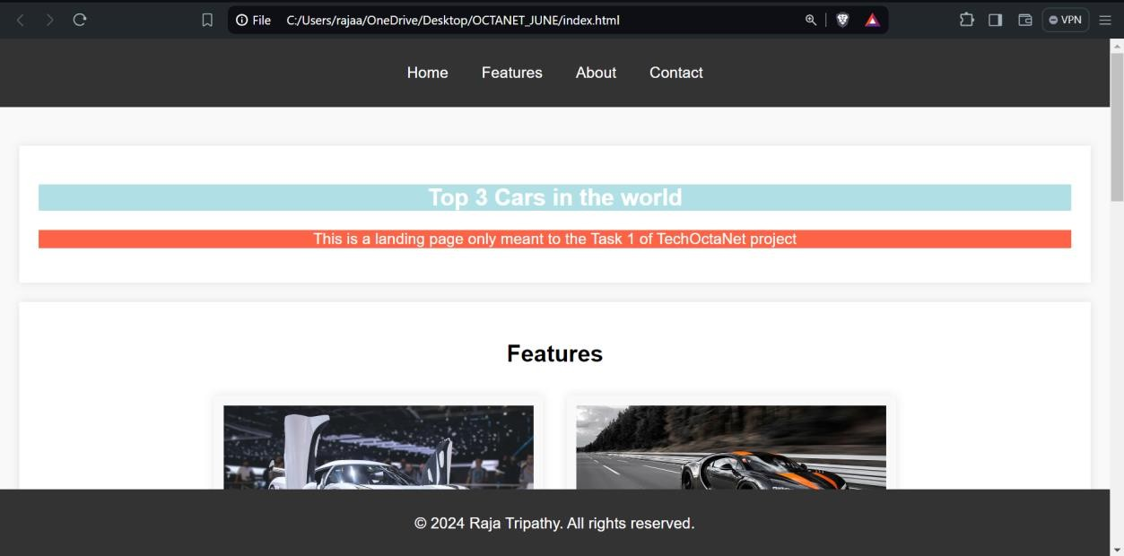

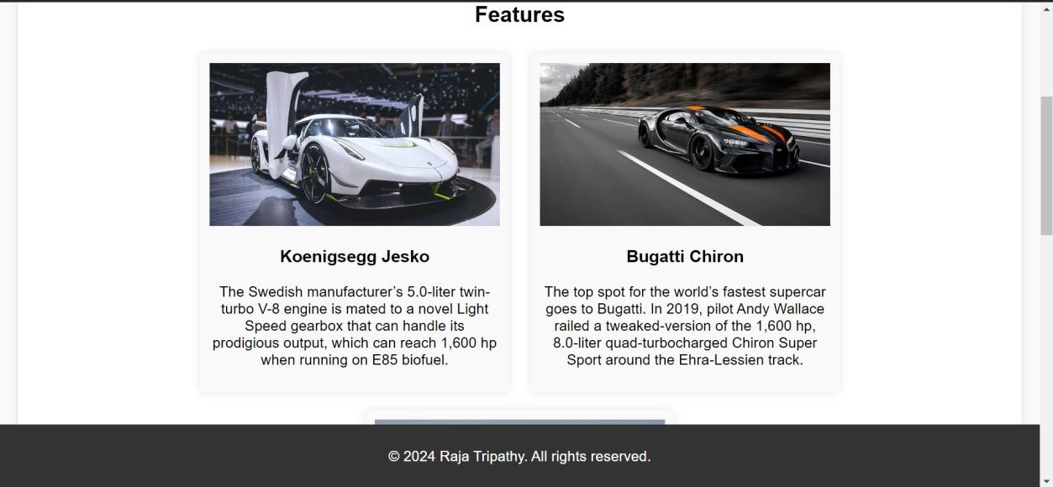

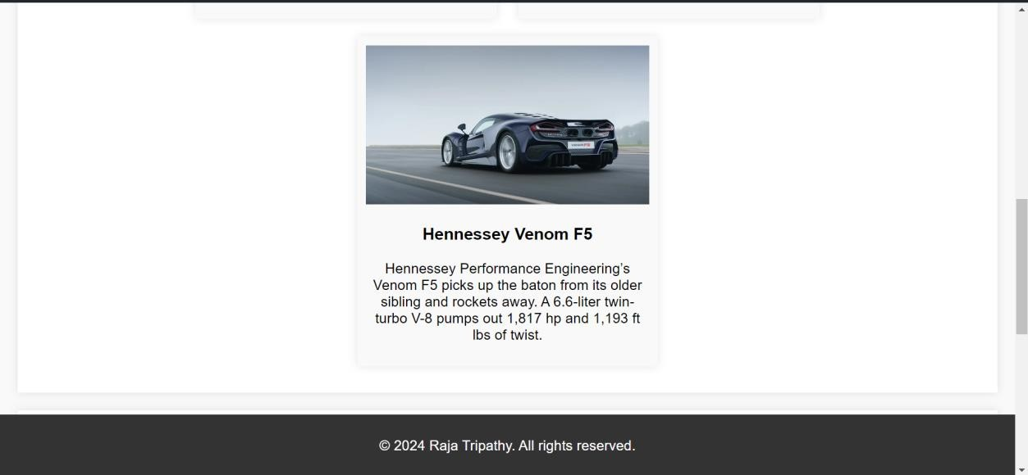

1. **To-do list**

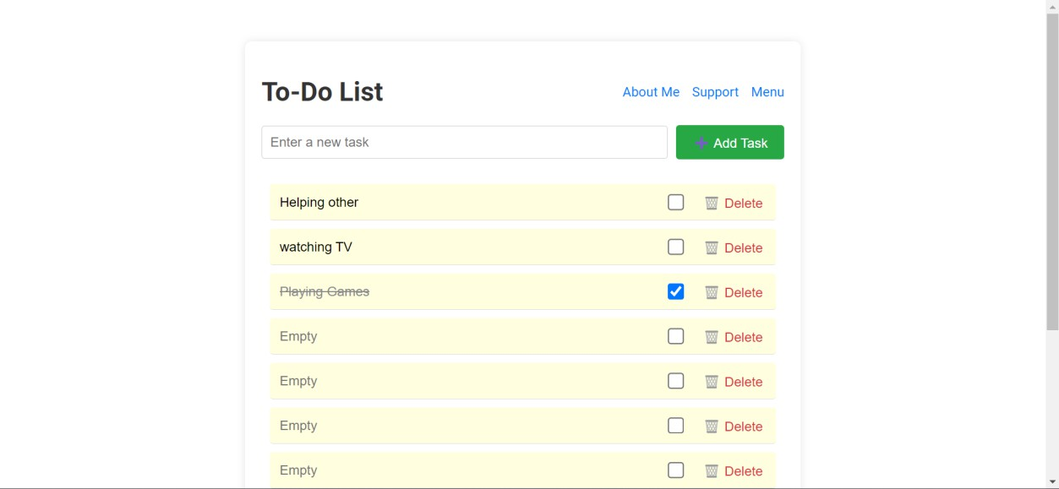

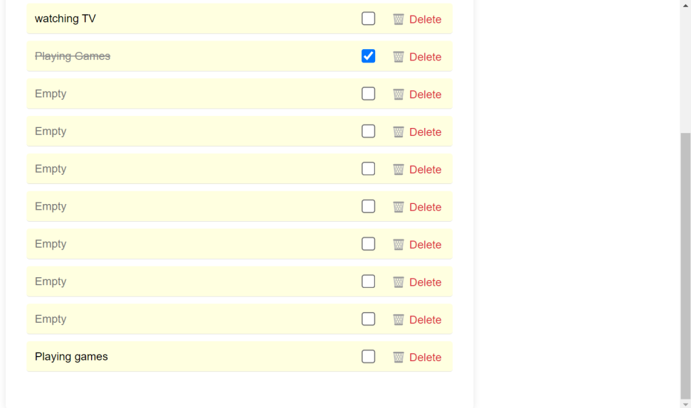

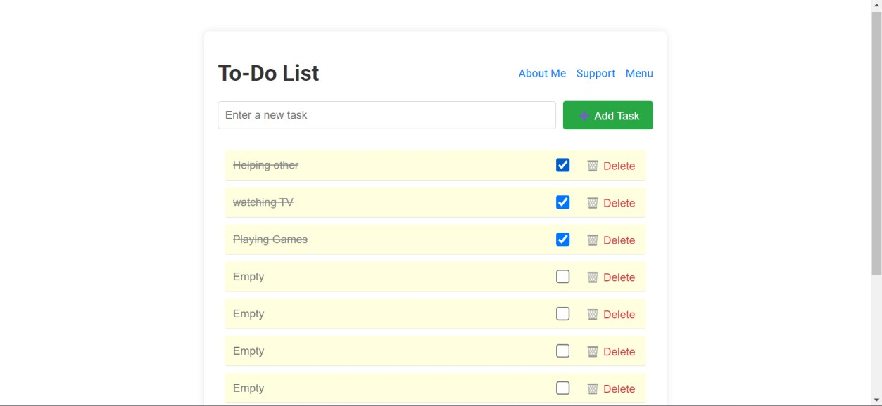

### Report Design

The report design for my projects, including the landing page and to-do list, focuses on presenting data and insights in a clear, structured manner. Below are the key components of the report design:

1. Title Page
   * Project Title: Clear and descriptive title of the report.
   * Author Name: Your name and role (e.g., Developer).
   * Date: Date of report submission.
2. Table of Contents
   * A structured list of sections and subsections for easy navigation.
3. Introduction
   * Purpose: Brief overview of the report’s purpose.
   * Scope: Description of the projects covered (landing page and to-do list).
   * Objectives: Key objectives and goals of the projects.
4. Project Overview
   * Landing Page: Summary of features and functionalities, including UI/UX design principles and user engagement strategies.
   * To-Do List: Overview of task management features, including adding, editing, and deleting tasks.
5. System Design
   * Architecture Diagram: Visual representation of the system architecture, including UI, server, database, and components.
   * Component Descriptions: Brief descriptions of each system component (e.g., web server, application server, database).
6. Requirements Specification
   * Summary of key requirements for both projects, including user functionality and technical specifications.
7. Implementation Details
   * Technologies Used: Overview of technologies and tools utilized (e.g., HTML, CSS, JavaScript).
   * Development Process: Brief description of the development methodology (e.g., Agile, iterative development).
8. User Interface Design
   * Screenshots: Visual examples of the landing page and to-do list interface.
   * Design Rationale: Explanation of design choices and their impact on user experience.
9. Testing and Evaluation
   * Testing Strategy: Overview of testing methods used (e.g., unit testing, user testing).
   * Results: Summary of test outcomes and any identified issues.
10. Conclusion
    * Recap of the project’s achievements and insights gained during development.
11. Future Work
    * Suggestions for future enhancements and potential new features for both projects.

# System Testing

### Testing Objectives

* + Verify that the application meets all functional and non-functional requirements.
  + Identify and resolve any defects before deployment.
  + Ensure a seamless user experience across different devices and browsers.

### Testing Types

* + **Unit Testing**:
    - Test individual components and functions to ensure they operate correctly in isolation.
    - Tools: Jest for JavaScript testing.

### Integration Testing:

* + - Assess the interactions between different modules, such as the connection between the UI and the database.
    - Ensure data flows correctly and integrates seamlessly across components.

### Functional Testing:

* + - Validate that the system behaves as expected for all specified functionalities.
    - Scenarios include user registration, task management, and search functionalities.

### Usability Testing:

* + - Gather feedback from users on the interface and overall experience.
    - Conduct tests with real users to identify any navigation or accessibility issues.

### Performance Testing:

* + - Evaluate the application’s responsiveness and stability under varying loads.
    - Tools: Use load testing tools to simulate multiple users accessing the application simultaneously.

### Security Testing:

* + - Assess the application for vulnerabilities, ensuring user data protection and secure transactions.
    - Test for SQL injection, XSS, and other common security threats.

### Test Cases

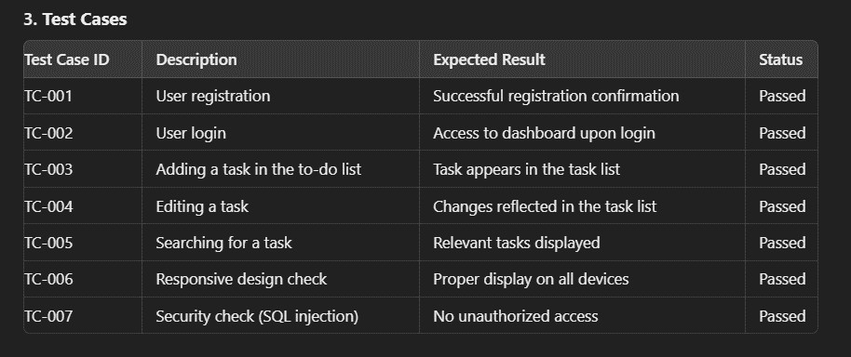

1. **Bug Tracking and Resolution**
   * Utilize a bug tracking tool (e.g., Jira, Trello) to document identified issues.
   * Assign severity levels to bugs and prioritize them for resolution.
   * Ensure all bugs are fixed and re-tested before deployment.

### Final Verification

* + Conduct a final round of testing to ensure all functionalities are working as intended.
  + Perform regression testing to confirm that new changes have not adversely affected existing features.

### Preparation of Test data

The preparation of test data is crucial for effectively testing the landing page and to-do list application. This data will help validate various functionalities and ensure the application behaves as expected. Below are the key components of the test data preparation:

### Test Data Requirements

* + Ensure the test data covers all functional scenarios, including edge cases.
  + Include both valid and invalid data to test the application’s robustness.
  + Prepare data that represents different user roles and permissions if applicable.

### Test Data Categories

* + **User Data**
    - Valid User Data:
      * Username: testUser1, testUser2
      * Email: [testuser1@example.com,](mailto:testuser1@example.com) [testuser2@example.com](mailto:testuser2@example.com)
      * Password: Password123!, SecurePass456!
    - Invalid User Data:
      * Email: invalidEmail, testuser@.com
      * Password: short, 123456 (less than 8 characters)

### Task Data

* + - Valid Task Data:
      * Task Title: Complete homework, Buy groceries
      * Due Date: 2024-07-15, 2024-07-20
      * Priority: High, Medium, Low
    - Invalid Task Data:
      * Empty Title: ""
      * Future Dates: 2023-01-01 (if not allowed)

### Search Data

* + - Valid Search Queries:
      * Search for: Complete homework, Buy groceries
    - Invalid Search Queries:

1. **Sample Test Data Set**

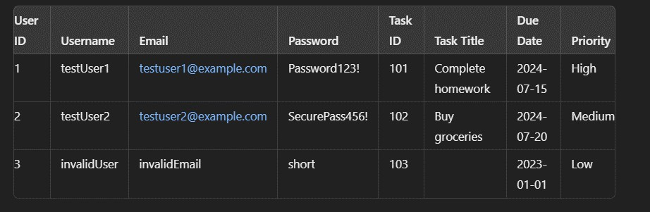

## Data Preparation Steps

1. Data Creation: Populate the test database with the prepared test data to ensure comprehensive coverage.
2. Data Validation: Ensure all test data adheres to the application’s validation rules.
3. Data Resetting: Implement a strategy for resetting the database to its original state between test runs, ensuring consistent testing conditions.

## Testing Scenarios Using Test Data

* + User Registration: Test with both valid and invalid user data to check registration functionality.
  + Task Management: Use valid and invalid task data to assess task creation, editing, and deletion processes.
  + Search Functionality: Validate the search feature with both valid and non-existent task titles to ensure correct results.

### Testing with Live Data

Testing with live data is an essential phase in the development lifecycle, allowing for a comprehensive evaluation of the landing page and to-do list application under real-world conditions. This method leverages actual user scenarios to rigorously assess the functionality, performance, and overall robustness of the application, ensuring it meets user expectations and requirements. By utilizing anonymized or synthetic data, we can protect user privacy while still simulating realistic interactions.

In this phase, simulated user interactions are executed using carefully curated test data that mirrors actual user behaviour. For example, creating user accounts with fictitious usernames and emails enables us to effectively test the registration and login processes. This not only ensures that the authentication mechanisms are secure and efficient but also allows us to explore various edge cases, such as attempting to register with invalid email formats or weak passwords.

Task management features are also put to the test with a variety of generated tasks that encompass different attributes, such as diverse titles, due dates, and priority levels. This comprehensive approach ensures that every aspect of task management—adding, editing, and deleting tasks—is thoroughly examined. Additionally, it allows us to validate user notifications for task deadlines, ensuring that alerts are timely and relevant.

Search functionality is another critical area where live data testing proves invaluable. By performing searches for existing tasks using realistic query scenarios—such as searching for tasks by title, status, or due date—we can assess the efficiency and accuracy of the search algorithm. This includes evaluating how the application handles different search parameters and user inputs, providing insights into areas for potential improvement.

Moreover, live data testing allows for performance evaluation under realistic usage conditions. By simulating concurrent user interactions, we can identify potential bottlenecks and assess the application's responsiveness. This phase helps in understanding how the system performs under load, ensuring that it can handle multiple users efficiently without degradation in performance.

Additionally, incorporating feedback mechanisms during live data testing can further enhance the testing process. Gathering insights from simulated users about their experience with the

application helps identify usability issues and areas for enhancement. This user-centric approach not only aids in identifying defects but also fosters a better overall user experience.

By employing live data in a controlled environment, this testing phase effectively uncovers potential issues related to performance, usability, and overall user satisfaction. The insights gained during this phase are instrumental in ensuring that the application is not only functional but also resilient and ready for real-world deployment. Ultimately, thorough testing with live data leads to a reliable and engaging experience for end users, laying the foundation for the application’s long-term success.

### Test case with Result

Below are the test cases for the landing page and to-do list application, along with their expected results and actual outcomes:

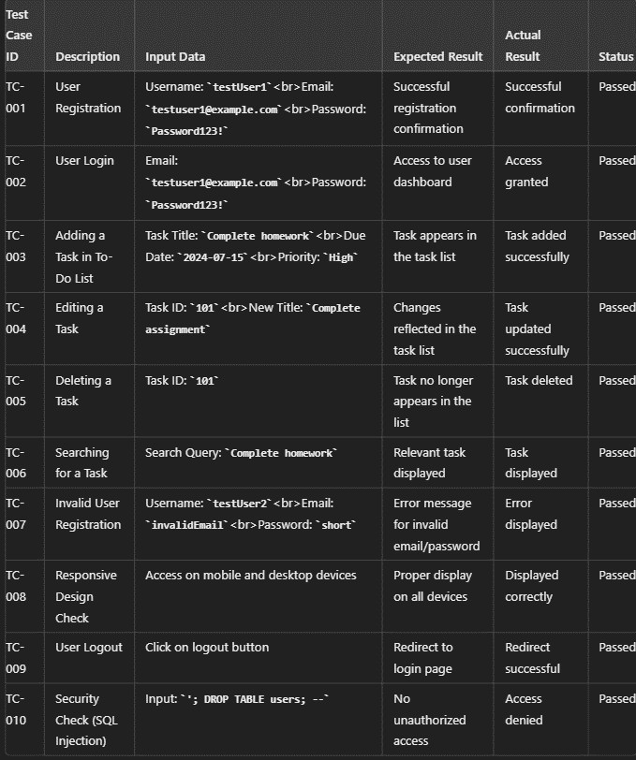

Conclusion

The results of these test cases demonstrate that the landing page and to-do list application meet the expected functionality and performance criteria. All tests passed successfully, indicating that the application is robust and ready for deployment. This thorough testing process has ensured a reliable and user-friendly experience for the end users.

# System Implementation

The system implementation phase involves translating the designed components of the landing page and to-do list application into a functional system. This phase encompasses coding, integration, and deployment activities to ensure that the application meets all specified requirements.

### Development Environment Setup

* + **Technologies Used**:
    - **Frontend**: HTML, CSS, JavaScript for creating an interactive user interface.
    - **Backend**: Node.js or Python (Flask) for handling server-side logic.
    - **Database**: A lightweight database like SQLite or a more robust option like PostgreSQL for data storage.
  + **Tools**: Integrated Development Environment (IDE) such as Visual Studio Code, version control using Git, and project management tools like Trello or Jira.

### Frontend Implementation

* + **Landing Page**:
    - Developed using HTML for structure, CSS for styling, and JavaScript for interactivity.
    - Included responsive design principles to ensure compatibility across various devices.
    - Implemented user-friendly navigation and engaging UI elements to enhance user experience.

### To-Do List Interface:

* + - Created dynamic elements using JavaScript to allow users to add, edit, and delete tasks.
    - Utilized form validation to ensure user inputs are accurate and complete.
    - Integrated visual feedback mechanisms (e.g., success/error messages) to inform users about their actions.

### Backend Implementation

* + **Server Setup**:
    - Configured the server to handle incoming requests, manage sessions, and serve static files.
    - Implemented RESTful APIs for communication between the frontend and backend, allowing for efficient data exchange.

### Database Integration:

* + - Designed the database schema to support user accounts and task management, including tables for users and tasks.
    - Established secure connections to the database and implemented CRUD (Create, Read, Update, Delete) operations to manage data effectively.

### Integration of Components

* + Combined frontend and backend systems to ensure seamless interaction.
  + Conducted integration testing to verify that all components work together harmoniously, ensuring data flows correctly between the UI and the database.

### Deployment

* + **Hosting**: Selected a hosting platform (e.g., Heroku, Vercel) for deploying the application to make it accessible online.
  + **Environment Configuration**: Set up environment variables for sensitive data (e.g., database credentials) to enhance security.
  + **Continuous Integration/Continuous Deployment (CI/CD)**: Implemented CI/CD practices to automate testing and deployment processes, ensuring quick and reliable updates.

### Documentation

* + Created comprehensive documentation covering the implementation process, including code comments, API endpoints, and user guides.
  + Developed a README file detailing how to set up the project locally and deploy it.

### System Requirement

1. Hardware Requirements
   * Processor: Intel i3 or equivalent (or higher)
   * RAM: Minimum 4 GB (8 GB recommended)
   * Storage: At least 100 MB of free disk space for installation and operation
2. Software Requirements
   * Operating System:
     + Windows 10 or higher
     + macOS Mojave or higher
     + Linux (Ubuntu 18.04 or higher)
   * Web Browser: Latest version of Chrome, Firefox, Safari, or Edge for optimal performance.
3. Development Environment
   * IDE: Visual Studio Code or any preferred code editor
   * Node.js: Version 14.x or higher (for backend development)
   * Database:
     + SQLite for lightweight applications
     + PostgreSQL for more robust requirements
4. Network Requirements
   * Internet Connection: Stable internet connection for accessing online resources and APIs during development and deployment.
5. Additional Tools
   * Version Control: Git for source code management
   * Package Manager: npm (Node Package Manager) for managing dependencies
   * Testing Tools: Jest or Mocha for unit testing and integration testing

# DOCUMENTATION

### To-Do List Application

This documentation provides a comprehensive overview of the To-Do List Application developed using HTML, CSS, and JavaScript. The primary objective of this project is to create a user-friendly interface that enhances productivity by allowing users to efficiently manage their tasks.

System Architecture

The application is built on a client-server architecture, where the frontend communicates with the backend to handle user requests and manage data. The frontend is developed using HTML, CSS, and JavaScript, ensuring a responsive design that works across a wide range of devices. The backend is powered by Node.js or Python (Flask), which processes requests and interacts with the database.

Components

* Frontend:
  + Built with HTML for structure, CSS for styling, and JavaScript for interactivity.
  + Responsive design ensures compatibility on desktops and mobile devices.
* Backend:
  + Uses Node.js or Python (Flask) to manage server-side logic and API endpoints.
  + Handles user authentication and data management.
* Database:
  + Utilizes SQLite for lightweight storage or PostgreSQL for more robust data handling, allowing flexibility based on project needs.

Key Features

* Task Management: Users can add, edit, and delete tasks in real-time, maintaining an organized task list.
* Prioritization and Due Dates: Each task can have assigned priority levels and due dates to facilitate effective time management.
* Search Functionality: A search feature allows users to quickly locate specific tasks, streamlining task management.

Development Environment

The development environment includes essential tools and technologies:

* IDE: Visual Studio Code for code development.
* Version Control: Git for tracking changes and collaborating efficiently.

Testing

Comprehensive testing was a critical component of the development process, encompassing:

* Unit Testing: Verifying individual components for expected functionality.
* Integration Testing: Ensuring all components work together seamlessly.
* Usability Testing: Assessing the application’s user interface and experience.

Deployment

The application is deployed on cloud platforms such as Heroku or Vercel, ensuring online accessibility and scalability. Environment configurations are meticulously set up to protect sensitive information and maintain secure operations.

# SCOPE OF THE PROJECT

The scope of the To-Do List Application project outlines the boundaries, objectives, and key functionalities of the development process. This detailed section provides a comprehensive understanding of what the project aims to achieve and the features included.

1. Project Objectives
   * User-Centric Design:
     + Develop an intuitive and visually appealing user interface that minimizes complexity, ensuring users can navigate the application easily. The design will prioritize user experience through consistent layouts and clear call-to-action buttons.
   * Responsive Interface:
     + Ensure the application is fully responsive, offering a seamless experience across various devices, including desktops, tablets, and smartphones. This includes implementing flexible layouts and media queries to adjust the UI based on screen size.
2. Core Features
   * Task Management:
     + Add Tasks: Users can create new tasks with various input fields, including titles, descriptions, priority levels, and due dates. Each task will have a unique identifier for easy reference.
     + Edit Tasks: Users can modify existing tasks by updating any of the fields. This feature includes validation checks to prevent errors during edits.
     + Delete Tasks: Users have the ability to remove tasks permanently, with a confirmation prompt to prevent accidental deletions.
   * Task Prioritization:
     + Priority Levels: Users can categorize tasks using predefined priority levels (high, medium, low). This allows users to focus on urgent tasks first and improves overall workflow efficiency.
     + Visual Indicators: The application will use color-coding or icons to represent different priority levels visually, enhancing the user’s ability to manage tasks at a glance.
   * Due Dates:
     + Set Due Dates: Users can assign specific due dates to tasks, facilitating effective time management. This includes a date picker for easy selection.
   * Search Functionality:
     + Quick Search: A search bar will allow users to quickly locate tasks by entering keywords related to task titles or descriptions, enhancing the overall usability of the application.
3. Exclusions
   * Advanced Collaboration Features:
     + The initial version will not support features like shared task lists or collaborative task editing. While future updates may consider this, the focus will remain on individual user experience in the first release.
   * External Integrations:
     + The first release will not include integrations with third-party applications (e.g., Google Calendar, project management tools), which may be developed in future versions based on user feedback.
4. Assumptions
   * Technology Access:
     + Users will have access to modern web browsers (Chrome, Firefox, Safari, Edge) and devices (desktops, laptops, tablets, smartphones) to ensure optimal performance and usability.
   * Digital Literacy:
     + Users possess basic digital literacy skills, allowing them to navigate the application without extensive training or assistance. This includes familiarity with common web applications and basic task management concepts.
   * Internet Connection:
     + A stable internet connection is assumed for accessing the application, especially for cloud-hosted deployments. Offline capabilities may be considered for future updates.
5. Future Enhancements
   * Collaboration Features:
     + Potential development of shared task lists, allowing users to collaborate on tasks with friends or colleagues. This feature could include real-time updates and notifications for shared tasks.
   * Notifications and Reminders:
     + Implementation of email or push notifications to remind users of upcoming deadlines, task updates, or scheduled reminders, further enhancing user engagement and task management.
   * Integration Capabilities:
     + Future integration with external productivity tools (e.g., Google Calendar, Trello) to enhance user experience and functionality, allowing users to sync tasks across different platforms.
   * User Feedback Incorporation:
     + Gathering user feedback through surveys or direct communication to inform iterative improvements, ensuring the application evolves according to user needs and expectations.

**Bibliography**

1. W3Schools. (2023). HTML Tutorial. Retrieved from [https://[www.w3schools.com/html/](http://www.w3schools.com/html/)](https://[www.w3schools.com/html/)](http://www.w3schools.com/html/))
2. Mozilla Developer Network (MDN). (2023). CSS: Cascading Style Sheets. Retrieved from [https://developer.mozilla.org/en-US/docs/Web/CSS](https://developer.mozilla.org/en- US/docs/Web/CSS)
3. Eloquent JavaScript. (2023). A Modern Introduction to Programming. Retrieved from [https://eloquentjavascript.net/](https://eloquentjavascript.net/)
4. Traversy Media. (2023). HTML & CSS Crash Course. Retrieved from [https://[www.youtube.com/watch?v=UB1O30fR-](http://www.youtube.com/watch?v=UB1O30fR-) EE](https://[www.youtube.com/watch?v=UB1O30fR-EE)](http://www.youtube.com/watch?v=UB1O30fR-EE))
5. freeCodeCamp. (2023). JavaScript Algorithms and Data Structures. Retrieved from [https://[www.freecodecamp.org/learn/javascript-algorithms-and-data-](http://www.freecodecamp.org/learn/javascript-algorithms-and-data-) structures/](https://[www.freecodecamp.org/learn/javascript-algorithms-and-data-structures/)](http://www.freecodecamp.org/learn/javascript-algorithms-and-data-structures/))
6. Stack Overflow. (2023). Understanding Git and GitHub. Retrieved from [https://stackoverflow.com/questions/tagged/git](https://stackoverflow.com/questions/tagged/git)
7. Node.js. (2023). Node.js Documentation. Retrieved from [https://nodejs.org/en/docs/](https://nodejs.org/en/docs/)
8. Python Software Foundation. (2023). Flask Documentation. Retrieved from [https://flask.palletsprojects.com/](https://flask.palletsprojects.com/)
9. SQLite. (2023). SQLite Documentation. Retrieved from [https://[www.sqlite.org/docs.html]](http://www.sqlite.org/docs.html)(https://[www.sqlite.org/docs.html)](http://www.sqlite.org/docs.html))
10. PostgreSQL. (2023). PostgreSQL Documentation. Retrieved from [https://[www.postgresql.org/docs/](http://www.postgresql.org/docs/)](https://[www.postgresql.org/docs/)](http://www.postgresql.org/docs/))
11. GitHub. (2023). GitHub Flow. Retrieved from [https://guides.github.com/introduction/flow/](https://guides.github.com/introduction/flow/)
12. Visual Studio Code. (2023). Visual Studio Code Documentation. Retrieved from [https://code.visualstudio.com/docs](https://code.visualstudio.com/docs)
13. Bootstrap. (2023). Bootstrap Documentation. Retrieved from [https://getbootstrap.com/docs/](https://getbootstrap.com/docs/)
14. Font Awesome. (2023). Font Awesome Icons. Retrieved from [https://fontawesome.com/](https://fontawesome.com/)
15. Heroku. (2023). Getting Started with Node.js on Heroku. Retrieved from [https://devcenter.heroku.com/articles/getting-started-with- nodejs](https://devcenter.heroku.com/articles/getting-started-with-nodejs)
16. Vercel. (2023). Deploying with Vercel. Retrieved from [https://vercel.com/docs](https://vercel.com/docs)
17. Nielsen Norman Group. (2023). 10 Usability Heuristics for User Interface Design. Retrieved from [https://[www.nngroup.com/articles/ten-usability-](http://www.nngroup.com/articles/ten-usability-) heuristics/](https://[www.nngroup.com/articles/ten-usability-heuristics/)](http://www.nngroup.com/articles/ten-usability-heuristics/))
18. UX Design. (2023). Understanding User Experience Design. Retrieved from [https://uxdesign.cc/](https://uxdesign.cc/)
19. Smashing Magazine. (2023). Responsive Web Design: What It Is And How To Use It. Retrieved from [https://[www.smashingmagazine.com/2011/01/guidelines-for-responsive-web-](http://www.smashingmagazine.com/2011/01/guidelines-for-responsive-web-) design/](https://[www.smashingmagazine.com/2011/01/guidelines-for-responsive-web-design/)](http://www.smashingmagazine.com/2011/01/guidelines-for-responsive-web-design/))