**SQL Exercise**

1. List of the employees who are working on BRO Recruitment project.

Query-

select distinct

e.emp_first_name,

ep.emp_project_id,

p.project_name

from tb_employee_dtl e

inner join tb_emp_project_dtl ep on e.id = ep.emp_id

inner join tb_project_dtl p on ep.emp_project_id= p.id

where ep.emp_project_id='4'

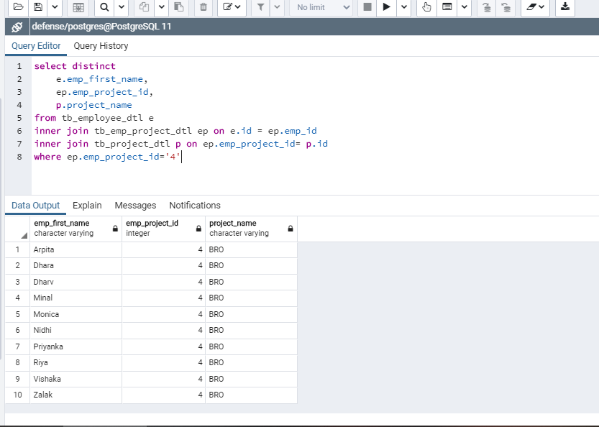

2. List of the employees who are not working on EME Project.

Query-

select distinct

e.emp_first_name,

ep.emp_project_id,

p.project_name

from tb_employee_dtl e

inner join tb_emp_project_dtl ep on e.id = ep.emp_id

inner join tb_project_dtl p on ep.emp_project_id= p.id

where ep.emp_project_id != '1'

order by ep.emp_project_id

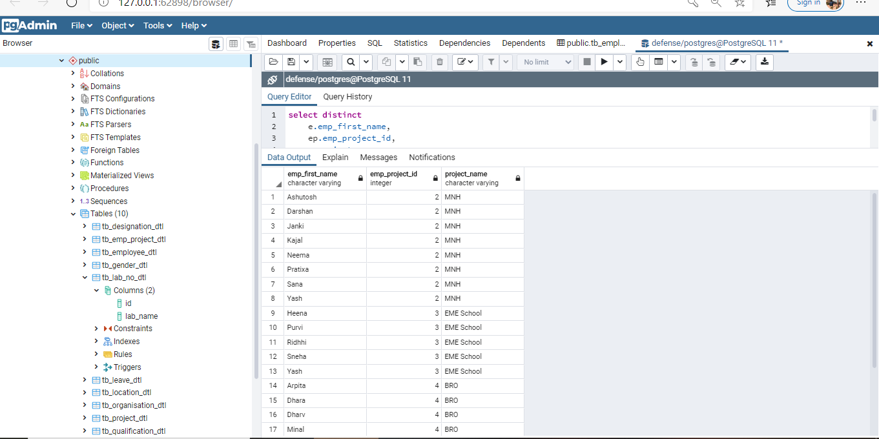

3. List of the employees whose experience is more or equal to 2 years in descending order.

Query –

SELECT emp_first_name,

joining_date,

age(CURRENT_DATE, joining_date) as total_yea

FROM tb_employee_dtl

WHERE EXTRACT(YEAR FROM age(CURRENT_DATE, joining_date)) >= 2

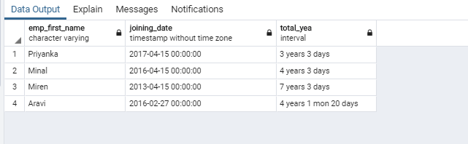

4. List of the employees whose salary is less than 20,000 Rs.

Query-

Select emp_first_name,emp_salary

From tb_employee_dtl

Where emp_salary < 20000

order by emp_first_name

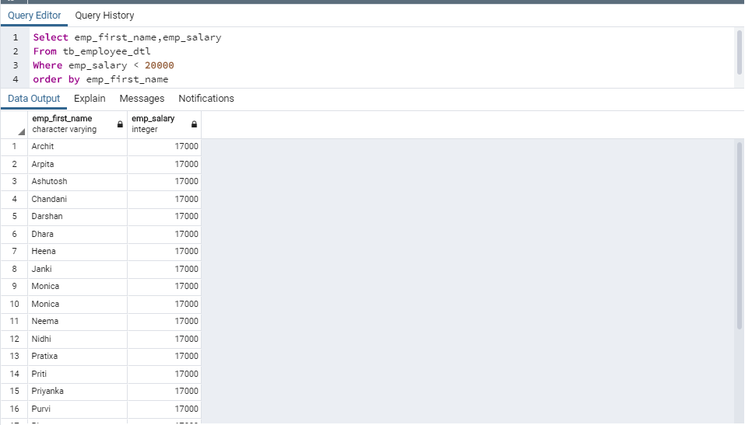

5. List of the employees whose salary is more than 20,000 Rs.

Query-

Select emp_first_name,emp_salary

From tb_employee_dtl

Where emp_salary > 20000

order by emp_first_name

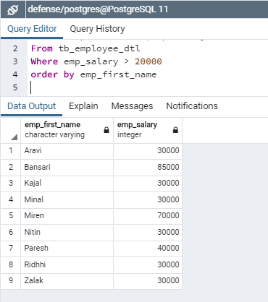

6. List of the employees whose salary in between of 10,000 to 50,000 Rs.

Query-

Select emp_first_name,emp_salary

From tb_employee_dtl

Where emp_salary between 10000 and 50000

order by emp_first_name

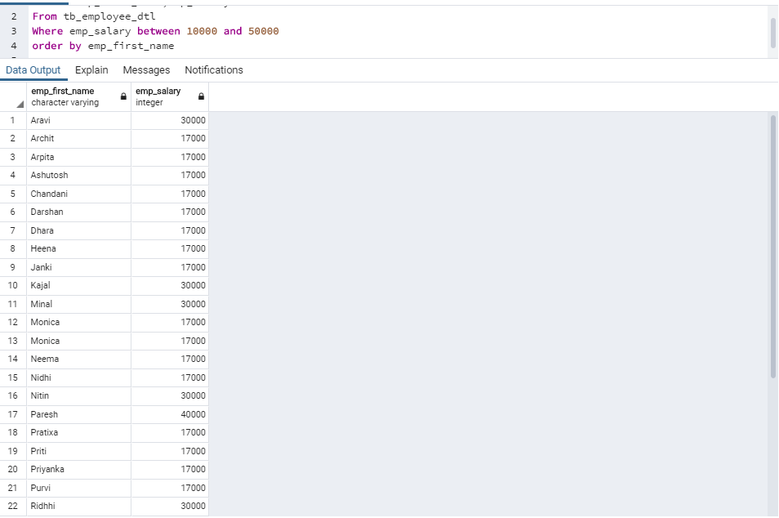

7. List the employee who has minimum salary.

Query-

SELECT emp_first_name, emp_salary FROM tb_employee_dtl

WHERE emp_salary = (SELECT MIN(emp_salary) FROM tb_employee_dtl)

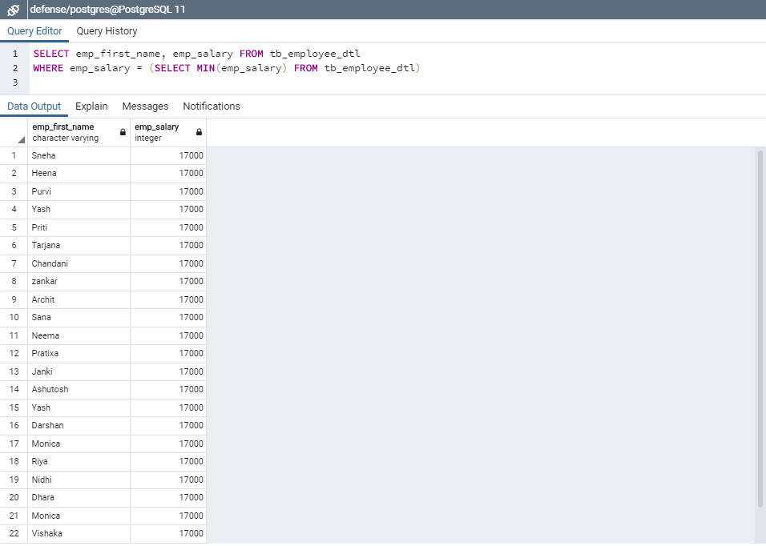

8. List the employee who has maximum salary.

Query-

SELECT emp_first_name, emp_salary FROM tb_employee_dtl

WHERE emp_salary = (SELECT MAX(emp_salary) FROM tb_employee_dtl)

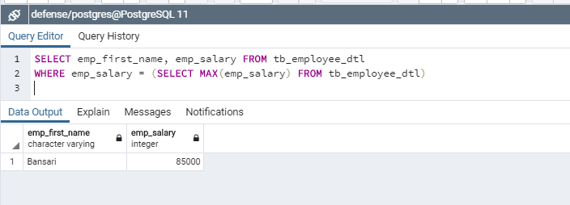

9. Total salary of all employees and average salary of each employee.

Query-

SELECT SUM(emp_salary) as total_salary, AVG(emp_salary) as average_salary

FROM tb_employee_dtl

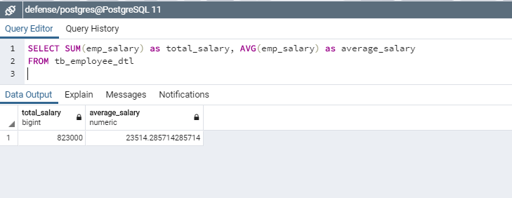

10. List of the employees who are working on diff. project to be mention project name in ascending order and employees name in descending order.

Query-

select distinct

e.emp_first_name,

p.project_name

from tb_employee_dtl e

inner join tb_emp_project_dtl ep on e.id = ep.emp_id

inner join tb_project_dtl p on ep.emp_project_id= p.id

order by e.emp_first_name desc, p.project_name asc

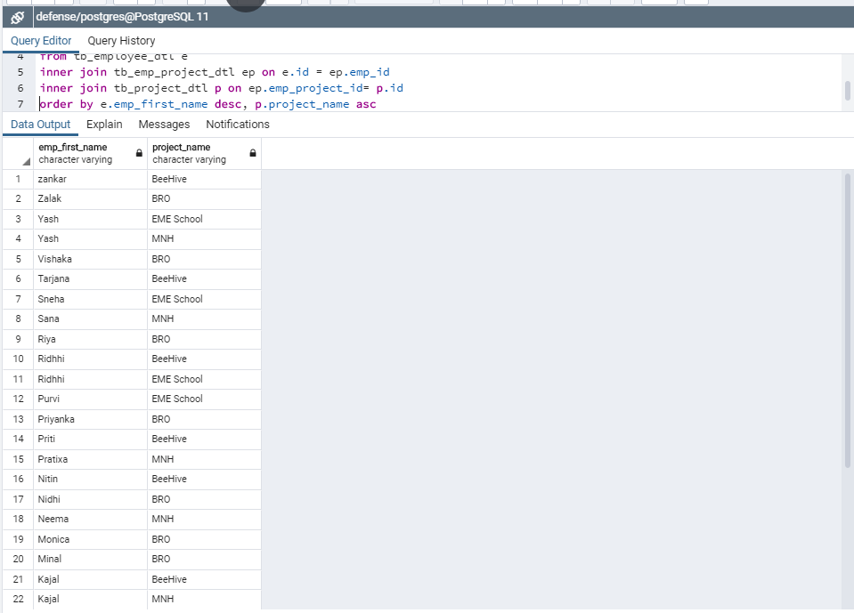

11. List of the employees who joined in the month of July.

Query -

SELECT emp_first_name,joining_date

FROM tb_employee_dtl

WHERE to_char(joining_date, 'mon')='jul'

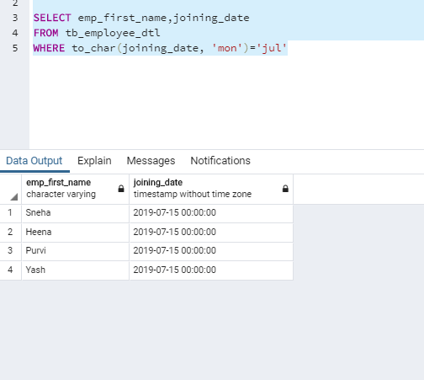

12. List of the employees who joined in the year of 2018.

­­ Query –

select emp_first_name, joining_date from tb_employee_dtl

where to_char(joining_date,'YYYY') = '2018'

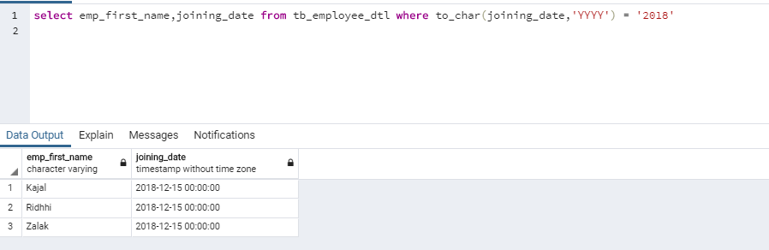

13. List of the employees who are resident of Gandhinagar.

Query –

select e.emp_first_name, l.emp_city

from tb_location_dtl l

inner join tb_employee_dtl e on l.id = e.emp_loc_id

where e.emp_loc_id = '1'

order by e.emp_first_name

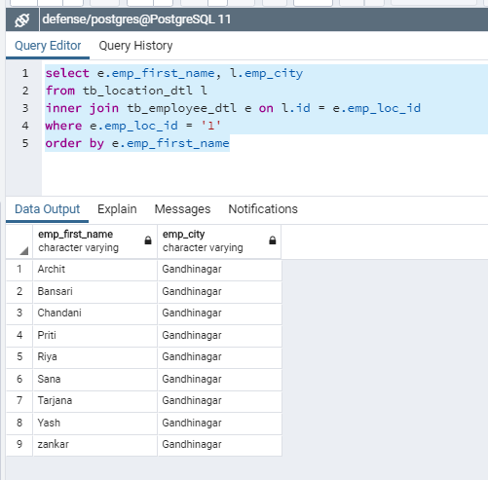

14. List of the employees who up down from different cities to Gandhinagar. (mention cities name)

Query –

select e.emp_first_name, l.emp_city

from tb_location_dtl l

inner join tb_employee_dtl e on l.id = e.emp_loc_id

where e.emp_loc_id != '1'

order by e.emp_first_name

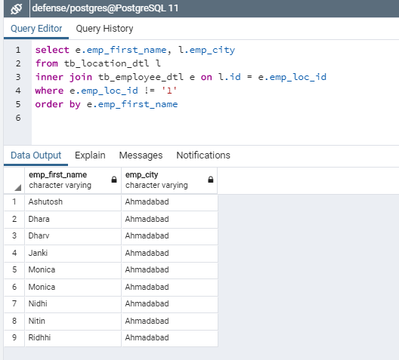

15. No. of Employees based on their technical Qualification(Graduate/Post Graduate)

Query-

select e.emp_first_name, q.qualification_name

from tb_employee_dtl e

inner join tb_qualification_dtl q on e.qualification_id = q.id

order by q.id

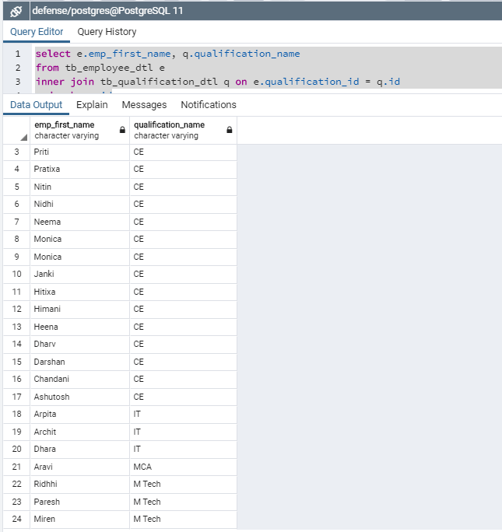

16. The Number of employees in each project where less than 5 number of employees.

Query –

select

count(ep.emp_id) as emp_count,

ep.emp_project_id,

p.project_name

from tb_emp_project_dtl ep

inner join tb_project_dtl p on ep.emp_project_id= p.id

group by ep.emp_project_id,p.project_name

having count(ep.emp_id) < 5

(NOTE: NOW NO ONE PROJECT HAS NO OF EMPLOYEE LESS THAN FIVE THAT’S WHY RESULT IS EMPTY)

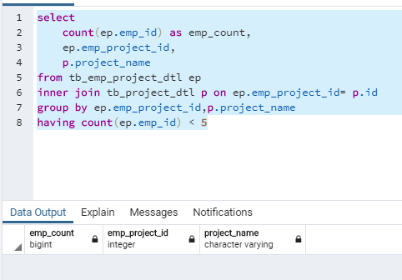

17. List the Team Leader name, Project Name and numbers of employees working for those team leaders in ascending order on team leader ID.

Query –

select distinct e.id,e.emp_first_name, a.emp_count,

p.project_name

from tb_emp_project_dtl ep

inner join tb_project_dtl p on ep.emp_project_id= p.id

inner join tb_employee_dtl e on ep.emp_id = e.id

inner join tb_designation_dtl d on e.designation_id = d.id and d.id = 2

inner join (select count(emp_id) as emp_count,emp_project_id from tb_emp_project_dtl

group by emp_project_id) a on p.id = a.emp_project_id

group by e.id,e.emp_first_name, a.emp_count, p.project_name

order by e.id

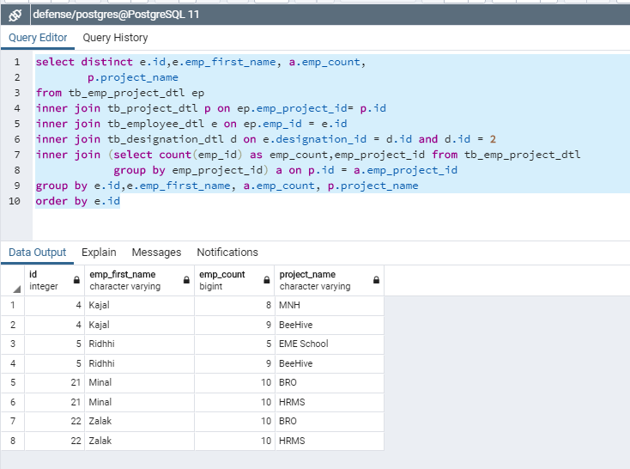

18. List of the employees whose name having more or equal to six characters limit to 5 employees.

Query –

select emp_first_name

from tb_employee_dtl

where length(emp_first_name) >= '6' limit 5

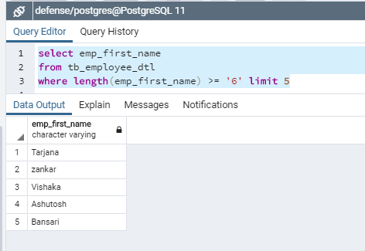

19. List of the employees whose name start with ‘M’ and with 5 Characters in their name.

Query –

select emp_first_name

from tb_employee_dtl

where length(emp_first_name) = '5' and emp_first_name like 'M%'

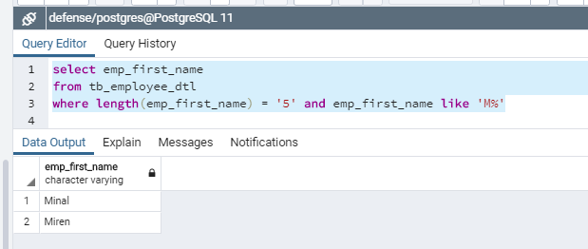

20. List of the employees whose name having 5 Characters in name, 2nd Character must be ‘I’ and end character to be ‘L’.

Query –

select emp_first_name

from tb_employee_dtl

where length(emp_first_name) = '5' and UPPER(emp_first_name) like '_I%L'

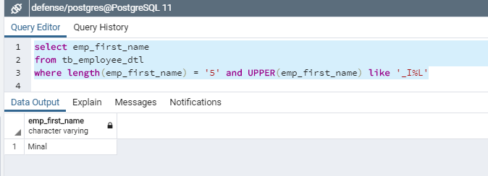

21. List all the employees with thier Designation as a team lead/Senior developer in Ascending Order.

Query –

select distinct e.emp_first_name,

d.designation_name

from tb_employee_dtl e

inner join tb_designation_dtl d on e.designation_id = d.id

where e.designation_id = '2'

order by e.emp_first_name asc

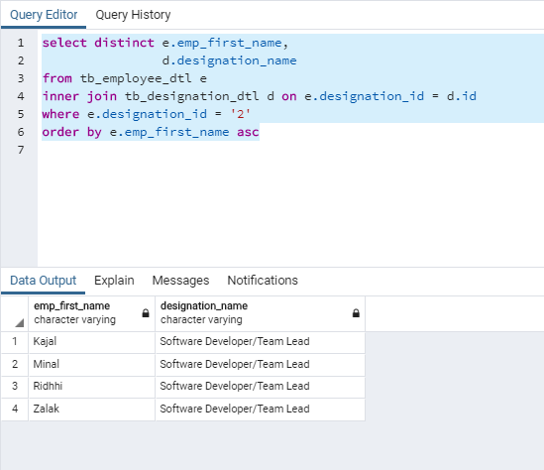

22. List all the Detail of employees like Age, Salary, Experience who is from Ethos and Ncog and having experience more than one year.

Query –

SELECT e.emp_first_name,e.emp_salary, e.joining_date,

age(CURRENT_DATE, e.joining_date) as total_year,

o.organisation

FROM tb_employee_dtl e

inner join tb_organisation_dtl o on e.organisation_id = o.id

WHERE extract(year from age(CURRENT_DATE, joining_date)) >= 1 and (o.id = '1' or o.id = '2')

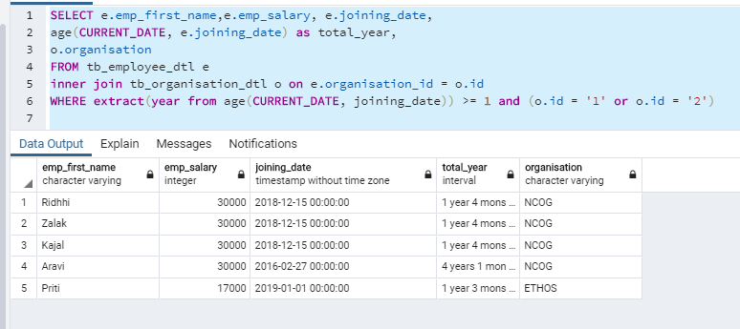

23. List all the Employees whose Name Start with (A,M,K,P) and end with (N,L,H) in Descending Order.

Query –

select emp_first_name

from tb_employee_dtl

where UPPER(emp_first_name) like 'A%'

or UPPER(emp_first_name) like 'M%'

or UPPER(emp_first_name) like 'K%' or UPPER(emp_first_name) like 'P%'

or UPPER(emp_first_name) like '%N'or UPPER(emp_first_name) like '%L'or UPPER(emp_first_name) like '%H'

ORDER BY emp_first_name DESC

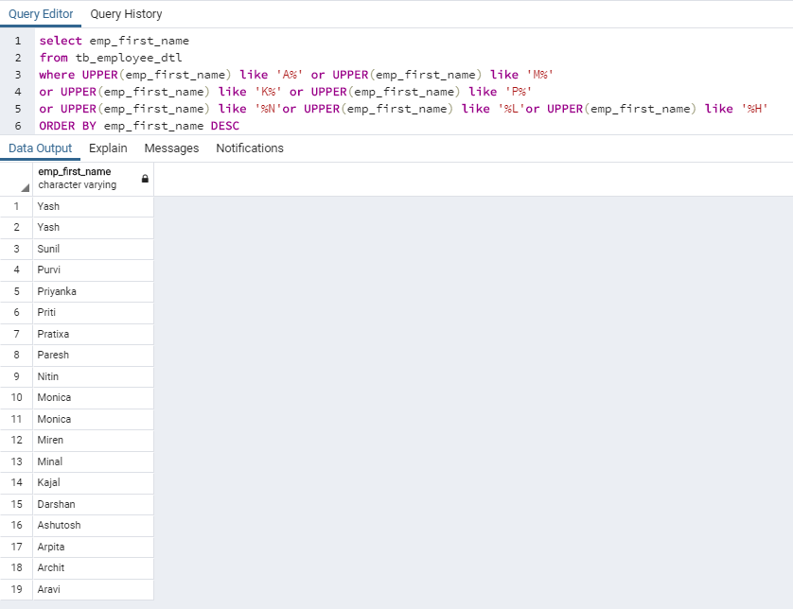

24. Find the number of counts of Employees in all Projects(Project wise count of employees).

Query –

select

count(ep.emp_id) as emp_count,

p.project_name

from tb_emp_project_dtl ep

inner join tb_project_dtl p on ep.emp_project_id= p.id

group by p.project_name

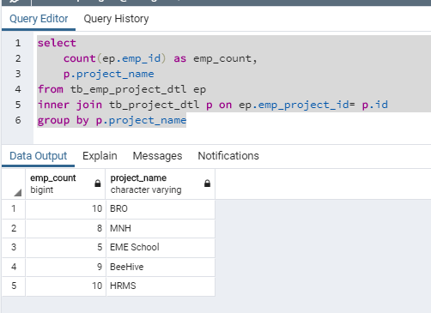

25. Write a SQL query to fetch Details Project Name,Employee name whose Designation is Team Leaders and counts of Employee under them.

Query –

select distinct p.project_name,e.emp_first_name as team_leader, a.emp_count as team_size

from tb_emp_project_dtl ep

inner join tb_project_dtl p on ep.emp_project_id= p.id

inner join tb_employee_dtl e on ep.emp_id = e.id

inner join tb_designation_dtl d on e.designation_id = d.id and d.id = 2

inner join (select count(emp_id) as emp_count,emp_project_id from tb_emp_project_dtl

group by emp_project_id) a on p.id = a.emp_project_id

group by e.emp_first_name, a.emp_count, p.project_name

order by e.emp_first_name

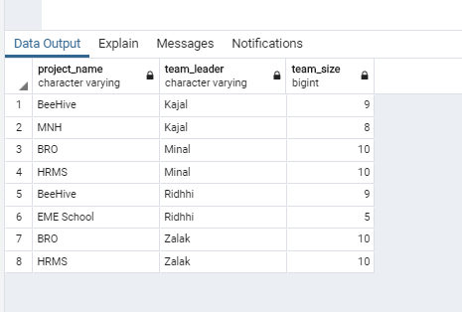

26. Find the details of the Team Leaders like his/her Name ,Age, organization, designation, salary, Experience and also they have more than one project.

Query –

select e.emp_first_name as team_leader,

EXTRACT(YEAR FROM age(CURRENT_DATE, e.emp_dob)) as emp_age,

o.organisation,

d.designation_name,

e.emp_salary,

(age(CURRENT_DATE, e.joining_date)) as experience

from tb_employee_dtl e

inner join tb_organisation_dtl o on e.organisation_id = o.id

inner join tb_designation_dtl d on e.designation_id = d.id and d.id = 2

inner join (select count(emp_project_id) as emp_count,emp_id from tb_emp_project_dtl

group by emp_id

having count(distinct emp_project_id) > 1) a on e.id = a.emp_id

order by e.emp_first_name

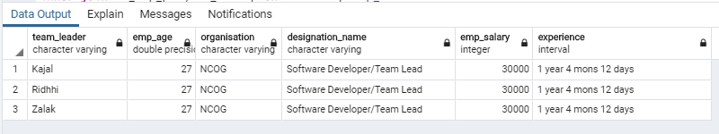

27. Write a query to fetch details of all employees excluding the employees who have less than one year of Experience.

Query -

SELECT emp_first_name,emp_salary, joining_date,

age(CURRENT_DATE, joining_date) as total_year

FROM tb_employee_dtl

WHERE extract(year from age(CURRENT_DATE, joining_date)) < 1

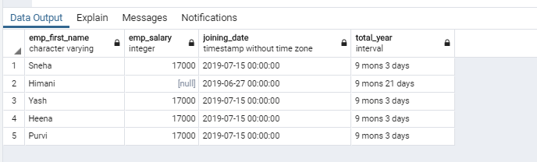

28. Write a query to fetch details of 5 Highest Experience having qualification in M.Tech/MCA and age should be greater than 25.

(Use Limit).

Query –

select e.emp_first_name,q.qualification_name,e.emp_dob,

EXTRACT(YEAR FROM age(CURRENT_DATE, e.emp_dob)) as b_year,

extract(year from age(CURRENT_DATE, joining_date)) as experience

from tb_employee_dtl e

inner join tb_qualification_dtl q on e.qualification_id = q.id and (q.id = '3' or q.id = '4')

where EXTRACT(YEAR FROM age(CURRENT_DATE, e.emp_dob)) > 25

order by experience desc

limit 5

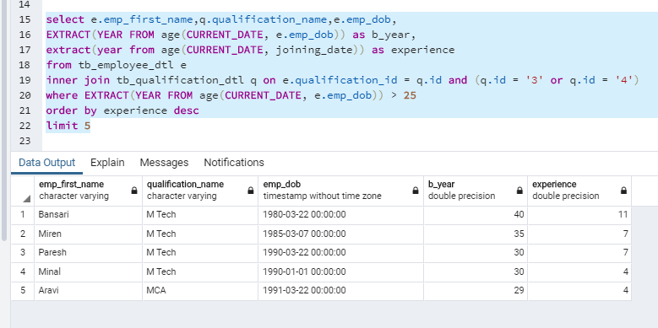

29. List of all the Employees with their name and Organization having total leaves of current Year is greater than 15 days and display result in ascending order of total leaves count.

Query –

select e.emp_first_name, o.organisation, l.no_of_leave as total_leaves

from tb_employee_dtl e

inner join tb_organisation_dtl o on e.organisation_id = o.id

inner join tb_leave_dtl l on e.id = l.emp_id

where l.no_of_leave > 15

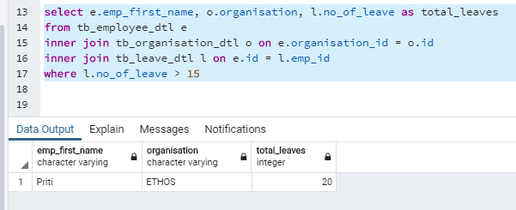

30. Write a query to fetch details that capture number of the leaves of all the employees of last month and it should be organization wise.

Query –

select distinct e.emp_first_name,

(select sum(l.no_of_leave) from tb_organisation_dtl o

inner join tb_leave_dtl l on e.id = l.emp_id and e.organisation_id = o.id

where e.organisation_id = '1'

) as ncog,

(select sum(l.no_of_leave) from tb_organisation_dtl o

inner join tb_leave_dtl l on e.id = l.emp_id

and e.organisation_id = o.id

where e.organisation_id = '2'

) as ethos

from tb_leave_dtl l

inner join tb_employee_dtl e on e.id = l.emp_id

inner join tb_organisation_dtl o on e.organisation_id = o.id

where extract(month from leave_to) = extract(month from(CURRENT_DATE - INTERVAL '1' MONTH))

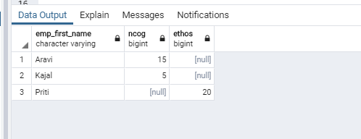

31. Write a query to fetch details Project wise like this for all Projects w.r.t the Number of Employees with their Highest Qualification and also include Security and Casual labors as a Other in Project Name.

Query –

select distinct p.project_name,

(select count(ep.emp_project_id) from tb_employee_dtl e

inner join tb_emp_project_dtl ep on e.id = ep.emp_id

and ep.emp_project_id = p.id

where e.qualification_id = '1') as ce,

(select count(ep.emp_project_id) from tb_employee_dtl e

inner join tb_emp_project_dtl ep on e.id = ep.emp_id

and ep.emp_project_id = p.id

where e.qualification_id = '2') as it,

(select count(ep.emp_project_id) from tb_employee_dtl e

inner join tb_emp_project_dtl ep on e.id = ep.emp_id

and ep.emp_project_id = p.id

where e.qualification_id = '3') as mca,

(select count(ep.emp_project_id) from tb_employee_dtl e

inner join tb_emp_project_dtl ep on e.id = ep.emp_id

and ep.emp_project_id = p.id

where e.qualification_id = '4') as m_tech

from tb_project_dtl p

inner join tb_emp_project_dtl ep on p.id = ep.emp_project_id

inner join tb_employee_dtl e on ep.emp_id = e.id

order by p.project_name

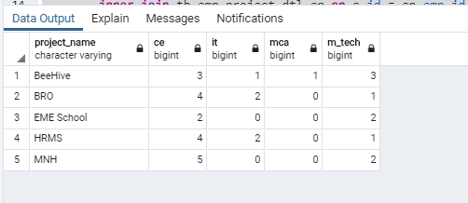

32. Name of Employee with Designation who is in multiple Projects(Exclude the Employee who is in single project) with Project Name. Conditions Applied Duplication of Employee Name but Not Project Name:

Query –

select

e.emp_first_name,

d.designation_name,

p.project_name

from tb_employee_dtl e

inner join tb_emp_project_dtl ep on e.id = ep.emp_id

inner join tb_project_dtl p on ep.emp_project_id = p.id

inner join tb_designation_dtl d on e.designation_id = d.id

where

ep.emp_project_id in (select emp_project_id from tb_emp_project_dtl group by emp_project_id

having count(distinct emp_id) > 1)

order by p.project_name

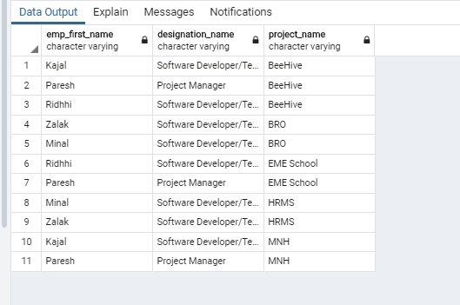

33. Create a Query which Display Name of Employee with Experience and their Designation will be based on this cases:

Case 1 :Employee whose

Experience > 8 and Qualification B.tech/M.tech is Project Manager

Case 2 :Employee whose

Experience > 6 and Qualification M.tech/MCA is Project Technical head.

Case 3 :Employee whoseExperience >= 2 and Experience <= 6 and Qualification M.tech/MCA/B.Tech is Team Leaders.

Case 4 :Employee whose

Experience >= 1 and Experience <= 2 and Qualification B.Tech is Developers.

Case 5 :Employee whose

Experience < 1 Qualification B.Tech/BCA is Junior Developers.

Case 6 :Employee whose

Experience > 3 Qualification Diploma is Network Group.

Case 7 :

Remaining are falls into “Others”

Query –

select distinct emp_first_name, age(CURRENT_DATE, joining_date) as experience,

(case

when qualification_id = 4 and

experience > 8 then 'Project Manager'

when qualification_id in (4,3) and

experience > 6 then 'Technical head'

when qualification_id in (4,3,2,1) and

experience >=2 and experience <=6 then 'Team Leaders'

when qualification_id in (4,3,2,1) and

experience >=1 and experience <=2 then 'Developers'

when qualification_id in (3,2,1) and

experience < 1 then 'Junior Developers'

when qualification_id = 5 and

experience > 3 then 'Network Group'

else 'Other' end ) as Designation

from (select e.joining_date,e.qualification_id,e.emp_first_name,extract(year from age(CURRENT_DATE, e.joining_date)) as experience

from tb_employee_dtl e ) as foo

where experience is not null

order by Designation

