We believe that BERT embeddings would be a good representation of text generated by the black card and white card combinations. However, BERT embeddings are 768 dimensional; since we have 500 white cards, 66 one slot black cards, and 12 two slots black cards, it makes a total more than 3 million combinations of these 768-dimensional embeddings. A neural network that takes in 768-dimensional features input is too big to be implemented on our server and storing them takes a lot of computational resources. For this reason, we turned to PCA to reduce the BERT embeddings into smaller dimension but equally rich text representations. Running PCA on 3 million embeddings is simply infeasible. Hence, we ran PCA on a dataset consists of 33000 combinations from the one-slot black cards and 33000 sample combinations from the two-slot black cards. Using the eigenvector matrix generated from this dataset, we generalize PCA to other combinations. As shown in the Figure 1, reducing the BERT embeddings into 69 dimension keeps 88.6 % of the original representation, which is desirable. To double check that our PCA works, we plotted a 3-dimensional PCA where each color represents a black card, as shown in Figure 2. Note that 3-dimensional PCA only keeps 21.6 % of the original information but the clusters are already visible, showing that similar meaning sentences do tend to cluster. Overall, the PCA approach looks promising and was therefore deployed in our final bot.

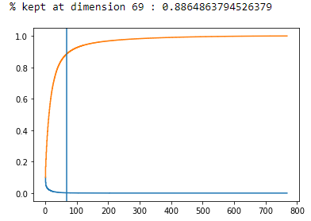

Figure 1

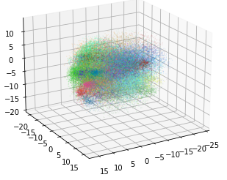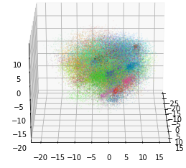

Figure 2 viewed from two different angles

Figures that may want to be added

