**Course Three Task3 Report**

**by**

**Shifeng (Steve) Li**

**03/05/2022**

In this project, the Blackwell Electronics historical sales data and new sales data sets are analyzed using R caret data analysis techniques to predict sales of difference product types, and access the impact the reviews have on sales.

1. **How the service review and customer reviews have the impact to the sales volume?**

From the quantified correlation analysis, found that the correlation value between 5-star customer review and sales volume is **1**, the correlation value between 4-star customer review and sales volume is **0.87**, the correlation value between 3-star customer review and sales volume is **0.76**, and the correlation value between PositiveService review and sales volume is **0.62**.

Therefore, the service review and customer reviews do have the impact to the sales volume. And the 5-star customer review has the highest impact.

1. **Can the new sales data set predict the sales of the PC, Laptop, Netbook, and Smartphone very well?**

To find out the answer, applied three different regression algorithms to do the machine learning process on the historical data set. Build the models with the Support Vector Machines algorithm, Gradient Boosting algorithm, and Random Forest algorithm. Then conducted the machine learning to collect the quantified prediction accuracy level for forecasting the four product types sales volume.

The following is the summary of the four product types’ sales volume prediction accuracy levels from the three models.

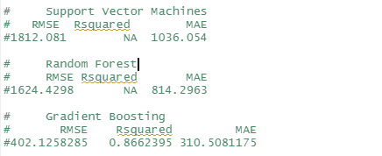

Based on the comparisons of the three models, the Gradient Boosting algorithm based model is chosen for doing the prediction of the four product types’ sales volume, using the new data set.

And here is the summary of the prediction of the four product types’ sales volume.

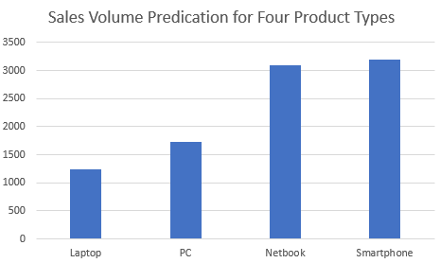

Also, the following chart shows how the service and customer reviews have the impact to the sales volume.

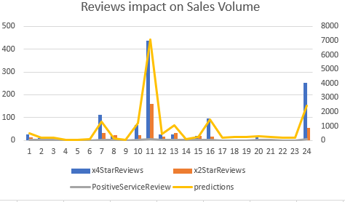

**Uploaded to: https://github.com/UTOct21DaPtSteve/Steve_Course3**