**Course Three Task4 Report**

**by**

**Shifeng (Steve) Li**

**03/07/2022**

In this project, we are going through the market basket association analysis on Electronidex’s transaction data. The study discoveries and findings will help Blackwell’s board of directors to better understand see Electronidex’s customer purchase pattern, and how the line items in the transactions are associated.

1. **Insightful Rules**

When applying the market basket association analysis on the Electronidex transaction dataset, by tuning the combination of the support and confident parameter values, identified a set of rules that have reasonable level of lift and confidence values. From these rules, have the following insights.

1) When transactions have line items like desktops and monitors, the transactions often have HP Laptop as the line item too.

2) When transactions have line items like desktops and monitors, the transactions often have iMac as the line item too.

3) In the cases as the above two categories, the chance that the transactions have the HP Laptop as the result is higher than having the iMac as the result.

**2. Visualization**

Using the itemFrequencyPlot, identified the relative item frequency that has 10 items illustrated as the following plot.

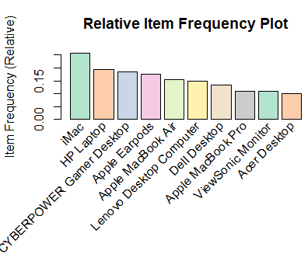

1. **Findings and Observations**

Among all the transactions, the following items are the most frequently sold items:

iMac sold in 2519 transactions out of 9835

HP Laptop sold in 1909 transactions out of 9835

CYBERPOWER Gamer Desktop sold in 1809 transactions out of 9835

Apple Earpods sold in 1715 transactions out of 9835

Apple MacBook Air sold in 1530 transactions out of 9835

Also, observed that, for all 9835 Electronidex’s transactions,in average, each transaction contains 4.83 line items.

1. **The values Electronidex’s transaction study can bring to Blackwell**

From studying the Electronidex’s transactions, found the pattern that when people buy the desktops, and monitors, they tend to buy HP Laptop or iMac too.

Also, the study found that iMac, and HP Laptop are the most frequently sold items in all Electronidex’s transactions, plus these two items are bundling with many other item types with the high confidence level in association rules, it can generate more sales if Blackwell can include iMac and HP Laptop in the selling items inventory.

Blackwell can certainly get valuable line item blending optimization from Electronidex’s transaction data study, but for whether or not for Blackwell to acquire Electronidex, there will be more factors to asses, such as operation cost, etc.

1. **Recommendations**

Based on the identified top life/confidence rules of the transaction line items association, suggest the following recommendations:

1. When launching advertising campaign, bundle Desktops, monitors with HP Laptop/iMac, to offer the attractive packages to cause more attention from the customers.
2. On the shelfs in the store, or on the online shopping web page, put the associated items together to maximize the chance for customers to drop the item into the shopping cart.
3. Dynamically generate discount/coupon when the checkout scanning line items appear to match to the items in the rules, that will help to encourage the customer to round up all associated items in the rules, to maximize the sales for Blackwell.

**Uploaded to: https://github.com/UTOct21DaPtSteve/Steve_Course3**