OrgHub – Option1 Proposal

1. Requirements covered
- Cross-organization overview with color-coded events grouped by organization/date and a total upcoming-event count.
- Organization-scoped event creation, editing, removal, organizer/date/time details, and meeting-type filtering.
- Independent organization details: name, contact email, color, and notification style.
- Organization-scoped members with position/rank, plus add, edit, and remove member workflows.
- Organization drop-down switches context without mixing events or members across organizations.
- Complete authentication flow: Login and Create Account screens, with data associated with the signed-in account.
- Elevated role assignment (such as Officer) restricted to authorized Admin users and checked outside the UI.

2. Model classes

Account
Attributes: accountId: UUID, name: String, email: String, passwordHash: String, role: AccountRole. Methods: authenticate(email,password): boolean; updateProfile(name,email): void. Represents an app user. Store a password hash, not a plain-text password.

Organization
Attributes: organizationId: UUID, name: String, contactEmail: String, colorCode: String, notificationStyle: NotificationStyle. Methods: updateDetails(...): void; getUpcomingEventCount(): int. Stores organization-specific details and preferences.

Membership
Attributes: membershipId: UUID, account: Account, organization: Organization, memberName: String, position: String, role: OrganizationRole. Methods: updateDetails(...): void; canAssignRole(...): boolean. Connects an account to an organization; lets the same person have different roles in different organizations.

Event
Attributes: eventId: UUID, organization: Organization, title: String, description: String, organizer: String, dateTime: LocalDateTime, meetingType: MeetingType. Methods: updateDetails(...): void; isUpcoming(): boolean. Each event belongs to one organization.

UserSession
Attributes: currentAccount: Account. Methods: signIn(account): void; signOut(): void; isAuthenticated(): boolean. Tracks the signed-in account for the active application session.

3. Relationships and multiplicity
- Organization 1 — 0..* Event: an organization may have many events; each event belongs to exactly one organization.
- Organization 1 — 0..* Membership: an organization may have many memberships; each membership belongs to one organization.
- Account 1 — 0..* Membership: an account may participate in multiple organizations through separate membership records.
- UserSession holds the currently authenticated Account while the session is active.
- Membership is separate from Account because a person may have a different rank in each organization.

4. UML class diagram
Solid associations represent model relationships; dashed arrows represent controller/service dependencies.
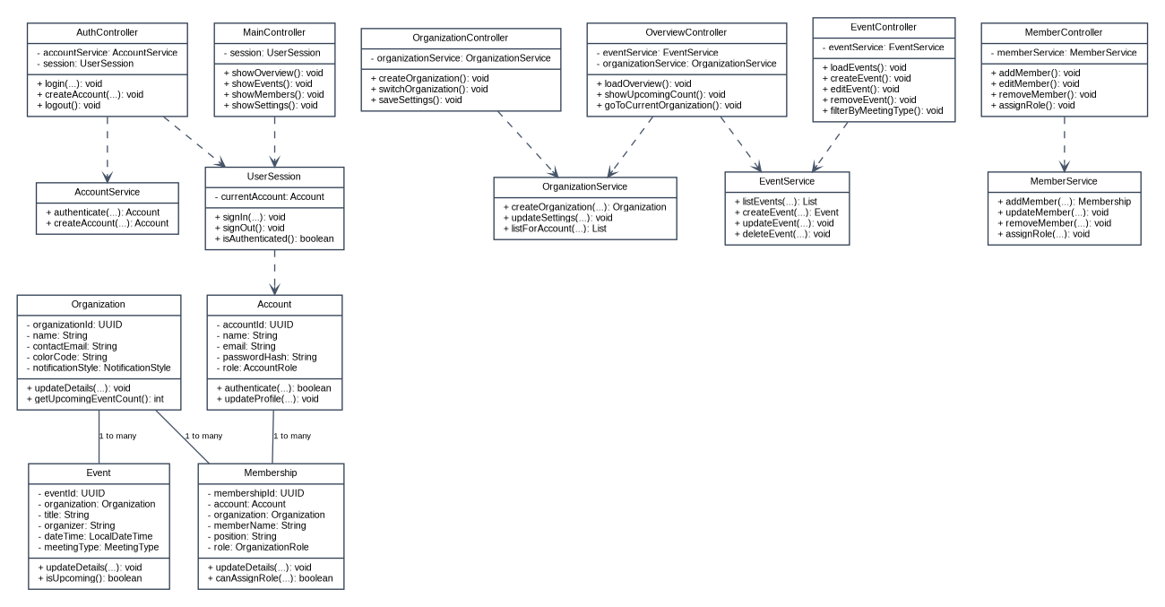

5. Controllers and services

AuthController
Fields: AccountService, UserSession. Methods: login(...), createAccount(...), logout(). Validates form data and routes the user after successful authentication.

MainController
Fields: UserSession. Methods: showOverview(), showEvents(), showMembers(), showSettings(). Coordinates navigation and selected-organization context.

OverviewController
Fields: EventService, OrganizationService. Methods: loadOverview(), showUpcomingCount(), goToCurrentOrganization(). Displays color-coded cross-organization events and count.

EventController
Fields: EventService. Methods: loadEvents(), createEvent(), editEvent(), removeEvent(), filterByMeetingType(). Ensures actions use the selected organization.

OrganizationController
Fields: OrganizationService. Methods: createOrganization(), switchOrganization(), saveSettings(). Manages organization selection and editable settings.

MemberController
Fields: MemberService. Methods: addMember(), editMember(), removeMember(), assignRole(). Exposes role assignment only to authorized admins and supports editing existing members.

Recommended service classes
- AccountService — authenticate(email,password): Account; createAccount(...): Account. Enforces unique email and verifies password hashes.
- OrganizationService — createOrganization(...): Organization; updateSettings(...): void; listForAccount(account): List<Organization>. Returns only organizations the account may access.
- EventService — listEvents(organization): List<Event>; createEvent(...): Event; updateEvent(...): void; deleteEvent(...): void. Validates organization scope.
- MemberService — addMember(...): Membership; updateMember(...): void; removeMember(...): void; assignRole(...): void. Enforces authorization, including Admin-only elevated role assignment.

6. FXML view plan
- login-view.fxml — Controller: AuthController. Email/password fields, Login button, link to Create Account.
- create-account-view.fxml — Controller: AuthController. Name, email, password and confirmation fields, Create Account button, link back to Login.
- main-view.fxml — Controller: MainController. Application shell, navigation, organization selector, and content area.
- overview-view.fxml — Controller: OverviewController. Color-coded events grouped by organization/date, upcoming total, Go to Current Organization button.
- events-view.fxml — Controller: EventController. Current organization’s event list, meeting-type filter, Create/Edit/Remove actions.
- members-view.fxml — Controller: MemberController. Current organization’s member list, Add/Edit/Remove controls, permission-aware role editing.
- organization-settings-view.fxml — Controller: OrganizationController. Organization name, contact email, color, and notification style.
- event-form-view.fxml — Controller: EventController. Reusable create/edit form for title, organizer, date/time, description, and meeting type.
- member-form-view.fxml — Controller: MemberController. Reusable add/edit form for member name, position, and role; elevated roles restricted to authorized admins.

7. Security and design rules (the -5 pts. on the submission notes from the Project Proposal)
- New accounts should not automatically receive app-wide Admin privileges.
- MemberService must verify permissions before assigning Officer/Admin roles; hiding a UI control alone is not security.
- Every event and member query must be scoped to the selected organization and to organizations the signed-in account may access.
- Switching organizations changes the active context; it must not merge or overwrite other organizations’ data.
- Editing a member updates the existing Membership record rather than creating a duplicate.
- Confirm whether Admin is an app-wide role, an organization-level role, or both. This proposal separates AccountRole from OrganizationRole to avoid accidentally granting global privileges.

8. Example interaction flows
Login: login-view.fxml → AuthController.login → AccountService.authenticate → UserSession stores account → main-view.fxml.
Create event: Events tab → EventController → EventService validates selected organization → save event → refresh Events and Overview.
Assign Officer: member form → MemberController → MemberService checks current organization’s Admin permission → update role or reject request.
Switch organization: organization selector → OrganizationController/MainController updates selected context → Events and Members reload for that organization only.

