United States of America
Estimation of Radar Linear Frequency Modulation (LFM) bandwidth at the -40 dB point

Introduction
Unwanted emission masks in the out-of-band domain for radiodetermination radar systems are contained in Recommendation ITU-R SM.1541, Annex 8. The ITU-R out-of-band (OOB) emission masks for primary radars systems are intended to recommend an acceptable degree of electromagnetic compatibility among radar systems, and between such systems and those of other radio services sharing the frequency spectrum.
In the development of the out-of-band emission masks for radiodetermination radar systems, it was the view of several administrations that there was a need to further investigate the state-of-the-art radar systems and their ability to suppress unwanted emissions. This review of radar unwanted emissions in the out-of-band domain is to be completed by 2006. See Recommendation ITU-R SM.1541, Annex 8, Note 3.

The outstanding issue concerns the “design objectives” highlighted in this document. This “design objective” concerns the possibility of making more stringent the requirement for radars with regard to the “roll-off" of out of-band (OOB) emissions.

This document describes the derivation of a proposed equation designed to approximate radar spectral bandwidth at the -40 dB below normalized waveform spectrum magnitude for Linear Frequency Modulation pulse and compares it to the theoretical FFT calculations.

Equation Derivation Steps and Assumptions
The following paragraphs have short descriptions of the steps taken to derive the proposed B_{-40dB} equation along with the necessary assumptions.

The assumptions are:
- The shapes of pulses are trapezoidal with finite rise and fall times.
- The pulse modulation is Linear Frequency Modulation (LFM).
- Pulse rise and fall times vary between 0.00004% and 50% of waveform pulse width duration.
- Chirp bandwidths vary between 0.375 MHz and 8 880 MHz.
- Compression ratios vary between 10 and 13 320 000.
- The minimum waveform compression ratio to a value is 10.
The analysis steps taken are:
- Identify a broad set of radar systems from ITU recommendations, real operational radars and possible radar waveform designs derived from reference (2).
- Eighty (80) radar systems are used in this analysis, with varying pulse width, bandwidth and rise and fall times as shown in the assumptions list.
- Compute the spectrum using FFT routine.
- Record the FFT results for the frequency bandwidth at the 40 dB point below the normalized maximum.
- Derive equations based on curve fit to the theoretical B₋₄₀ dB values
- Refine equation until the resulting estimates are bounded within ±9% of the theoretical FFT results.
- Compute and plot results.

The Proposed Equation:
The proposed equation attempts to compare to the theoretical FFT results. There are no margin or implementation factors included in the formula. The new B_{-40dB} is given by:

EQ-1

Where,
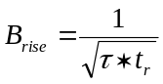 | To account for the rise time | EQ-2
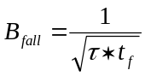 | To account for the fall time | EQ-3
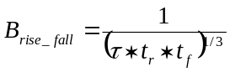 | To account for both the rise and fall times combination | EQ-4
τ | Pulse length (us) including rise and fall times
t_{r} | Pulse rise time (us)
t_{f} | Pulse fall time (us)
B | LFM bandwidth (MHz)
π | 3.141592654…..
R | 1 (Constant reserved for possible future use or more refinement)
N | 1 (Constant reserved for possible future use or more refinement)

From the calculated results it was determined that the condition of 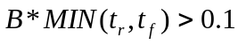
is necessary to obtain required results.
Results
The result of the proposed formula is compared with the theoretical FFT results as shown in Figure-1 below. The results track well with the FFT with a maximum error of ±9%:
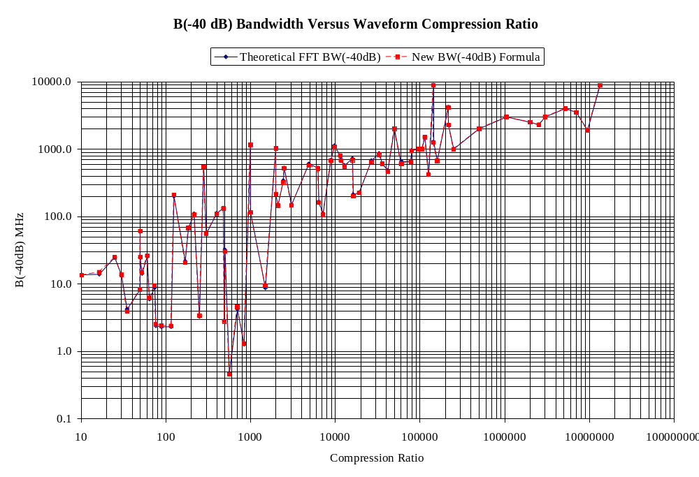
Figure 1: Results of FFT compared to proposed formula

Recommendations
The proposed formula provides good results as compared to the FFT for all the cases tested. It is recommended that this formula be further investigated as a potential first step to introducing the B(-40dB). The necessary radar waveform implementation factors, if needed, are to be determined in future work.

References
The following references are used:
- Report 837 Methods for Calculating Pulsed Radar Emission Spectrum Bandwidth (Document JRG-10).
- Skolnik, Radar Handbook 2nd Edition 1990, Table 10.2 Page 10.13

