Attachment 2

DOE Balances to be Recast by CID Report

The report is located in the GL Inquiry responsibility under Reports -> Request Standard -> Single Request.

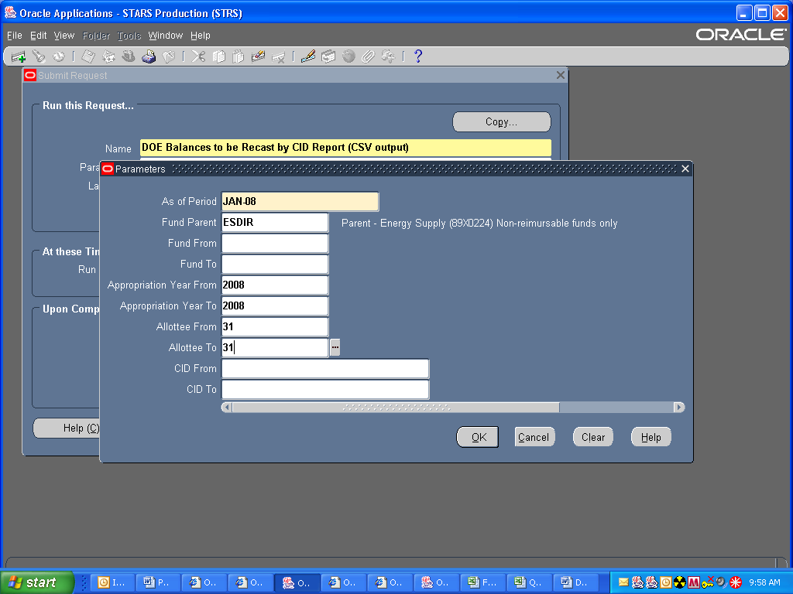

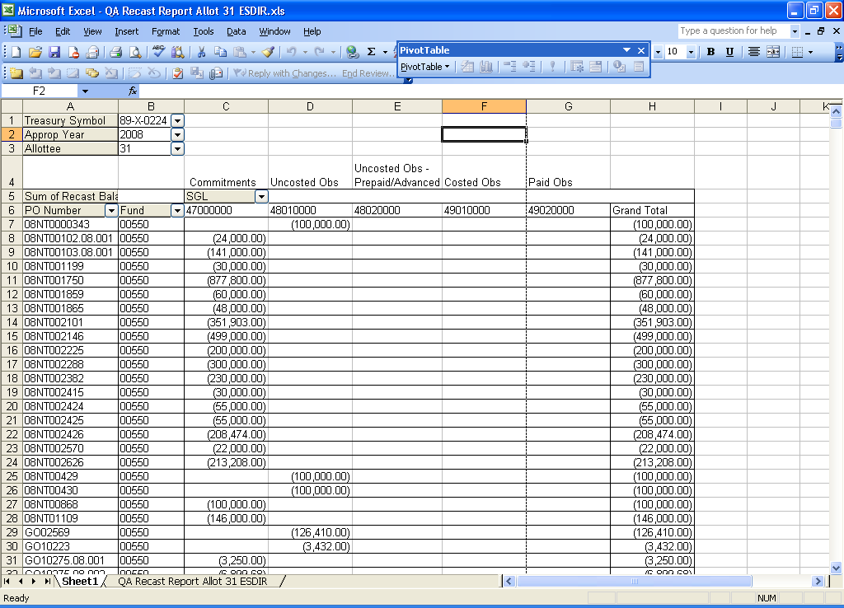

For the FY 2008 recast of 89X0224, you will want to run the report with the “ESDIR” parent fund to get all the funds except for those associated with reimbursable work. For the other TAFS being recast, you will want to use the crosswalk in Attachment 1 to run the report for certain funds and only pull out certain Program Values in the pivot table.

Uncosted Obs = SGLs 4801 and 4881
Costed Obs = SGLs 4901 and 4981
Paid Obs = SGLs 4802, 4882, 4902 and 4982

