
Contract Holder

Schedule for Environmental Services

Federal Supply Group 899

Class F999

FSS Contract GS—10F-0459R

September 1, 2005 through August 31, 2010

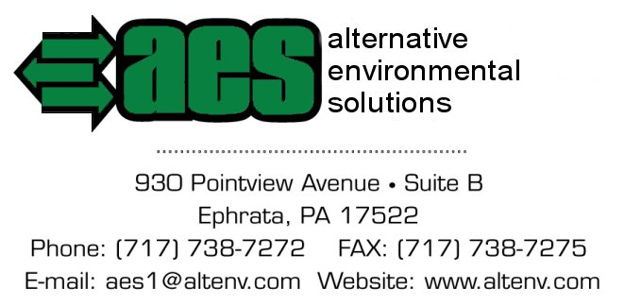

providing quality, client-centered environmental solutions

Business Size: Small
Contract Administration: John Ward
Email: jward@altenv.com

On-line access to contract ordering information, terms and conditions, up-to-date pricing, and the option to create an electronic delivery order is available through GSA Advantage!, a menu-driven database system. The INTERNET address for GSA Advantage! is: http://www.GSAAdvantage.gov.

For more information regarding ordering from Federal Supply Schedules click on the FSS Schedules button at
http://www.fss.gsa.gov

Mission Statement
Company Profile / Services
Contract Information
Customer Information
Labor Category
- • 899 - 1 Environmental Planning Services & Documentation
- • 899 - 2 Environmental Compliance Services
- • 899 - 8 Remediation Services
Web Site
Case Studies
Price List

Full service environmental and geologic solution providers focused on value added property assessment, development, restoration, and remediation.


Company Profile / Services

Alternative Environmental Solutions, Inc. (AES) is a small business that was formed in mid-1997 to provide quality and effective environmental solutions for its clients. Since that time, AES has distinguished itself in the regional environmental field and as a testament to its success, over 80-percent of our new work comes into our company as a direct result of repeat business and client referrals - loyal clients.

As a full service environmental management company, AES accurately assesses our client’s needs and develops specific technical strategies to address those requirements. Our highly experienced staff of professional geologists and scientists with successfully addressing a variety of environmental issues, including the following:
- ASTM-standard Phase I Environmental Site Assessment
- Site Characterization
- Site Environmental Analysis/Feasibility Study
- Underground Storage Tank (UST) installation/removal
- Soil and/or groundwater remediation
- Pilot Studies
- Remedial system design, installation, and operation
- Brownfields / Site Redevelopment
- Environmental Alternatives Analysis
- Risk Assessments
- Waste Management and Minimization
- Environmental Compliance
- Asbestos and Indoor Air Quality
- Geologic and Hydrogeologic Consulting Services

Throughout our efforts, you can rely on the fact that AES will utilize registered Pennsylvania-licensed geologists and experienced professional staff. In keeping with our client-centered philosophy, we provide you with a seamless transition from one stage of a project to another. This approach is a departure from traditional task-oriented methods, and minimizes the affect on our clients’ resources. Ultimately, it leads to quality, client-centered environmental solutions.

For more information on AES services please visit the below links.
Characterization / Remediation Services
Land Development Support Services
Other services

Home Page
Mission Statement

Contract Information
Customer Information

Labor category
Web Site

Case Studies
Price List

Contract Information

Home Page

Schedule for Environmental services
Federal Supply 899 Class: F999 Contract Number: GS-10F-0459R
Group: For more information on ordering from Federal Supply Schedules click on the FSS Schedules button at http://www.fss.gsa.gov

Contract Period: September 1, 2005 through August 31, 2010
Contractor: Alternative Environmental Solutions, Inc.
930 Pointview Avenue Suite B
Ephrata, PA 17522
Business Size: Small Business
Telephone: 717.738.7272
FAX Number 717.738.7275
Web Site: www.altenv.com
Contract Admin: John Ward
E-mail: jward@altenv.com

Mission Statement
Company Profile / Services

Customer Information
Labor Category
Web Site
Case Studies
Price List

Customer Information

1a. Table of Awarded Special Item Number(s) with appropriate cross-reference to page numbers: 899-1, 899-2 and 899-8
1b. Identification of the lowest priced model number and lowest unit price for that model for each special item number awarded in the contract. This price is the Government price based on a unit of one, exclusive of any quantity/dollar volume, prompt payment, or any other concession affecting price. Those contracts that have unit prices based on the geographic location of the customer, should show the range of the lowest price, and cite the areas to which prices apply.
1c. If the Contractor is proposing hourly rates a description of all corresponding commercial job titles, experience, functional responsibility and education for those types of employees or subcontractors who will perform services shall be provided. If hourly rates are not applicable, indicate “Not applicable” for this item.
2. Maximum Order: $5,000,000.00
3. Minimum Order: $100.00
4. Geographic Coverage (delivery Area): Domestic only
5. Point(s) of production (city, county, and state or foreign country): Same as company address
6. Discount from list prices or statement of net price: Government net prices (discounts already deducted). See Attachment
7. Quantity discounts: None Offered
8. Prompt payment terms: 5% - 30 days
9a. Notification that Government purchase cards are accepted at or below the micro-purchase threshold: Yes
9b. Notification whether Government purchase cards are accepted or not accepted above the micro-purchase threshold: will accept over $2,500
10. Foreign items (list items by country of origin): None
11a. Time of Delivery (Contractor insert number of days): Specified on the Task Order
11b. Expedited Delivery. The Contractor will insert the sentence “Items available for expedited delivery are noted in the price list.” under this heading. The Contractor may use a symbol of his choosing to highlight items from its price list that have expedited delivery: Contact Contractor
11c. Overnight and 2-day delivery. The Contractor will indicate whether overnight and 2-day delivery are available. Also, the Contractor will indicate that the schedule customer may contact the Contractor for rates for overnight and 2-day delivery: Contact Contractor
11d. Urgent Requirements. The Contractor will note in its price list the “Urgent Requirements” clause of its contract and advise agencies that they can also contact the Contractor’s representative to effect a faster delivery: Contact Contractor
12. F.O.B. Points(s): Destination
13a. Ordering Addresses(es): Same as company address
13b. Ordering procedures: For supplies and services, the ordering procedures, information on Blanket Purchase Agreements (BPA’s), and a sample BPA can be found at the GSA/FSS Schedule homepage ( fss.gsa.gov/schedules).
14. Payment address(es): Same as company address
15. Warranty provision: Contractor’s standard commercial warranty
16. Export Packing Charges (if applicable): N/A
17. Terms and conditions of Government purchase card acceptance (any thresholds above the micro-purchase level): Contact Contractor
18. Terms and conditions of rental, maintenance, and repair (if applicable): N/A
19. Terms and conditions of installation (if applicable): N/A
20. Terms and conditions of repair parts indicating date of parts price lists and any discounts from list prices (if applicable): N/A
20a. Terms and conditions for any other services (if applicable): N/A
21. List of service and distribution points (if applicable): N/A
22. List of participating dealers (if applicable): N/A
23. Preventive maintenance (if applicable): N/A
24a. Special attributes such as environmental attributes, (e.g., recycled content, energy efficiency, and/or reduced pollutants):
24b. If applicable, indicate that Section 508 compliance information is available on Electronic and Information Technology (EIT) supplies and services and show where full details can be found (e.g. contractor’s website or other location.) The EIT standards can be found at: www.Section508.gov/.
25. Data Universal Numbering System (DUNS) number: 04-8121110
26. Notification regarding registration in Central Contractor Registration (CCR) database: Registered

Labor Category

Home Page
Case Studies
Mission Statement
• 899 - 1 Environmental Planning Services & Documentation
Services include but are not limited to: Environmental Assessments and Environmental Impact Statements under the National Environmental Policy Act (NEPA); Endangered Species, Wetlands, Watersheds and other Natural Resource Management Plans; Archeological and/or Cultural Resource Management Plans; Environmental Program Management and Environmental Regulation Development; Economic, Technical and/or Risk Analysis, and other environmentally related studies and/or consultations; Homeland Security issues including vulnerability assessments, biochemical protection, identification of threats and protective measures to mitigate the threats, and Crime Prevention Through Environmental Design (CPTED) surveys.

• 899 - 2 Environmental Compliance Services
Services include but are not limited to: Environmental Compliance Audits; Compliance Management and/or Contingency Planning; Permitting; Spill Prevention/Control and Countermeasure Plans; Pollution Prevention Surveys; ISO 14000/Environmental Management Systems (EMS); and Community Right to-Know Act reporting.

- 899 - 8 Remediation Services
Provide the full range of methods and technologies supporting activities necessary for Remediation Services to the extent allowed by the Service Contract Act under FAR 37.3 in accordance with host nation, federal, state, and/or local statutes and regulations. Remediation Services include, but are not limited to, excavation, removal, remediation related laboratory testing, transportation, storage, treatment and/or disposal of hazardous waste in. Also, preparation, characterization, field investigation, conservation and site closures; wetland restoration, emergency response, UST/AST removal, air monitoring, soil vapor extraction, stabilization/solidification, bio-venting, carbon absorption, reactive walls, containment, monitoring and /or reduction of hazardous waste sites as well as ordnance removal and support. Remediation contractors shall conform to environmental permits, decision document requirements or other legal requirements. Examples include but are not limited to: Excavation, removal, manifesting, transportation, storage, treatment (on-site and off-site) and/or disposal of hazardous waste.

Company Profile / Services
Contract Information
Customer Information
Web Site

Price List

Home Page
Price List
SIN 899 - 1 Environmental Planning Services & Documentation
SIN 899 - 2 Environmental Compliance Services
SIN 899 - 8 Remediation Services

Mission Statement
Company Profile / Services

Contract Information
Customer Information

Labor Category
Web Site

Case Studies

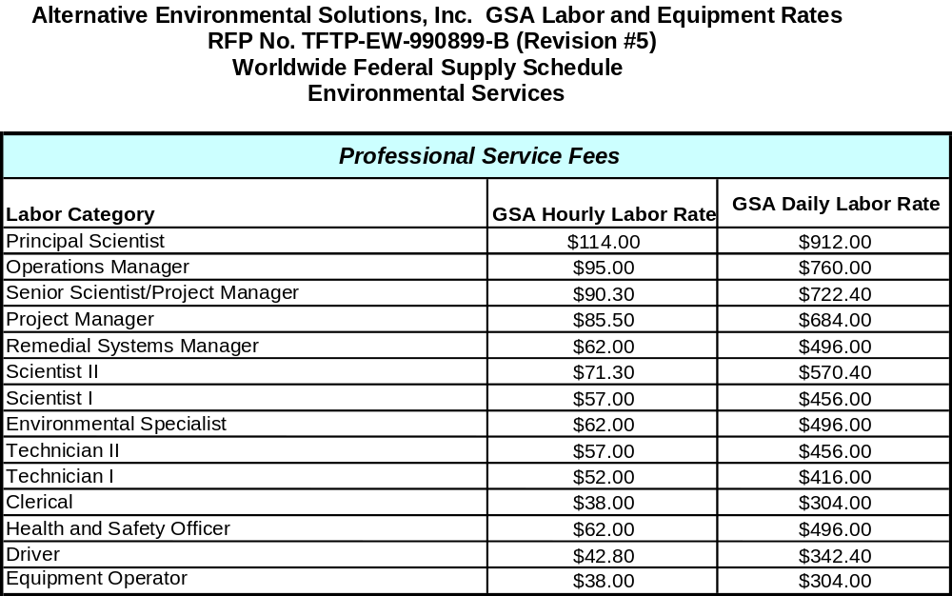

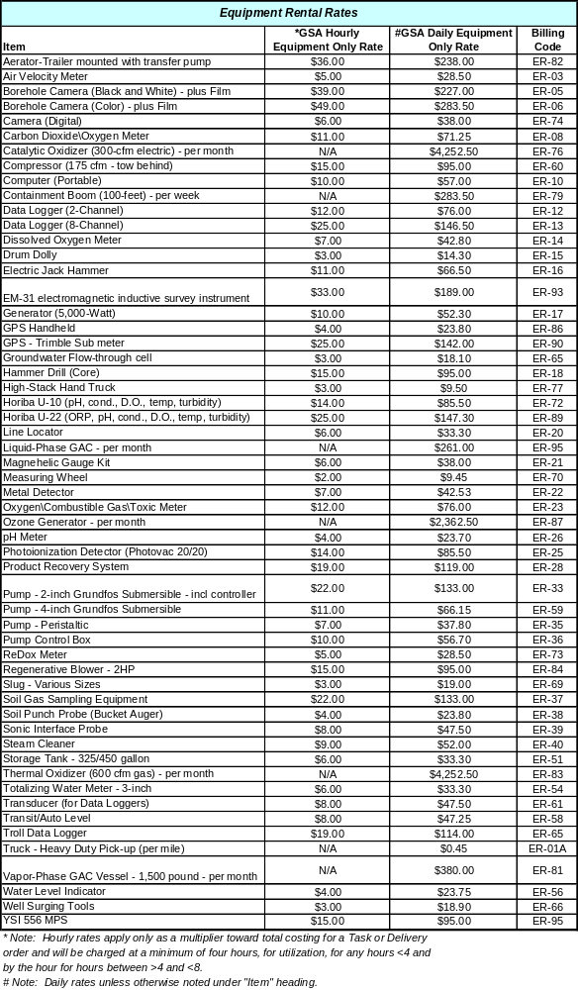

Continue Price List

Pricing (continued)

