**Objective 2: Installing Speccy to identify the specification of the PC like RAM, CPU, Hard Disk, OS etc.**

1. CPU Specification:

1. RAM Specification:

1. Hard Disk Specification:

1. Operating System Specification:

1. Graphics Specification:

**Objective 3: Basic commands used in MS-DOS:**

1. **DIR:**

Display a list of files and subdirectories in a directory.

1. **CD:**

Change the current working directory.

1. **MD:**

Create a new directory.

1. **RD:**

Remove a directory.

1. **COPY:**

Copies one or more files from one directory to another.

1. **DEL:**

Deletes one or more files.

1. **TYPE:**

Displays the content of the file.

1. **REN:**

Rename a file or directory.

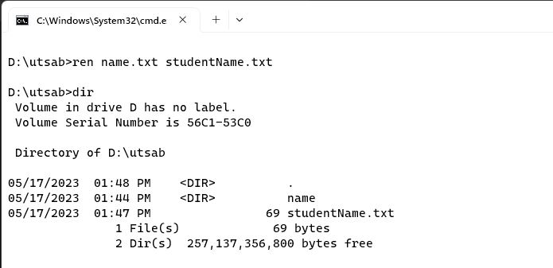

1. **ATTRIB:**

Displays or changes the attribute of a file.

1. **DATE:**

Show or change current date.

1. **EXIT:**

Exit the terminal.

**Conclusion:**

Hence, the objectives of the lab were successfully completed.