**Output:**

**Conclusion:**

Hence the objective of the lab were successsfully implemented.

**Output:**

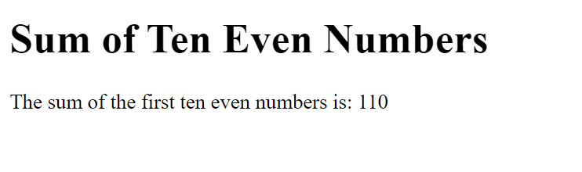

**Figure 3: Sum of first ten even number**

**Figure 2: Greatest among three number**

**Figure1: Positive, Negative or Zero**

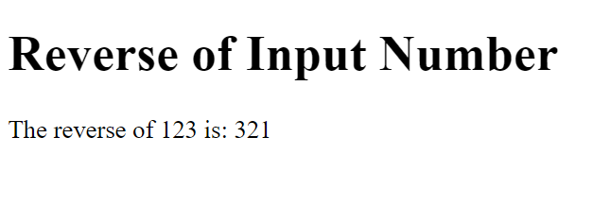

**Figure 4: Reverse of input number**

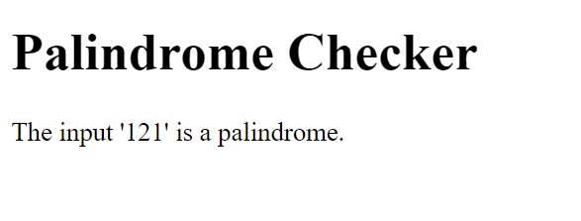

**Figure 5: Palindrome or not**

**Conclusion:**

Hence the objective of the lab was successsfully implemented.

|  |  |  |
| --- | --- | --- |
|  |  |  |
|  |  |  |
|  |  |  |
|  |  |  |
|  |  |  |
|  |  |  |