**Output:**

From.html

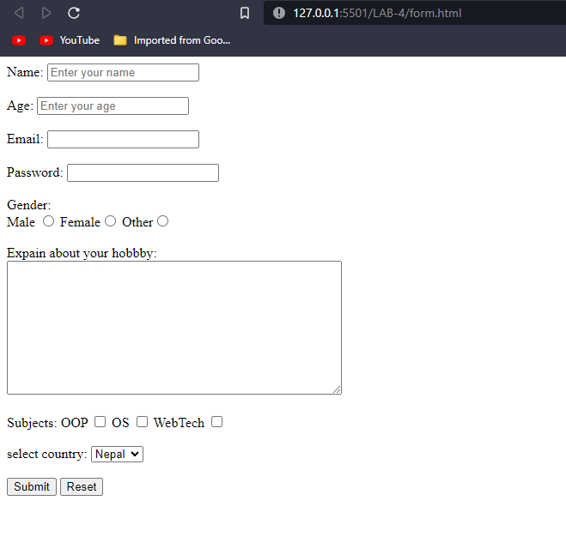

**Conclusion:**

Hence the objectives of the lab were successfully implemented in HTML.