**Output:**

index.html

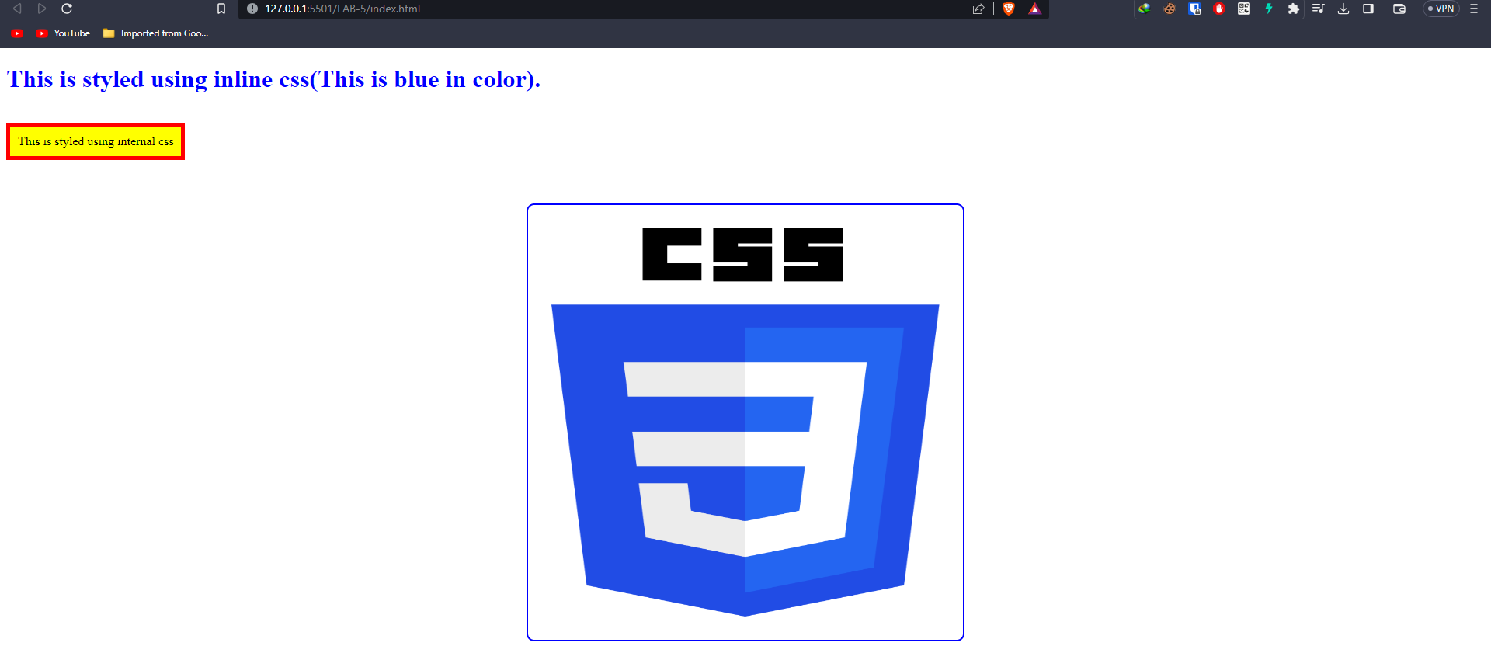

**Conclusion:**

Hence the objectives of the lab were successfully implemented using HTML and CSS.