**Output:**

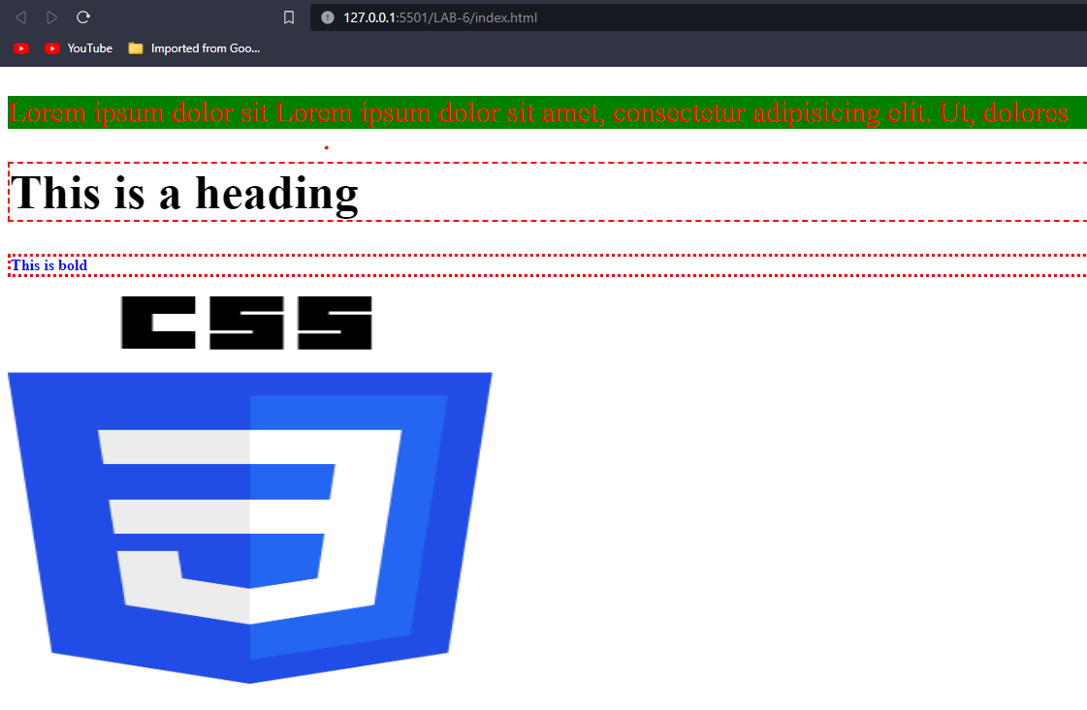

**Conclusion:**

Hence the objective of the lab were successsfully implemented.

**Output:**

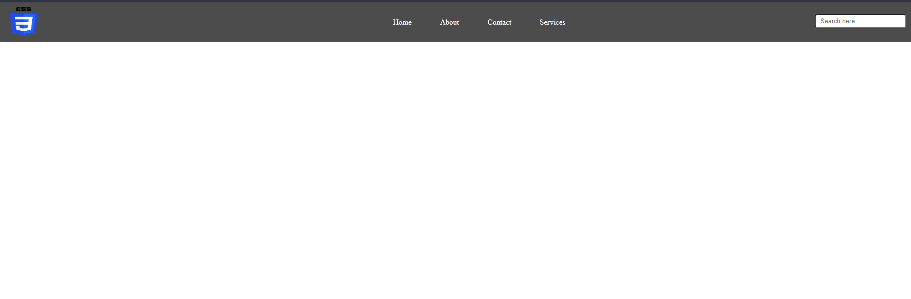

**Conclusion:**

Hence the objective of the lab was successsfully implemented.

**Output:**

Homepage:

Register page:

Login page:

Contact page:

**Conclusion:**

Hence the objective of the lab were successsfully implemented.

**Output:**

Between 1200-800 pixel:

Between 799-500 pixel:

Below 499 pixel:

**Conclusion:**

Hence the objective of the lab were successsfully implemented.