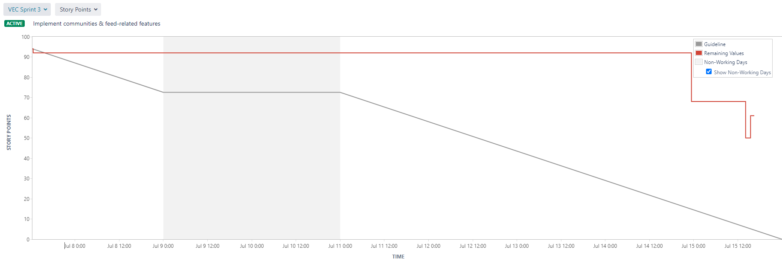

**Explanation:**

The burndown chart for sprint 2 is characterized by a plateau with a small spike up near the end. The small spike can be attributed to the addition of a new sub task and in turn, addition of new story points. The dips near the end of the sprint are misleading as they would indicate that the allocated tasks for the sprint were being worked on only near the end of the sprint. In reality, the tasks were split up into 3-4 subtasks and distributed amongst the team members. The subtasks were being completed by team members incrementally and when all subtasks for a task were completed, that task would then be marked completed as well. Furthermore, since some subtasks depend on other subtasks, it would usually take the length of the whole sprint to complete all the subtasks for a specific task.

**Velocity:**

Our velocity for the previous sprint was 74 while the velocity for our current sprint is 94. We decided to increase the velocity as team members would not be dragged down by the difficulties of learning the technologies they would be working with (which was a prevalent issue in the previous sprint). Furthermore, a lot of the parts worked on in this sprint were similar to the parts from the previous sprint and so, team members had an easier time producing work.