**Schedule**

[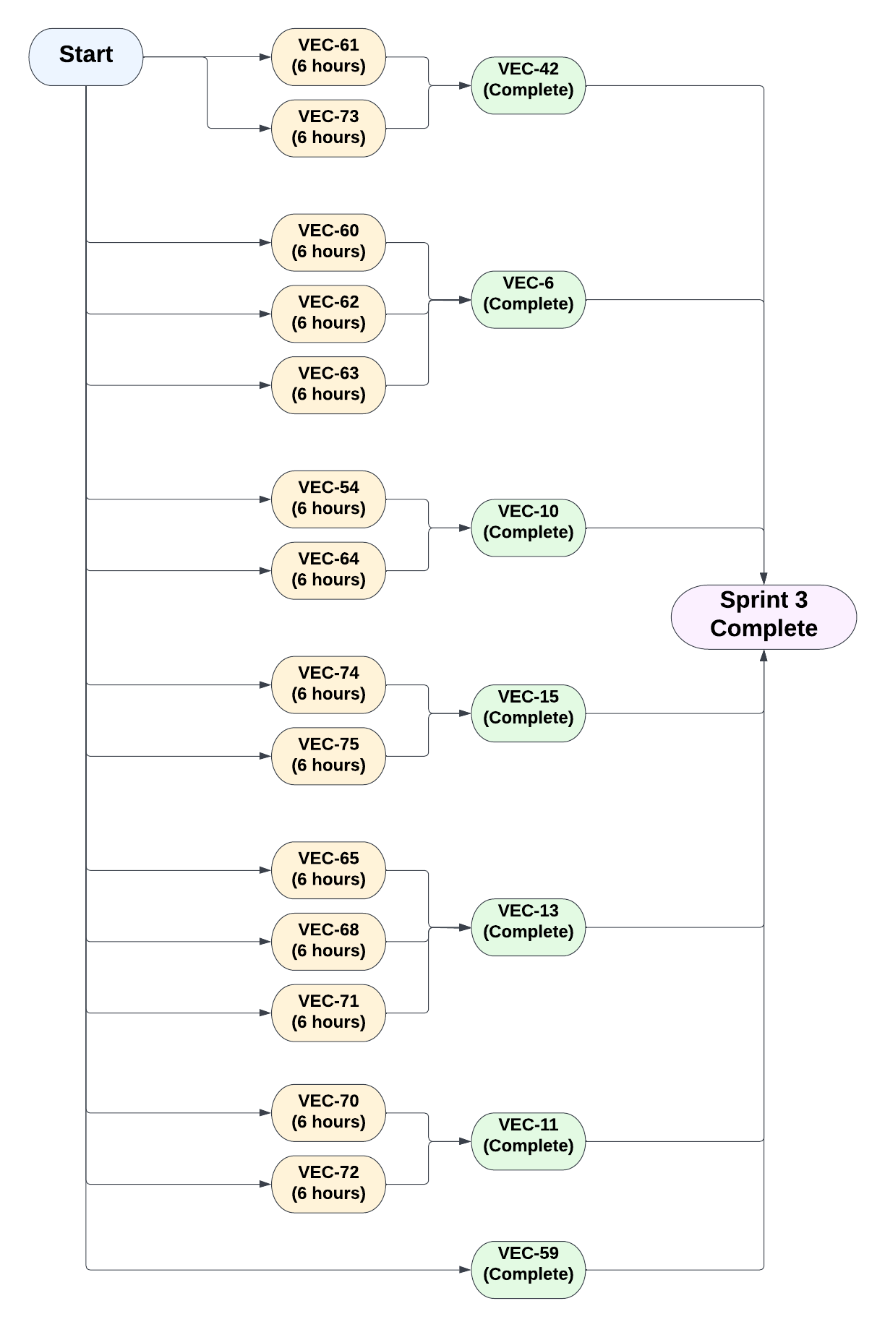](https://lucid.app/documents/edit/bed46cb1-55ff-456b-96ad-ee6493b4f7c2/0?callback=close&name=docs&callback_type=back&v=552&s=612)

**The critical path is in bold and red.**

To prevent delays within our deliverables and to ensure that all members of the team had tasks to work on consistently, we held frequent meetings to find out what the blockers are to team members’ tasks and actively deal with these impediments as soon as possible. Each member of the team was also assigned to some independent tasks that do not depend on the completion of some other task, this is such that each member would be able to work on those given tasks when the completion of the dependencies of their other tasks are currently in progress.