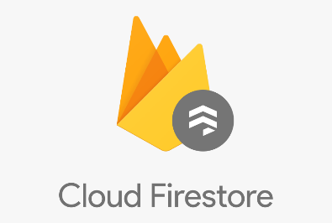­­

Auth microservice

Front End React App

**JAMStack Style application.**

<https://jamstack.org/>

<https://www.netlify.com/jamstack/>

Hashed user password

User Login unique identifier

User content & data

Authorized user info

Database

Cloud file storage

Authorized user info

Login details