Untitled

# Make a table

Create a subset of the mtcars data.

library(data.table)  
library(tabulizer)  
library(tabulizerjars)  
  
pdf.file <- "~/AnnualReports/data/02UndergraduateCostOfAttendance.pdf" # Define path to PDF file  
pdf.dat <- extract_tables(pdf.file) # Extract data table  
# Coerce output matrix to data.frame  
# pdf.tbl <- data.frame(pdf.dat[[1]][-1, ])  
pdf.tbl <- data.table(pdf.dat[[1]][-1, ]) # Coerce output matrix to data.table  
names(pdf.tbl) <- pdf.dat[[1]][1, ]  
names(pdf.tbl)[1]<-"Description"  
pdf.tbl[, c(2:11)] <-lapply(pdf.tbl[, c(2:11)], function(y) as.numeric(gsub('[^a-zA-Z0-9.]', '', y)))  
pie(table(pdf.tbl[2:5,11])) # create pie chart

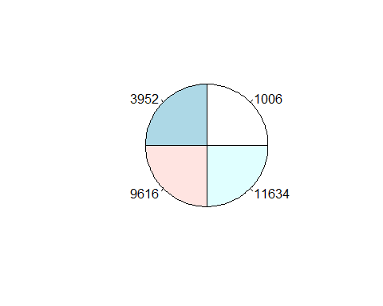

library(knitr)  
kable(pdf.tbl)

|  |  |  |  |  |  |  |  |  |  |  |
| --- | --- | --- | --- | --- | --- | --- | --- | --- | --- | --- |
| Description | 2007-08 | 2008-09 | 2009-10 | 2010-11 | 2011-12 | 2012-13 | 2013-14 | 2014-15 | 2015-16 | 2016-17 |
| Resident Costs*: | NA | NA | NA | NA | NA | NA | NA | NA | NA | NA |
| Tuition & Fees | 5622 | 6030 | 7530 | 8736 | 9472 | 9842 | 10262 | 10836 | 11622 | 11634 |
| Books & Supplies | 840 | 900 | 960 | 1030 | 1078 | 848 | 916 | 800 | 840 | 1006 |
| Room & Board | 7292 | 7528 | 8046 | 8460 | 8708 | 8970 | 9246 | 9246 | 9450 | 9616 |
| Misc. & Travel | 2300 | 2300 | 1464 | 1510 | 1562 | 1590 | 1640 | 1798 | 3222 | 3952 |
| Resident Total Costs | 16054 | 16758 | 18000 | 19736 | 20820 | 21250 | 22064 | 22680 | 25134 | 26208 |
| Nonresident Costs*: | NA | NA | NA | NA | NA | NA | NA | NA | NA | NA |
| Tuition & Fees | 20726 | 22342 | 25740 | 26946 | 27682 | 28052 | 28472 | 29046 | 29832 | 29844 |
| Books & Supplies | 840 | 900 | 960 | 1030 | 1078 | 848 | 916 | 800 | 840 | 1006 |
| Room & Board | 7292 | 7528 | 8046 | 8460 | 8708 | 8970 | 9246 | 9246 | 9450 | 9616 |
| Misc. & Travel | 2300 | 2300 | 1464 | 1510 | 1562 | 1590 | 1640 | 1798 | 3746 | 4662 |
| Nonresident Total Costs | 31158 | 33070 | 36210 | 37946 | 39030 | 39460 | 40274 | 40890 | 43868 | 45128 |