Office of Student Financial Aid

2019-20 Annual Reports

## Table of Contents

* Undergraduate Cost of Attendance
  + Undergrad COA Percentage of Total Cost
  + Cost of Attendance Expenses
* Financial Aid Awarded to Students - Five-Year Comparison
  + Average Award Per Recipient chart
  + Average Award Per Recipient Chart
* Types and Sources of Aid
  + Financial Aid Awarded: Sources of Financial Aid Table
  + Financial Aid Awarded: Sources of Financial Aid Chart
  + Financial Aid Awarded: Types of Financial Aid Table
  + Financial Aid Awarded: Types of Financial Aid Chart
* Academic Year Student Financial Aid Awards by Type
  + Academic Year Student Financial Aid Awards by Type Table
* HOPE Scholarship Awards by Tier
  + Financial Aid Awarded: Sources of Financial Aid Table
  + HOPE Scholarship Awards by Tier Table
  + HOPE Scholarship Awards by Tier
  + Percent Change in HOPE Scholarship Awards by Tier
* ZELL Scholarship Awards by Tier
  + Financial Aid Awarded: Sources of Financial Aid Table
  + ZELL Scholarship Awards by Tier
  + ZELL Scholarship Awards by Tier
  + Percent Change in ZELL Scholarship Awards by Tier
* HOPE-ZELL Scholarship Awards by Tier
  + Percent of Undergraduates with HOPE/Zell Scholarship Awards
  + Pct Undergraduates with HOPE or Zell
* HOPE-ZELL Scholarship Award Totals
  + HOPE-ZELL Scholarship Award Totals
  + HOPE-ZELL Scholarship Award Totals Comparison
* HOPE-ZELL Max Awards Compared to Tuition
  + HOPE-ZELL Scholarship Award Totals
* History of Average Federal Pell Grant Awards
  + History of Average Federal Pell Grant Awards
* Pell-Max-Awards
  + Pell Grant Maximum Award and In-State COA
  + Pell Grant Max Award and Out-of-State COA
* Pell-Grant-Comparison
  + UGA Pell Grant Recipients to SEC Institutions
  + UGA Pell Grant Recipients to Comparator Peer Institutions
  + UGA Pell Grant Recipients to Aspirational Peer Institutions

# OSFA Org Chart

Here is the current OSFA Organization chart.

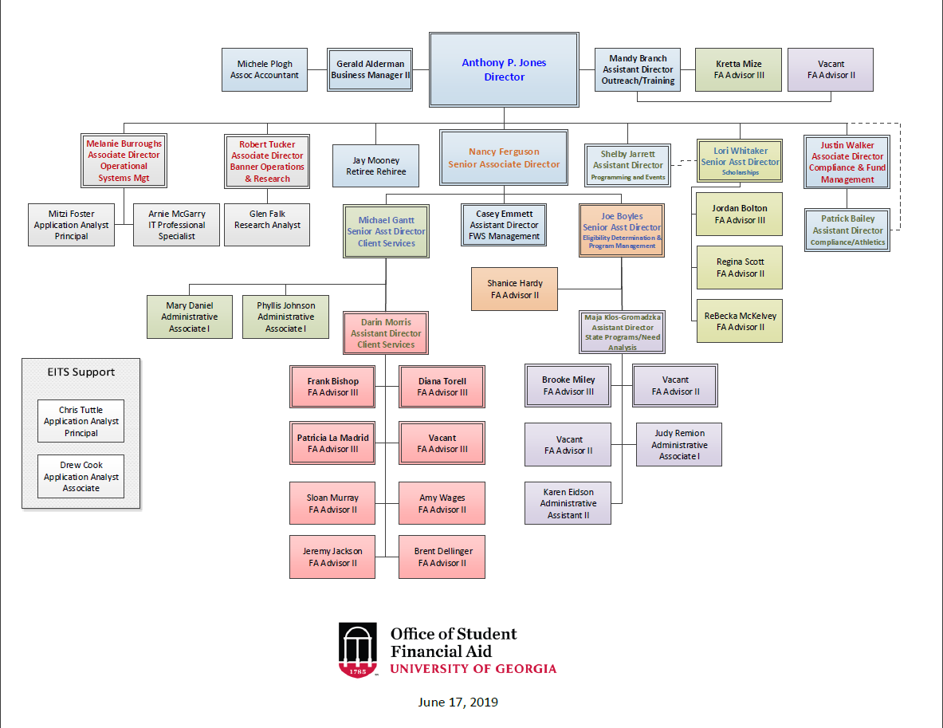

Figure 1: OSFA Org Chart

# 01. Student Financial Aid Summary



# 02. Undergraduate Cost of Attendance



| costs | 2009-10 | 2010-11 | 2011-12 | 2012-13 | 2013-14 | 2014-15 | 2015-16 | 2016-17 | 2017-18 | 2018-19 |
| --- | --- | --- | --- | --- | --- | --- | --- | --- | --- | --- |
| Resident Costs*: |  |  |  |  |  |  |  |  |  |  |
| Tuition & Fees | $7,530 | $8,736 | $9,472 | $9,842 | $10,262 | $10,836 | $11,622 | $11,634 | $11,818 | $11,830 |
| Books & Supplies | 960 | 1,030 | 1,078 | 848 | 916 | 800 | 840 | 1,006 | 986 | 986 |
| Room & Board | 8,046 | 8,460 | 8,708 | 8,970 | 9,246 | 9,246 | 9,450 | 9,616 | 10,060 | 10,038 |
| Misc. & Travel | 1,464 | 1,510 | 1,562 | 1,590 | 1,640 | 1,798 | 3,222 | 3,952 | 3,540 | 3,834 |
| Resident Total Costs | $18,000 | $19,736 | $20,820 | $21,250 | $22,064 | $22,680 | $25,134 | $26,208 | $26,404 | $26,688 |
| Nonresident Costs*: |  |  |  |  |  |  |  |  |  |  |
| Tuition & Fees | $25,740 | $26,946 | $27,682 | $28,052 | $28,472 | $29,046 | $29,832 | $29,844 | $30,392 | $30,404 |
| Books & Supplies | 960 | 1,030 | 1,078 | 848 | 916 | 800 | 840 | 1,006 | 986 | 986 |
| Room & Board | 8,046 | 8,460 | 8,708 | 8,970 | 9,246 | 9,246 | 9,450 | 9,616 | 10,060 | 10,038 |
| Misc. & Travel | 1,464 | 1,510 | 1,562 | 1,590 | 1,640 | 1,798 | 3,746 | 4,662 | 4,250 | 4,334 |
| Nonresident Total Costs | $36,210 | $37,946 | $39,030 | $39,460 | $40,274 | $40,890 | $43,868 | $45,128 | $45,688 | $45,762 |

## 02 Undergrad COA Percentage of Total Cost

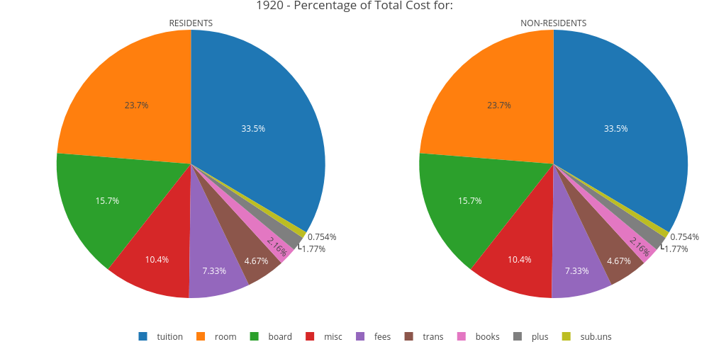

## 02 Cost of Attendance Expenses

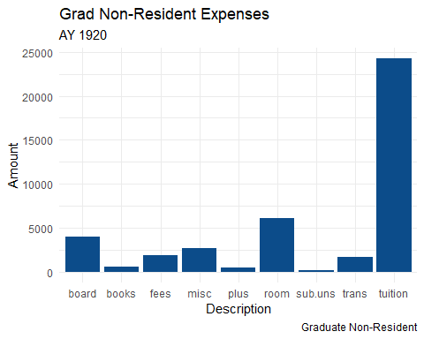

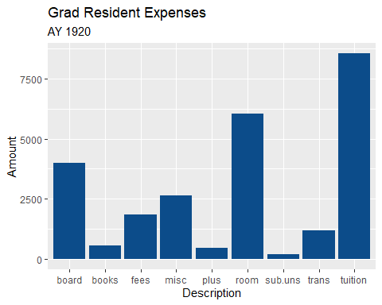

# 03. Financial Aid Awarded to Students - Five-Year Comparison



Financial Aid Awarded

| desc | 2014_15 | 2015_16 | 2016_17 | 2017_18 | 2018_19 |
| --- | --- | --- | --- | --- | --- |
| level: Undergraduate: | | | | | |
| Enrolled | 26,882 | 27,547 | 27,952 | 28,848 | 29,611 |
| Recipients | 26,349 | 26,857 | 27,553 | 28,559 | 29,276 |
| Total Aid | $313,528,990 | $338,037,770 | $352,728,679 | $378,801,172 | $391,735,413 |
| level: Graduate | | | | | |
| Enrolled | 8,315 | 8,583 | 8,623 | 8,758 | 9,041 |
| Recipients | 8,420 | 7,794 | 8,107 | 8,350 | 8,192 |
| Total Aid | $182,926,198 | $192,381,760 | $193,839,746 | $199,155,892 | $199,742,687 |

## 03. Average Award Per Recipient chart

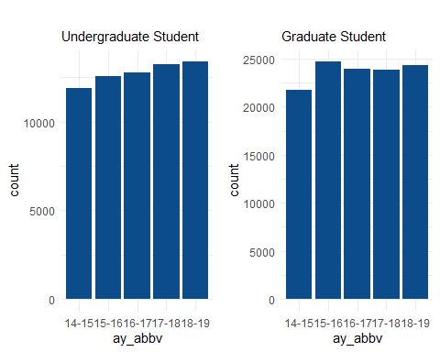

## 03. Average Award Per Recipient Chart

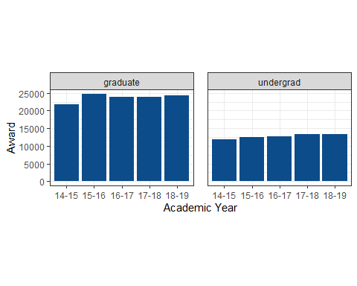

# 04. Types and Sources of Aid



Financial Aid Awarded

## 04. Financial Aid Awarded: Sources of Financial Aid Table

| **Source** | **Amount** | **All Students** | **Undergraduate Pct.** | **Student Pct.** |
| --- | --- | --- | --- | --- |
| Federal | $133,183,445 | $211,670,688 | 34.00% | 35.79% |
| Institutional | $51,481,432 | $168,865,545 | 13.14% | 28.55% |
| State | $188,937,170 | $190,623,801 | 48.23% | 32.23% |
| Private | $18,133,366 | $20,318,066 | 4.63% | 3.44% |
| Total | $391,735,413 | $591,478,100 | 100.00% | 100.00% |

## 04. Financial Aid Awarded: Sources of Financial Aid Chart

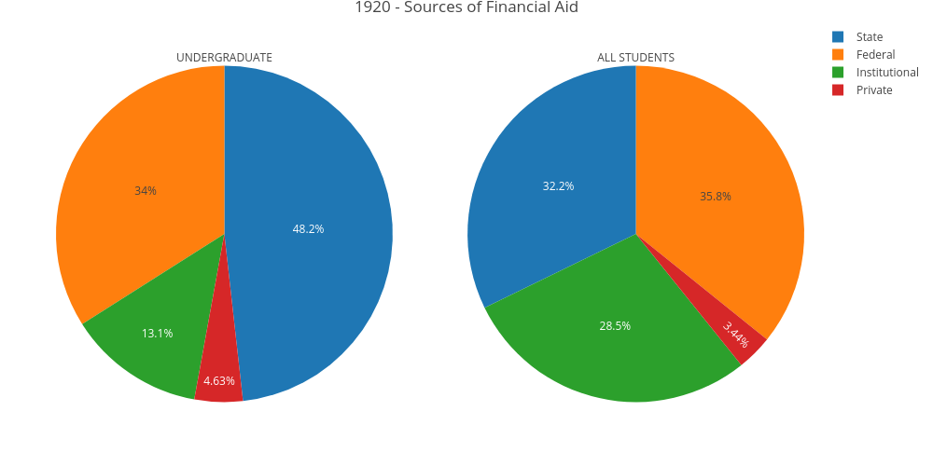

## 04. Financial Aid Awarded: Types of Financial Aid Table

| **Types of Financial Aid** | | | |
| --- | --- | --- | --- |
| **Undergraduate** | | **All Students** | |
| **Type** | **Amount** | **Type** | **Amount** |
| Loans | $111,544,861 | Loans | $191,433,772 |
| Grants, Scholarships & Waivers | $279,402,983 | Grants, Scholarships & Waivers | $399,239,572 |
| Work Study | $787,569 | Work Study | $804,756 |
| Total | $391,735,413 | Total | $591,478,100 |

## 04. Financial Aid Awarded: Types of Financial Aid Chart

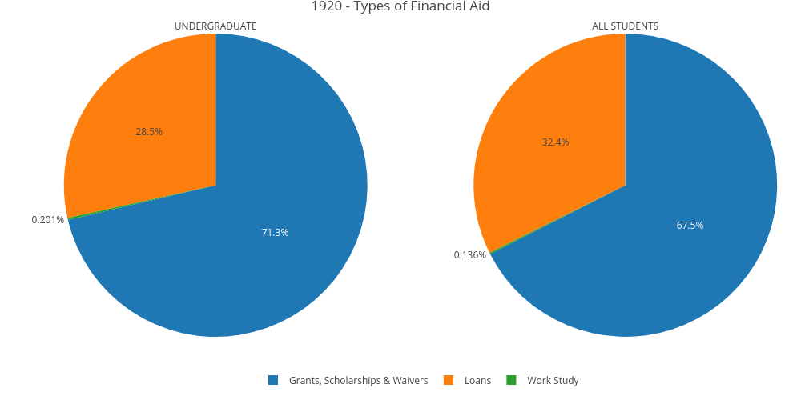

# 05. Academic Year Student Financial Aid Awards by Type



Academic Year Student Financial Aid Awards by Type:

For Academic Years 2018-19 and 2019-20

## 05. Academic Year Student Financial Aid Awards by Type Table

|  | **2019-20** | | | | | | **2018-19** | | | | | |
| --- | --- | --- | --- | --- | --- | --- | --- | --- | --- | --- | --- | --- |
| **Student Aid Program** | **# Awards** | **Amt Undergrad** | **# Awards** | **Amt Undergrad** | **Total # Awards** | **Total Amount** | **# Awards** | **Amt Undergrad** | **# Awards** | **Amt Undergrad** | **Total # Awards** | **Total Amount** |
| Federal Pell Grants | 6,674 | $31,463,054 | 0 | $0 | 6,674 | $31,463,054 | 6,800 | $31,167,104 | 0 | $0 | 6,800 | $31,167,104 |
| Federal Supplemental Educational Opportunity Grants | 1,044 | $961,706 | 0 | $0 | 1,044 | $961,706 | 876 | $770,359 | 0 | $0 | 876 | $770,359 |
| Federal (Other) Grants/Scholarships | 0 | $0 | 0 | $0 | 0 | $0 | 45 | $17,965 | 0 | $0 | 45 | $17,965 |
| HOPE Scholarships | 12,157 | $73,967,546 | 92 | $437,026 | 12,249 | $74,404,572 | 12,771 | $75,103,915 | 136 | $518,287 | 12,907 | $75,622,202 |
| Zell Miller Scholarship | 11,883 | $113,892,503 | 169 | $1,246,605 | 12,052 | $115,139,108 | 10,504 | $99,918,676 | 210 | $1,374,745 | 10,714 | $101,293,421 |
| State (Other) Grants/Scholarships | 66 | $229,170 | 1 | $3,000 | 67 | $232,170 | 65 | $243,168 | 3 | $3,667 | 68 | $246,835 |
| Institutional Grants/Scholarships | 6,613 | $28,402,687 | 1,620 | $9,310,157 | 8,233 | $37,712,844 | 5,850 | $24,003,272 | 1,565 | $8,203,065 | 7,415 | $32,206,337 |
| Athletic Scholarships | 560 | $12,738,081 | 15 | $466,465 | 575 | $13,204,546 | 541 | $12,055,894 | 19 | $454,310 | 560 | $12,510,204 |
| Graduate Assistantship Tuition Waivers | 0 | $0 | 4,062 | $95,284,892 | 4,062 | $95,284,892 | 0 | $0 | 3,884 | $92,320,996 | 3,884 | $92,320,996 |
| Miscellaneous Tuition/Fee Payments/Waivers | 983 | $10,340,664 | 1,557 | $12,322,599 | 2,540 | $22,663,263 | 1,325 | $11,341,394 | 1,582 | $12,963,795 | 2,907 | $24,305,189 |
| Other (External) Grants/Scholarships | 2,643 | $7,407,572 | 151 | $765,845 | 2,794 | $8,173,417 | 2,520 | $6,869,277 | 176 | $957,448 | 2,696 | $7,826,725 |
| Subtotal | 42,623 | $279,402,983 | 7,667 | $119,836,589 | 50,290 | $399,239,572 | 41,297 | $261,491,024 | 7,575 | $116,796,313 | 48,872 | $378,287,337 |
| Federal Perkins Loan | 0 | $0 | 0 | $0 | 0 | $0 | 279 | $1,225,203 | 0 | $0 | 279 | $1,225,203 |
| Federal PLUS Loans | 3,049 | $37,431,486 | 1,340 | $16,178,651 | 4,389 | $53,610,137 | 3,283 | $39,104,965 | 1,379 | $17,141,176 | 4,662 | $56,246,141 |
| Federal Direct Loans - Subsidized | 6,826 | $28,251,944 | 0 | $0 | 6,826 | $28,251,944 | 7,380 | $29,769,204 | 0 | $0 | 7,380 | $29,769,204 |
| Federal Direct Loans - Unsubsidized | 8,625 | $34,287,686 | 3,288 | $62,291,405 | 11,913 | $96,579,091 | 9,307 | $37,181,779 | 3,428 | $64,034,516 | 12,735 | $101,216,295 |
| State (Other) Loans | 164 | $847,951 | 0 | $0 | 164 | $847,951 | 141 | $689,730 | 0 | $0 | 141 | $689,730 |
| Other Loans | 953 | $10,725,794 | 106 | $1,418,855 | 1,059 | $12,144,649 | 831 | $8,588,862 | 85 | $1,171,772 | 916 | $9,760,634 |
| Subtotal | 19,617 | $111,544,861 | 4,734 | $79,888,911 | 24,351 | $191,433,772 | 21,221 | $116,559,743 | 4,892 | $82,347,464 | 26,113 | $198,907,207 |
| Federal Work-Study Programs | 404 | $787,569 | 9 | $17,187 | 413 | $804,756 | 373 | $750,405 | 7 | $12,115 | 380 | $762,520 |
| Totals | 62,644 | $391,735,413 | 12,410 | $199,742,687 | 75,054 | $591,478,100 | 60,736 | $352,728,679 | 11,858 | $193,839,746 | 72,594 | $546,568,425 |

# 06. HOPE Scholarship Awards by Tier



HOPE Scholarship Awards by Tier:

(For Academic Years 2012-13 and 2018-19)

## 06. Financial Aid Awarded: Sources of Financial Aid Table

|  | **2012-13** | | **2013-14** | | **2014-15** | | **2015-16** | | **2016-17** | | **2017-18** | | **2018-19** | | **2019-20** | |
| --- | --- | --- | --- | --- | --- | --- | --- | --- | --- | --- | --- | --- | --- | --- | --- | --- |
| **# Awards** | **Amount** | **# Awards** | **Amount** | **# Awards** | **Amount** | **# Awards** | **Amount** | **# Awards** | **Amount** | **# Awards** | **Amount** | **# Awards** | **Amount** | **# Awards** | **Amount** |
| HOPE Scholarship (1) | 4,232 | $21,302,027 | 4,576 | $16,833,674 | 3,445 | $17,515,909 | 3,189 | $16,282,916 | 2,917 | $15,220,786 | 2,947 | $15,267,465 | 2,778 | $14,897,419 | 2,192 | $11,351,133 |
| HOPE Scholarship (2) | 3,922 | $15,257,371 | 4,819 | $16,946,579 | 3,869 | $15,705,102 | 3,892 | $16,430,372 | 3,984 | $16,997,476 | 3,778 | $16,132,438 | 3,923 | $17,003,870 | 3,863 | $17,341,250 |
| HOPE Scholarship (3) | 5,097 | $20,048,256 | 5,671 | $20,074,650 | 5,208 | $21,885,162 | 5,039 | $21,296,285 | 5,230 | $22,429,766 | 5,170 | $22,359,652 | 5,142 | $22,955,910 | 5,228 | $24,101,607 |
| HOPE Scholarship (4) | 5,555 | $17,633,275 | 5,731 | $18,726,343 | 5,167 | $18,605,136 | 5,324 | $20,357,359 | 5,138 | $19,723,687 | 5,334 | $20,618,732 | 5,323 | $20,765,002 | 5,237 | $21,610,582 |

## 06. HOPE Scholarship Awards by Tier Table

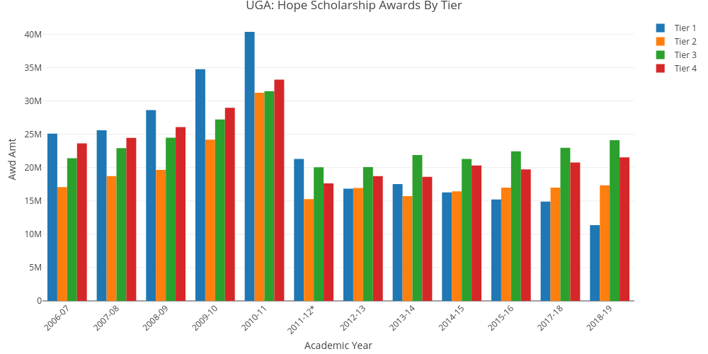

## 06. HOPE Scholarship Awards by Tier

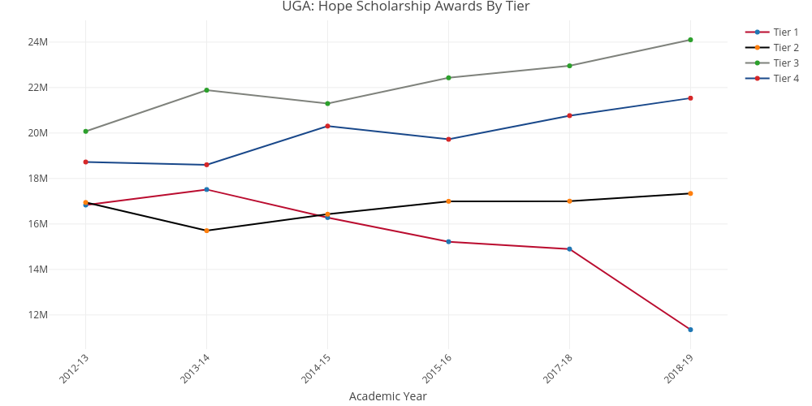

(#fig:6.2)Awd by Tier

## 06. Percent Change in HOPE Scholarship Awards by Tier

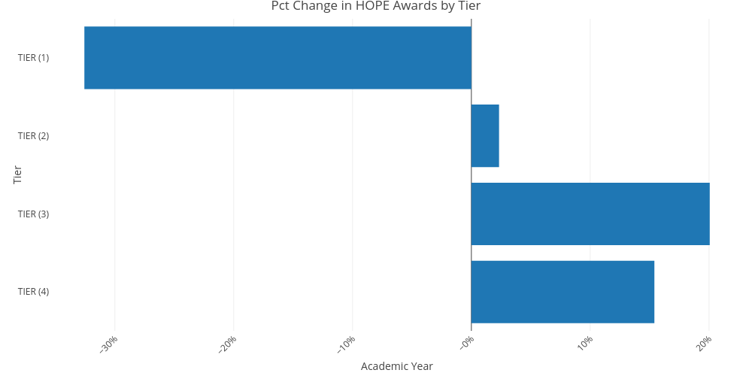

(#fig:6.3)Pct. Change by Tier

# 06. ZELL Scholarship Awards by Tier



zell Scholarship Awards by Tier:

(For Academic Years 2012-13 and 2018-19)

## 06. Financial Aid Awarded: Sources of Financial Aid Table

|  | **2012-13** | | **2013-14** | | **2014-15** | | **2015-16** | | **2016-17** | | **2017-18** | | **2018-19** | | **2019-20** | |
| --- | --- | --- | --- | --- | --- | --- | --- | --- | --- | --- | --- | --- | --- | --- | --- | --- |
| **# Awards** | **Amount** | **# Awards** | **Amount** | **# Awards** | **Amount** | **# Awards** | **Amount** | **# Awards** | **Amount** | **# Awards** | **Amount** | **# Awards** | **Amount** | **# Awards** | **Amount** |
| ZELL Scholarship (1) | 2,378 | $14,833,447 | 2,484 | $17,050,973 | 2,979 | $20,638,942 | 3,313 | $24,664,288 | 3,700 | $29,870,870 | 3,973 | $31,991,360 | 4,483 | $37,407,219 | 5,117 | $42,059,541 |
| ZELL Scholarship (2) | 1,835 | $9,094,777 | 1,890 | $10,621,096 | 2,251 | $13,097,889 | 2,559 | $15,861,648 | 2,965 | $19,655,804 | 3,217 | $21,713,793 | 3,616 | $24,160,955 | 4,214 | $28,287,012 |
| ZELL Scholarship (3) | 1,915 | $9,066,224 | 1,671 | $9,010,788 | 2,270 | $12,040,254 | 2,487 | $14,593,041 | 2,954 | $18,376,455 | 3,275 | $20,421,618 | 3,569 | $22,671,900 | 3,970 | $25,755,112 |
| ZELL Scholarship (4) | 1,573 | $5,302,239 | 1,325 | $7,250,669 | 1,741 | $8,669,874 | 1,914 | $10,597,877 | 2,248 | $13,616,709 | 2,561 | $15,287,026 | 2,840 | $17,053,347 | 3,109 | $19,037,443 |

## 06. ZELL Scholarship Awards by Tier

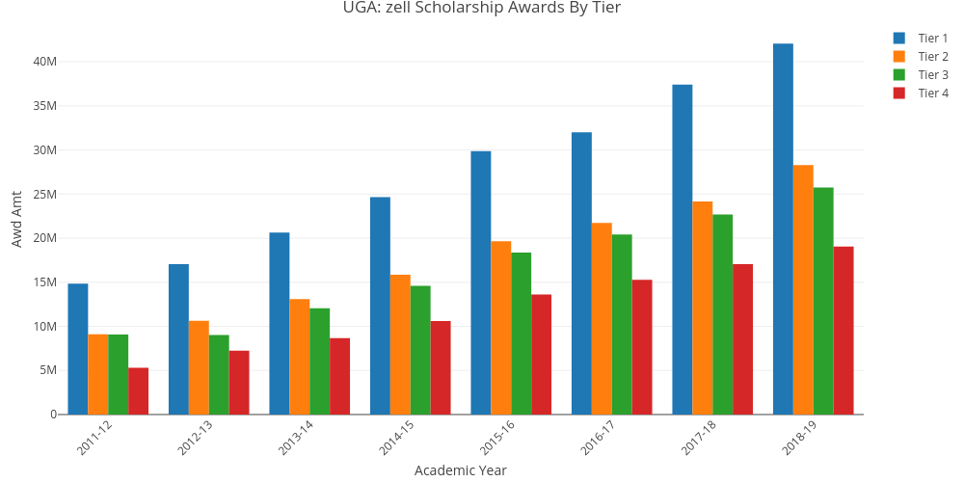

## 06. ZELL Scholarship Awards by Tier

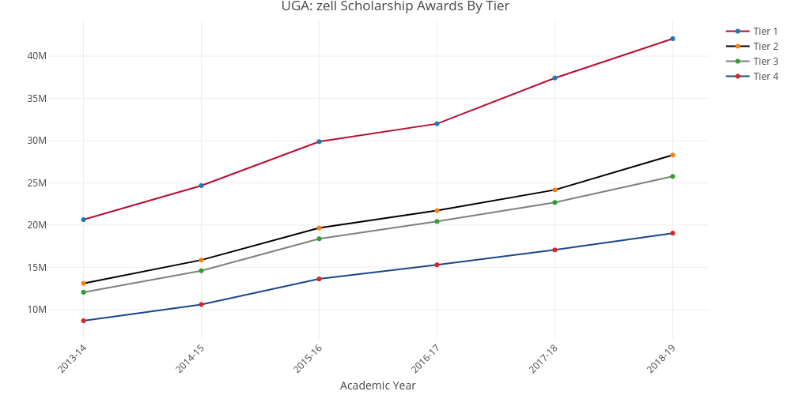

(#fig:6.2)Awd by Tier

## 06. Percent Change in ZELL Scholarship Awards by Tier

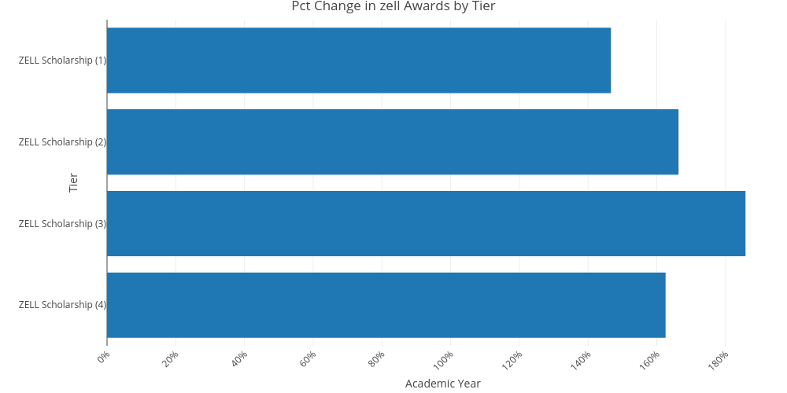

(#fig:6.3)Pct. Change by Tier

# 07. HOPE-ZELL Scholarship Awards by Tier



Hope/Zell Scholarship Awards by Tier:

(For Academic Years 2012-13 and 2018-19)

## 07. Percent of Undergraduates with HOPE/Zell Scholarship Awards

| Description | 2009-10 | 2010-11 | 2011-12 | 2012-13 | 2013-14 | 2014-15 | 2015-16 | 2016-17 | 2017-18 | 2018-19 |
| --- | --- | --- | --- | --- | --- | --- | --- | --- | --- | --- |
| 1. Undergrad Enrollment | 26,142 | 25,947 | 26,373 | 26,259 | 26,278 | 26,882 | 27,547 | 27,951 | 28,848 | 29,611 |
| 2. Hope Awards | 19,163 | 19,574 | 14,531 | 13,954 | 13,695 | 13,325 | 12,969 | 12,925 | 12,771 | 12,157 |
| 3. Hope Pct | 73.30% | 75.44% | 55.10% | 53.14% | 52.12% | 49.57% | 47.08% | 46.24% | 44.27% | 41.06% |
| 4. Zell Awards |  |  | 5,763 | 6,303 | 6,924 | 7,613 | 8,662 | 9,493 | 10,504 | 11,883 |
| 5. Zell Pct |  |  | 21.85% | 24.00% | 26.35% | 28.32% | 31.44% | 33.96% | 36.41% | 40.13% |

## 07. Pct Undergraduates with HOPE or Zell

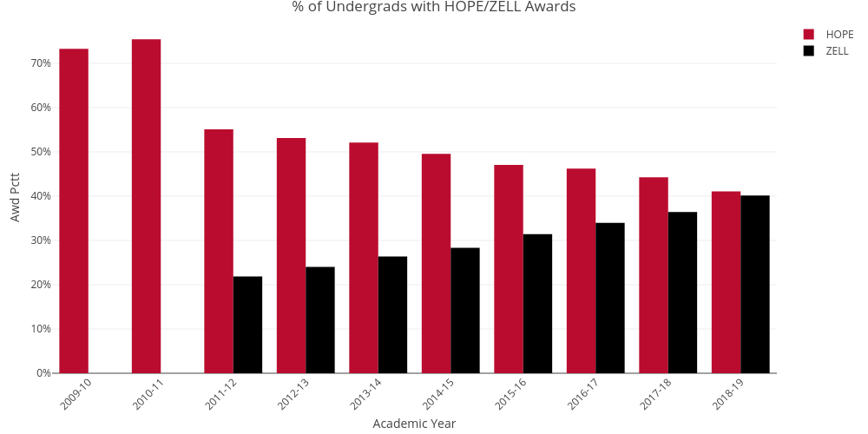

# 08. HOPE-ZELL Scholarship Award Totals



Hope/Zell Scholarship Awards by Tier:

(For Academic Years 2012-13 and 2018-19)

## 08. HOPE-ZELL Scholarship Award Totals

| Award | Total Awards | Total Amount | Total Award Pct. | Total Award Pct. |
| --- | --- | --- | --- | --- |
| HOPE Scholarship Totals: | 16,520 | $74,404,572 | 50.17% | 39.25% |
| Zell Miller Scholarship Totals: | 16,410 | $115,139,108 | 49.83% | 60.75% |
| Combined HOPE and Zell Miller Scholarship Totals: | 32,930 | $189,543,680 | 100.00% | 100.00% |

## 08. HOPE-ZELL Scholarship Award Totals Comparison

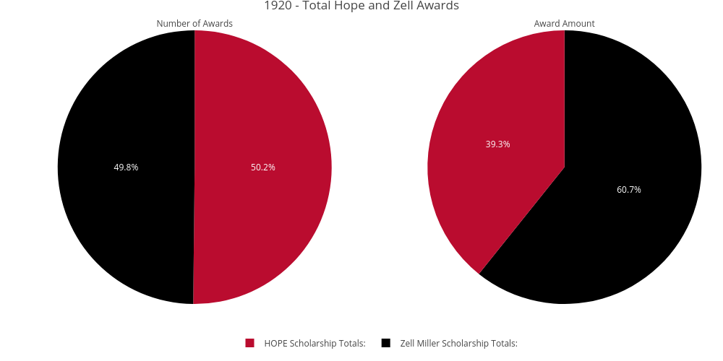

# 09. HOPE-ZELL Max Awards Compared to Tuition



Hope/Zell Scholarship Awards Totals :

(For Academic Years 2011-12 and 2018-19)

## 09. HOPE-ZELL Scholarship Award Totals

| name | 2011-12 | 2012-13 | 2013-14 | 2014-15 | 2015-16 | 2016-17 | 2017-18 | 2018-19 |
| --- | --- | --- | --- | --- | --- | --- | --- | --- |
| tuition | $4,736 | $4,921 | $5,131 | $5,418 | $5,811 | $5,817 | $5,909 | $5,909 |
| hope | $3,182 | $3,182 | $3,277 | $3,390 | $3,495 | $3,495 | $3,600 | $3,720 |
| hope | 87.38% | 83.22% | 81.64% | 78.93% | 74.65% | 74.65% | 75.38% | 77.89% |
| zell | $3,641 | $3,823 | $4,014 | $4,295 | $4,682 | $4,682 | $4,776 | $4,776 |
| zell | 100.00% | 100.00% | 100.00% | 100.00% | 100.00% | 100.00% | 100.00% | 100.00% |

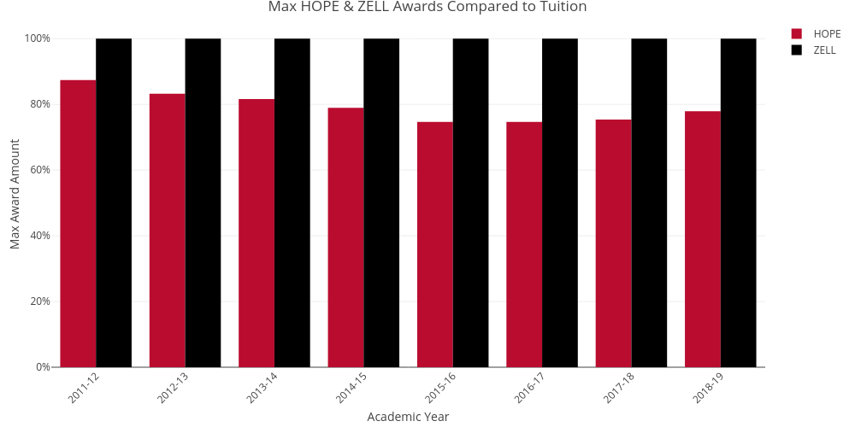

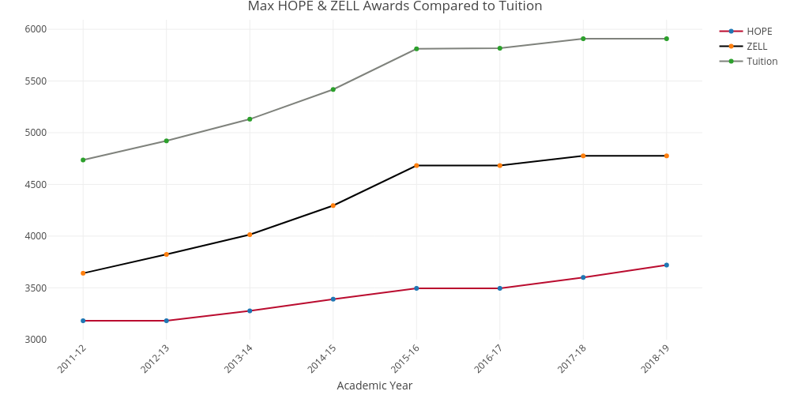

# 10. History of Average Federal Pell Grant Awards



HISTORY OF AVERAGE FEDERAL PELL GRANT AWARDS:

(For Academic Years 1993-94 and 2018-19)

## 10. History of Average Federal Pell Grant Awards

| **Academic Year** | **awd_usa** | **UGA. Avg. Award** |
| --- | --- | --- |
| 1993-94 | $1,506 | $1,416 |
| 1994-95 | $1,502 | $1,402 |
| 1995-96 | $1,515 | $1,454 |
| 1996-97 | $1,577 | $1,499 |
| 1997-98 | $1,696 | $1,605 |
| 1998-99 | $1,876 | $1,828 |
| 1999-00 | $1,933 | $1,876 |
| 2000-01 | $2,070 | $2,046 |
| 2001-02 | $2,376 | $2,297 |
| 2002-03 | $2,338 | $2,503 |
| 2003-04 | $2,467 | $2,539 |
| 2004-05 | $2,441 | $2,538 |
| 2005-06 | $2,486 | $2,567 |
| 2006-07 | $2,494 | $2,611 |
| 2007-08 | $2,620 | $2,832 |
| 2008-09 | $2,945 | $3,246 |
| 2009-10 | $3,611 | $3,337 |
| 2010-11 | $4,115 | $4,013 |
| 2011-12 | $3,451 | $3,861 |
| 2012-13 | $3,478 | $3,920 |
| 2013-14 | $3,541 | $4,044 |
| 2014-15 | $3,590 | $4,109 |
| 2015-16 | $3,646 | $4,110 |
| 2016-17 | $3,656 | $4,127 |
| 2017-18 | $3,921 | $4,583 |
| 2018-19 | $4,039 | $4,714 |

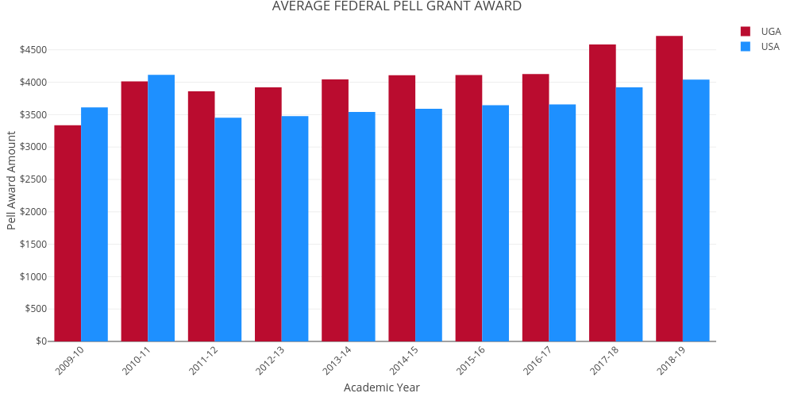

# 11-Pell-Max-Awards



PELL GRANT MAXIMUM AWARDS:

(For Academic Years 1993-94 and 2018-19)

## 11. Pell Grant Maximum Award and In-State COA

| Description | 2010.11 | 2011.12 | 2012.13 | 2013.14 | 2014.15 | 2015.16 | 2016.17 | 2017.18 | 2018.19 |
| --- | --- | --- | --- | --- | --- | --- | --- | --- | --- |
| Max Pell Award | $5,550 | $5,550 | $5,550 | $5,645 | $5,730 | $5,775 | $5,815 | $5,920 | $6,095 |
| Tuition/Fees | $8,736 | $9,472 | $9,842 | $10,262 | $10,836 | $11,622 | $11,634 | $11,818 | $11,830 |
| % of Tuition/Fees Covered by Max Pell Award* | 63.53% | 58.59% | 56.39% | 55.01% | 52.88% | 49.69% | 49.98% | 50.09% | 51.52% |
| Total COA** | $19,736 | $20,820 | $21,250 | $22,064 | $22,680 | $25,134 | $26,208 | $26,404 | $26,688 |
| % of Total COA Covered by Max Pell Award* | 28.12% | 26.66% | 26.12% | 25.58% | 25.26% | 22.98% | 22.19% | 22.42% | 22.84% |

## 11. Pell Grant Max Award and Out-of-State COA

| Description | 2010.11 | 2011.12 | 2012.13 | 2013.14 | 2014.15 | 2015.16 | 2016.17 | 2017.18 | 2018.19 |
| --- | --- | --- | --- | --- | --- | --- | --- | --- | --- |
| Max Pell Award | $5,550 | $5,550 | $5,550 | $5,645 | $5,730 | $5,775 | $5,815 | $5,920 | $6,095 |
| Tuition/Fees | $26,946 | $27,682 | $28,052 | $28,472 | $29,046 | $29,832 | $29,844 | $30,392 | $30,404 |
| % of Tuition/Fees Covered by Max Pell Award | 20.60% | 20.05% | 19.78% | 19.83% | 19.73% | 19.36% | 19.48% | 19.48% | 20.05% |
| Total COA** | $37,946 | $39,030 | $39,460 | $40,274 | $40,890 | $43,868 | $45,128 | $45,688 | $45,762 |
| % of Total COA Covered by Max Pell Award | 14.63% | 14.22% | 14.06% | 14.02% | 14.01% | 13.16% | 12.89% | 12.96% | 13.32% |

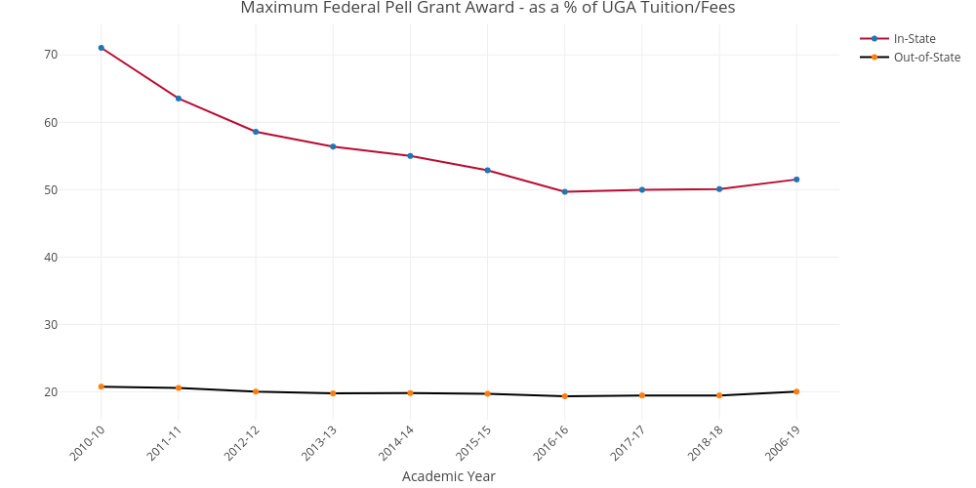 ## 11. Federal Pell Grant as a % of Total Undergraduate Enrollment ***

| Description | 2010.11 | 2011.12 | 2012.13 | 2013.14 | 2014.15 | 2015.16 | 2016.17 | 2017.18 | 2018.19 |
| --- | --- | --- | --- | --- | --- | --- | --- | --- | --- |
| 1. Max Pell Award | $5,550 | $5,550 | $5,550 | $5,645 | $5,730 | $5,775 | $5,815 | $5,920 | $6,095 |
| 2. Total Pell Grant Recipients | $6,631 | $7,081 | $6,750 | $6,831 | $6,737 | $6,655 | $6,569 | $6,800 | $6,674 |
| 3. Total Pell Grant Dollars Awarded | $26,608,894 | $27,339,910 | $26,463,148 | $27,626,496 | $27,681,078 | $27,350,719 | $27,107,550 | $31,167,104 | $31,463,054 |
| 4. Total Undergraduate Enrollment | $25,947 | $26,373 | $26,259 | $26,278 | $26,882 | $27,547 | $27,952 | $28,848 | $29,611 |
| 5. % Undergraduates with Pell Grant Awards | 25.56% | 26.85% | 25.71% | 26.00% | 25.06% | 24.16% | 23.50% | 23.57% | 22.54% |

# 12-Pell-Grant-Comparison



## 12. UGA Pell Grant Recipients to SEC Institutions

| Institution | Fall Undergrad Enrollment | # of Pell Recipients | % With Pell Grant | Tot Dollars Received | Average Award |
| --- | --- | --- | --- | --- | --- |
| Mississippi State University | 18,010 | 6,457 | 35.85% | $30,162,275 | $4,671 |
| University of Florida | 34,564 | 11,253 | 32.56% | $54,372,604 | $4,831 |
| The University of Tennessee-Knoxville | 22,653 | 5,961 | 26.31% | $27,614,712 | $4,632 |
| University of Mississippi | 17,784 | 4,632 | 26.05% | $22,579,395 | $4,874 |
| Louisiana State University and Agricultural & Mechanical College | 23,468 | 5,961 | 25.40% | $27,953,826 | $4,689 |
| University of Kentucky | 21,746 | 5,364 | 24.67% | $24,207,326 | $4,512 |
| University of Georgia | 29,474 | 6,674 | 22.64% | $31,462,631 | $4,714 |
| Texas A & M University-College Station | 53,194 | 12,032 | 22.62% | $56,468,144 | $4,693 |
| University of Missouri-Columbia | 22,030 | 4,898 | 22.23% | $21,678,597 | $4,426 |
| University of South Carolina-Columbia | 26,300 | 5,589 | 21.25% | $25,955,191 | $4,643 |
| University of Arkansas | 23,121 | 4,820 | 20.85% | $21,123,212 | $4,382 |
| The University of Alabama | 32,177 | 6,237 | 19.38% | $27,866,176 | $4,467 |
| Vanderbilt University | 6,840 | 1,103 | 16.13% | $5,037,501 | $4,567 |
| Auburn University | 24,147 | 3,812 | 15.79% | $17,354,029 | $4,552 |

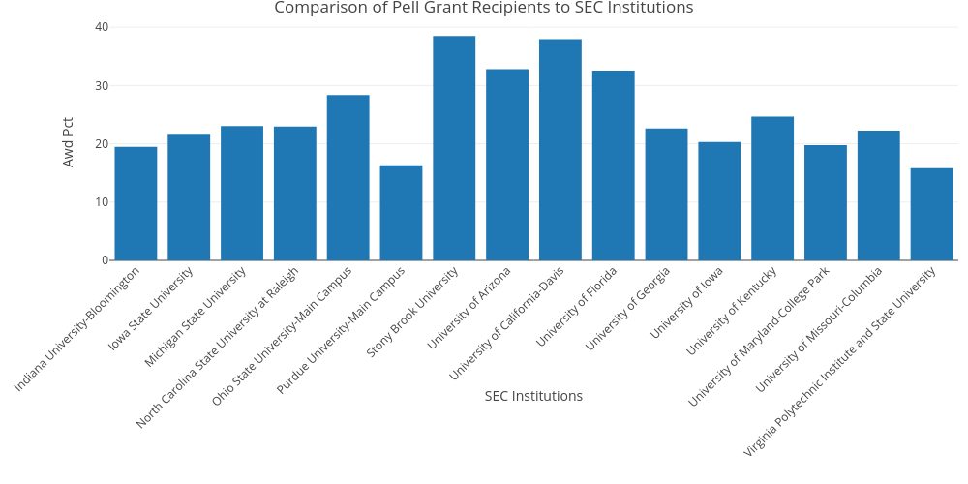

## 12. UGA Pell Grant Recipients to Comparator Peer Institutions

| Institution | Fall Undergrad Enrollment | # of Pell Recipients | % With Pell Grant | Tot Dollars Received | Average Award |
| --- | --- | --- | --- | --- | --- |
| Stony Brook University | 17,407 | 6,701 | 38.50% | $33,637,460 | $5,019 |
| University of California-Davis | 30,698 | 11,652 | 37.96% | $58,239,926 | $4,998 |
| University of Arizona | 33,509 | 10,992 | 32.80% | $50,722,022 | $4,614 |
| University of Florida | 34,564 | 11,253 | 32.56% | $54,372,604 | $4,831 |
| Ohio State University-Main Campus | 45,769 | 12,974 | 28.35% | $57,645,394 | $4,443 |
| University of Kentucky | 21,746 | 5,364 | 24.67% | $24,207,326 | $4,512 |
| Michigan State University | 39,208 | 9,027 | 23.02% | $44,834,975 | $4,966 |
| North Carolina State University at Raleigh | 23,708 | 5,447 | 22.98% | $24,480,217 | $4,494 |
| University of Georgia | 29,474 | 6,674 | 22.64% | $31,462,631 | $4,714 |
| University of Missouri-Columbia | 22,030 | 4,898 | 22.23% | $21,678,597 | $4,426 |
| Iowa State University | 29,248 | 6,348 | 21.70% | $27,900,649 | $4,395 |
| University of Iowa | 23,410 | 4,748 | 20.28% | $20,371,302 | $4,290 |
| University of Maryland-College Park | 30,184 | 5,969 | 19.78% | $27,361,428 | $4,583 |
| Indiana University-Bloomington | 32,991 | 6,424 | 19.47% | $30,155,573 | $4,694 |
| Purdue University-Main Campus | 33,495 | 5,467 | 16.32% | $24,727,941 | $4,523 |
| Virginia Polytechnic Institute and State University | 27,730 | 4,392 | 15.84% | $19,931,664 | $4,538 |

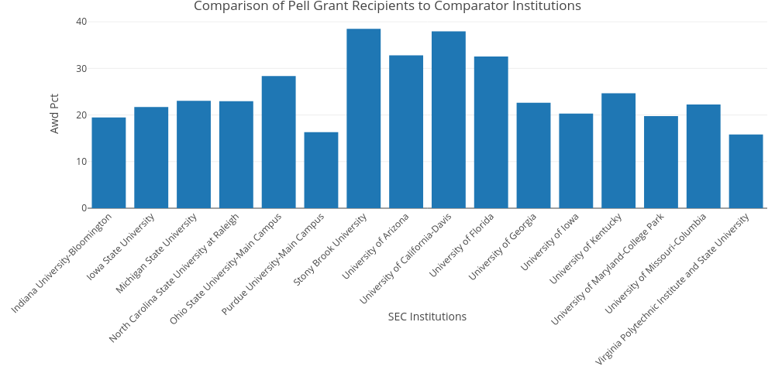

## 12. UGA Pell Grant Recipients to Aspirational Peer Institutions

| Institution | Fall Undergrad Enrollment | # of Pell Recipients | % With Pell Grant | Tot Dollars Received | Average Award |
| --- | --- | --- | --- | --- | --- |
| Pennsylvania State University-Main Campus | 40,108 | 19,479 | 48.57% | $82,562,917 | $4,238 |
| University of California-Los Angeles | 31,568 | 10,772 | 34.12% | $55,734,691 | $5,174 |
| University of California-Berkeley | 30,845 | 8,871 | 28.76% | $44,007,292 | $4,960 |
| University of Illinois at Urbana-Champaign | 32,974 | 8,038 | 24.38% | $39,662,636 | $4,934 |
| The University of Texas at Austin | 40,329 | 9,675 | 23.99% | $46,357,541 | $4,791 |
| University of Georgia | 29,474 | 6,674 | 22.64% | $31,462,631 | $4,714 |
| University of Minnesota-Twin Cities | 31,451 | 6,868 | 21.84% | $29,732,756 | $4,329 |
| University of Michigan-Ann Arbor | 30,079 | 5,623 | 18.69% | $26,272,349 | $4,672 |
| University of Virginia-Main Campus | 16,405 | 2,325 | 14.17% | $11,007,427 | $4,734 |

