Office of Student Financial Aid

Annual Reports

Glen C. Falk

2020-03-10

# OSFA Org Chart

Here is the current OSFA Organization chart.

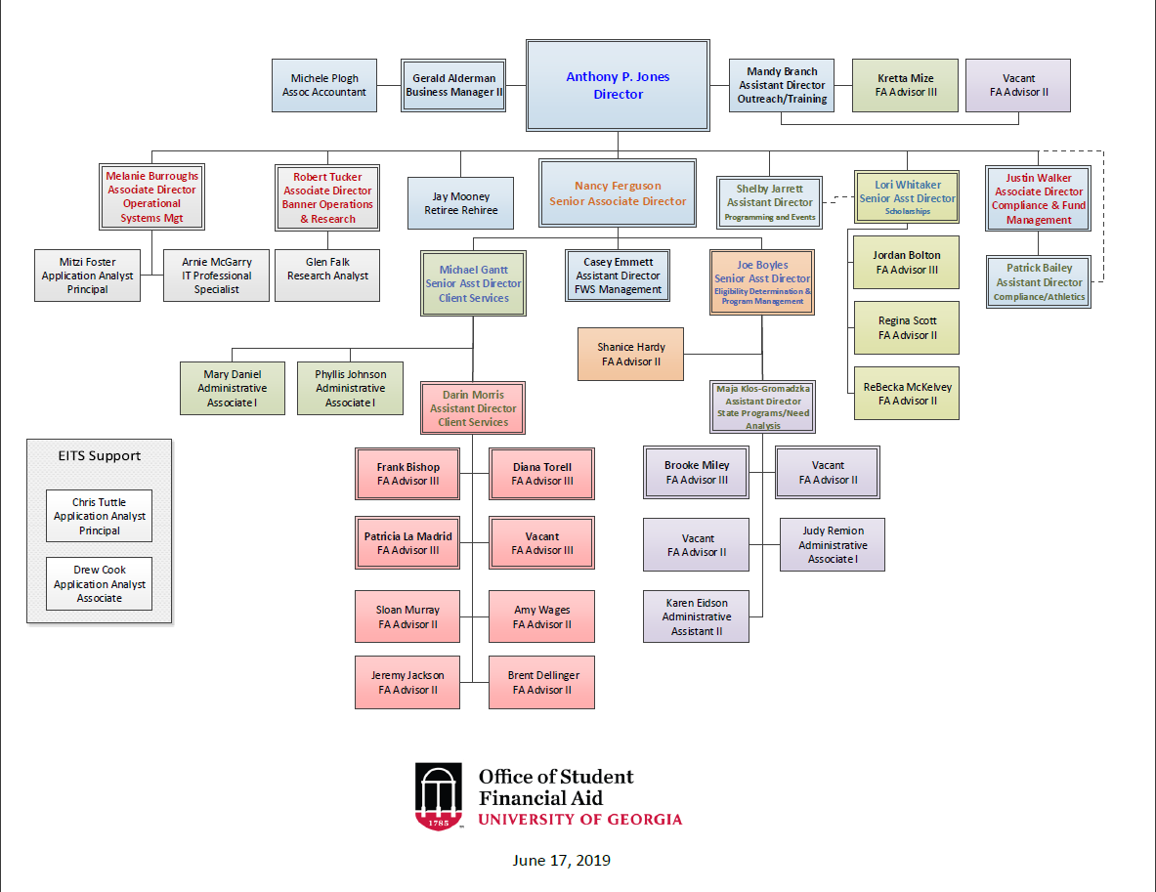

Figure 1: OSFA Org Chart

# 01. Student Financial Aid Summary

You can label chapter and section titles using {#label} after them, e.g., we can reference Chapter 1. If you do not manually label them, there will be automatic labels anyway, e.g., Chapter ??.

Figures and tables with captions will be placed in figure and table environments, respectively.

par(mar = c(4, 4, .1, .1))  
plot(pressure, type = 'b', pch = 19)

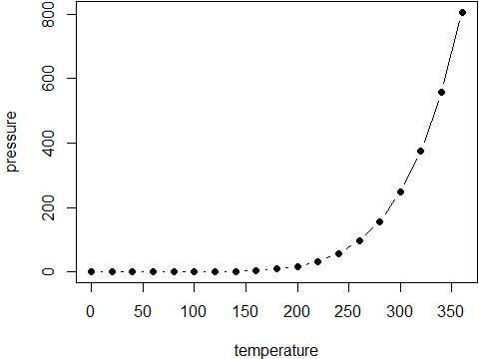

Figure 2: Here is a nice figure!

Reference a figure by its code chunk label with the fig: prefix, e.g., see Figure 2. Similarly, you can reference tables generated from knitr::kable(), e.g., see Table 1.

knitr::kable(  
 head(iris, 20), caption = 'Here is a nice table!',  
 booktabs = TRUE  
)

Table 1: Here is a nice table!

|  |  |  |  |  |
| --- | --- | --- | --- | --- |
| Sepal.Length | Sepal.Width | Petal.Length | Petal.Width | Species |
| 5.1 | 3.5 | 1.4 | 0.2 | setosa |
| 4.9 | 3.0 | 1.4 | 0.2 | setosa |
| 4.7 | 3.2 | 1.3 | 0.2 | setosa |
| 4.6 | 3.1 | 1.5 | 0.2 | setosa |
| 5.0 | 3.6 | 1.4 | 0.2 | setosa |
| 5.4 | 3.9 | 1.7 | 0.4 | setosa |
| 4.6 | 3.4 | 1.4 | 0.3 | setosa |
| 5.0 | 3.4 | 1.5 | 0.2 | setosa |
| 4.4 | 2.9 | 1.4 | 0.2 | setosa |
| 4.9 | 3.1 | 1.5 | 0.1 | setosa |
| 5.4 | 3.7 | 1.5 | 0.2 | setosa |
| 4.8 | 3.4 | 1.6 | 0.2 | setosa |
| 4.8 | 3.0 | 1.4 | 0.1 | setosa |
| 4.3 | 3.0 | 1.1 | 0.1 | setosa |
| 5.8 | 4.0 | 1.2 | 0.2 | setosa |
| 5.7 | 4.4 | 1.5 | 0.4 | setosa |
| 5.4 | 3.9 | 1.3 | 0.4 | setosa |
| 5.1 | 3.5 | 1.4 | 0.3 | setosa |
| 5.7 | 3.8 | 1.7 | 0.3 | setosa |
| 5.1 | 3.8 | 1.5 | 0.3 | setosa |

You can write citations, too. For example, we are using the **bookdown** package (Xie 2020) in this sample book, which was built on top of R Markdown and **knitr** (Xie 2015).

# COA

## COA Tables

### Example one - flextable

| costs | ay2009-10 | ay2010-11 | ay2011-12 | ay2012-13 | ay2013-14 | ay2014-15 | ay2015-16 | ay2016-17 | ay2017-18 | ay2018-19 |
| --- | --- | --- | --- | --- | --- | --- | --- | --- | --- | --- |
| Resident Costs*: |  |  |  |  |  |  |  |  |  |  |
| Tuition & Fees | $7,530 | $8,736 | $9,472 | $9,842 | $10,262 | $10,836 | $11,622 | $11,634 | $11,818 | $11,830 |
| Books & Supplies | 960 | 1,030 | 1,078 | 848 | 916 | 800 | 840 | 1,006 | 986 | 986 |
| Room & Board | 8,046 | 8,460 | 8,708 | 8,970 | 9,246 | 9,246 | 9,450 | 9,616 | 10,060 | 10,038 |
| Misc. & Travel | 1,464 | 1,510 | 1,562 | 1,590 | 1,640 | 1,798 | 3,222 | 3,952 | 3,540 | 3,834 |
| Resident Total Costs | $18,000 | $19,736 | $20,820 | $21,250 | $22,064 | $22,680 | $25,134 | $26,208 | $26,404 | $26,688 |
| Nonresident Costs*: |  |  |  |  |  |  |  |  |  |  |
| Tuition & Fees | $25,740 | $26,946 | $27,682 | $28,052 | $28,472 | $29,046 | $29,832 | $29,844 | $30,392 | $30,404 |
| Books & Supplies | 960 | 1,030 | 1,078 | 848 | 916 | 800 | 840 | 1,006 | 986 | 986 |
| Room & Board | 8,046 | 8,460 | 8,708 | 8,970 | 9,246 | 9,246 | 9,450 | 9,616 | 10,060 | 10,038 |
| Misc. & Travel | 1,464 | 1,510 | 1,562 | 1,590 | 1,640 | 1,798 | 3,746 | 4,662 | 4,250 | 4,334 |
| Nonresident Total Costs | $36,210 | $37,946 | $39,030 | $39,460 | $40,274 | $40,890 | $43,868 | $45,128 | $45,688 | $45,762 |

### Example two - gt

COA

Undergrad

costs

ay2009-10

ay2010-11

ay2011-12

ay2012-13

ay2013-14

ay2014-15

ay2015-16

ay2016-17

ay2017-18

ay2018-19

Resident Costs*:

Tuition & Fees

$7,530

$8,736

$9,472

$9,842

$10,262

$10,836

$11,622

$11,634

$11,818

$11,830

Books & Supplies

960

1,030

1,078

848

916

800

840

1,006

986

986

Room & Board

8,046

8,460

8,708

8,970

9,246

9,246

9,450

9,616

10,060

10,038

Misc. & Travel

1,464

1,510

1,562

1,590

1,640

1,798

3,222

3,952

3,540

3,834

Resident Total Costs

$18,000

$19,736

$20,820

$21,250

$22,064

$22,680

$25,134

$26,208

$26,404

$26,688

Nonresident Costs*:

Tuition & Fees

$25,740

$26,946

$27,682

$28,052

$28,472

$29,046

$29,832

$29,844

$30,392

$30,404

Books & Supplies

960

1,030

1,078

848

916

800

840

1,006

986

986

Room & Board

8,046

8,460

8,708

8,970

9,246

9,246

9,450

9,616

10,060

10,038

Misc. & Travel

1,464

1,510

1,562

1,590

1,640

1,798

3,746

4,662

4,250

4,334

Nonresident Total Costs

$36,210

$37,946

$39,030

$39,460

$40,274

$40,890

$43,868

$45,128

$45,688

$45,762

### Example three - kable

costs

ay2009-10

ay2010-11

ay2011-12

ay2012-13

ay2013-14

ay2014-15

ay2015-16

ay2016-17

ay2017-18

ay2018-19

Resident Costs*:

Tuition & Fees

$7,530

$8,736

$9,472

$9,842

$10,262

$10,836

$11,622

$11,634

$11,818

$11,830

Books & Supplies

960

1,030

1,078

848

916

800

840

1,006

986

986

Room & Board

8,046

8,460

8,708

8,970

9,246

9,246

9,450

9,616

10,060

10,038

Misc. & Travel

1,464

1,510

1,562

1,590

1,640

1,798

3,222

3,952

3,540

3,834

Resident Total Costs

$18,000

$19,736

$20,820

$21,250

$22,064

$22,680

$25,134

$26,208

$26,404

$26,688

Nonresident Costs*:

Tuition & Fees

$25,740

$26,946

$27,682

$28,052

$28,472

$29,046

$29,832

$29,844

$30,392

$30,404

Books & Supplies

960

1,030

1,078

848

916

800

840

1,006

986

986

Room & Board

8,046

8,460

8,708

8,970

9,246

9,246

9,450

9,616

10,060

10,038

Misc. & Travel

1,464

1,510

1,562

1,590

1,640

1,798

3,746

4,662

4,250

4,334

Nonresident Total Costs

$36,210

$37,946

$39,030

$39,460

$40,274

$40,890

$43,868

$45,128

$45,688

$45,762

costs

ay2009-10

ay2010-11

ay2011-12

ay2012-13

ay2013-14

ay2014-15

ay2015-16

ay2016-17

ay2017-18

ay2018-19

Resident Costs*:

Tuition & Fees

$7,530

$8,736

$9,472

$9,842

$10,262

$10,836

$11,622

$11,634

$11,818

$11,830

Books & Supplies

960

1,030

1,078

848

916

800

840

1,006

986

986

Room & Board

8,046

8,460

8,708

8,970

9,246

9,246

9,450

9,616

10,060

10,038

Misc. & Travel

1,464

1,510

1,562

1,590

1,640

1,798

3,222

3,952

3,540

3,834

Resident Total Costs

$18,000

$19,736

$20,820

$21,250

$22,064

$22,680

$25,134

$26,208

$26,404

$26,688

Nonresident Costs*:

Tuition & Fees

$25,740

$26,946

$27,682

$28,052

$28,472

$29,046

$29,832

$29,844

$30,392

$30,404

Books & Supplies

960

1,030

1,078

848

916

800

840

1,006

986

986

Room & Board

8,046

8,460

8,708

8,970

9,246

9,246

9,450

9,616

10,060

10,038

Misc. & Travel

1,464

1,510

1,562

1,590

1,640

1,798

3,746

4,662

4,250

4,334

Nonresident Total Costs

$36,210

$37,946

$39,030

$39,460

$40,274

$40,890

$43,868

$45,128

$45,688

$45,762

### Example four - xtable

## % latex table generated in R 3.6.3 by xtable 1.8-4 package  
## % Tue Mar 10 07:21:22 2020  
## \begin{table}[ht]  
## \centering  
## \begin{tabular}{}  
## \toprule  
## & costs & ay2009-10 & ay2010-11 & ay2011-12 & ay2012-13 & ay2013-14 & ay2014-15 & ay2015-16 & ay2016-17 & ay2017-18 & ay2018-19 \\   
## \midrule  
## 1 & Resident Costs*: & & & & & & & & & & \\   
## 2 & Tuition \& Fees & \$7,530 & \$8,736 & \$9,472 & \$9,842 & \$10,262 & \$10,836 & \$11,622 & \$11,634 & \$11,818 & \$11,830 \\   
## 3 & Books \& Supplies & 960 & 1,030 & 1,078 & 848 & 916 & 800 & 840 & 1,006 & 986 & 986 \\   
## 4 & Room \& Board & 8,046 & 8,460 & 8,708 & 8,970 & 9,246 & 9,246 & 9,450 & 9,616 & 10,060 & 10,038 \\   
## 5 & Misc. \& Travel & 1,464 & 1,510 & 1,562 & 1,590 & 1,640 & 1,798 & 3,222 & 3,952 & 3,540 & 3,834 \\   
## 6 & Resident Total Costs & \$18,000 & \$19,736 & \$20,820 & \$21,250 & \$22,064 & \$22,680 & \$25,134 & \$26,208 & \$26,404 & \$26,688 \\   
## 7 & Nonresident Costs*: & & & & & & & & & & \\   
## 8 & Tuition \& Fees & \$25,740 & \$26,946 & \$27,682 & \$28,052 & \$28,472 & \$29,046 & \$29,832 & \$29,844 & \$30,392 & \$30,404 \\   
## 9 & Books \& Supplies & 960 & 1,030 & 1,078 & 848 & 916 & 800 & 840 & 1,006 & 986 & 986 \\   
## 10 & Room \& Board & 8,046 & 8,460 & 8,708 & 8,970 & 9,246 & 9,246 & 9,450 & 9,616 & 10,060 & 10,038 \\   
## 11 & Misc. \& Travel & 1,464 & 1,510 & 1,562 & 1,590 & 1,640 & 1,798 & 3,746 & 4,662 & 4,250 & 4,334 \\   
## 12 & Nonresident Total Costs & \$36,210 & \$37,946 & \$39,030 & \$39,460 & \$40,274 & \$40,890 & \$43,868 & \$45,128 & \$45,688 & \$45,762 \\   
## \bottomrule  
## \end{tabular}  
## \end{table}

## COA Charts

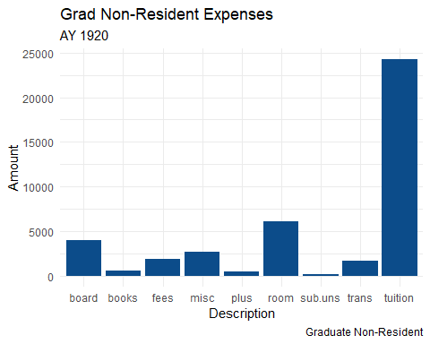

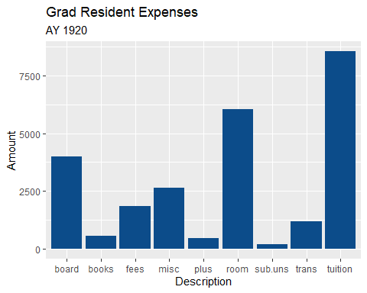

(#fig:2.2.2-coa-res)coa-res

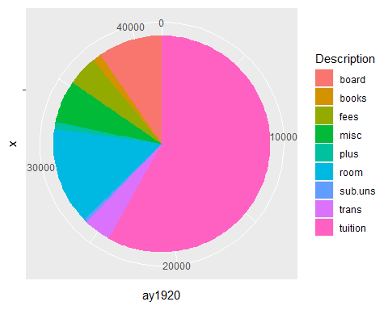

(#fig:2.2.3-coa-non)coa-grad-non-pie

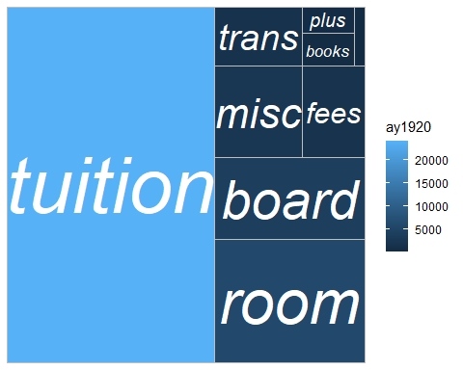 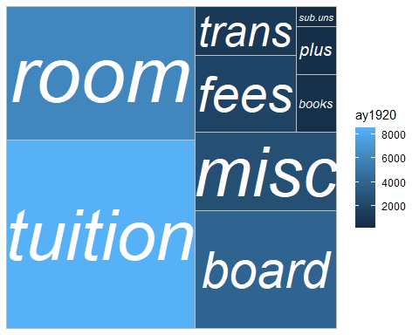

# Financial Aid Awarded



Undergraduate Cost of Attendance

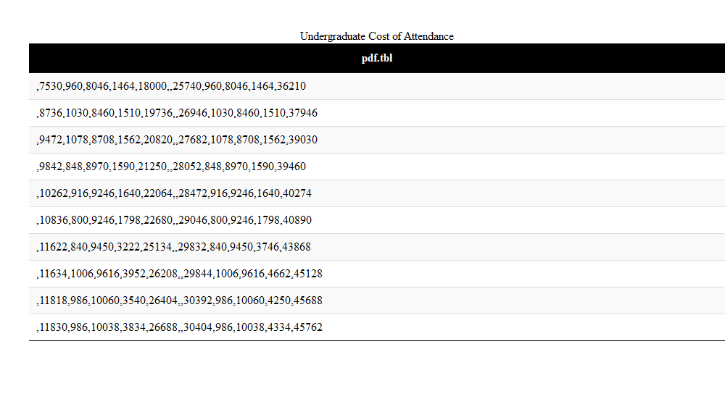

(#tab:2.o-UG-COA)Undergraduate Cost of Attendance Table

|  |
| --- |
| x |
| NA |
| 7530 |
| 960 |
| 8046 |
| 1464 |
| 18000 |
| NA |
| 25740 |
| 960 |
| 8046 |
| 1464 |
| 36210 |

|  |
| --- |
| x |
| NA |
| 8736 |
| 1030 |
| 8460 |
| 1510 |
| 19736 |
| NA |
| 26946 |
| 1030 |
| 8460 |
| 1510 |
| 37946 |

|  |
| --- |
| x |
| NA |
| 9472 |
| 1078 |
| 8708 |
| 1562 |
| 20820 |
| NA |
| 27682 |
| 1078 |
| 8708 |
| 1562 |
| 39030 |

|  |
| --- |
| x |
| NA |
| 9842 |
| 848 |
| 8970 |
| 1590 |
| 21250 |
| NA |
| 28052 |
| 848 |
| 8970 |
| 1590 |
| 39460 |

|  |
| --- |
| x |
| NA |
| 10262 |
| 916 |
| 9246 |
| 1640 |
| 22064 |
| NA |
| 28472 |
| 916 |
| 9246 |
| 1640 |
| 40274 |

|  |
| --- |
| x |
| NA |
| 10836 |
| 800 |
| 9246 |
| 1798 |
| 22680 |
| NA |
| 29046 |
| 800 |
| 9246 |
| 1798 |
| 40890 |

|  |
| --- |
| x |
| NA |
| 11622 |
| 840 |
| 9450 |
| 3222 |
| 25134 |
| NA |
| 29832 |
| 840 |
| 9450 |
| 3746 |
| 43868 |

|  |
| --- |
| x |
| NA |
| 11634 |
| 1006 |
| 9616 |
| 3952 |
| 26208 |
| NA |
| 29844 |
| 1006 |
| 9616 |
| 4662 |
| 45128 |

|  |
| --- |
| x |
| NA |
| 11818 |
| 986 |
| 10060 |
| 3540 |
| 26404 |
| NA |
| 30392 |
| 986 |
| 10060 |
| 4250 |
| 45688 |

|  |
| --- |
| x |
| NA |
| 11830 |
| 986 |
| 10038 |
| 3834 |
| 26688 |
| NA |
| 30404 |
| 986 |
| 10038 |
| 4334 |
| 45762 |

# Types and Sources of Aid.xls

Some *significant* applications are demonstrated in this chapter.

## Example one

## Example two

# Academic Year Student Financial Aid Awards by Type

We have finished a nice book.

Xie, Yihui. 2015. *Dynamic Documents with R and Knitr*. 2nd ed. Boca Raton, Florida: Chapman; Hall/CRC. <http://yihui.name/knitr/>.

———. 2020. *Bookdown: Authoring Books and Technical Documents with R Markdown*. <https://CRAN.R-project.org/package=bookdown>.