* In the RStudio Global Settings can you please snapshot and send the following options; General, Code-Editing, Code-Display, Code-Diagnostics, Pane Layout and Packages.
* Once this completed can you please go to the menu bar, click Help | Check for Updates and also send that to me.
* Finally, In the lower right hand quadrant of RStudio, there is the Files, Plots, Packages, Help and View pane. Select the 'Packages' tab and click the Update button.
* Here are some screenshots for you to follow:

1. RStudio: Global Options: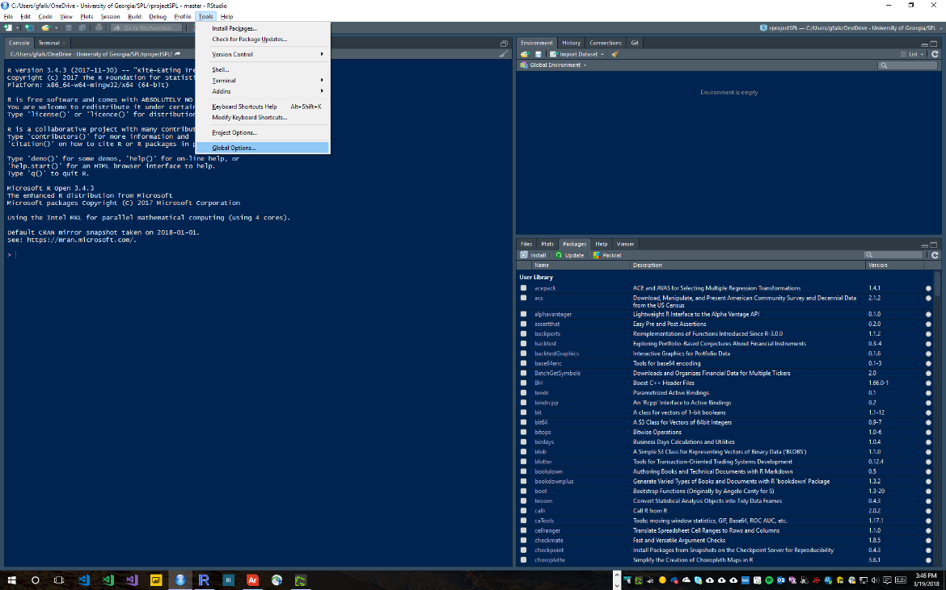
2. General Options: 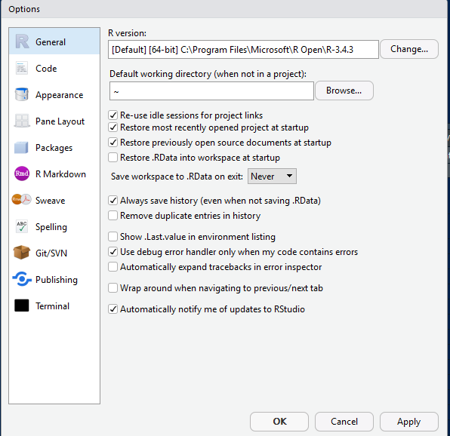
3. Code Options: Editing tab

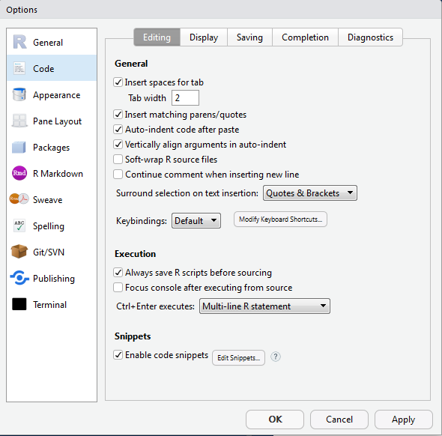

1. Code Options: Display tab

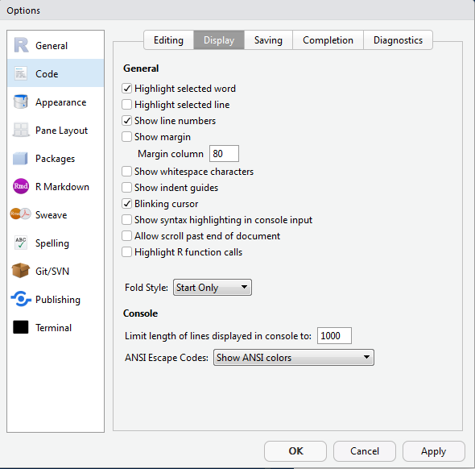

1. Code Options: Diagnostics Tab

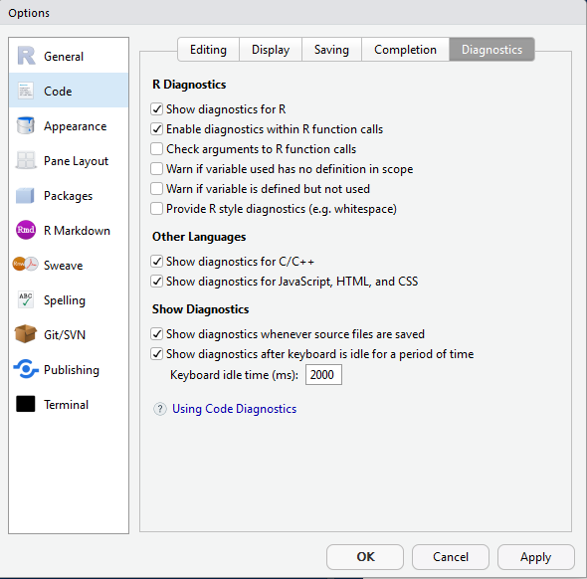

1. Pane Layout Options:

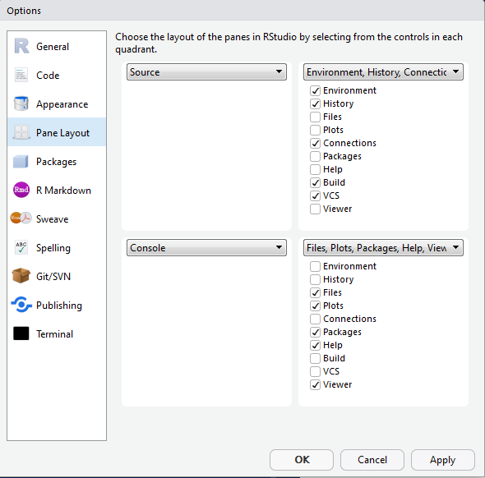

1. RStudio Packages Options:

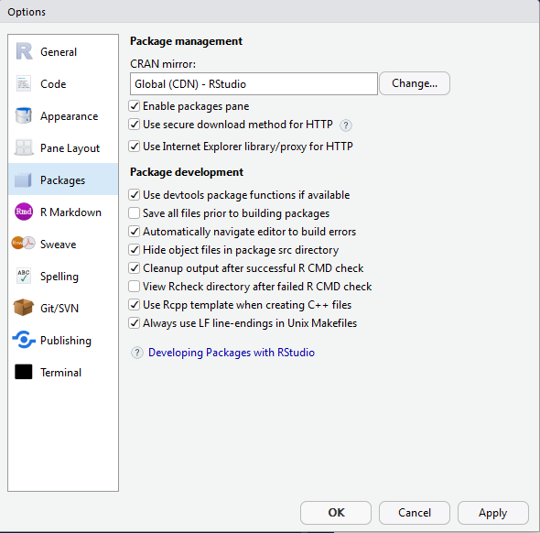

1. RStudio Updates: In the menu bar, click Help | Check for Updates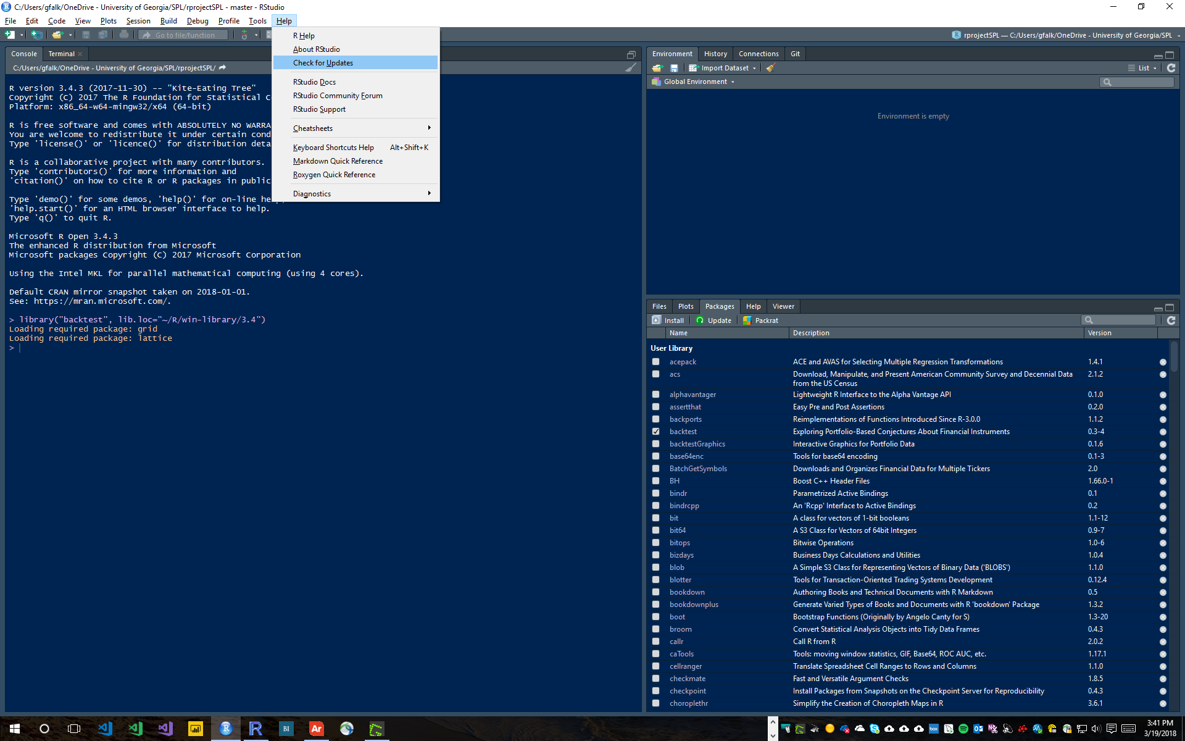
2. RStudio Packages – In the lower right hand quadrant of RStudio, there is the Files, Plots, Packages, Help view. Select the 'Packages' tab and click the Update button.