* In the RStudio Global Settings can you please snapshot and send the following options; General, Code-Editing, Code-Display, Code-Diagnostics, Pane Layout and Packages.
* Here are some screenshots for you to follow:

1. RStudio: Global Options: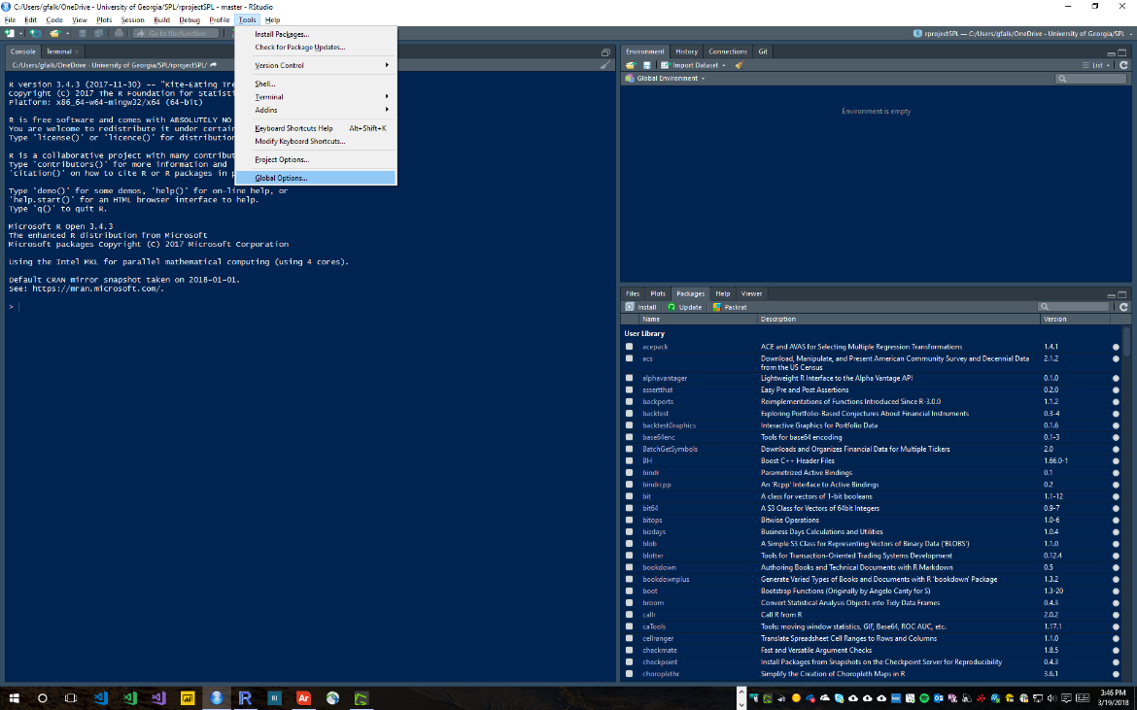
2. General Options: 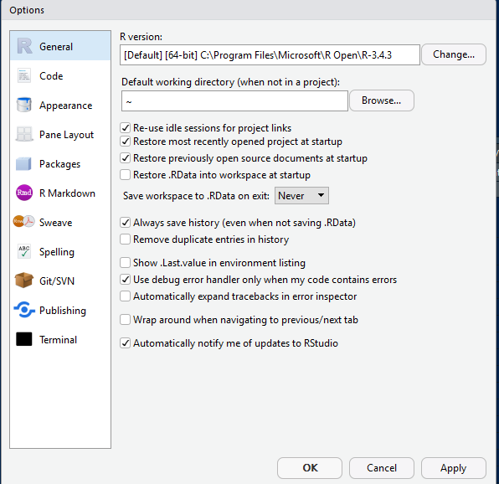
3. Code Options: Editing tab

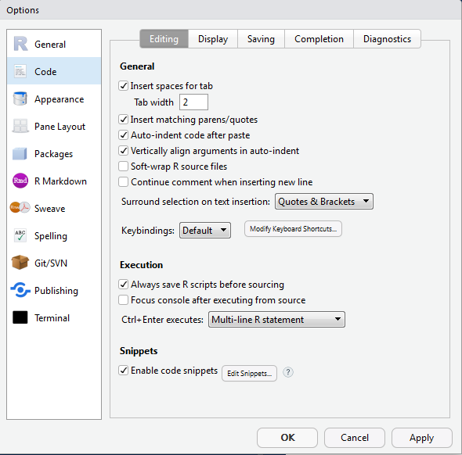

1. Code Options: Display tab

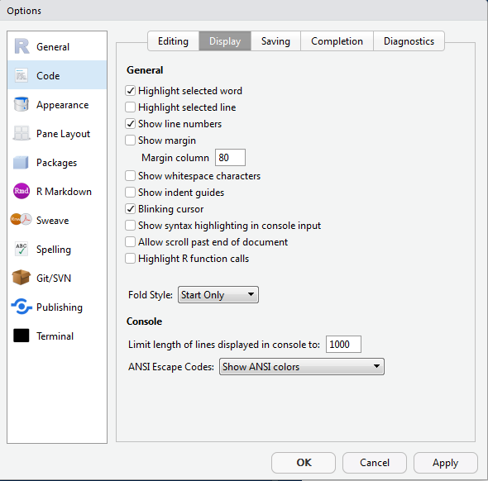

1. Code Options: Diagnostics Tab

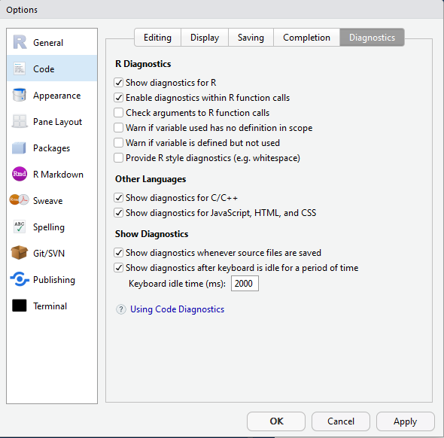

1. Pane Layout Options:

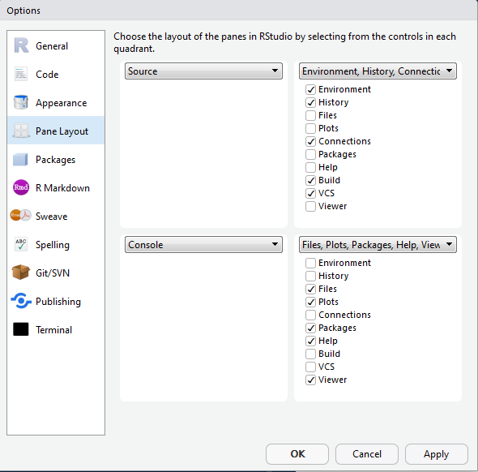

1. RStudio Packages Options:

