RStudio: Global Options:

1. General Options:

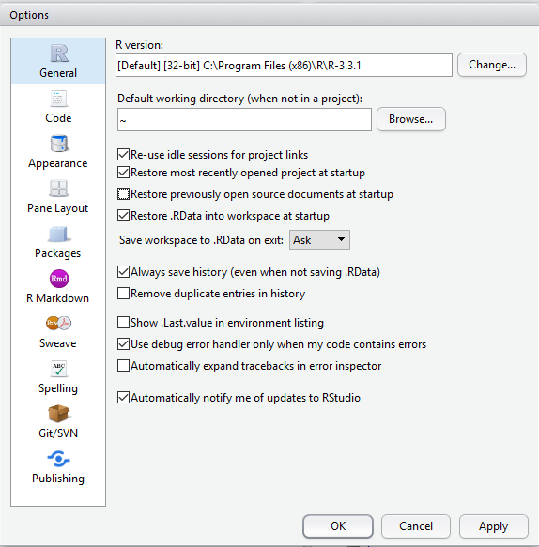

1. Code Options: Editing tab

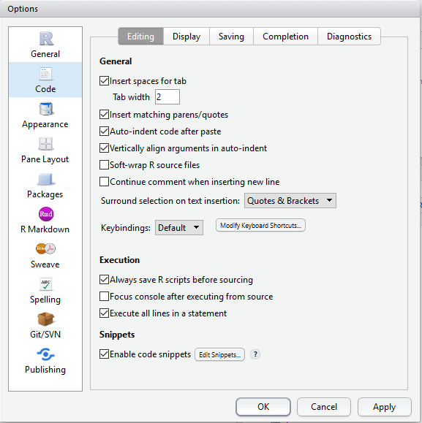

1. Code Options: Display tab

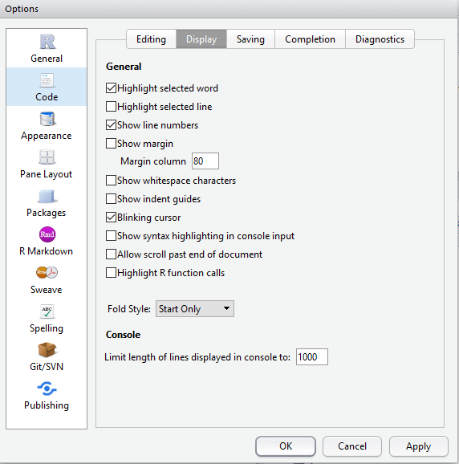

1. Code Options: Diagnostics Tab

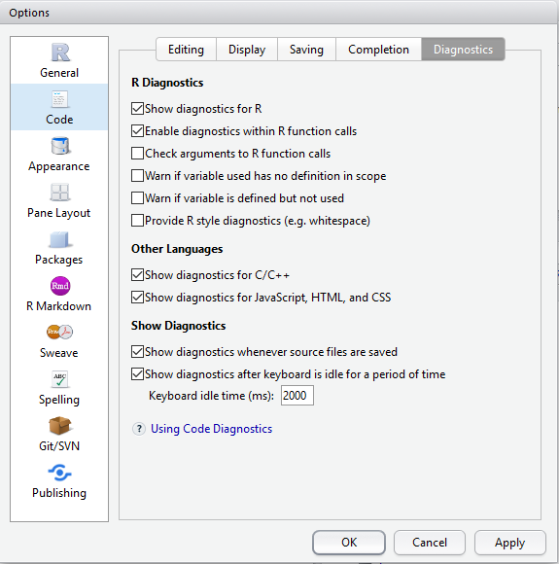

1. Pane Layout Options:

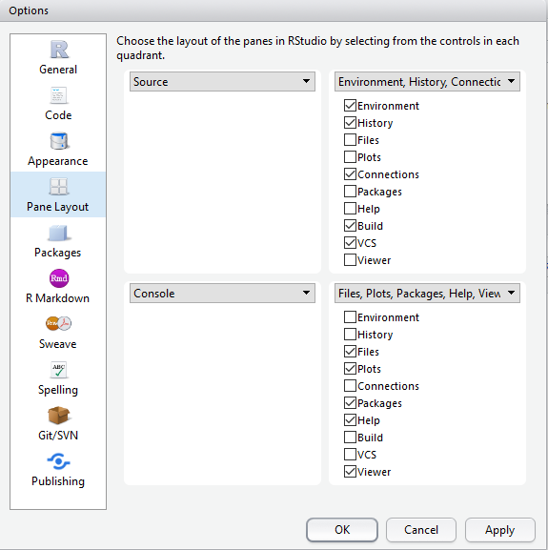

1. RStudio Packages Options:

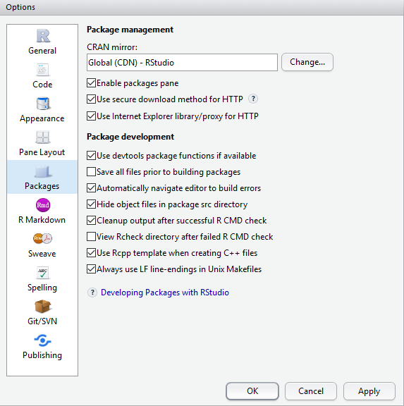

1. RStudio Updates: In the menu bar, click Help | Check for Update

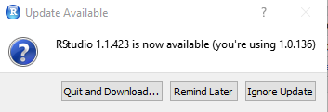

1. RStudio Packages – In the lower right hand quadrant of RStudio, there is the Files, Plots, Packages, Help view. Select the 'Packages' tab and click the Update button.

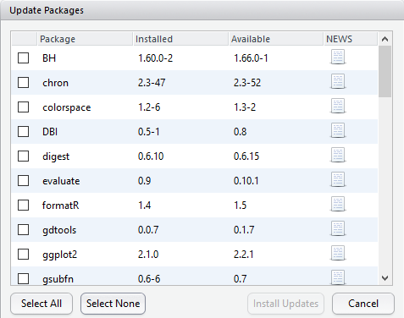

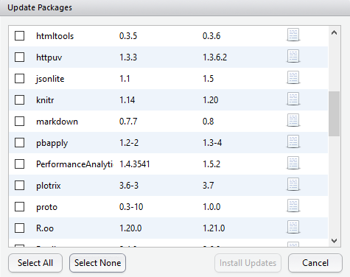

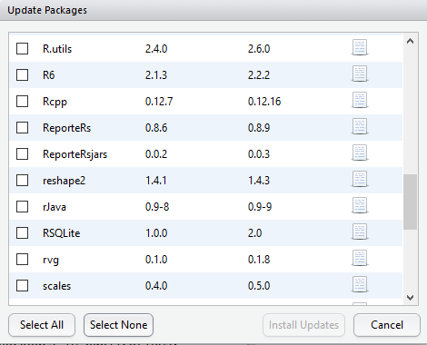

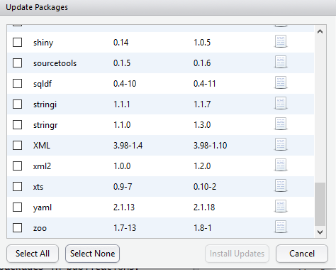

* Operating System:

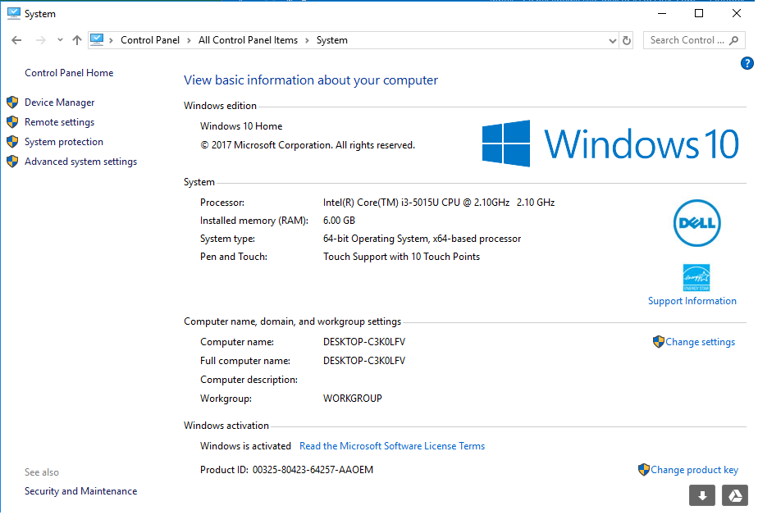

* Device:

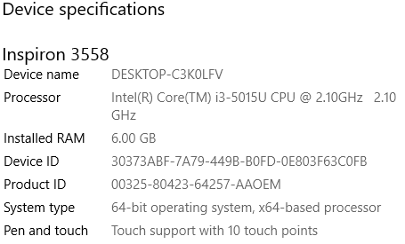

* RStudio Error:
  + When I go into R studio I opened performance.R and pressed source and then got the following error message.

