RStudio: Global Options:

1. General Options:

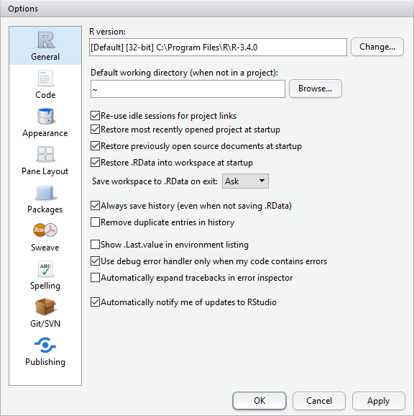

1. Code Options: Editing tab

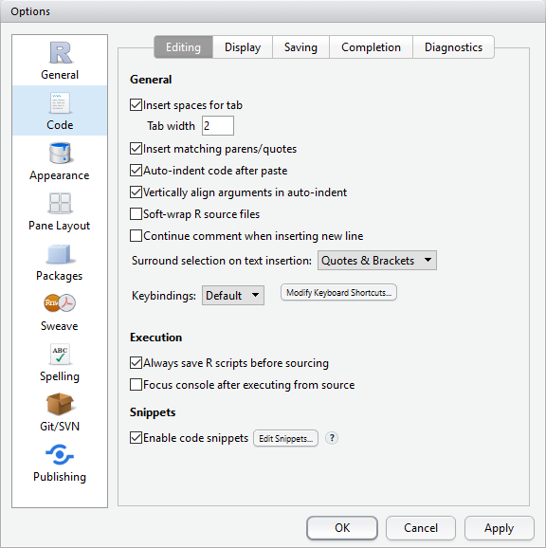

1. Code Options: Display tab

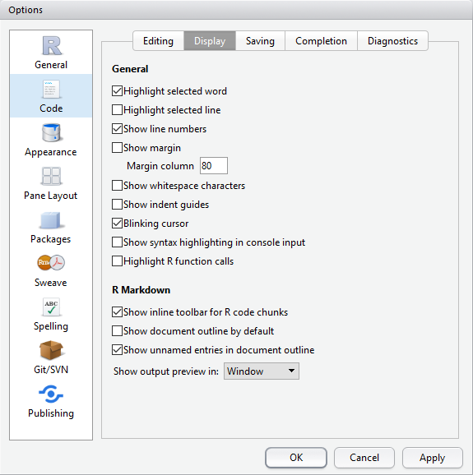

1. Code Options: Diagnostics Tab

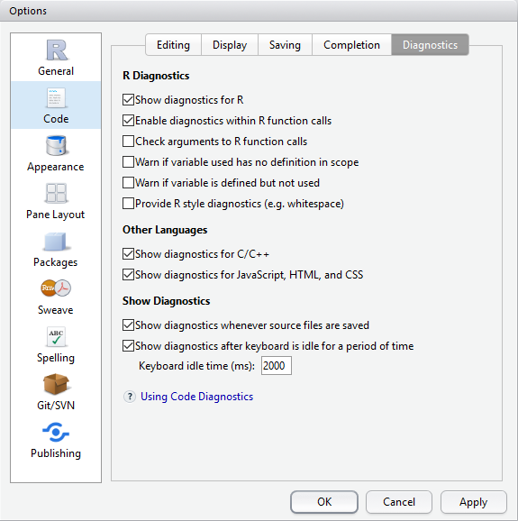

1. Pane Layout Options:

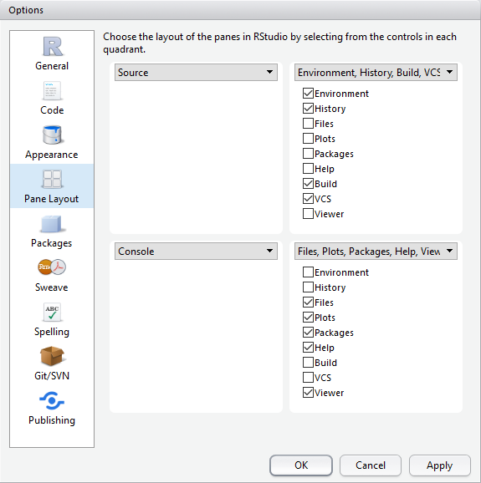

1. RStudio Packages Options:

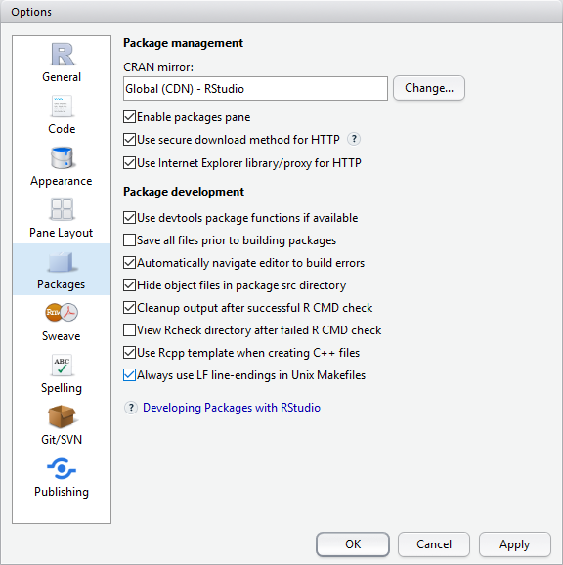

* RStudio Updates: In the menu bar, click Help | Check for Update
* RStudio Packages – In the lower right hand quadrant of RStudio, there is the Files, Plots, Packages, Help view. Select the 'Packages' tab and click the Update button.
* Operating System:

