Civil engineering, draft 7

Richard Layton

July 8, 2014

This is a new report format based on an R package I learned about at the R conference. I can still write [dynamic documents](http://www.jstatsoft.org/v56/b02/paper) to produce my reports, but *the output is a Word document*.

I'm hoping that this format will simplify our review, comment, and revisions of displays. You can use the usual Word tools to review and comment directly in this document.

# ASEE and MIDFIELD

|  |  |  |  |
| --- | --- | --- | --- |
| dspn | source | N | pctFemale |
| MCE | asee | 17656 | 0.12 |
| ELE_CPE | asee | 12995 | 0.11 |
| CVE_ENE | asee | 12359 | 0.22 |
| ISE | asee | 3306 | 0.33 |
| CHE | asee | 6104 | 0.31 |
| average | asee | 10484 | 0.18 |
| MCE | midfield | 15360 | 0.13 |
| ELE_CPE | midfield | 18505 | 0.12 |
| CVE_ENE | midfield | 11966 | 0.22 |
| ISE | midfield | 8223 | 0.34 |
| CHE | midfield | 7240 | 0.36 |
| average | midfield | 12259 | 0.21 |

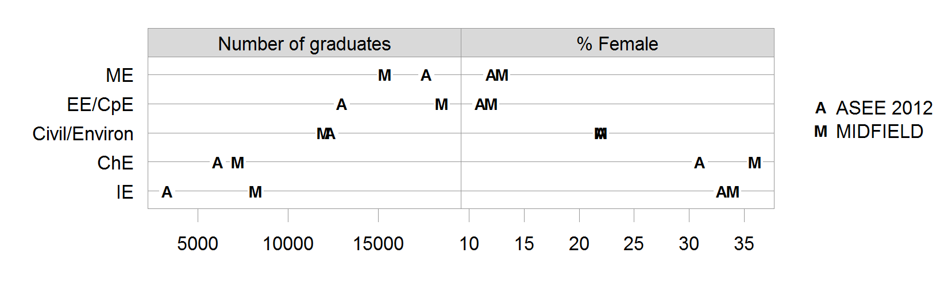

Figure 1. Number of graduates and female fraction of common disciplines in two data sets: MIDFIELD and the 2012 ASEE.

# Humphreys and Freeland (1992)

|  |  |  |  |
| --- | --- | --- | --- |
| pathYr4 | sex | N | pct |
| persisting | female | 39 | 0.64 |
| persisting | male | 74 | 0.63 |
| switching | female | 15 | 0.25 |
| switching | male | 23 | 0.19 |
| leaving | female | 7 | 0.11 |
| leaving | male | 21 | 0.18 |

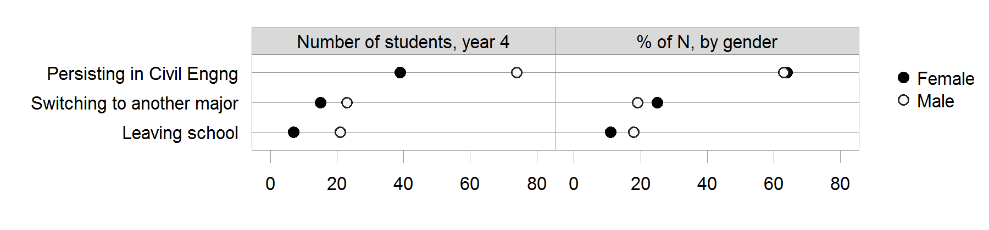

Figure 2. Findings from Humphreys and Freeland (1992). Civil engineering persistence, 1985--87 first-year cohorts combined, one-year outcomes, $N=$ 61 females, 118 males.

# Choosing a discipline

Spreadsheet: REE Disciplines data - 2014-04-12.xlsx

Worksheet tab: Race-Gender CVE

|  |  |  |  |
| --- | --- | --- | --- |
| Race/Ethnicity Gender | Starters in ENGR | Starters in Civil | % Civil |
| White Male | 59424 | 7297 | 12.3 |
| Black Male | 6026 | 514 | 8.5 |
| Asian Male | 4110 | 209 | 5.1 |
| Hispanic Male | 1937 | 177 | 9.1 |
| White Female | 13847 | 1850 | 13.4 |
| Black Female | 3555 | 275 | 7.7 |
| Asian Female | 1124 | 115 | 10.2 |
| Hispanic Female | 531 | 69 | 13.0 |
| All Male | 71497 | 8197 | 11.5 |
| All Female | 19057 | 2309 | 12.1 |
| All Students | 90554 | 10506 | 11.6 |

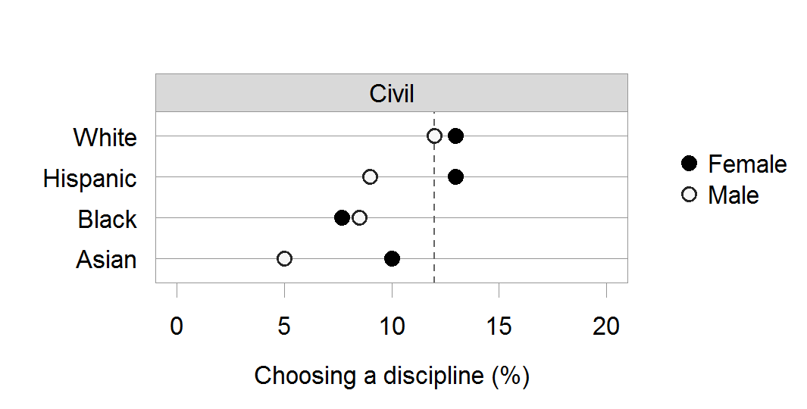

Figure 3. Percent of ENGR matriculants choosing the discipline (at institutions with the discipline). The vertical reference line is the discipline aggregate percentage of ENGR.

# Six-year graduation rates

Data source.

Spreadsheet: REE Disciplines data - 2014-04-12.xlsx

Worksheet tab: CVE

Multiple worksheet tabs for family of disciplines: ASE BE ChE CpE CVE EE IE ME

|  |  |  |  |  |  |  |  |
| --- | --- | --- | --- | --- | --- | --- | --- |
| eth | gen | CVE_y0 | CVE_y6 | CVE_rate | family_y0 | family_y6 | family_rate |
| Asian | Female | 115 | 48 | 41.7 | 871 | 356 | 40.9 |
| Black | Female | 275 | 83 | 30.2 | 2989 | 1063 | 35.6 |
| Hispanic | Female | 69 | 26 | 37.7 | 422 | 161 | 38.2 |
| White | Female | 1850 | 845 | 45.7 | 10526 | 4235 | 40.2 |
| Asian | Male | 209 | 94 | 45.0 | 3409 | 1407 | 41.3 |
| Black | Male | 514 | 143 | 27.8 | 5187 | 1560 | 30.1 |
| Hispanic | Male | 177 | 65 | 36.7 | 1546 | 508 | 32.9 |
| White | Male | 7297 | 3213 | 44.0 | 47852 | 18048 | 37.7 |

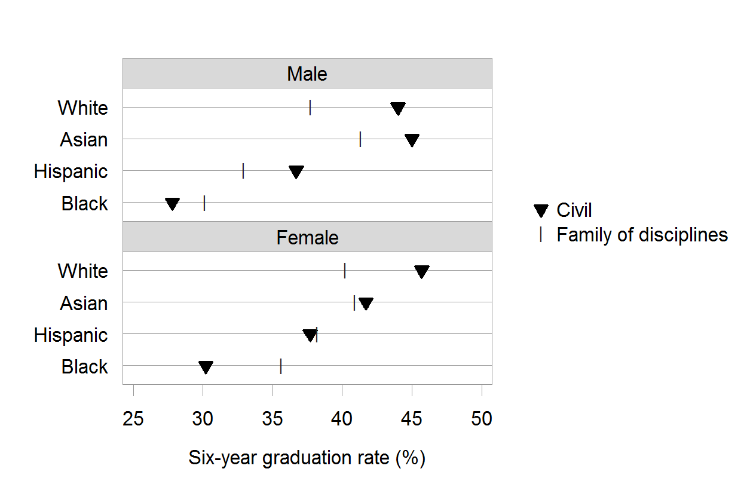

Figure 4. Six-year graduation rates by race-gender group. Rows are ordered by median graduation rate in Civil engineering.

# Trajectories

|  |  |  |  |  |  |  |  |
| --- | --- | --- | --- | --- | --- | --- | --- |
| eth | gen | all_y0 | all_y4 | all_y6 | start_y0 | start_y4 | start_y6 |
| Asian | Female | 115 | 123 | 111 | 115 | 58 | 48 |
| Black | Female | 275 | 194 | 162 | 275 | 101 | 83 |
| Hispanic | Female | 69 | 82 | 69 | 69 | 32 | 26 |
| White | Female | 1850 | 1916 | 1802 | 1850 | 918 | 845 |
| Asian | Male | 209 | 279 | 266 | 209 | 103 | 94 |
| Black | Male | 514 | 379 | 291 | 514 | 191 | 143 |
| Hispanic | Male | 177 | 263 | 242 | 177 | 72 | 65 |
| White | Male | 7297 | 7777 | 7122 | 7297 | 3597 | 3213 |

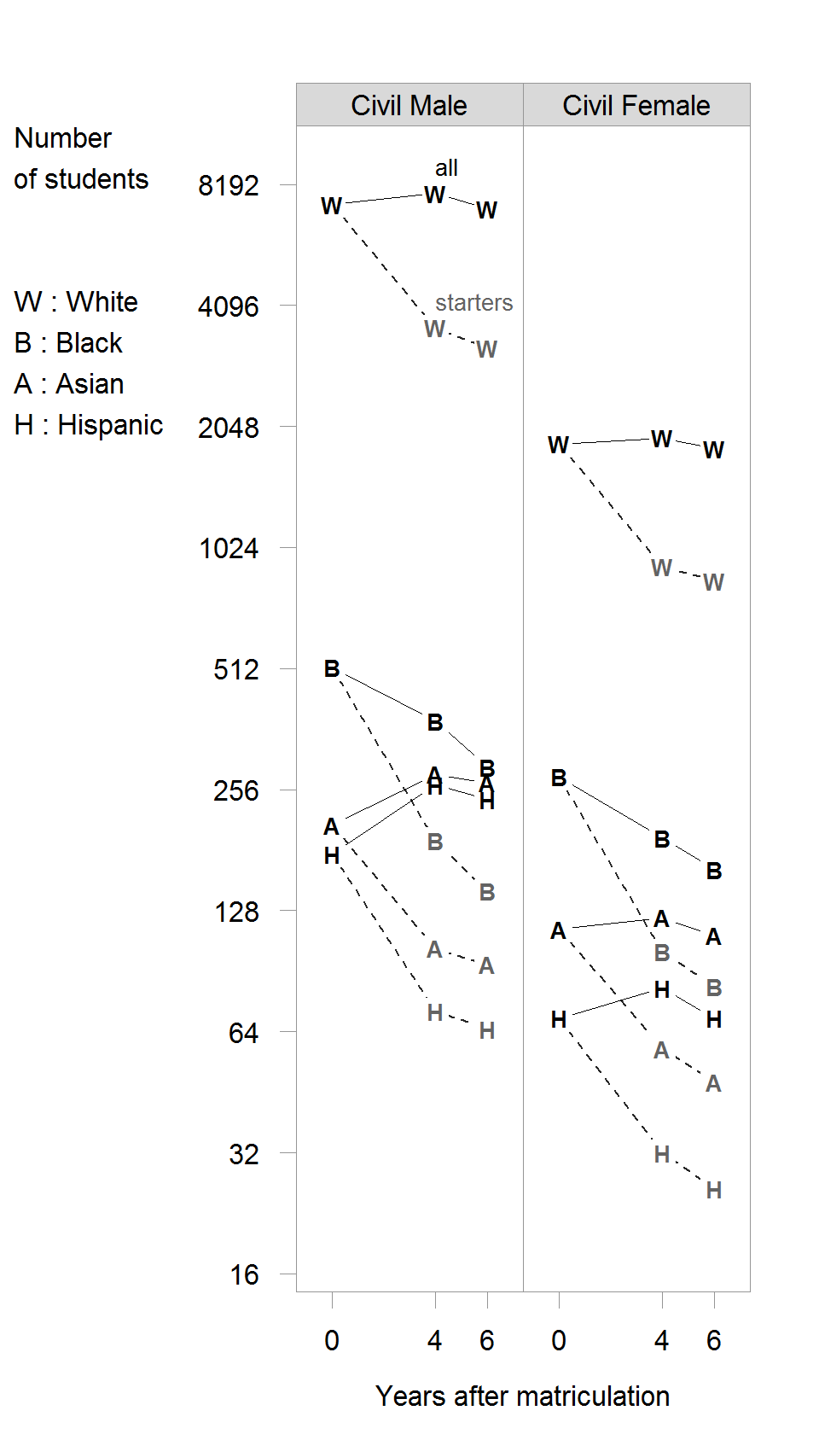

Figure 5. Trajectories. The vertical scale is log-base-2, thus every tick mark is double the previous tick mark.

# Stickiness

Data source

Spreadsheet: REE Disciplines data - 2014-04-12.xlsx

Worksheet tab: Stickiness

Discipline subset: CVE

No institutions omitted.

|  |  |  |  |  |  |
| --- | --- | --- | --- | --- | --- |
| dspn | eth | gen | grad | ever | stk |
| CVE | Asian | Female | 111 | 184 | 60.3 |
| CVE | Black | Female | 162 | 424 | 38.2 |
| CVE | Hispanic | Female | 69 | 127 | 54.3 |
| CVE | White | Female | 1802 | 2879 | 62.6 |
| CVE | Asian | Male | 266 | 440 | 60.5 |
| CVE | Black | Male | 291 | 789 | 36.9 |
| CVE | Hispanic | Male | 242 | 457 | 53.0 |
| CVE | White | Male | 7122 | 11718 | 60.8 |
| CVE | all | all | 10065 | 17018 | 59.1 |

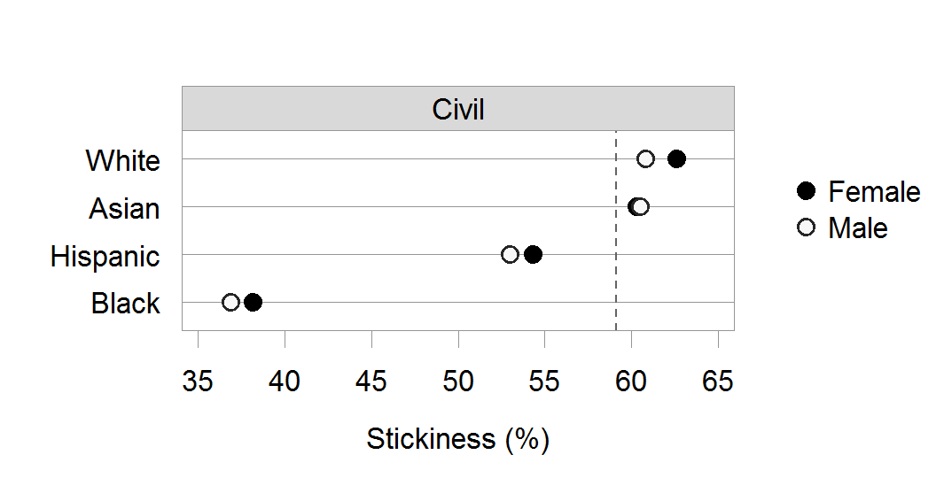

Figure 6. Stickiness.

# Transfers and FTIC stickiness

Data source

Spreadsheet: REE Disciplines data - 2014-04-12.xlsx

Worksheet tab: Stickiness

Discipline subset: CVE

|  |  |  |  |  |  |  |  |
| --- | --- | --- | --- | --- | --- | --- | --- |
| eth | gen | FTIC_grad | FTIC_ever | FTIC_stk | Transfer_grad | Transfer_ever | Transfer_stk |
| Asian | Female | 93 | 156 | 59.6 | 18 | 28 | 64.3 |
| Black | Female | 118 | 341 | 34.6 | 44 | 83 | 53.0 |
| Hispanic | Female | 39 | 87 | 44.8 | 30 | 40 | 75.0 |
| White | Female | 1434 | 2298 | 62.4 | 368 | 581 | 63.3 |
| Asian | Male | 180 | 305 | 59.0 | 86 | 135 | 63.7 |
| Black | Male | 204 | 616 | 33.1 | 87 | 173 | 50.3 |
| Hispanic | Male | 145 | 295 | 49.2 | 97 | 162 | 59.9 |
| White | Male | 5336 | 8860 | 60.2 | 1786 | 2858 | 62.5 |

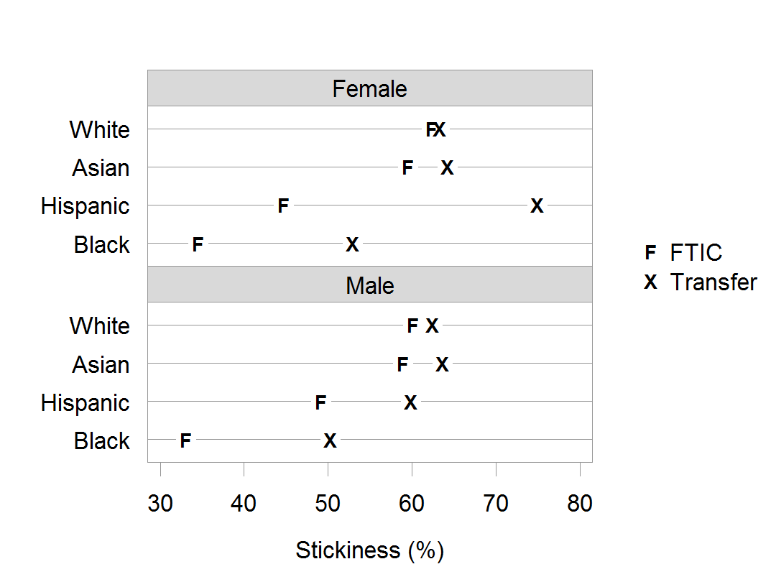

Figure 7. Stickiness disaggregated by cohort. Panels (and rows) are ordered by median stickiness.