**Exercises (cooking recipes)**

**Analyzing your model results**

We will explore model results (output variables), analyze them and comparing among different runs (i.e. different resolutions and with/without human influence).

The main tools that we will use: cdo and ncview (and aguila).

The following exercises are just few ideas. Please feel free to introduce some improvisation.

1. Calculate the long term mean of annual local runoff (m/year).

$ cdo timmean human/netcdf/runoff_annuaTot_output.nc longterm_annual_runoff_human.nc

Using ncview, you may also want to visualize and compare the long term average of runoff fields from different scenarios/runs. Note that the components of runoff consist of directRunoff (Q1), interflow (Q2), and baseflow (Q3). You may also want to visualize the long term mean values of these components and make comparisons among different runs.

Some other variables that you may want to compare are totalEvaporation, gwRecharge, surfaceWaterAbstraction, totalGroundwaterAbstraction, nonFossilGroundwaterAbstraction, fossilGroundwaterAbstraction, etc.

1. Calculate the long term mean of annual precipitation (m/year).

$ cdo timmean human/netcdf/precipitation_annuaTot_output.nc longterm_annual_precipitation_human.nc

Note that the precipitation field for all scenarios/runs should be the same.

1. Then, you can calculate the runoff coefficient = runoff / precipitation

$ cdo div longterm_annual_runoff_human.nc longterm_annual_precipitation_human.nc runoff_coefficient_human.nc

1. Using ncview (or aguila), visualize your runoff coefficient maps and try to understand their patterns.
2. Calculate monthly climatology of discharge fields from all runs. An example is given as follows.

$ cdo ymonmean natural/netcdf/discharge_monthAvg_output.nc climatology_discharge_natural.nc

1. Then, using ncview, visualize climatology discharge fields. Next, try to plot the discharge time series at one of the pixels (e.g. the most downstream pixel). This can be done using the “Dump” menu in the time series window of ncview. Compare these time series among scenarios.

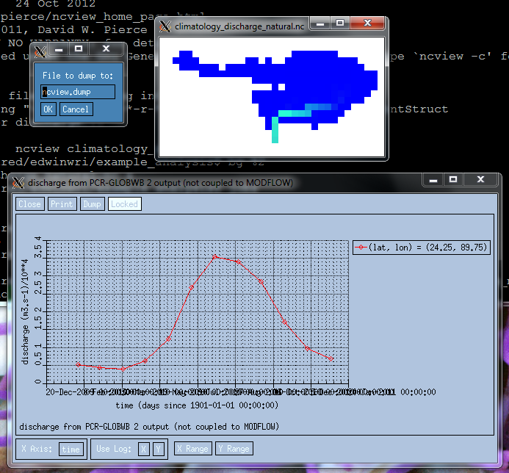

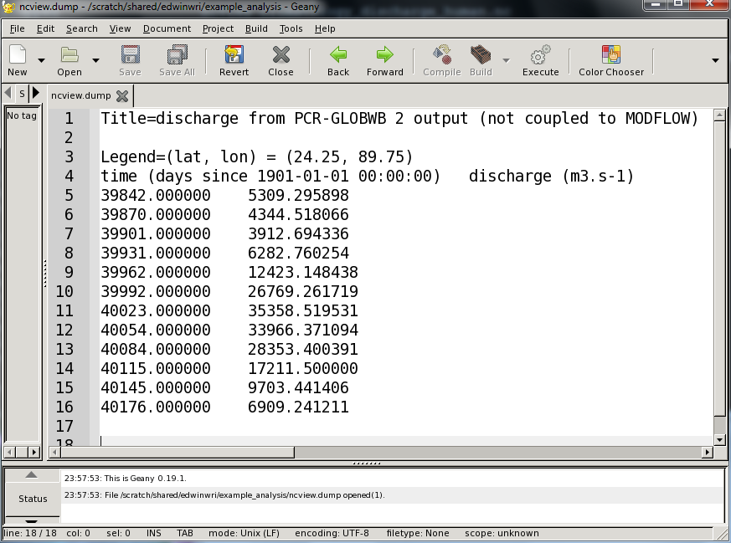

1. You may also want to compare/evaluate/validate your climatology discharge to GRDC data (please check the GRDC website, e.g. <https://www.bafg.de/GRDC>).