**Exercises (cooking recipes)**

**Using supercomputer to run a PCR-GLOBWB**

For this exercise, we will use snellius as our supercomputer. PS: Some of you may not have a Snellius account. If this is the case, please join others (or you can also use eejit as well).

1. Please login to Snellius.

$ ssh -XY [edwin@snellius.surf.nl](mailto:edwin@snellius.surf.nl)

1. Understanding your supercomputer, login nodes and computational nodes, see the picture below. Please also type “sview” (then, Edwin will give some explanation).

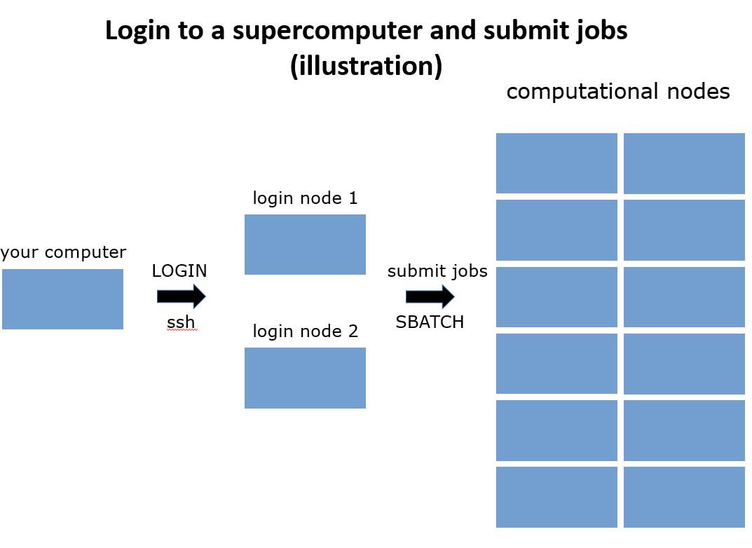

Note: Please do not execute your computations (especially large ones) on login nodes! These login nodes are used by all cartesius users (so don’t make them mad).

1. Please type the following commands (that are available for Snellius only).

# to check your account information, remaining budget (SBUs), etc

$ accinfo

# to check the SBUs that were used (not always up to date)

$ accuse

$ accuse -d

# to check the status of SBUs (better, including running jobs)

$ budget-overview

1. We will use the file “sbatch_example.sh” that is located on “/home/edwin/jobs/example/”. Please copy it to your directory and open it using geany. Edwin will explain the content.

# copy the file to your own directory currently running)

$ pwd

/home/edwinmod/tmp

$ cp /home/edwin/jobs/example/sbatch_example.sh .

# open it using geany

$ geany sbatch_example.sh

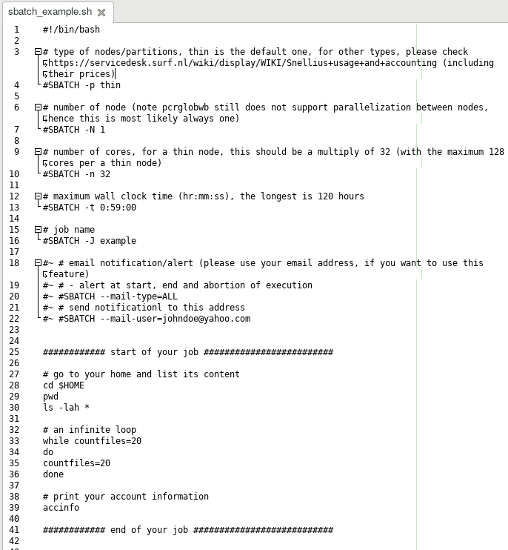

1. Please submit the “sbatch_example.sh” job using the following sbatch command.

$ sbatch sbatch_example.sh

sbatch: Single node jobs run on a shared node by default. Add --exclusive if you want to use a node exclusively.

sbatch: You will be charged for 0.25 node. A full node consists of 128 CPU cores, 229376 MiB of memory and 0 GPUs and can be shared by up to 4 jobs.

Submitted batch job 1859254

1. You can check its status, by using the following “squeue” command.

# squeue

JOBID PARTITION NAME USER ST TIME NODES NODELIST(REASON)

1859254 thin example edwinmod PD 0:00 1 (Priority)

# at this moment the job was still queueing

# after a while, please check it again

$ squeue

JOBID PARTITION NAME USER ST TIME NODES NODELIST(REASON)

1849203 staging touch-ed edwinmod PD 0:00 1 (BeginTime)

1859254 thin example edwinmod R 0:26 1 tcn81

# now it was already running; this job, which contains an infinite loop, would run until its wall clock time finished (59 mins)

1. Please check the slurm output of the job (for example using geany).

# geany slurm-<your_job_id>.out

$ geany slurm-1859254.out

1. If your job is still running, you may want to cancel it using the following command

# to cancel a job: scancel <your_job_id>

$ scancel 1859254

1. Exercise: Please replace the infinite loop part of the above “sbatch_example.sh” with some command lines to execute a PCR-GLOBWB run (you may want to check your previous exercises).

Some clues:

* Do not forget to load all software packages/modules required for running PCR-GLOBWB. You can use the bash file “/home/edwin/load_all_default.sh”
* You can use the PCR-GLOBWB input files that are stored on the directory “/projects/0/dfguu/data/hydroworld/pcrglobwb2_input_release/version_2019_11_beta_extended/pcrglobwb2_input”
* For the output folder, you can use “/scratch-shared/<your_user_name>” (example: /scratch-shared/edwin)