## 1) Create mLab Account on mlab.com

Verify your email to access account

## 2) Create Free Sandbox Deployment

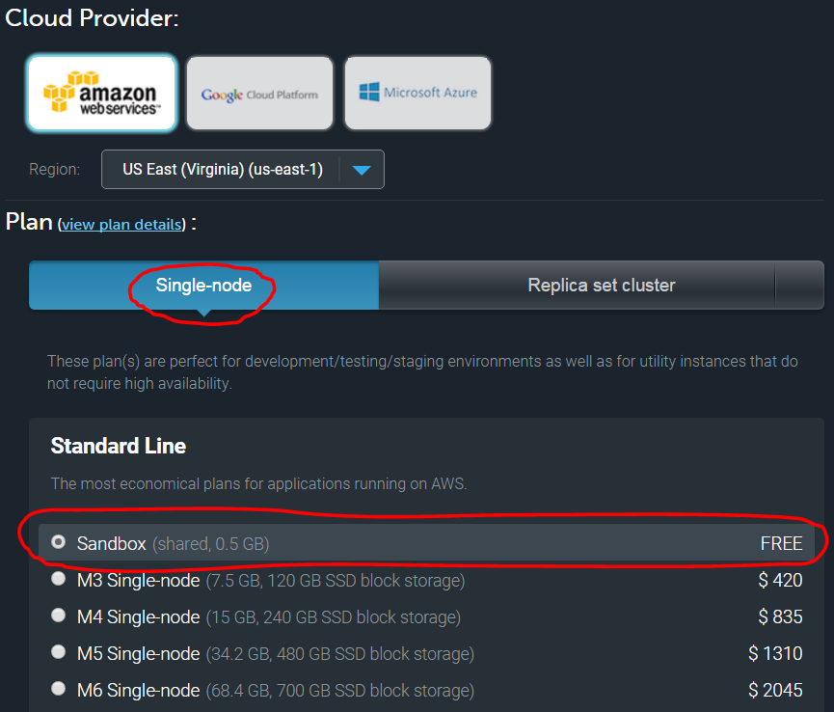

## 3) Create Database Name: emr

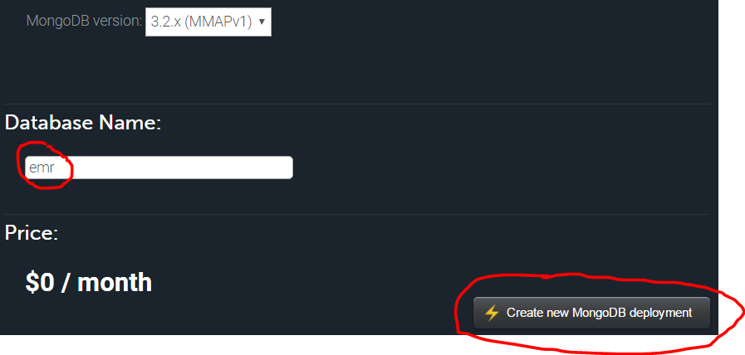

## 4) Create DB User

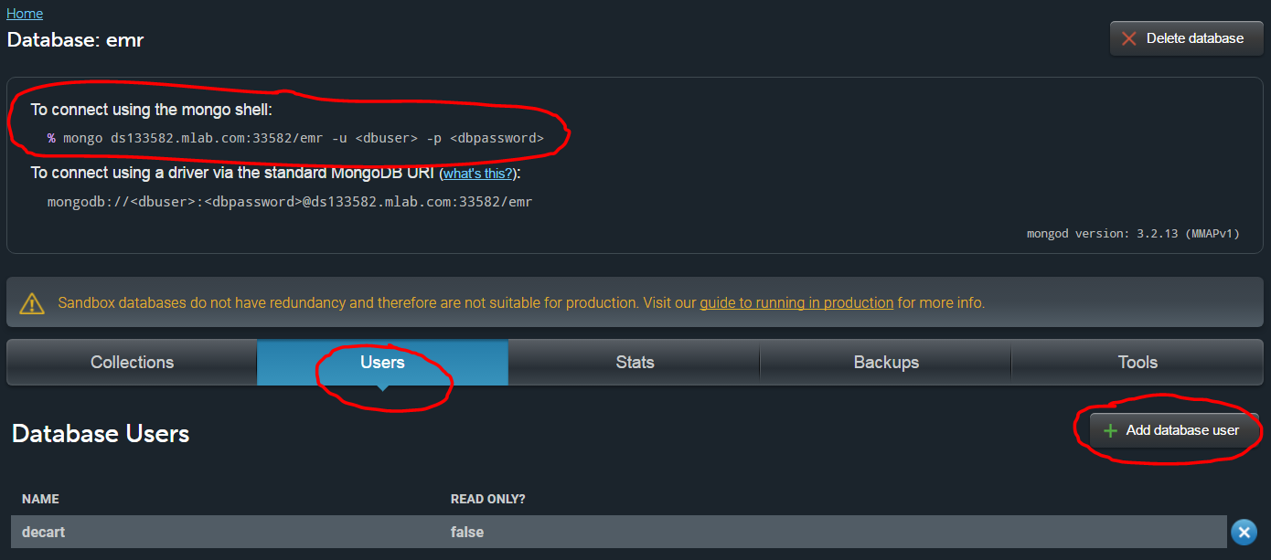

### 5) Connect to mLab with pymongo on JupyterHub

Login to <https://jupyterhub.med.utah.edu> with your github account credentials

Follow the instructions on this file to practice working with mongoDB:

<https://jupyterhub.med.utah.edu/user/petermo13/notebooks/PyMongo.ipynb>

Github File:

* 5a) Insert a few Patient Registration Documents
* 5b) Update your document
* 5c) Query to Verify Updated Document
* 5d) Run Aggregate Queries to Get Average Age of Patients
* 5e) Count Records
* 5f) Delete One Document
* 5g) List ALL Documents