1) If we have to delete a whole repository(in git), which command is used ??

a-> rm -rf .git

2)Repository meaning in a simple world?

a-> when we track a folder and add to this folder in git, this folder is now known as a repository.

3)How do we have a crate repository in git?

a-> git init this command thought we can crate git repository.

4)which command is a crate blank file ??

a-> touch

5) git diff ??

a-> It compare the working directory to stages area's [means red and green lines dif.]

6) git diff --staged ??

a-> It compare the last commit to staging areas.

7) git commit -a -m "Direct commit" ??

a-> It commands all tracked files ka stage Kar Deta hee and aek commit bna Deta hee.

8) Which command is if we delete a file through git ??

a-> git rm [file name]

9)Which command is if we remain a file through git ??

a-> git mv [file name with extanetion] [file name which we will change]

ex:-

git mv first.txt uv.txt

10) git rm -- cached ??

a-> It command is used when we add to .gitignore but when running git status so it is tracked this file, soo we stoping this file from tracking

then we used this command.

11) git log ??

a-> It command shows all commit in a repository

12) git log -p ??

a-> It command shows all commits and changes to the repository.

13) git log --stat ??

a-> It command shows all commits and changes in a smart way to the repository.

14) git log --pretty=oneline ??

a-> It command shows all commit in one line in a repository

14) git log --pretty=short ??

a-> It command shows all commit short [ time + commit ] in a repository

14) git log --pretty=full ??

a-> It command shows all commit full means [ author name + time + commit ] in a repository

15) author name: This creates a file

and

commit name: This is a change to a file

16) git log --since=2.days

a-> It command shows all commit in the last 2 days in a repository

17) git log --since=2.months

a-> It command shows all commit in the last 2 months in a repository

18) git log --since=2.years

a-> It command shows all commit in the last 2 years in a repository

19) git log --pretty=format:"%h --%an"

a-> It command means %h = abbreviated commit hash & %an = author-name

-->>> For more information please search this website: [ https://git-scm.com/docs/git-log ]

20) git log --pretty=format:"%h --%ae"

a-> It command means %h = abbreviated commit hash & %ae = author email-id

21) git log -p -1 ??

a-> It command shows the one commit in the repository

22) git commit --amend ??

a-> In this command is mrajed to our changes to the whole commit

-->> When we right a [git commit --amend than] then one editor open it is know as VM editor

and

it's worked

if writing something then first of all type [ i ]

and if back in git then type [ ESC : wq ]

23) which command that we want to unstage a file ??

a-> git restore --staged [file name]

ex. ->>>

git restore --staged uday.docx

24) git checkout -- [file name] ??

a-> This commade is matched the last commit of git.That means last commit sathe compare kari de che

25) git checkout -f ??

a-> This command is match our working directry to our last commit.

26) git remote mean??

a-> It means website means it connected to our local directory to GitHub.

and this process is to easy.

--------->Imp questions: How to push in GitHub??

>>

>>

1. git remote

1.1 git remote -v

origin git@github.com:UVwithHack/Demo.git (fetch)

origin git@github.com:UVwithHack/Demo.git (push)

2. git remote add [origin] [git@github.com:UVwithHack/uday.git]

3. git push -u origin master

3.3 we push and we can see this one [warning: could not find UI helper 'GitHub.UI'] this

then we set this problem first

-- git remote set-url origin (git@github.com:UVwithHack/Demo.git)

this bracket ssh url if above(HTTPS URL) not work than we set this

27) Alias In Git.

a-> Alias is a keyword that is sorted from the command.

like

git status alias

git st

(In this command is: git config --global alias.s status )

28) git checkout -b [Branch name] ??

a-> This command is used a create a new branch and also add in sab-branches in git.

29) Resolving Merge conflicts.

a->

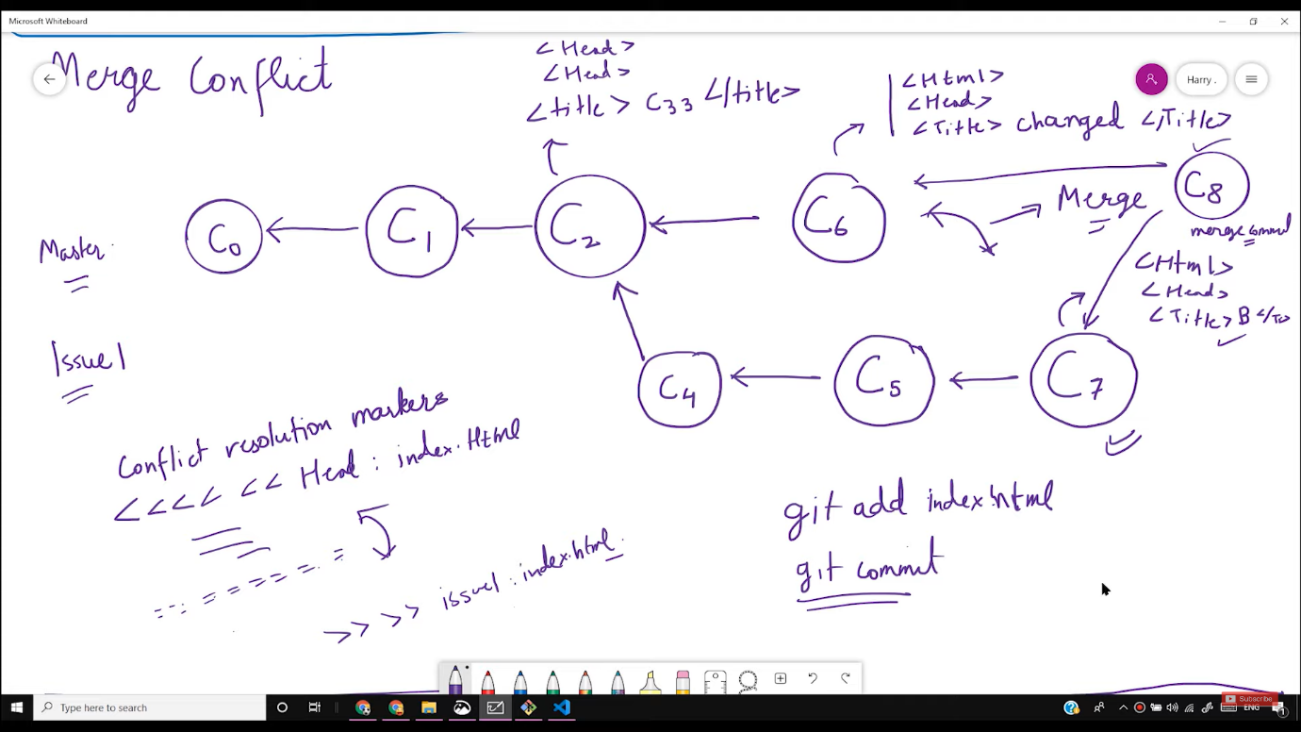

30) Git Branching Workflow in production.

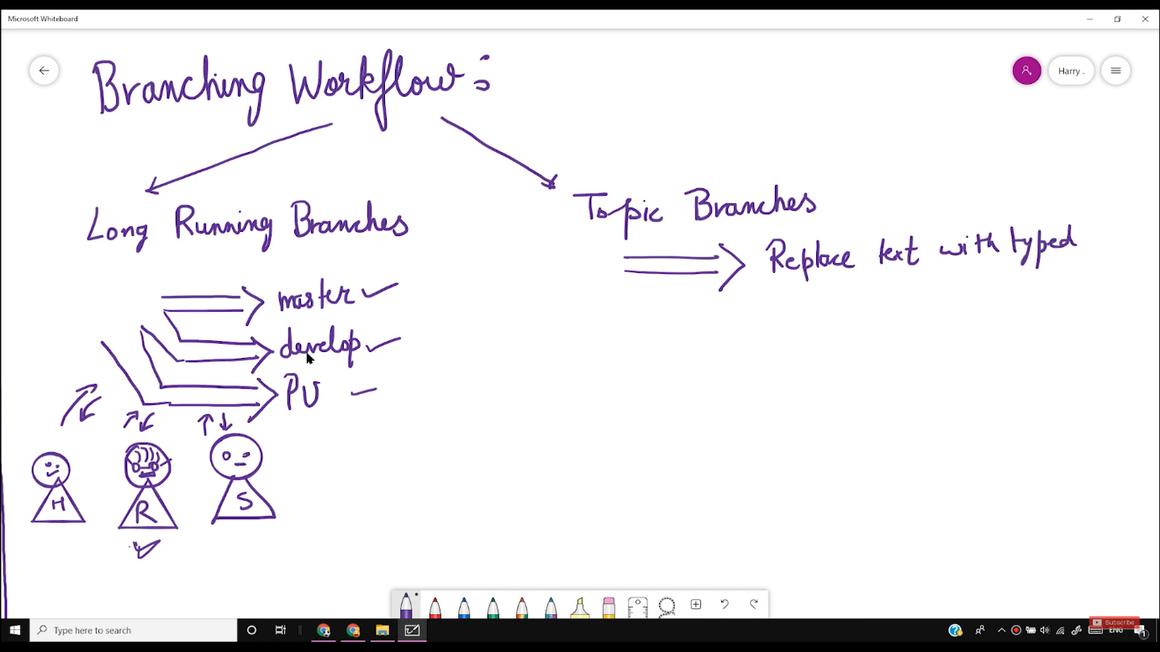

31 ) git push -d [your remote name] [your branch name] .

a-> This command though we can delete a branch in GitHub.

Ex. git push -d origin bugfix