Exploratory Data Analysis of a Unified Host and Network Dataset

Catherine Beazley, Karan Gadiya, Rakesh Ravi K U, David Roden, Boda Ye, Brendan Abraham, Donald E. Brown, Malathi Veeraraghavan
University of Virginia, {cmb5et, khg8mh, rk9cx, dr2de, by8jj, bea3ch, deb, mv5g}@virginia.edu

Abstract - Exploratory data analysis is invaluable for understanding data, choosing correct models, and interpreting, validating, and applying results. It often leads to the discovery of patterns that can answer a number of research questions. In this paper, we perform exploratory data analysis on cybersecurity data in the NetFlow Dataset from “The Unified Host and Network Dataset”. “The Unified Host and Network Dataset” is a large, open source dataset collected on the Los Alamos National Laboratory (LANL) enterprise network that was published to encourage new research in cybersecurity. The NetFlow Dataset is a compilation of flow logs from routers within the LANL network that are aggregated to a relational format using network stitching. Our exploratory data analysis shows distinct patterns and clusters within a day of data. Specifically, scatter plots of the number of packets sent by the destination device versus the number of packets sent by the source device show three distinct, no-intercept linear relationships between the variables. The relationships suggest three common patterns for how the source device and destination device interactively send packets to each other. Our analysis also shows that byte and packet distributions of connections on rare ports and connections on common ports are statistically different, suggesting these differences can be used to discriminate between normal and abnormal network behavior. Our findings may be useful for research into classification problems with a Unified Host and Network Dataset and for furthering cluster analysis in cybersecurity research.

Index Terms – Cluster Analysis, Cybersecurity, Unified Host and Network Dataset
Introduction and Background
Cybercrime is increasing and evolving, with cybercriminals targeting data by hacking core systems to steal, disrupt or destroy information, and with malware attacks becoming more sophisticated and difficult to detect and prevent [1]-[2]. The number of security breaches has increased this year by 11% and the cost of attacks to organizations has increased from $1.4 million to $13.0 million. As cybercrime evolves and becomes riskier, businesses and institutions must prioritize and adapt their technologies for detecting and preventing cybercrime in its ever-changing landscape. If cybersecurity protection does not adapt to the evolving cybercrime landscape, there can be a global loss of $5.2 trillion over the next 5 years [1].
Data analysis of cybersecurity network traffic predicts, detects, and examines network irregularities and ultimately helps cyber analysts to create intrusion detection systems that prevent malicious actors from accessing the network. Insights from exploratory data analysis on network traffic data are important for these intrusion detection systems, and 84% of businesses use data analysis methods to build these systems and prevent attacks [2]. In this paper, we analyze network traffic data to uncover latent structural patterns in NetFlow data that could be useful for intrusion detection systems and other network traffic classification tasks.

Literature Review

In cybersecurity, many researchers analyze packet capture and NetFlow datasets. Packet captures describe network traffic at the most granular level, including information about packet payloads. In contrast, NetFlow describes aggregate, flow level statistics pertaining to timing and volume of data transfer between a source and destination. Packet Capture is predominantly used to evaluate security threats because of its detailed payload information, but analyzing NetFlow is still a useful method for screening malicious traffic, as it is easier to collect, store and analyze than packet captures. By analyzing NetFlow data first, the investigators can limit the number of packets and payloads to analyze and respond to threats quicker [3]-[4].
Cybersecurity researchers have addressed exploring NetFlow data in different manners. Minarik and Dymacek make an intuitive graph-based visualization of NetFlow data that can be used to explore features and to visualize communications on a network [5]. Fischer, Mansmann, Keim, Pietzko, and Waldvogel also propose data visualizations to help understand network traffic. They propose a TreeMap Visualization and a database design supplemented with alerts from an intrusion detection system which makes analyzing and filtering NetFlow data easier and more efficient [6]. While NetFlow consists of higher-level connection information than Packet Capture, it is still a large dataset because of the large number of connections on a network. Gilbert, Kotidis, Muthukrishnan, and Strauss handle the datasets’ large size by proposing a method for network data approximation that can be used for exploratory data analysis [7]. We create data visualizations that describe the network traffic and analyze a day of data and by taking representative random samples.

Data

“The Unified Host and Network Dataset” consists of network and computer events collected from the Los Alamos National Laboratory (LANL) enterprise network over a 90-day period [8]. It is divided into two datasets: the Host dataset and the NetFlow dataset. The Host dataset consists of host logs, which record all Windows authentication events on user machines, and the NetFlow dataset consists of NetFlow records, which record network activity between two devices. The features in the NetFlow dataset are the following:
- Time – The start time of the event in epoch time format.
- Duration – Duration of the event in seconds
- SrcDevice – Anonymized ID of the device that likely initiated the event.
- DstDevice - Anonymized ID of the receiving device.
- Protocol – The protocol number.
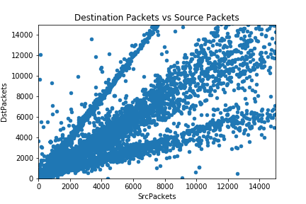
- SrcPort – The port used by SrcDevice.
- DstPort – The port used by DstDevice.
- SrcPackets – The number of packets sent by SrcDevice during the event.
- DstPackets – The number of packets sent by DstDevice during the event.
- SrcBytes – The number of bytes sent by SrcDevice during the event.
- DstBytes – The number of bytes sent by DstDevice during the event.

To create the NetFlow dataset, LANL used network stitching on the flows, reconciling opposing unidirectional NetFlow records of bidirectional connections into biflows, which are flows for which the features are separated by source activity and destination activity. For instance, rather than having one feature for the number of packets sent, a biflow has two features: the number of packets sent by the source device and the number of packets sent by the destination device. LANL also aggregated records based on five tuples, which are the sets of source device, source port, destination device, destination port, and protocol. By formatting the data into biflows and by aggregating flows, many of the events contain large duration, packet, and byte values.
In cases when LANL’s stitching was unsuccessful, the number of source or destination packets was 0 [8]. We removed those connections from the dataset during preprocessing and we are assuming the remaining connections with nonzero source and destination packets were collected and stitched correctly.

Packet Analysis

Scatter plots of the number of packets sent by the destination device (DstPackets) versus number of packets sent by the source device (SrcPackets) show three distinct, no-intercept linear relationships. The slopes of these relationships can be interpreted as the ratio of DstPackets to SrcPackets, and the three distinct relationships indicate three patterns for the way the source and destination devices interact by sending and receiving packets in a biflow. This three-relationship pattern holds consistently; samples consisting of consecutive biflows taken over a fixed period of time and representative random samples of varying size from a day of data in the NetFlow dataset show the same three, no-intercept linear relationships when plotted on the same dimensions. The representative random samples of a day of data were taken so that each of the sample’s summary statistics are at most one standard deviation from the summary statistics describing that day of data.
Figures I, II, and III show that the same pattern holds on different samples. Figure I shows a sample of 25,000 consecutive observations. Figure II shows a representative random sample of 3 million observations. Figure III shows a representative random sample of 6 million observations. All three plots show the three relationships and that as the sample size increases, the relationships become less clear.
FIGURE I
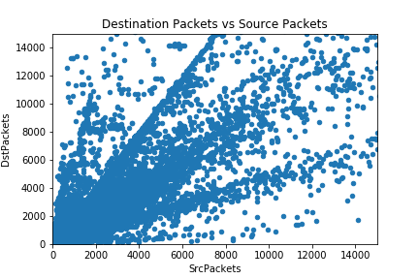
Sample of 25,000 Consecutive Observations
FIGURE II
Representative Random Sample of 3 million Observations
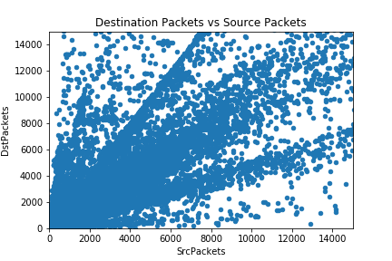
FIGURE III
Representative Random Sample of 6 million Observations

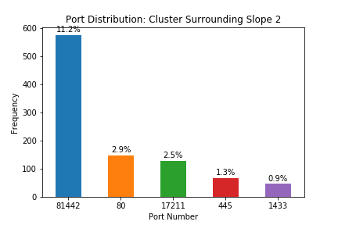
Clustering

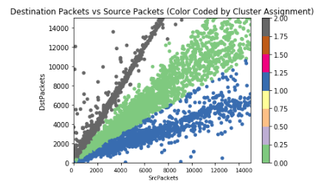
The relationships can be clustered using K-Means with cosine similarity and the lines with slopes 2, 1, and ½ define the centroids of the three clusters as seen in Figure IV. The slopes can be interpreted as network connections during which the destination device sends twice as many packets as the source device sends; both devices send the same number of packets; and the destination device sends half as much traffic as the source device. Interestingly, these relationships are symmetrical around the line y = x as the slopes of 2 and ½ are inverses of each other and are both 18.435 degrees from the line of symmetry.
FIGURE IV
Sample of 25,000 Consecutive Observations after K-Means Clustering with Cosine Similarity

The clusters contain different amounts of traffic. The clusters surrounding the 2, 1, ½ slopes consists of 20.6%, 56.4%, and 23.0% of the data, respectively. These percentages mean that most of the data are involved in connections during which the source and destination send the same number of packets.
I. Port Analysis
A difference in port distribution can show a difference among the clusters, as different ports are tied to different network activities. For example, the majority of normal web traffic occurs on ports 80 and 443, which are used for HTTP and HTTPS respectively. Conversely, malicious activity often occurs on lesser used ports.
A chi-squared test on the independence of cluster assignment and destination port distributions achieved a significantly small p-value (p<<0.001), suggesting that different clusters have statistically different port distributions and are thus involved in different network activity. Connections in all three clusters most frequently use port 443, which is HTTPS, but differ in the rest of their port distributions. Specifically, the clusters surrounding slopes 2, 1, and ½ have 76.2%, 63.5%, and 73.5% of connections on HTTPS, respectively. These distributions make sense, as most benign connections are on HTTP and HTTPS. The port distributions of the top 5 remaining ports for the clusters surrounding slopes 2, 1, and ½ are seen in Figure V, Figure VI, and Figure VII, respectively.

FIGURE V
Port Distribution of the Cluster Surrounding Slope 2 excluding Port 443
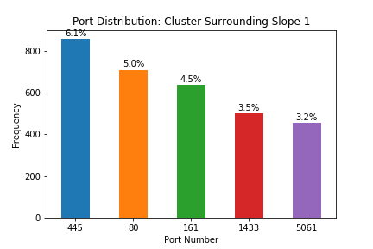
FIGURE VI
Port Distribution of the Cluster Surrounding Slope 1 excluding Port 443

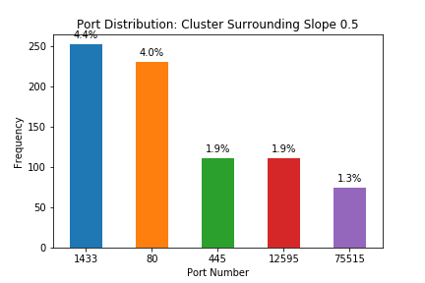
FIGURE VII
Port Distribution of the Cluster Surrounding Slope ½ excluding Port 443

II. Protocol Analysis
All connections in the data are from either Transport Control Protocol (TCP) or User Diagram Protocol (UDP). TCP and UDP are both are transport protocols, meaning they establish a connection between the source and device to send packets to each other, but they differ in that TCP guarantees the delivery and correct order of packets and UDP does not. Without guaranteeing that packets are delivered correctly, UDP connections can be much faster, but because of its assurance of correct packet delivery, TCP is the most commonly used protocol.
Evaluating protocol distributions is another way to classify normal network activity and to distinguish network activity for each cluster, as protocols can show what activities are happening in each cluster. The clusters’ protocol distributions show a vast majority of connections use TCP, as expected. Table I shows the protocol distributions for each cluster and for the overall sample.

TABLE I
Percent of Connections for each Protocol
Cluster | Percent of TCP Connections | Percent UDP Connections
Surrounding Slope 2  Surrounding Slope 1  Surrounding Slope ½  Overall | 99.1%  94.8%  99.2%  96.7% | 0.9%  5.2%  0.8%  3.3%

A chi-squared test on the independence cluster assignment and protocol distribution achieved a significantly small p-value (p<<0.001), indicating that the clusters have statistically different protocol distributions. While overall the three distributions are different, the same test performed on pairs of clusters showed that the pair of clusters surrounding slopes 2 and ½ do not have statistically different protocol distributions. These two clusters have nearly identical protocol distributions, with over 99% of connections using TCP and less than 1% using UDP. In contrast, the cluster surrounding slope 1 has roughly 95% of connections using TCP and 5% of connections using UDP.
It makes sense that the cluster surrounding slope 1 has a more heterogeneous protocol distribution because this cluster contains the most data, consisting of over half of the connections, and has a greater variation in data, as seen in the clustered plot in Figure IV. Since the clusters surrounding slopes 2 and ½ are more homogeneous, with points lying close to each other in the plot, it makes sense that they would also have a more homogeneous distribution.

Network Communication on Rare Ports

Some malware and cyber threat groups are known to act on uncommon ports, as using some of these ports is a way to bypass certain proxies and firewalls. Cybersecurity researchers often detect malicious activity by analyzing the connections on uncommon ports. Evaluating rare ports, defined as destination ports involved in few connections, is thus a way to classify and distinguish normal and anomalous connections [9].
We define rare ports as ports involved in less than 100 connections and we compare connections on these rare ports to connections on HTTP or HTTPS, as HTTP and HTTPS are the most common ports and we know their network activity well.
A Kolmogorov-Smirnov test showed rare port connections and HTTP or HTTPS connections have statistically different distributions for the number of packets sent by the source device, the number of packets sent by the destination device, the number of bytes sent by the source device, and the number of bytes sent by the destination device.
The means for each of the distributions for rare and common ports are shown in Table II. The means of the four distributions for connections on rare ports are much greater than those for the connections on HTTP or HTTPS ports, suggesting that connections on rare ports send and receive substantially more packets and bytes. Thus, network activity on rare ports is characterized by abnormally large data transfers which could possibly indicate suspicious activity.

TABLE II
Means for Connections on Rare Ports and for Connections on HTTP/HTTPS Ports
Variable | Mean (Rare) | Mean (HTTP/HTTPS)
SrcPackets  DstPackets  SrcBytes  DstBytes | 2721.50  2020.42  177164.17  363584.16 | 92.04  125.81  27097.96  120550.58

The distributions for connections on uncommon ports also have much larger variances than those for the connections on HTTP or HTTPS ports. The larger variances suggest that there is more diverse behavior occurring on rare ports, consequently meaning that common network connections on HTTP and HTTPS are more homogeneous, following more closely to a given pattern for the number of packets and bytes to send and receive. The variances for each of the distributions for both port categories are in Table III.

TABLE III
Variances for Connections on Rare Ports and for Connections on HTTP/HTTPS Ports
Variable | Variance (Rare) | Variance (HTTP/HTTPS)
SrcPackets  DstPackets  SrcBytes  DstBytes | 3.73e+12  1.83e+12  6.53+15  1.53e+16 | 1.28e+8  4.60e+8  9.02e+12  5.72e+14

Conclusion and Future Work

In this paper, we find a clear pattern showing three distinct relationships between the number of packets sent by the destination device and the number of packets sent by the source device. The three relationships can be clustered using K-Means with cosine similarity and are the connections in each of the clusters are involved in different network activity, as they have statistically different port and protocol distributions. The clusters, port distributions, and protocol distributions also classify normal network behavior for connections in this dataset, suggesting common connections in this dataset have a ratio of source packet to destination packets of 2, 1, or ½, and most frequently use TCP and connect on HTTPS.
We also classify abnormal network activity through rare port connection analysis, finding that connections on rare ports have statistically different distributions than connections on HTTP or HTTPS. With different distributions and much larger means and variances, we classify connections on rare ports as abnormal and propose that abnormal network connections have much larger number of packets and bytes.
Our results have broad applications in network traffic classification. The clusters may be used to classify or describe normal network activity, may be used as features for feature engineering, or as motivation to analyze NetFlow packets and follow a similar analytical approach. Our work classifies normal network activity and abnormal network activity and distinguishes between them. This difference in network activity is important for understanding what characterizes anomalous network activity to create intrusion detection systems and perform other classification problems on NetFlow data.
While our results are clear, they may not be transferable to other cybersecurity network datasets as the data in the NetFlow dataset may be formatted differently. For future work, we intend to apply our understanding of the data’s features to explore anomaly detection and other classification problems on the NetFlow Dataset.

Acknowledgements

“The research reported in this document/presentation was performed in connection with contract number W911NF- 18-C-0019 with the U.S. Army Contracting Command - Aberdeen Proving Ground (ACC-APG) and the Defense Advanced Research Projects Agency (DARPA). The views and conclusions contained in this document/presentation are those of the authors and should not be interpreted as presenting the official policies or position, either expressed or implied, of ACC-APG, DARPA, or the U.S. Government unless so designated by other authorized documents. Citation of manufacturer's or trade names does not constitute an official endorsement or approval of the use thereof. The U.S. Government is authorized to reproduce and distribute reprints for Government purposes notwithstanding any copyright notation hereon.”

References

[1] “Ninth Annual Cost of Cybercrime Study.” www.accenture.com/us-en/insights/security/cost-cybercrime-study. 2019. Accessed: March 26, 2019.
[2] “How Big Data Helps Avoid Cybersecurity Threats” digitalistmag.com/cio-knowledge/2018/08/27/how-big-data-helps-avoid-cybersecurity-threats-06184059. Accessed: February 26, 2019.
[3] “Traffic Analysis for Network Security: Appraoches for Going Beyond Network Flow Data.” 2016. insights.sei.cmu.edu/sei_blog/2016/09/traffic-analysis-for-network-security-two-approaches-for-going-beyond-network-flow-data.html. Accessed: February 27, 2019.
[4] “Network Flow Analysis.” 2008. defcon.org/images/defcon-16/dc16-presentations/defcon-16-potter.pdf. Accessed: February 27, 2019.
[5] Minarik P., Dymacek T. (2008) NetFlow Data Visualization Based on Graphs. In: Goodall J.R., Conti G., Ma KL. (eds) Visualization for Computer Security. VizSec 2008. Lecture Notes in Computer Science, vol 5210. Springer, Berlin, Heidelberg
[6] Fischer F., Mansmann F., Keim D.A., Pietzko S., Waldvogel M. (2008) Large-Scale Network Monitoring for Visual Analysis of Attacks. In: Goodall J.R., Conti G., Ma KL. (eds) Visualization for Computer Security. VizSec 2008. Lecture Notes in Computer Science, vol 5210. Springer, Berlin, Heidelberg
[7] Gilbert A. C., Kotidis Y., Muthukrishnan S., Strauss M. J.(2008) QuickSAND: Quick Summary and Analysis of Network Data. In: Goodall J.R., Conti G., Ma KL. (eds) Visualization for Computer Security. VizSec 2008. Lecture Notes in Computer Science, vol 5210. Springer, Berlin, Heidelberg
[8] M. Turcotte, A. Kent and C. Hash, “Unified Host and Network Data Set”, in ArXiv e-prints. Aug. 2017.
[9] “Uncommonly Used Port” attack.mitre.org/techniques/T1065/. Accessed: March 27, 2019.
[10] “TCP (Transfer Control Protocol).” searchnetworking.techtarget.com/definition/TCP. Accessed: February 27, 2019.
[11] “What is connection-oriented?” searchnetworking.techtarget.com/definition/connection-oriented. Accessed: February 27, 2019.
[12] “ICMP (Internet Control Message Protocol).” searchnetworking.techtarget.com/definition/ICMP. Accessed: February 27, 2019.
[13] “Protocol Numbers.” iana.org/assignments/protocol-numbers/protocol-numbers.xhtml. Accessed: February 27, 2019.
[14] “Protocol Numbers.” iana.org/assignments/protocol-numbers/protocol-numbers.xhtml. Accessed: February 27, 2019.
[15] “The Value of Exploratory Data Analysis.” 2017. svds.com/value-exploratory-data-analysis. Accessed: February 27, 2019.
[16] “TCP/IP Well Known Port Numbers (0 to 1023).” meridianoutpost.com/resources/articles/well-known-tcpip-ports.php. Accessed: February 27, 2019

