Blinkit Sales & Customer Insights

Executive Summary

This report presents a comprehensive analysis of Blinkit’s grocery sales data. It explores sales trends, product and outlet performance, and customer behavior through multiple KPIs and charts. The objective is to identify key drivers of sales, highlight underperforming areas, and suggest actionable business strategies.

Dataset Description
Primary Sheet Used: BlinkIT Grocery Data
Rows: 8523, Columns: 13
Columns available: Item Fat Content, Sr No, Item Identifier, Item Type, Outlet Establishment Year, Outlet Identifier, Outlet Location Type, Outlet Size, Outlet Type, Item Visibility, Item Weight, Total Sales, Rating

Key Performance Indicators (KPIs)
Total Sales: 1,201,681.49
Average Sales: 140.99
Number of Unique Items: 3
Average Rating: 3.97

Total Sales by Fat Content

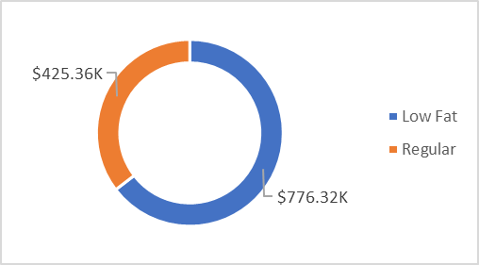

This chart illustrates how fat content influences sales. High-fat and low-fat categories contribute differently, suggesting customer preference patterns and potential for targeted promotions.

Total Sales by Item Type

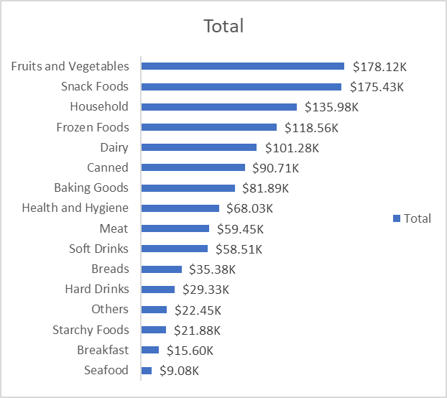

This bar chart shows sales distribution across item categories. Top-selling categories dominate revenue contribution, while low-performing ones may need reevaluation or promotional support.

Fat Content by Outlet for Total Sales

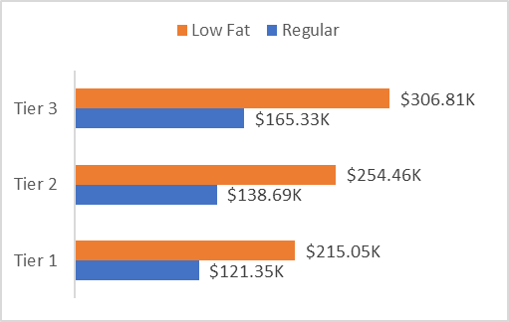

This stacked chart compares sales across outlets segmented by fat content. It highlights which outlets sell more high-fat vs low-fat items, helping tailor inventory strategies.

Total Sales by Outlet Establishment

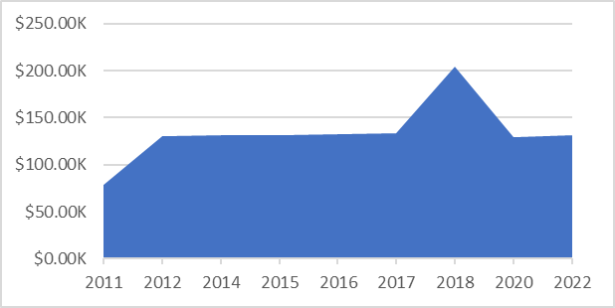

This line chart shows how outlet establishment year or type influences sales. Older or more established outlets may generate higher revenue, reflecting brand trust and customer loyalty.

Sales by Outlet Size

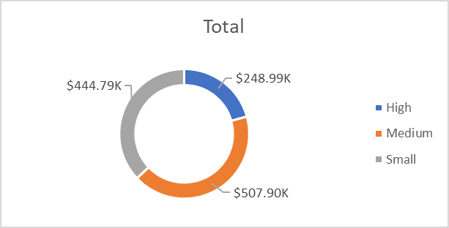

This pie chart shows sales distribution by outlet size. Larger outlets usually contribute more sales, but smaller outlets can be more efficient in certain locations.

Sales by Outlet Location

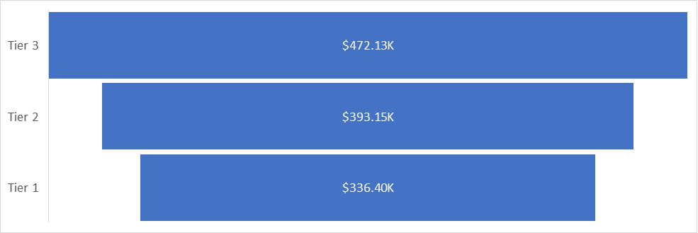

This chart compares sales across different locations. High-performing regions could be prioritized for expansion, while low-performing ones may require local marketing.

All Metrics by Outlet Type

The following table summarizes all key metrics by outlet type:
Outlet Establishment Year | Total Sales sum | Total Sales mean | Item Fat Content count | Rating mean
2011.0 | 78131.5666 | 140.7775974774774 | 555.0 | 3.977117117117117
2012.0 | 130476.859 | 140.2976987096774 | 930.0 | 3.985483870967742
2014.0 | 131809.015 | 141.4259824034335 | 932.0 | 3.949570815450644
2015.0 | 130942.780 | 140.9502477933261 | 929.0 | 3.959956942949408
2016.0 | 132113.369 | 142.0573868817204 | 930.0 | 3.958387096774193
2017.0 | 133103.907 | 143.1224806451613 | 930.0 | 3.944516129032258
2018.0 | 204522.257 | 139.7964846206425 | 1463.0 | 3.968147641831852
2020.0 | 129103.960 | 139.4211235421166 | 926.0 | 3.9816414686825055
2022.0 | 131477.776 | 141.67863836206897 | 928.0 | 3.971228448275862
This table consolidates sales, average sales, number of items, and average rating by outlet type, helping management compare performance comprehensively.

Key Findings

- Sales are influenced by product fat content and item category.
- Outlet characteristics (size, establishment year, type, location) significantly affect performance.
- Larger and older outlets generate more consistent revenue.
- Customer ratings provide useful feedback for improving item performance.

Recommendations

- Increase focus on top-selling categories while promoting underperformers.
- Optimize inventory by aligning fat content supply with outlet-level demand.
- Prioritize expansion in high-performing locations and large outlets.
- Conduct customer rating analysis to improve weaker product categories.

Conclusion

This report consolidates Blinkit's sales performance analysis across multiple dimensions. By leveraging insights from products, outlets, and customer preferences, Blinkit can drive sustainable growth, enhance customer satisfaction, and strengthen its competitive position.

