**UVVM Guide** –a step-by-step guide for beginning with UVVM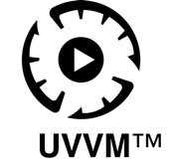

This guide is an introduction and step-by-step guide for beginning with UVVM, along with examples of common tasks that the designers will have to carry out.

1 Introduction 2

2 Installation 2

2.1 Updating UVVM Light 2

3 Testbench 3

4 Compilation 3

5 Further reading 4

# Introduction

UVVM (Universal VHDL Verification Methodology) is a free and open source methodology for making very structured VHDL-based testbenches. UVVM has been released with two different complexity levels, a low complexity UVVM Light repository with the Utility library and BFMs (Bus Functional Models), without advanced features such as VVCs and command distribution system, and the complete UVVM repository with all features available.

The UVVM Light repository is a lightweight version of UVVM that can be used with simple testbenches and as a low-level introduction to UVVM.

**Note** that UVVM Utility Library may only be compiled with VHDL 2008.

# Installation

UVVM Light can be downloaded as a zip file or cloned using git. We are continuously adding new features to UVVM and the easiest way to receive the updates is by cloning UVVM with git.

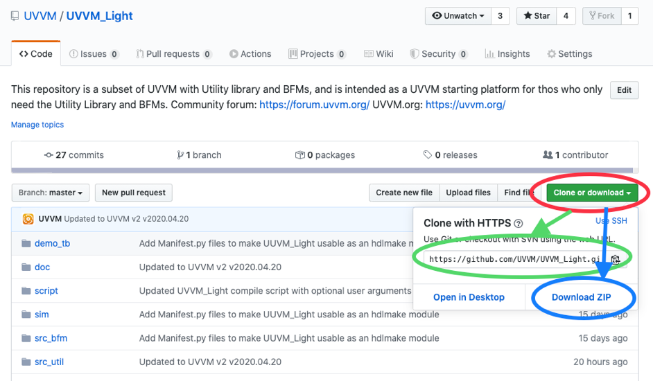

Figure 1GitHub

1. Navigate to the UVVM Light repository on GitHub: <https://github.com/UVVM/UVVM_Light>
2. Select “Clone or download” marked with a red circle in Figure 1
   1. Clone by copying the repository address (green circle) and from the project folder  
      running the command: git clone https://github.com/UVVM/UVVM_Light.git
   2. Or download everything as a zip (blue circle) and extract the download file in the   
      project folder.
3. After cloning or unzipping UVVM Light you have all that is needed to start using UVVM and the BFMs inside your testbench.

## Updating UVVM Light

The method for updating UVVM Light depends on the chosen installation method:

* cloned using git:   
  run the following command in terminal inside the UVVM Light folder to receive the latest release changes: git pull
* downloaded as a zip:   
  repeat step 2b in section 2 and replace the old UVVM Light version with the new downloaded version.

Figure 2 Testbench

# Testbench

**library** **IEEE**;

**use** **IEEE.std_logic_1164.all**;

**library** **uvvm_util**;

context uvvm_util.uvvm_util_context;

use uvvm_util.sbi_bfm_pkg.all;

**entity** **uvvm_tb** **is**

**end** **entity** **uvvm_tb**;

**architecture** **func** **of** **uvvm_tb** **is**

**begin**

p_main : **process**

**begin**

log("Starting simulations.");

std.env.stop;

**wait**;

**end** **process** **p_main**;

**end** **func**;

Include uvvm_util_context and the BFMs you will be using in your testbench to start using UVVM Light:  
library uvvm_util;  
context uvvm_util.uvvm_util_context;

use uvvm_util.sbi_bfm_pkg.all;  
  
See Figure 2. The context file will ensure that necessary UVVM Utility packages are made available from within the testbench.

# Compilation

UVVM Light can be compiled by calling the UVVM_Light/script/compile.do tcl file using simulator GUI or from the command line.

The compile.do script can have two arguments, where the first argument is the UVVM_Light installation path and the second is the target path of the compilation, i.e. compile.do <source_path> <target_path>

The following two examples of compiling UVVM Light from the command line and with Modelsim GUI have the following directory structure:  
/UVVM_Light  
 /demo_tb  
 /doc  
 /script  
 /sim  
 /src_bfm  
 /src_util  
/my_project  
 /sim  
 /src

Figure 3 Modelsim compilation

and the vsim command / Modelsim GUI is run from the /my_project folder with the /sim folder as compilation target:

* Command line example:  
    
  $ vsim -c -do "do ../uvvm_light/script/compile.do ../uvvm_light ./sim"  
    
  where ../uvvm_light/script/compile.do is the relative path to the compile.do script, ../uvvm_light is the relative path to UVVM Light installation (source path), and ./sim is the relative path to the compilation target (target path).
* Modelsim GUI example is shown in Figure 3 where ../uvvm_light/script/compile.do is the relative path to the compile.do script, ../uvvm_light is the relative path to UVVM_Light installation (source path), and ./sim is the relative path to the compilation target (target path).

# Further reading

We recommend that everyone new to UVVM have a look at the Simple_TB_step_by_step.pps and UVVM_Utility_Library_Concepts_and_Usage.pps power point presentations located in the UVVM_Light/doc folder. Inside the /doc folder you will also find the Utility library quick reference - util_quick_ref.pdf, along with all the quick references for all of the BFMs.

Disclaimer: This IP and any part thereof are provided "as is", without warranty of any kind, express or implied, including but not limited to the warranties of merchantability, fitness for a particular purpose and noninfringement.  
In no event shall the authors or copyright holders be liable for any claim, damages or other liability, whether in an action of contract, tort or otherwise, arising from, out of or in connection with this IP.

**INTELLECTUAL**

**PROPERTY**

There are several other documents to explore and we recommend that you start reading those located in the UVVM/uvvm_vvc_framework/doc folder when you feel ready to advance with the other many features of UVVM in the complete UVVM install.

We encourage the UVVM community to participate in the UVVM user forum with questions and discussions at <https://forum.uvvm.org>, and to visit the UVVM news site at <https://uvvm.org>.