Risk Prediction of Theft Crimes in Urban Communities: An Integrated Model of LSTM and ST-GCN
Growing population increasing urbanization which will give rise to growing communities and will increase risk of crimes. Increasing crime will put people’s security at risk and make difficult for security professional to maintain law and order. To tackle crime in growing urban communities author of this paper employing combination of two different algorithms such as LSTM (long short term memory) and GCN (Graph Convolution Network).
LSTM is known to perform better prediction on temporal features like Date & Time and GCN known for best prediction on Spatial Features like Location. Combination of both LSTM & GCN can automatically and effectively detect the high-risk areas in a city. Topological maps of urban communities carry the dataset in the model, which mainly includes two modules such as spatial & temporal features extraction module and temporal feature extraction module to extract the factors of theft crimes collectively.
To train and test above algorithm performance author has utilized US crime and Chicago Crime datasets and then for spatial features author has joined weather information like Temperature on Chicago dataset but this weather information extraction process we don’t know so we have used Date & Time for LSTM temporal features training and Crime locations as Spatial features training with GCN.
Author has evaluate propose algorithm performance in terms of R2square, RMSE and MAPE. R2square consider as accuracy for crime rate prediction model and then RMSE (root mean square error) and MAPE (mean absolute percentage error) represents difference between true and predicted crime rate. So the lower the difference the better is the algorithm.
Combination of propose LSTM & GCN algorithm is known as ST-GCN and compare this propose algorithms performance with existing algorithms like Random Forest and LSTM. Among all algorithms propose is giving high R2score and less RMSE and MAPE.
Chicago crime dataset can be downloaded from below URL
https://www.kaggle.com/datasets/currie32/crimes-in-chicago/data?select=Chicago_Crimes_2012_to_2017.csv
So by using above dataset we have trained and test propose algorithm performance.
SCREEN SHOTS
We have coded this project using JUPYTER notebook and below are the code and output screens with blue colour comments
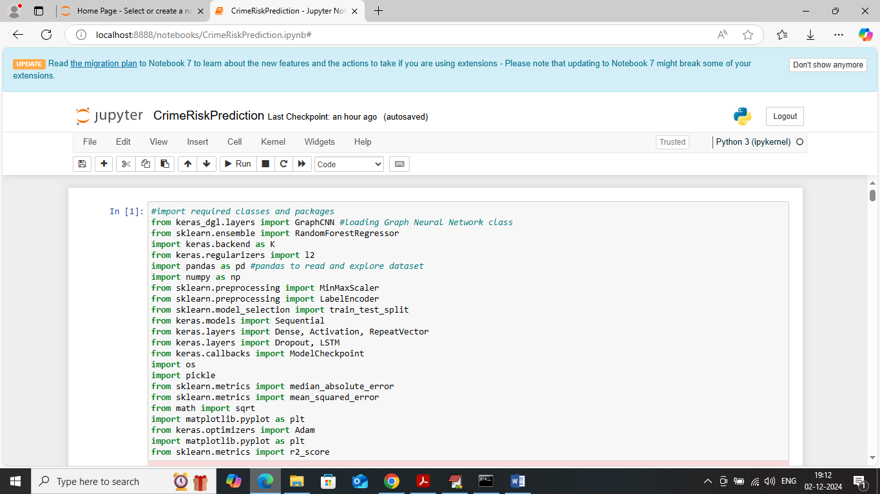
In above screen importing required packages such as LSTM, Random Forest, Graph CNN and many more
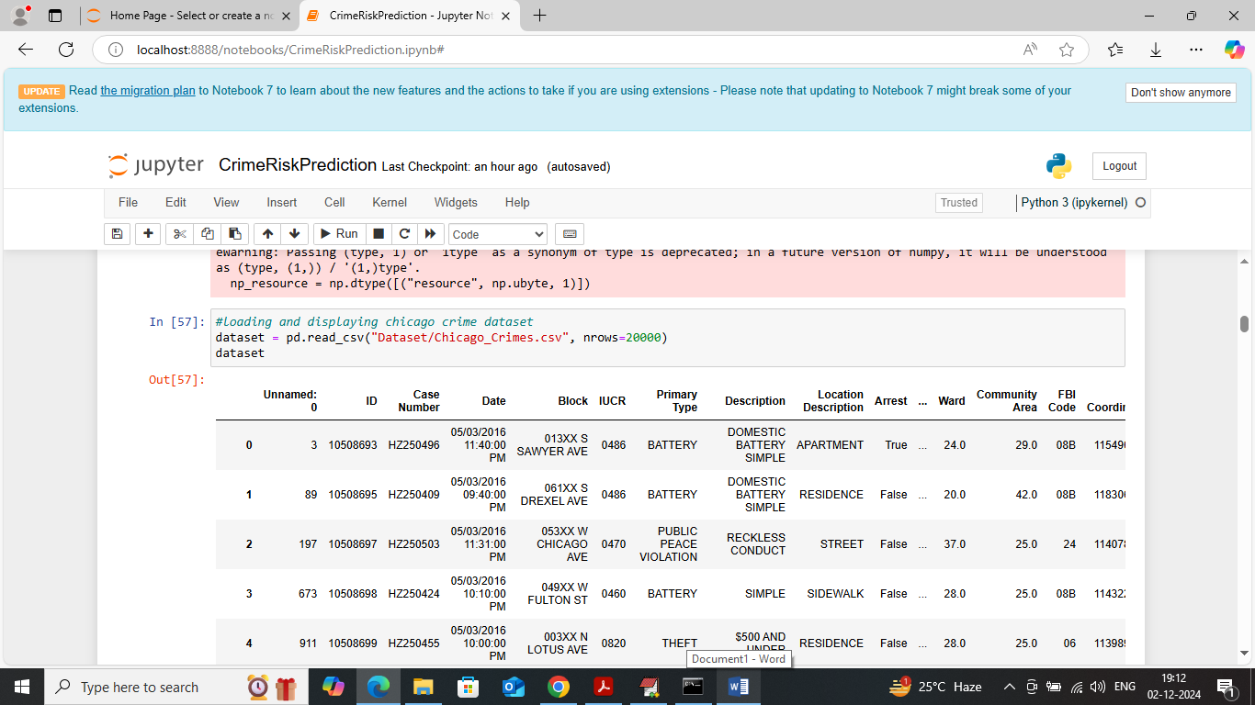
In above screen loading and displaying ‘Chicago Crime’ dataset and can see dataset contains both numeric and non-numeric values but algorithms will take only numeric values so by employing dataset processing technique we need to convert all data to numeric format
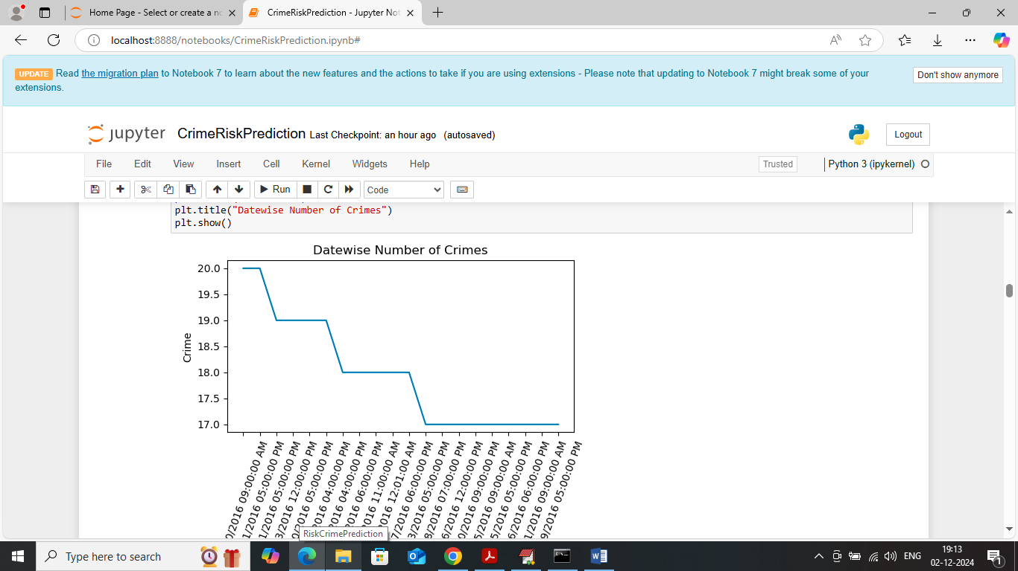
In above screen visualizing day wise number of crimes available in dataset where x-axis represents Date and y-axis represents ‘Number of Crimes’ on that day
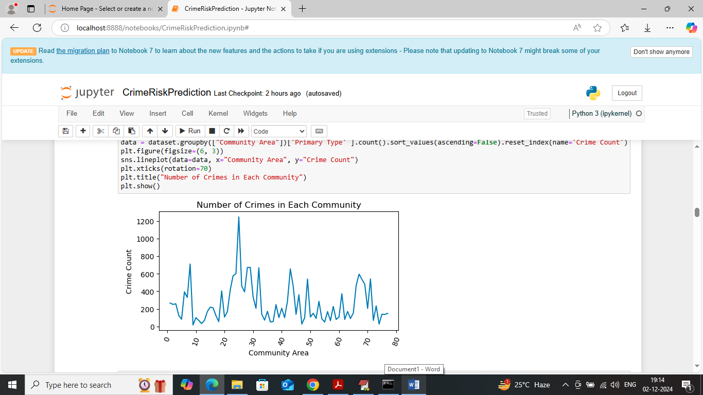
In above screen visualizing graph of ‘Number of crimes’ in different communities where x-axis represents community ID and y-axis represents number of crimes
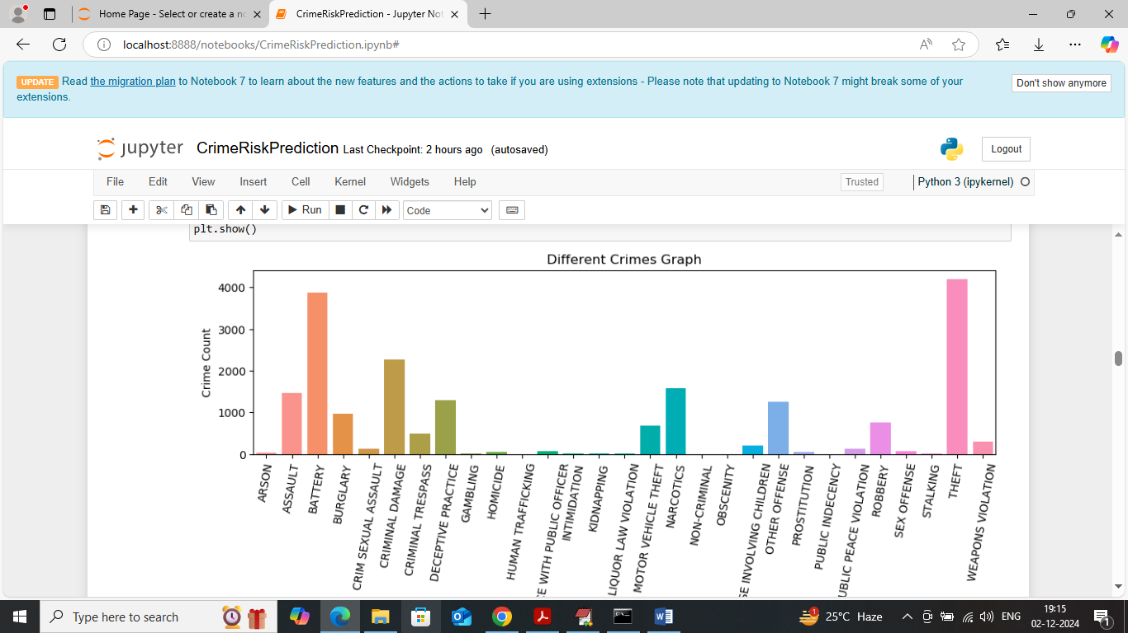
In above screen visualizing graph of different crimes found in dataset where x-axis represents ‘Crime Type’ and y-axis represents number of crimes
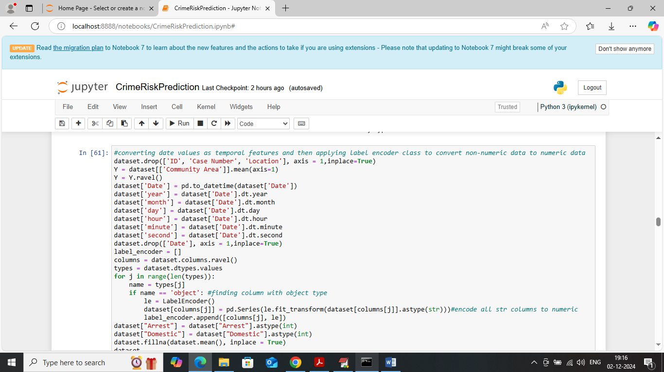
In above screen applying dataset processing techniques such as converting date into temporal features and then applying Label Encoder class to convert non-numeric data to numeric data and then replacing all missing values with mean and after executing above block will get below output
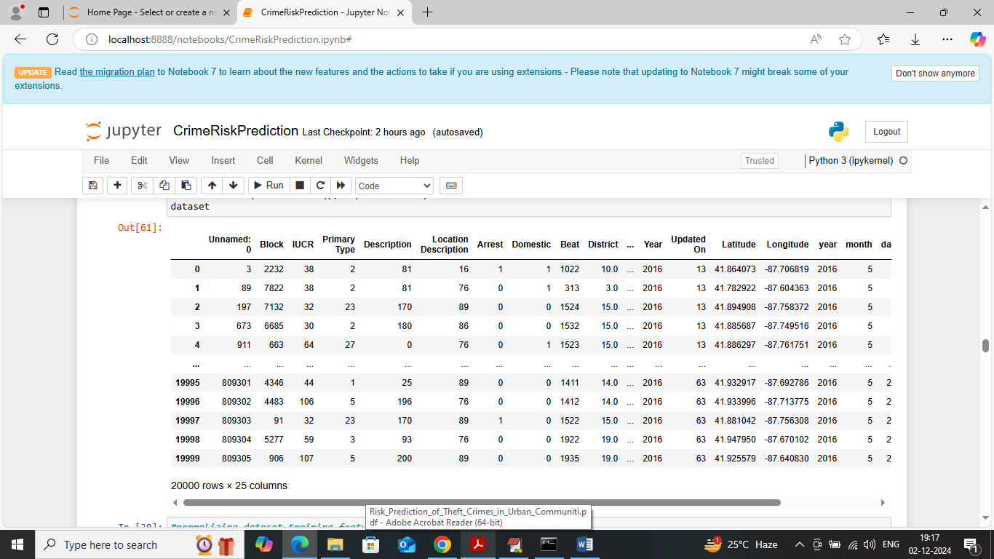
In above screen can see entire dataset values are converted to numeric format and dataset values look cleaned
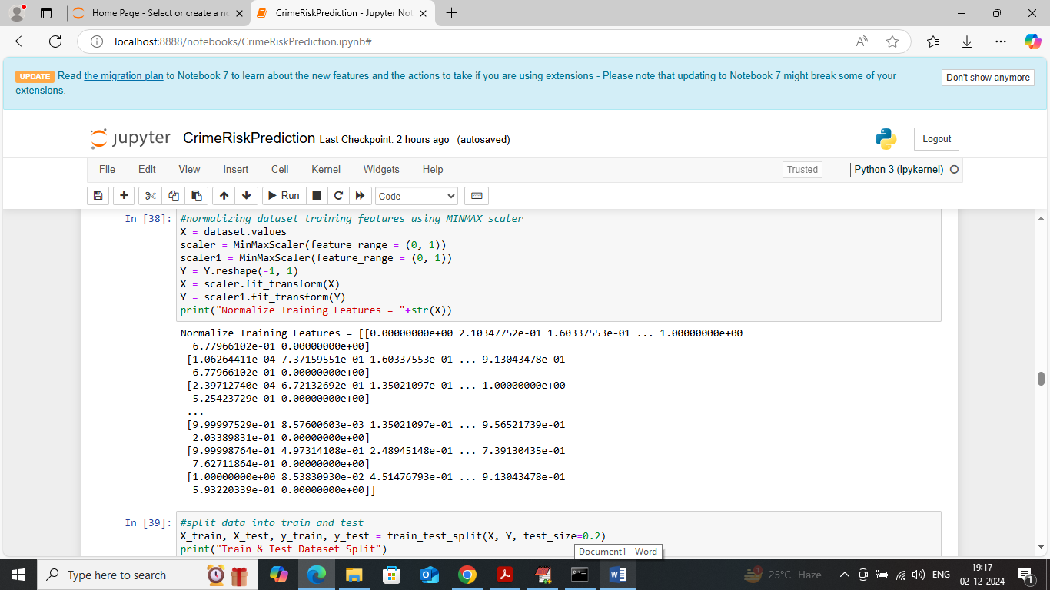
In above screen applying MINMAX normalization algorithm to normalize dataset training features
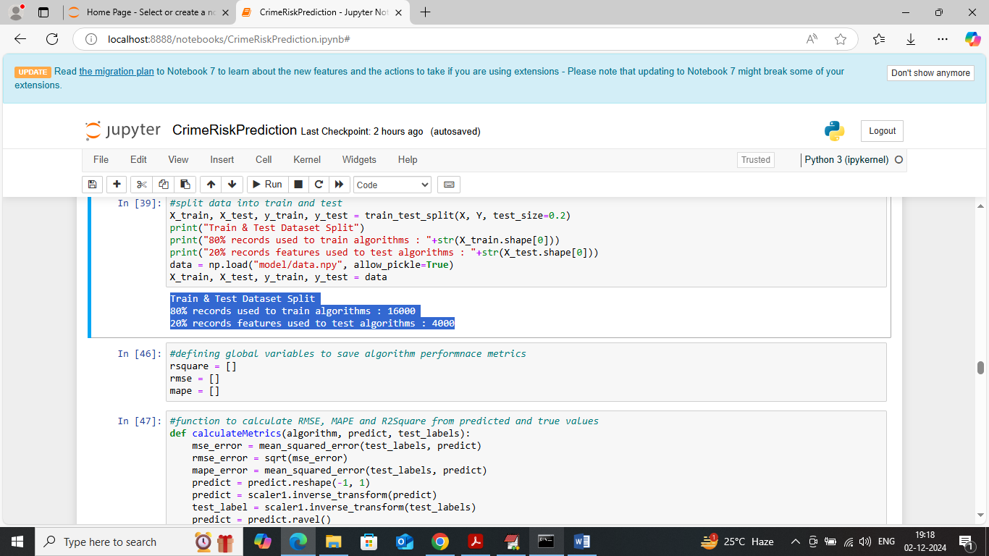
In above screen splitting dataset into train and test where application using 80% dataset for training and 20% for testing and then in blue colour text can see training and testing size. In next blocks defining function to calculate R2score and other metrics
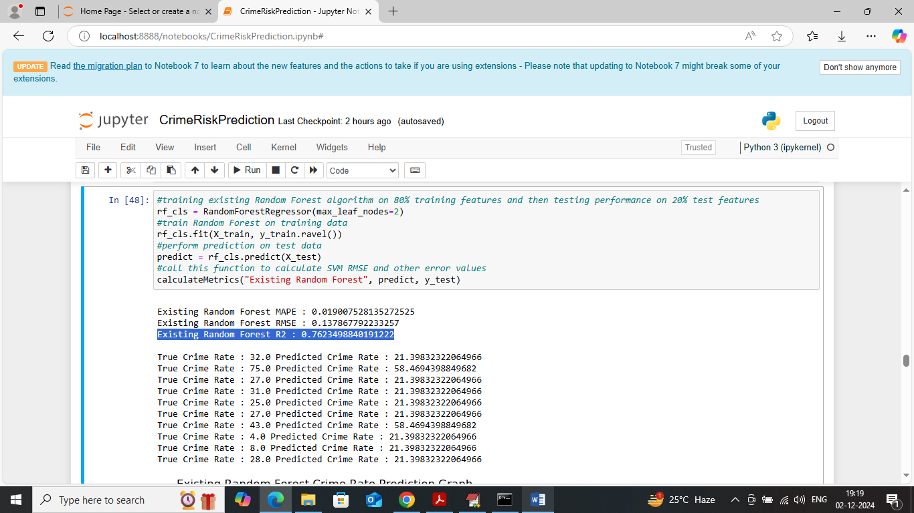
In above screen training existing Random Forest algorithm and then performing prediction on test data and then Random Forest got 76% R2score and can see RMSE and MAPE error. In next lines showing True Crime Rate and Predicted Crime Rate. In below screen can see same predicted crime rate in graph format
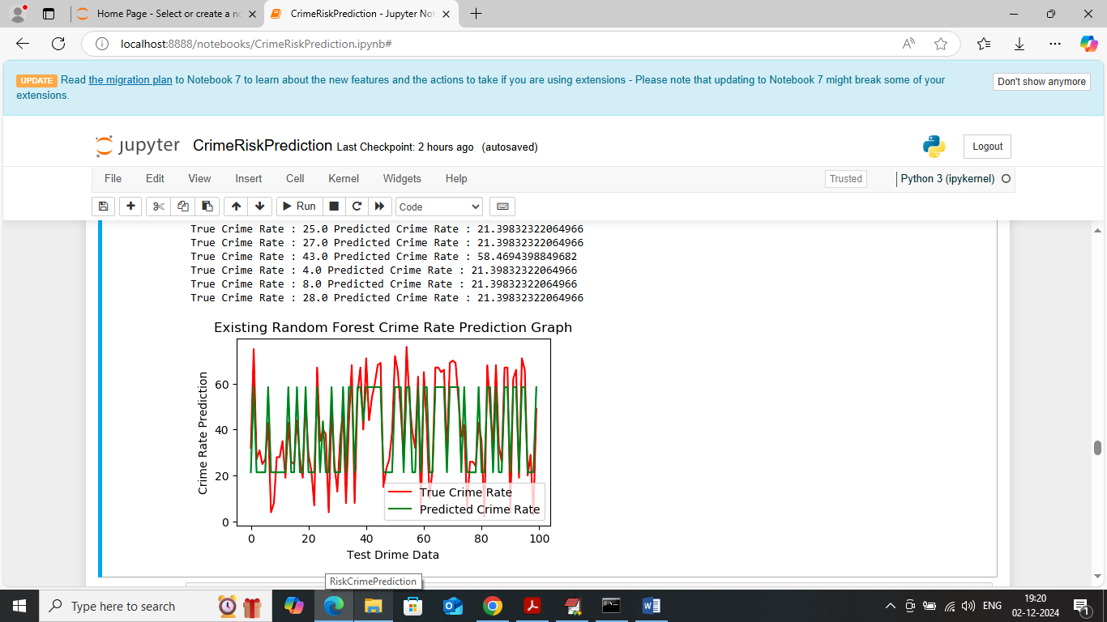
In above Random Forest crime predicted graph x-axis represents ‘Number of Test data’ and y-axis represents Crime Rate and then red line represents True Crime Rate and green lien represents predicted crime rate. In above graph can see there is huge graph between True and predicted crime rate so Random Forest is not accurate in prediction
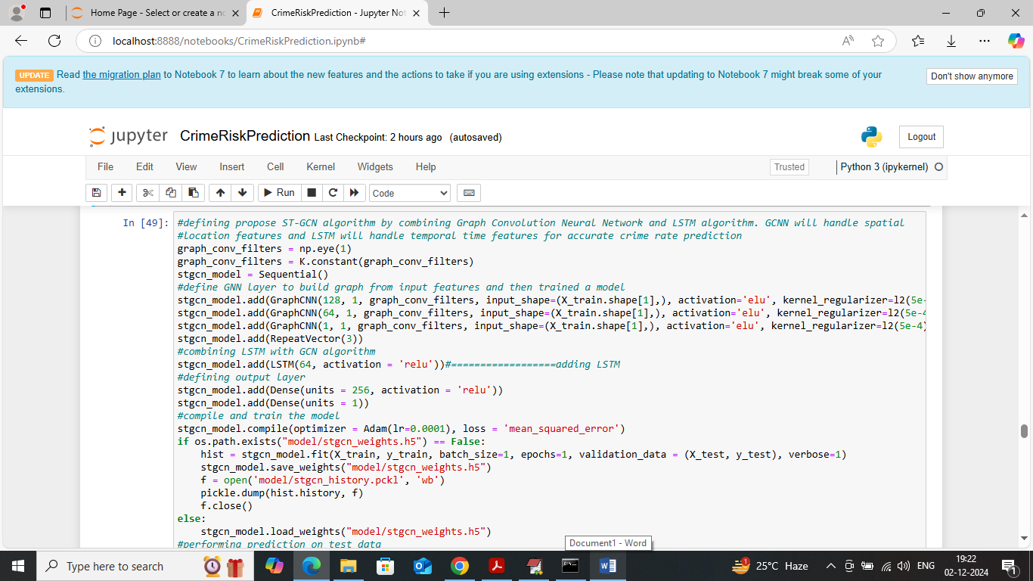
In above screen defining and training propose ST-GCN algorithm by combining LSTM and GCN and after executing above algorithm will get below output
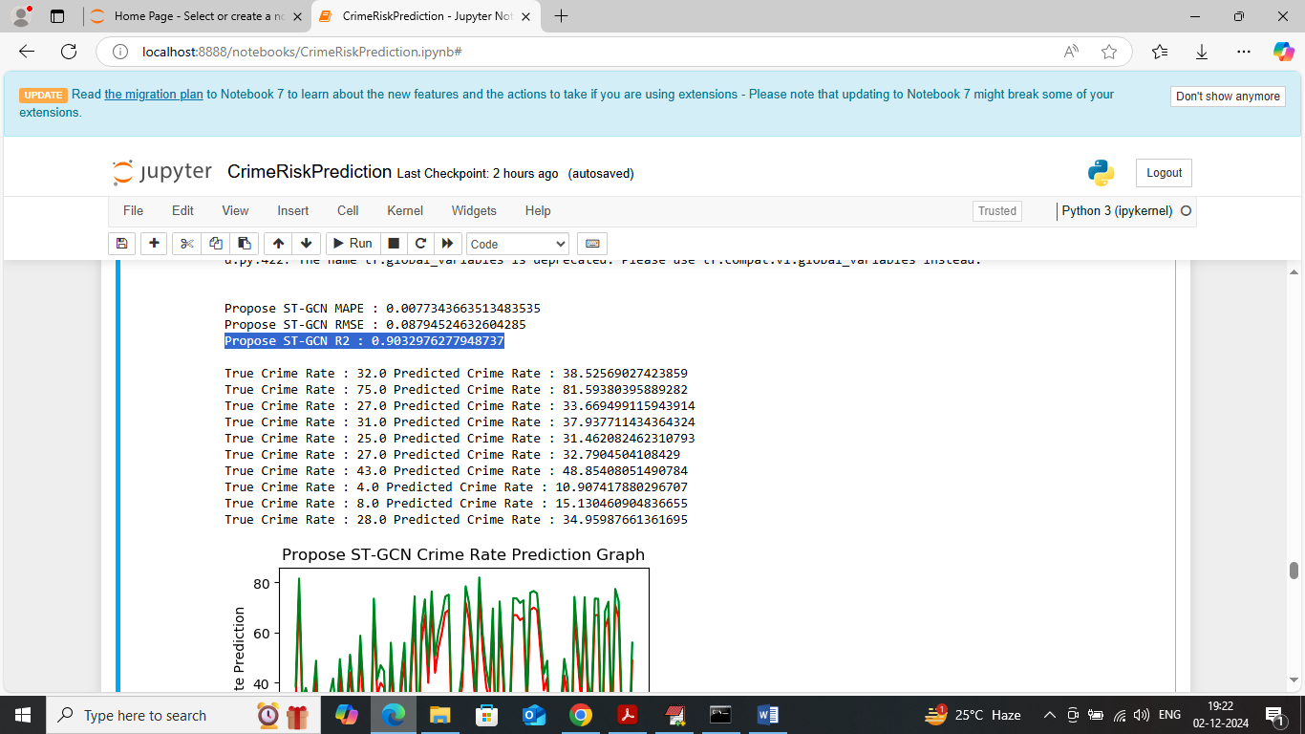
In above screen propose ST-GCN algorithm got 90% R2score and can see RMSE and MAPE error rate and in next lines can see True and predicted Crime Rate of propose algorithm and below is the propose algorithm prediction graph
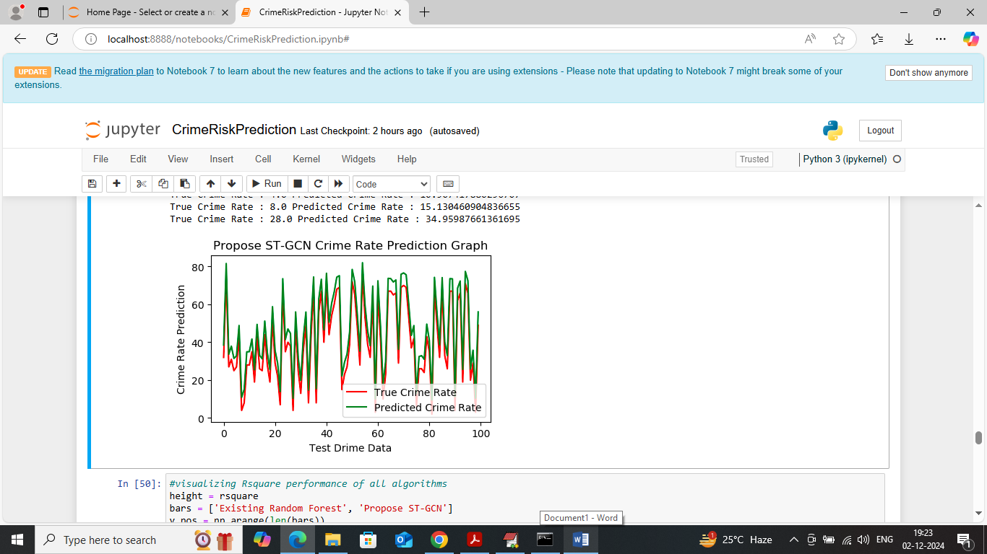
In above screen can see propose algorithm prediction graph where red line represents True Crime rate and green line represents Predicted Crime rate and can see both lines are fully overlapping with minor gap so we can say propose algorithm is better in crime rate prediction.
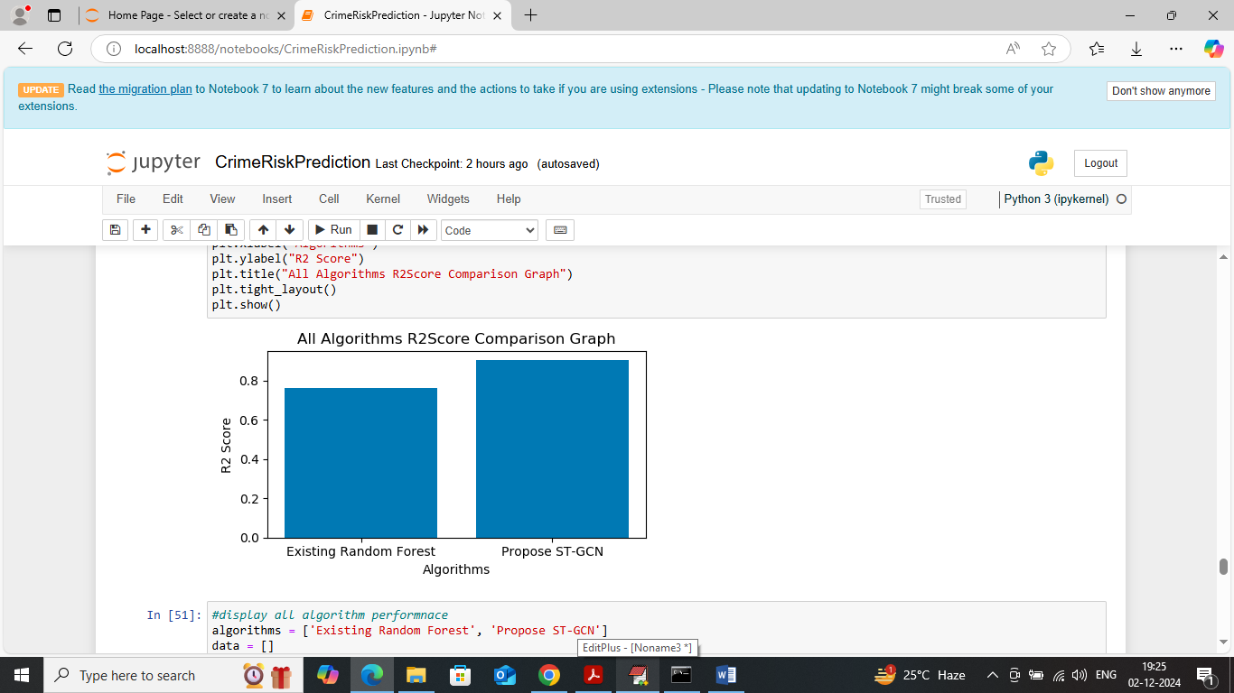
In above screen displaying R2score comparison graph with existing Random Forest and propose ST-GCN where x-axis represents algorithm names and y-axis represents R2score and in both algorithms propose ST-GCN got high R2score
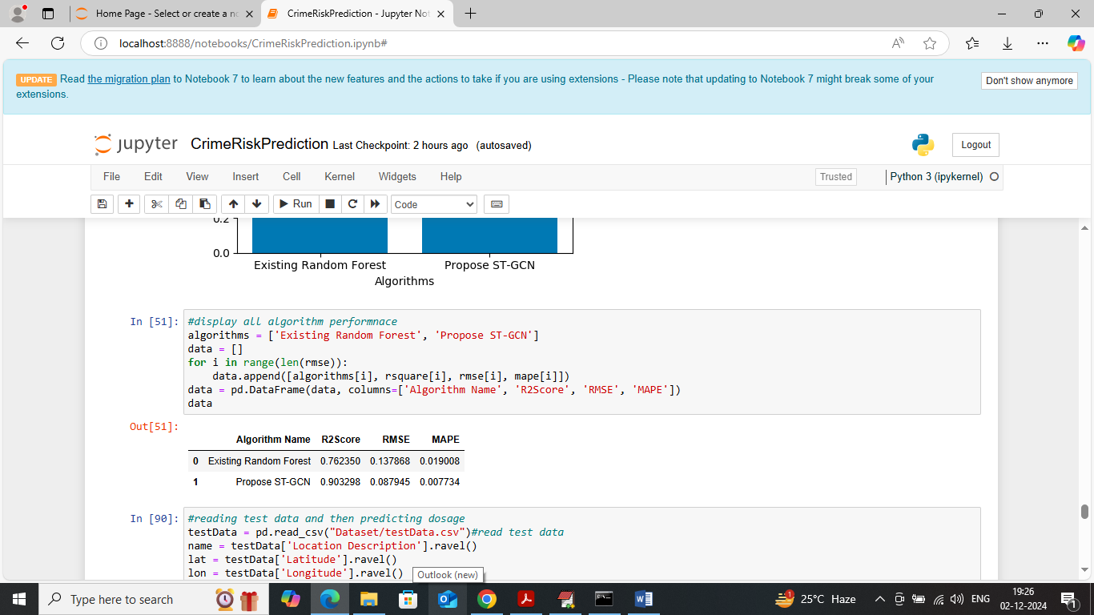
In above screen showing comparison table between existing and propose algorithms
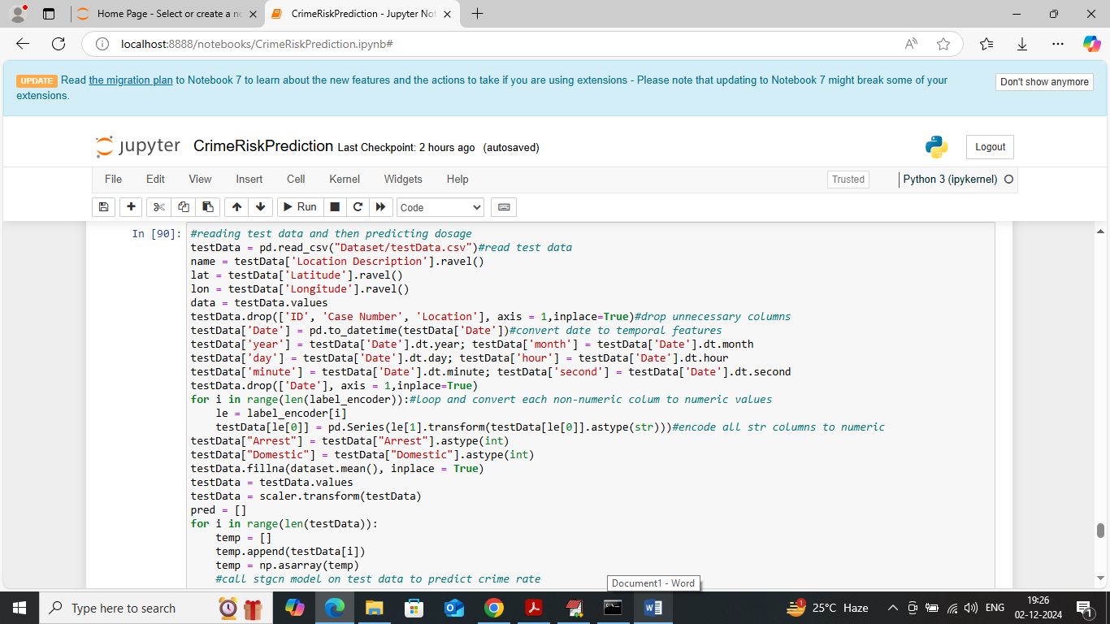
In above screen reading test data values and then applying propose ST-GCN algorithm to predict crime rate with location and after executing above block will get below output
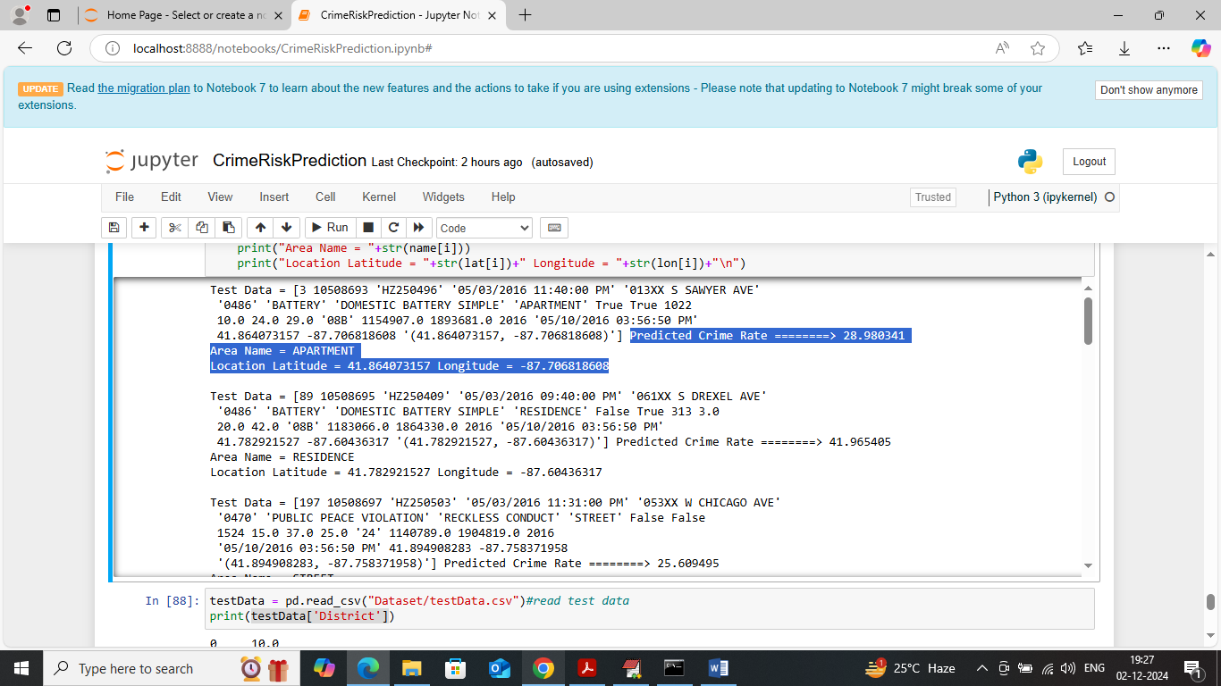
In above screen in square bracket can see test data values and after = arrow symbol can see predicted crime rate and then can see location name along with latitude and longitude.

