 | Old | New
CantileverBenchmark_Compliance_Mass | Total optimization time: 193.66 seconds  --------------------------------------------------  After snapping:  --------------------------------------------------  -------------- Iteration 151 -----------------  Percentage grey elements: 3.58%  Min. Objective (COMPLIANCE): 37.052  Constraint 1 (MASS): 2.88e+03 <= 2.88e+03?  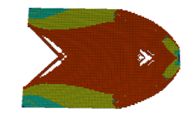 | Total optimization time: 195.13 seconds  --------------------------------------------------  After snapping:  --------------------------------------------------  -------------- Iteration 151 -----------------  Percentage grey elements: 3.38%  Min. Objective (COMPLIANCE): 37.057  Constraint 1 (MASS): 2.88e+03 <= 2.88e+03?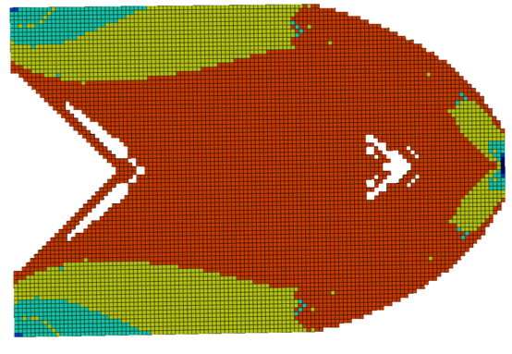
Bridge_Compliance_MassCost | Total optimization time: 415.34 seconds  --------------------------------------------------  After snapping:  --------------------------------------------------  -------------- Iteration 151 -----------------  Percentage grey elements: 2.88%  Min. Objective (COMPLIANCE): 233.49  Constraint 1 (MASS): 7.47e+03 <= 8e+03?  Constraint 2 (COST): 5.98e+03 <= 6e+03?  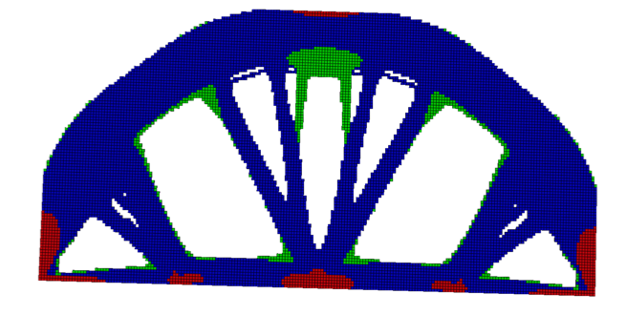 | Total optimization time: 413.40 seconds  --------------------------------------------------  After snapping:  --------------------------------------------------  -------------- Iteration 151 -----------------  Percentage grey elements: 2.85%  Min. Objective (COMPLIANCE): 233.46  Constraint 1 (MASS): 7.47e+03 <= 8e+03?  Constraint 2 (COST): 5.98e+03 <= 6e+03?  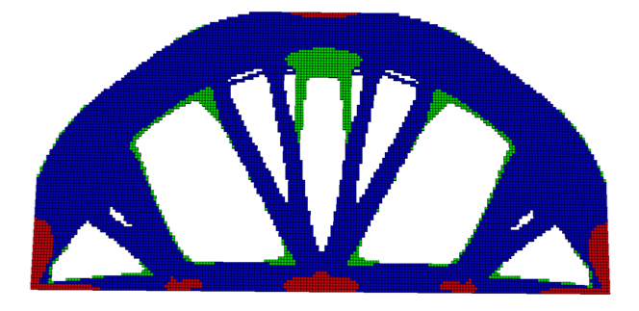

Bridge_Compliance_MassCost_Saitou | Total optimization time: 122.63 seconds  --------------------------------------------------  After snapping:  --------------------------------------------------  -------------- Iteration 151 -----------------  Percentage grey elements: 1.36%  Min. Objective (COMPLIANCE): 217.7  Constraint 1 (MASS): 1.86e+03 <= 2e+03?  Constraint 2 (COST): 1.49e+03 <= 1.5e+03?  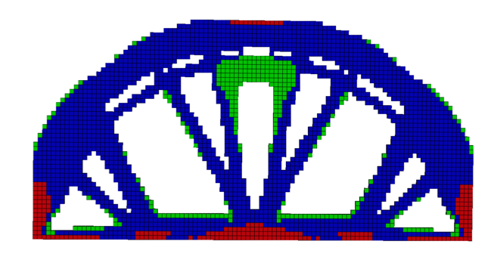 | Total optimization time: 122.24 seconds  --------------------------------------------------  After snapping:  --------------------------------------------------  -------------- Iteration 151 -----------------  Percentage grey elements: 1.52%  Min. Objective (COMPLIANCE): 217.86  Constraint 1 (MASS): 1.86e+03 <= 2e+03?  Constraint 2 (COST): 1.49e+03 <= 1.5e+03?  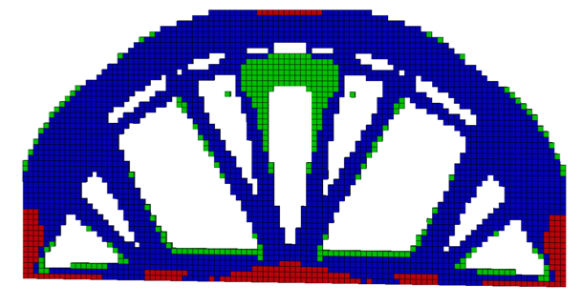
LBracketTopLoad_Compliance_MassCriticality | Total optimization time: 119.51 seconds  --------------------------------------------------  After snapping:  --------------------------------------------------  -------------- Iteration 151 -----------------  Percentage grey elements: 2.54%  Min. Objective (COMPLIANCE): 1.4125  Constraint 1 (MASS): 66.6 <= 75?  Constraint 2 (MAX_CRITICALITY): 0.8 <= 0.85?  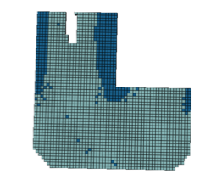 | Total optimization time: 125.71 seconds  --------------------------------------------------  After snapping:  --------------------------------------------------  -------------- Iteration 151 -----------------  Percentage grey elements: 2.54%  Min. Objective (COMPLIANCE): 1.4201  Constraint 1 (MASS): 66.2 <= 75?  Constraint 2 (MEAN_CRITICALITY): 0.465 <= 0.85?  

LBracketTopLoad_Stress_VolumeFraction_Mass | Total optimization time: 501.92 seconds  --------------------------------------------------  After snapping:  --------------------------------------------------  -------------- Iteration 151 -----------------  Percentage grey elements: 3.31%  Objective (PNORM_STRESS): 4.45e+07  Constraint 1 (VOL_FRACTION): 0.28 <= 0.3?  Constraint 2 (MASS): 29.5 <= 30?  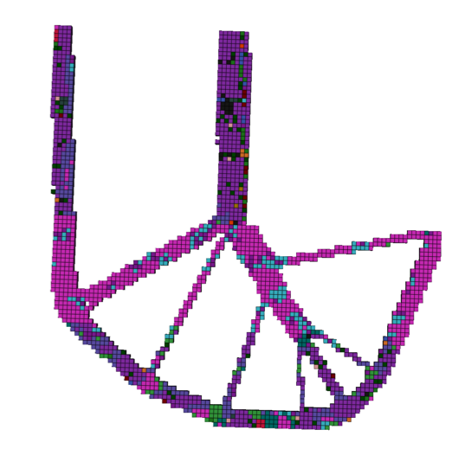 | Total optimization time: 484.35 seconds  --------------------------------------------------  After snapping:  --------------------------------------------------  -------------- Iteration 151 -----------------  Percentage grey elements: 3.21%  Objective (PNORM_STRESS): 4.462e+07  Constraint 1 (VOL_FRACTION): 0.28 <= 0.3?  Constraint 2 (MASS): 29.5 <= 30?  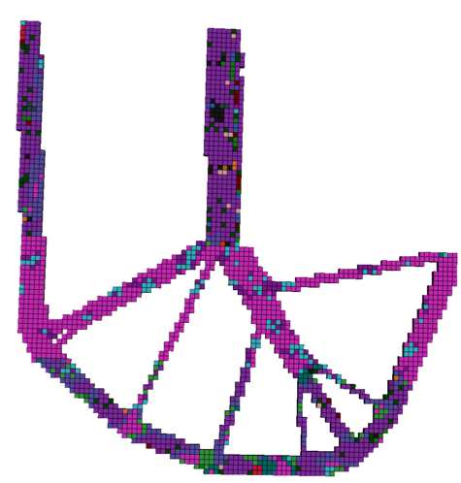

LBracketTopLoad_Mass_StressFF | Total optimization time: 455.05 seconds  --------------------------------------------------  After snapping:  --------------------------------------------------  -------------- Iteration 151 -----------------  Percentage grey elements: 4.10%  Min. Objective (MASS): 9.4676  Constraint 1 (STRESS_FAILURE_FACTOR): 0.35 <= 0.25?  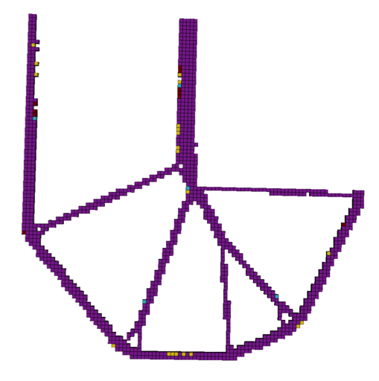 | Total optimization time: 456.80 seconds  --------------------------------------------------  After snapping:  --------------------------------------------------  -------------- Iteration 151 -----------------  Percentage grey elements: 4.21%  Min. Objective (MASS): 9.4333  Constraint 1 (STRESS_FAILURE_FACTOR): 0.34 <= 0.25?  