[Re] Marriage and happiness: Providing evidence against a relationship between inequality and happiness in Oishi, Kesebir, and Diener (2011)

Lauren Heintz, Tara Wilson, Ben Mathieu, Will Wright

20 February, 2020

A reference implementation of:

Grunberg, Rebecca L., Hyejun Kim, and Minjae Kim. 2014a. “Marriage and Happiness Grunberg Kim Kim.pdf.” Harvard Dataverse. <https://doi.org/10.7910/DVN/25655/MB980L>

Which is a reference implementation of:

Oishi, S., Kesebir, S., & Diener, E. (2011). Income Inequality and Happiness. Psychological Science, 22(9), 1095–1100. <https://doi.org/10.1177/0956797611417262>

The purpose of the following paper is to do a replication of the paper “Marriage and happiness: Providing evidence against a relationship between inequality and happiness in Oishi, Kesebir, and Diener (2011)” (Grunberg, Kim, and Kim 2014a). There is a crisis of reproducibility and replication in data science field. This paper follows the ReScience method of replicating a research paper to further validate the results of the paper. This particular replication is unique, because the paper being replicated is actually an alternate implementation of another paper, “Income Inequality and Happiness” (Oishi, Kesebir, and Diener 2011). While the first paper draws a connection between happiness and income, the second paper calls in the question the data used for this conclusion, and pulls in additional data for analysis. This second analysis, focused more on marriage and happiness is what this paper seeks to replicate.

# Introduction

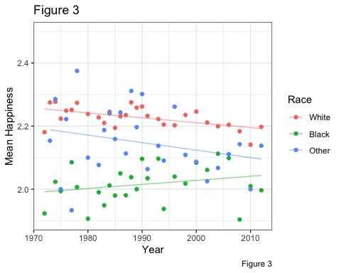

# Methods

#> [1] 1 2 3 4 5 6 7 8 9 10 11 12 13 14 15 16 17 18 19 20 21 22 23 24 25  
#> [26] 26 27 28 29 30 31 32 33 34 35 36 37 38 39 40 41 42 43 44  
#> [1] "hello world"

# Results

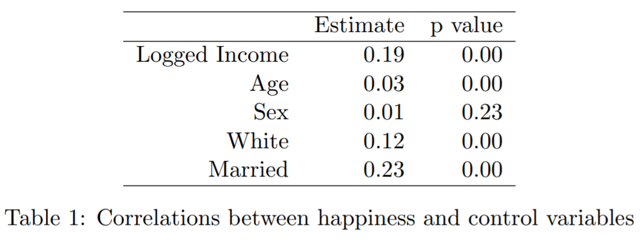

Figure 1: Table 1 from the original paper

The results from Table 1 in the original paper are shown in Figure 1.

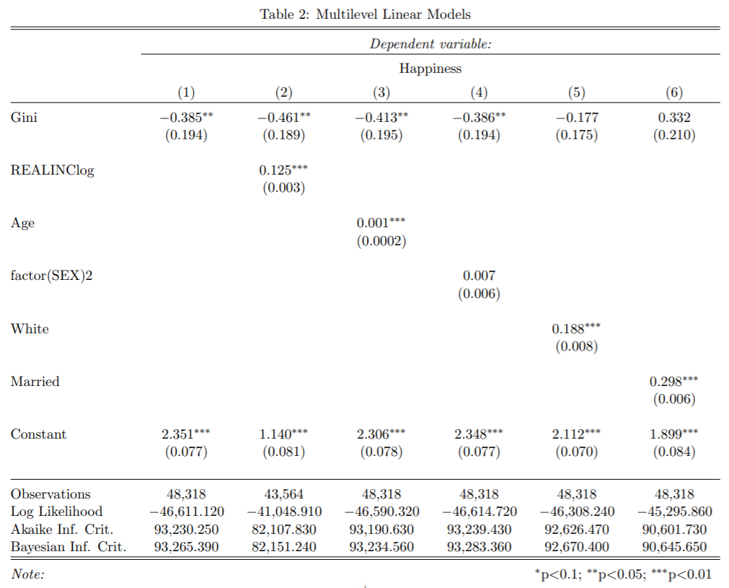

Figure 2: Table 2 from the original paper

The results from Table 2 in the original paper are shown in Figure 2.

# Conclusion

# References Cited

Reference 1: Grunberg, Kim, and Kim (2014a)  
Reference 2: Grunberg, Kim, and Kim (2014b) Reference 3: Oishi, Kesebir, and Diener (2011)

Grunberg, Rebecca L., Hyejun Kim, and Minjae Kim. 2014a. “Marriage and Happiness Grunberg Kim Kim.pdf.” Harvard Dataverse. doi:[10.7910/DVN/25655/MB980L](https://doi.org/10.7910/DVN/25655/MB980L).

———. 2014b. “Replication data for: Marriage and happiness: Providing evidence against a relationship between inequality and happiness in Oishi, Kesebir, and Diener (2011).” Harvard Dataverse. doi:[10.7910/DVN/25655](https://doi.org/10.7910/DVN/25655).

Oishi, Shigehiro, Selin Kesebir, and Ed Diener. 2011. “Income Inequality and Happiness.” *Psychological Science* 22 (9): 1095–1100. doi:[10.1177/0956797611417262](https://doi.org/10.1177/0956797611417262).