Phenology and the Intersection of Two Curves

2015-11-17

My lab has been working on a project forecasting how the timing of flowering will vary over space and through time with climate change[1]. To do this well, we need robust ways to quantify shifts in phenological timing. The approach we have taken so-far is to fit relatively simple functions to the observed data. But how do we quantify the amount of phenological match or mismatch for species that have different phenologies that can potentially be described using different mathematical relationships?

Here's where numerical integration comes in. This is an example with some simulated data. I've borrowed some of this code from [here](http://stats.stackexchange.com/questions/12209/percentage-of-overlapping-regions-of-two-normal-distributions).

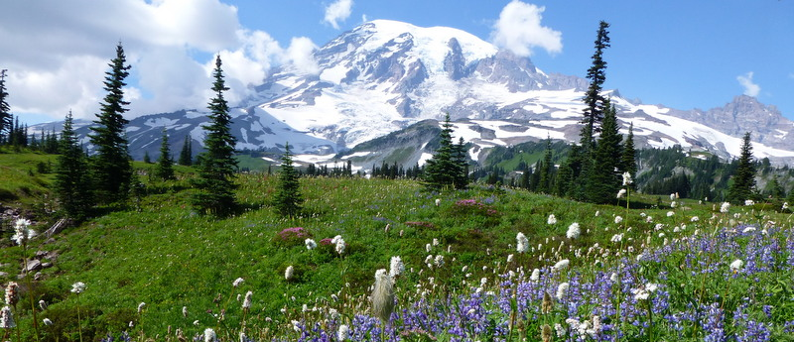

Subalpine meadows near Paradise on Mt. Rainier

First we define the two functions representing the two phenological curves from different species, times, or places. In this case, the curves are quasi-gaussian, with functional forms we can easily fit using logistic regression:

$$logit(y)=a+bx+cx^{2}$$

here the $logit()$ function is the link between our data and a nice simple polynomial fit. Another way to represent this relationship is:

$$y=\frac{e^{a+bx+cx^{2}}}{1+e^{a+bx+cx^{2}}}$$

I want to generate two curves of this form that represent the seasonal progression of life stages of two different organisms. I can make one of the curves asymmetric by log-transforming the x variable:

f1 <- function(x,a1,b1,c1) { exp(a1 + b1 * x + c1 * x^2)/  
 (1 + exp(a1 + b1 * x + c1 * x^2))   
}  
f2 <- function(x,a2,b2,c2) { exp(a2 + b2 * log(x) + c2 * log(x)^2)/  
 (1 + exp(a2 + b2 * log(x) + c2 * log(x)^2))   
}

Next we want to convert the two functions into density functions (meaning that areas under the curves should sum to one). This is one way to normalize measurements of different organisms that are potentially on different scales so they are more comparible. In this example, I'm doing this numerically to avoid a nasty integral. This works well unless the areas under the curve are really small.

f1_dens <- function(x,a1,b1,c1) {   
 y <- f1(x,a1,b1,c1)  
 yi <- integrate(f1, -Inf, +Inf, a1=a1, b1=b1, c1=c1)  
 return(y/yi[[1]])  
}  
  
f2_dens <- function(x,a2,b2,c2) {   
 y <- f2(x,a2,b2,c2)  
 yi <- integrate(f2, 1e-10, +Inf, a2=a2, b2=b2, c2=c2)  
 return(y/yi[[1]])  
}

Now we can define a function that returns the minimum of the two curves wherever they overlap.

min_f1f2_dens <- function(x, a1, b1, c1, a2, b2, c2) {  
 f1 <- f1_dens(x,a1,b1,c1)   
 f2 <- f2_dens(x,a2,b2,c2)  
 pmin(f1, f2)  
}

Now we can use some made-up parameters for each curve and stick them in a nice table:

a1 <- -65  
b1 <- 40  
c1 <- -6  
  
a2 <- -2  
b2 <- 7  
c2 <- -6  
xs <- seq(0.0001,5,by=0.01)

|  |  |  |  |
| --- | --- | --- | --- |
| Function | a | b | c |
| One | -65 | 40 | -6 |
| Two | -2 | 7 | -6 |

Let's plot these curves to make sure they look reasonable:

y1s <- f1(xs,a1,b1,c1)  
y2s <- f2(xs,a2,b2,c2)  
y1d <- f1_dens(xs,a1,b1,c1)  
y2d <- f2_dens(xs,a2,b2,c2)  
  
yid <- min_f1f2_dens(xs, a1, b1, c1, a2, b2, c2)  
xpd <- c(xs, xs[1])  
ypd <- c(yid, yid[1])

par(mfrow=c(1,1))  
plot(xs, y1s, type="n", ylim=c(0, max(y1d,y2d)),xlab="Time", ylab="Flowering Density")  
lines(xs, y1d, lty="solid")  
lines(xs, y2d, lty="dotted")

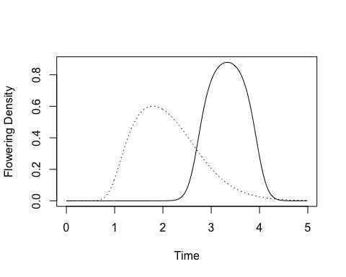

Two example curves.

Looks good, so the last step is to compute the area where the two densities intersect.

##Computes overlap  
over_dens <- integrate(min_f1f2_dens, 0, Inf, a1=a1, b1=b1, c1=c1, a2=a2, b2=b2, c2=c2)

Finally we can plot everything to make sure it makes sense.

par(mfrow=c(1,1))  
plot(xs, y1s, type="n", ylim=c(0, max(y1d,y2d)),xlab="x", ylab="Density")  
polygon(xpd, ypd, col="gray")  
lines(xs, y1d, lty="solid")  
lines(xs, y2d, lty="dotted")  
title(main=paste("Overlap: ",round(over_dens[[1]],2)))

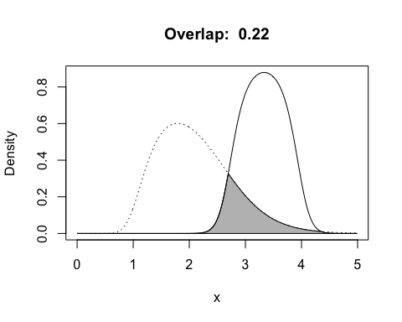

Two example curves and their overlap.

There are some analytical ways to do this for polynomial and Gaussian functions, but this approach is agnostic about what the functional form of the phenology curves are, so long as they have a finite integral.

1. Breckheimer et al. in prep.