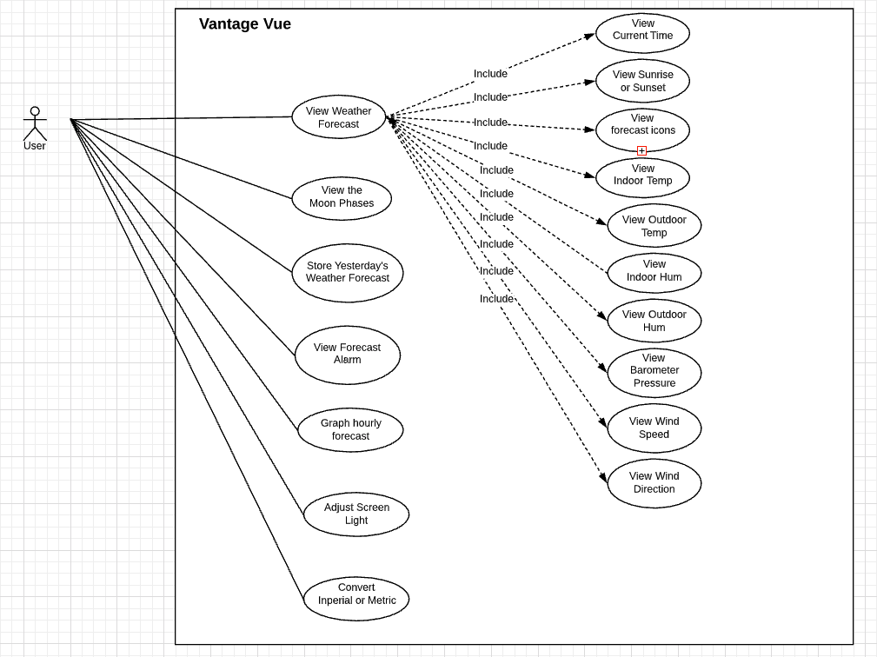

|  |  |
| --- | --- |
| Vantage Vue/Control Software | |
| **Function** | View Current Time |
| **Description** | Show the current time at the current location based on a simulation weather temperature |
| **Inputs** | none |
| **Source** | A simulation weather temperature |
| **Outputs** | Show the current data |
| **Destination** | Show the current data on the GUI |
| **Action** | Show 00:00:00 if it doesn’t connect to the internet. Show the current time if it connects to the internet. |
| **Requires** | Make sure the current time updates every second |
| **Precondition** | None |
| **Postcondition** | None |
| **Side effects** | None |

|  |  |
| --- | --- |
| Vantage Vue/Control Software | |
| **Function** | View Sunrise or Sunset |
| **Description** | Show the time of sunrise or sunset at the current location based a simulation weather temperature |
| **Inputs** | None |
| **Source** | A simulation weather temperature |
| **Outputs** | Show the time of sunrise or sunset |
| **Destination** | View the time of sunrise or sunset data on the GUI |
| **Action** | Show 00:00:00 if it doesn’t connect to the internet. Show the time of sunrise or sunset if it connects to the internet. |
| **Requires** | The sunset time must less than the sunrise time |
| **Precondition** | None |
| **Postcondition** | None |
| **Side effects** | None |

|  |  |
| --- | --- |
| Vantage Vue/Control Software | |
| **Function** | View Icons |
| **Description** | * Show the sunny icon if the weather forecast said that it is sunny today * Show the rainy icon if the weather forecast said that it is rainy today * Show the cloudy icon if the weather forecast said that it is cloudy today |
| **Inputs** | None |
| **Source** | A simulation weather temperature |
| **Outputs** | Show the icons with the weather forecast respectively |
| **Destination** | Show the icons on the GUI with the weather forecast respectively |
| **Action** | Show string if it doesn’t connect to the internet. Show the weather forecast icon if it connects to the internet. |
| **Requires** | None |
| **Precondition** | None |
| **Postcondition** | None |
| **Side effects** | None |

|  |  |
| --- | --- |
| Vantage Vue/Control Software | |
| **Function** | View Indoor Temperature |
| **Description** | Show current indoor temperature based on a simulation weather temperature |
| **Inputs** | None |
| **Source** | A simulation weather temperature |
| **Outputs** | Show indoor temperature |
| **Destination** | Show indoor temperature on the GUI |
| **Action** | Show 0oF or 0oC if it doesn’t connect to the internet. Show current indoor temperature if it connects to the internet. |
| **Requires** | * Update the temperature every minute * The temperature doesn’t exceed a record high or low |
| **Precondition** | None |
| **Postcondition** | None |
| **Side effects** | None |

|  |  |
| --- | --- |
| Vantage Vue/Control Software | |
| **Function** | View Outdoor Temperature |
| **Description** | Show current Outdoor temperature based on a simulation weather temperature |
| **Inputs** | None |
| **Source** | A simulation weather temperature |
| **Outputs** | Show inddor temperature |
| **Destination** | Show outdoor temperature on the GUI |
| **Action** | Show 0oF or 0oC if it doesn’t connect to the internet. Show current outdoor temperature if it connects to the internet. |
| **Requires** | * Update the temperature 10 seconds * The temperature doesn’t exceed a record high or low |
| **Precondition** | None |
| **Postcondition** | None |
| **Side effects** | None |

|  |  |
| --- | --- |
| Vantage Vue/Control Software | |
| **Function** | View Indoor Humidity |
| **Description** | Show current indoor humidity based on a simulation weather temperature |
| **Inputs** | None |
| **Source** | A simulation weather temperature |
| **Outputs** | Show indoor humidity |
| **Destination** | Show indoor humidity on the GUI |
| **Action** | Show 0% if it doesn’t connect to the internet. Show current indoor humidity if it connects to the internet. |
| **Requires** | * Update the humidity every minute * The humidity doesn’t exceed 100% or less than 0% |
| **Precondition** | None |
| **Postcondition** | None |
| **Side effects** | None |

|  |  |
| --- | --- |
| Vantage Vue/Control Software | |
| **Function** | View Outdoor Humidity |
| **Description** | Show current outdoor humidity based on a simulation weather temperature |
| **Inputs** | None |
| **Source** | A simulation weather temperature |
| **Outputs** | Show outdoor humidity |
| **Destination** | Show outdoor humidity on the GUI |
| **Action** | Show 0% if it doesn’t connect to the internet. Show current outdoor temperature if it connects to the internet. |
| **Requires** | * Update the temperature 50 seconds * The humidity doesn’t exceed 100% or less than 0% |
| **Precondition** | None |
| **Postcondition** | None |
| **Side effects** | None |

|  |  |
| --- | --- |
| Vantage Vue/Control Software | |
| **Function** | View Barometer Pressure |
| **Description** | Show current barometer pressure based on a simulation weather temperature |
| **Inputs** | None |
| **Source** | A simulation weather temperature |
| **Outputs** | Show barometer pressure |
| **Destination** | Show barometer pressure on the GUI |
| **Action** | Show 0 BAR if it doesn’t connect to the internet. Show barometer pressure if it connects to the internet. |
| **Requires** | Five-position trend arrow shows whether barometric pressure is rising, falling or stable. |
| **Precondition** | None |
| **Postcondition** | None |
| **Side effects** | None |

|  |  |
| --- | --- |
| Vantage Vue/Control Software | |
| **Function** | View Wind Speed |
| **Description** | Show current wind speed based on a simulation weather temperature |
| **Inputs** | None |
| **Source** | A simulation weather temperature |
| **Outputs** | Show wind speed |
| **Destination** | Show wind speed on the GUI |
| **Action** | Show 0 mph or 0 knot if it doesn’t connect to the internet. Show wind speed if it connects to the internet. |
| **Requires** | Cannot a negative number |
| **Precondition** | None |
| **Postcondition** | None |
| **Side effects** | None |

|  |  |
| --- | --- |
| Vantage Vue/Control Software | |
| **Function** | View Wind Direction |
| **Description** | Show current wind direction based on a simulation weather temperature |
| **Inputs** | None |
| **Source** | A simulation weather temperature |
| **Outputs** | Show wind direction |
| **Destination** | Show wind direction on the GUI |
| **Action** | Show wind direction if it connects to the internet. |
| **Requires** | None |
| **Precondition** | None |
| **Postcondition** | None |
| **Side effects** | None |

|  |  |
| --- | --- |
| Vantage Vue/Control Software | |
| **Function** | View Rainfall |
| **Description** | Show current rainfall based on a simulation weather temperature |
| **Inputs** | None |
| **Source** | A simulation weather temperature |
| **Outputs** | Show rainfall |
| **Destination** | Show rainfall on the GUI |
| **Action** | Show 0 inch if it doesn’t connect to the internet. Show rainfall if it connects to the internet. |
| **Requires** | * Update the rainfall 50 seconds * Cannot a negative number |
| **Precondition** | None |
| **Postcondition** | None |
| **Side effects** | None |

|  |  |
| --- | --- |
| Vantage Vue/Control Software | |
| **Function** | View Rain Rate |
| **Description** | Show current rain rate based on a simulation weather temperature |
| **Inputs** | None |
| **Source** | A simulation weather temperature |
| **Outputs** | Show rain rate |
| **Destination** | Show rain rate on the GUI |
| **Action** | Show rain rate if it connects to the internet. |
| **Requires** | Get updated rain totals and rain rate every 20 seconds for the last 25 hours, 25 days, and 25 months. |
| **Precondition** | None |
| **Postcondition** | None |
| **Side effects** | None |

|  |  |
| --- | --- |
| Vantage Vue/Control Software | |
| **Function** | View the Moon Phases |
| **Description** | Show current moon phases |
| **Inputs** | The current datetime |
| **Source** | Moon phase can be calculated based off data obtained from <https://svs.gsfc.nasa.gov/4768> |
| **Outputs** | Moon phase is returned as one of eight segments and is represented by icons |
| **Destination** | Show moon phase on the GUI |
| **Action** | Show moon phase. |
| **Requires** | Check that the moon phase returned is an integer between 0-8. |
| **Precondition** | None |
| **Postcondition** | None |
| **Side effects** | None |

|  |  |
| --- | --- |
| Vantage Vue/Control Software | |
| **Function** | Store yesterday’s weather forecast |
| **Description** | Store yesterday’s weather forecast so that it can be used in the future use |
| **Inputs** | None |
| **Source** | A simulation weather temperature |
| **Outputs** | all weather forecast data |
| **Destination** | Storage all weather forecast in memory |
| **Action** | Allows comparisons of changes in temperature and barometric pressure from day to day. |
| **Requires** | Check that change in temperature doesn't exceed 100 degrees for imperial scale. |
| **Precondition** | None |
| **Postcondition** | None |
| **Side effects** | None |

|  |  |
| --- | --- |
| Vantage Vue/Control Software | |
| **Function** | View Forecast Alarm |
| **Description** | View Forecast Alarm based on a simulation weather temperature |
| **Inputs** | * Get/Set alarm for high/low: temperature, humidity, wind speed (high only), rain (high only) * City or zip code |
| **Source** | A simulation weather temperature |
| **Outputs** | Show Forecast Alarm |
| **Destination** | Show Forecast Alarm on the GUI |
| **Action** | Show forecast alarm if it connects to the internet. |
| **Requires** | Set 22 simultaneous, different alarms to warn of dangers such as high winds, freezing temperatures, rain rate, heat index, flood warning, and more. |
| **Precondition** | None |
| **Postcondition** | None |
| **Side effects** | None |

|  |  |
| --- | --- |
| Vantage Vue/Control Software | |
| **Function** | Graph hourly/daily/monthly forecast |
| **Description** | Graph hourly/daily/monthly forecast based on a simulation weather temperature |
| **Inputs** | None |
| **Source** | A simulation weather temperature |
| **Outputs** | Data containing all hourly/daily/monthly forecast data with city or zip code input |
| **Destination** | Show graph on the GUI |
| **Action** | Show graph on the GUI |
| **Requires** | Verify that null data does not crash the application. |
| **Precondition** | None |
| **Postcondition** | None |
| **Side effects** | None |