GeographeAMP-report
Claude Spencer, Brooke Gibbons, Tim Langlois

Introduction
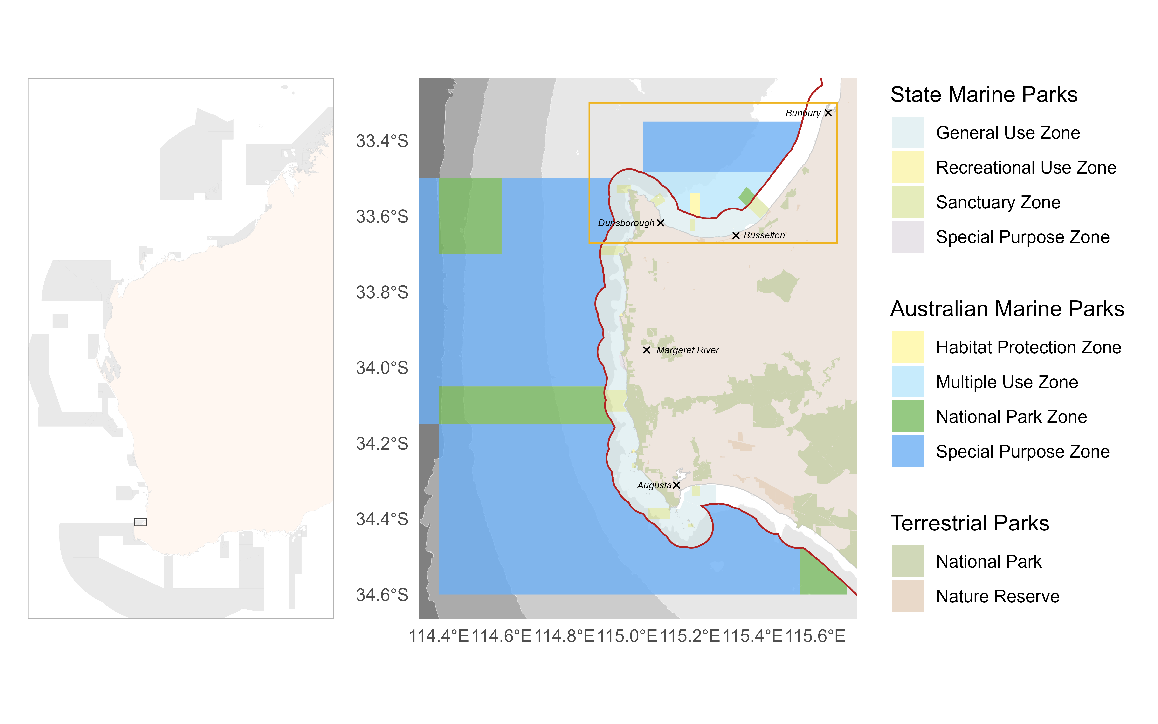
Figure 1: Study area of the Geographe Marine Park showing the State and Commonwealth (Australian Marine Park) managed marine park zones. The red line following the coast demarcates the border of state and commonwealth waters. Bathymetric contours shown are 30, 70, 200 & 700 m, which denote historical sea levels and ecosystem depth contours.

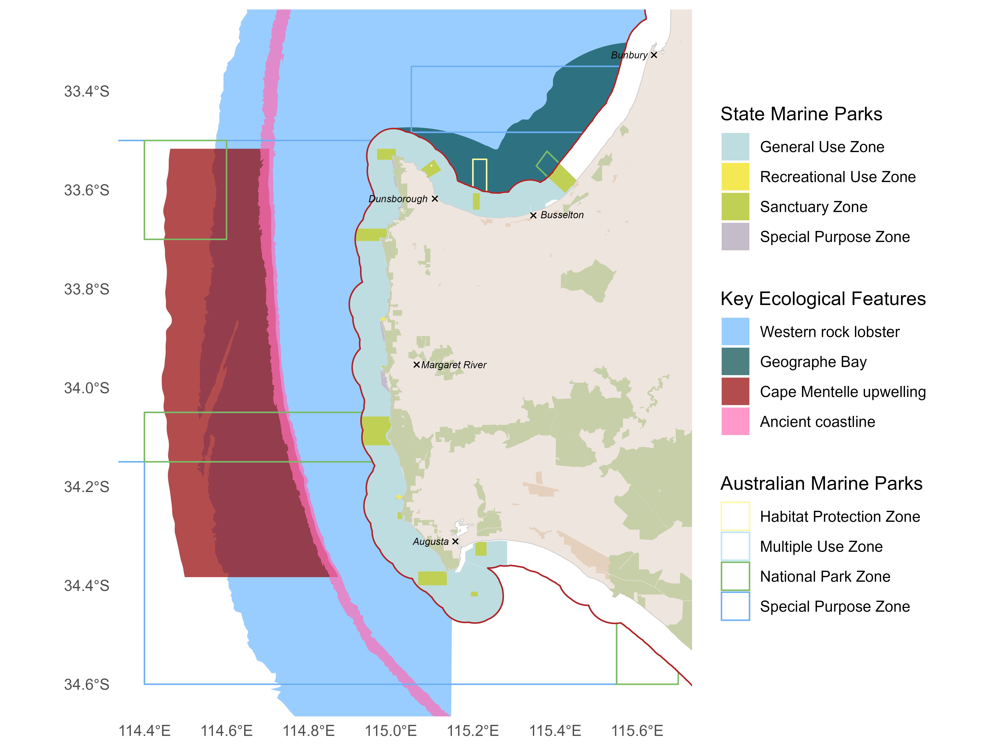
Figure 2: Key Ecological Features at the scale of the Geographe Marine Park. Excerpt from Marine Key Ecological Features of the Australian Marine Parks. Legend for Australian Marine Parks, Terrestrial Managed Areas and State Marine Parks can be found in Figure 1. The red line delimits state and commonwealth waters. Geographe Bay = Commonwealth marine environment within and adjacent to Geographe Bay, Ancient coastline = Ancient coastline at 90-120m depth.

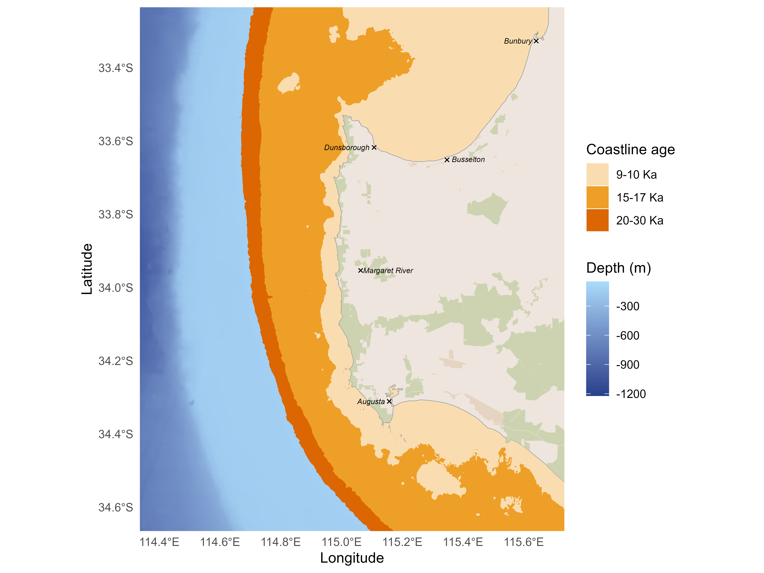

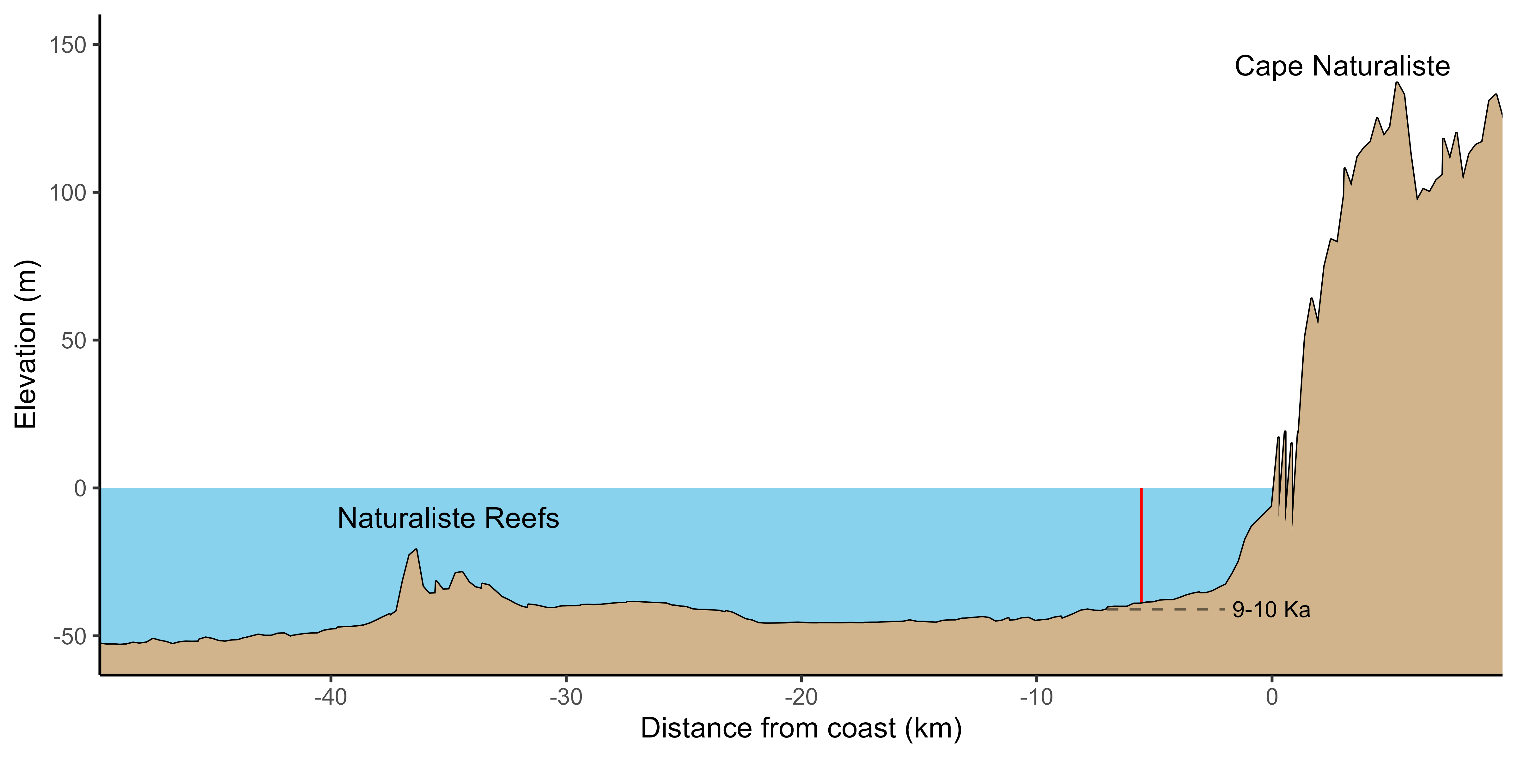

Methods
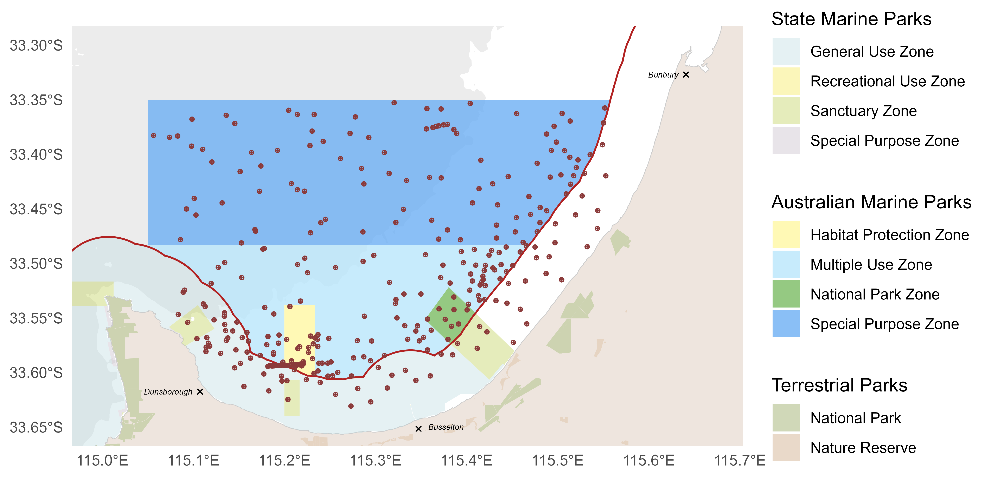
Figure 5: Sampling locations in the Geographe Marine Park. The red boundary following the coast demarcates State waters, and depth contours represent the 30 m ecosystem depth contour.

Results

Spatial predictions
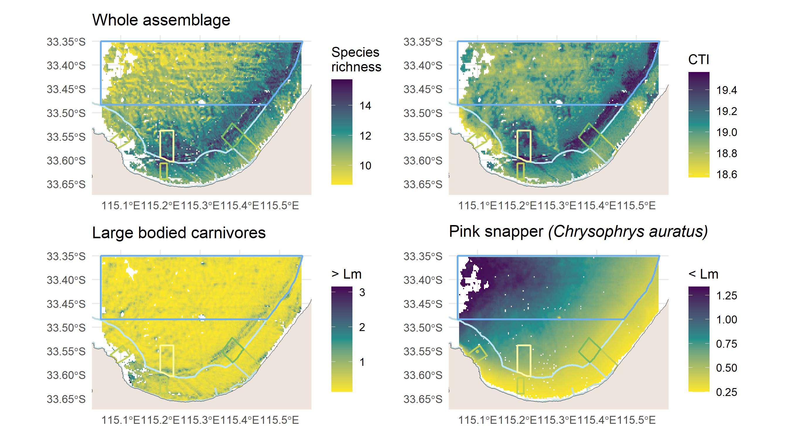
Figure 6: Spatial predictions of key fish metrics for the Geographe Marine Park.
Spatial patterns in the distribution of key fish metrics for the Geographe Marine Park highlight increased species richness along reef features that run through the National Park and Habitat Protection Zones (Figure 6).

Temporal predictions
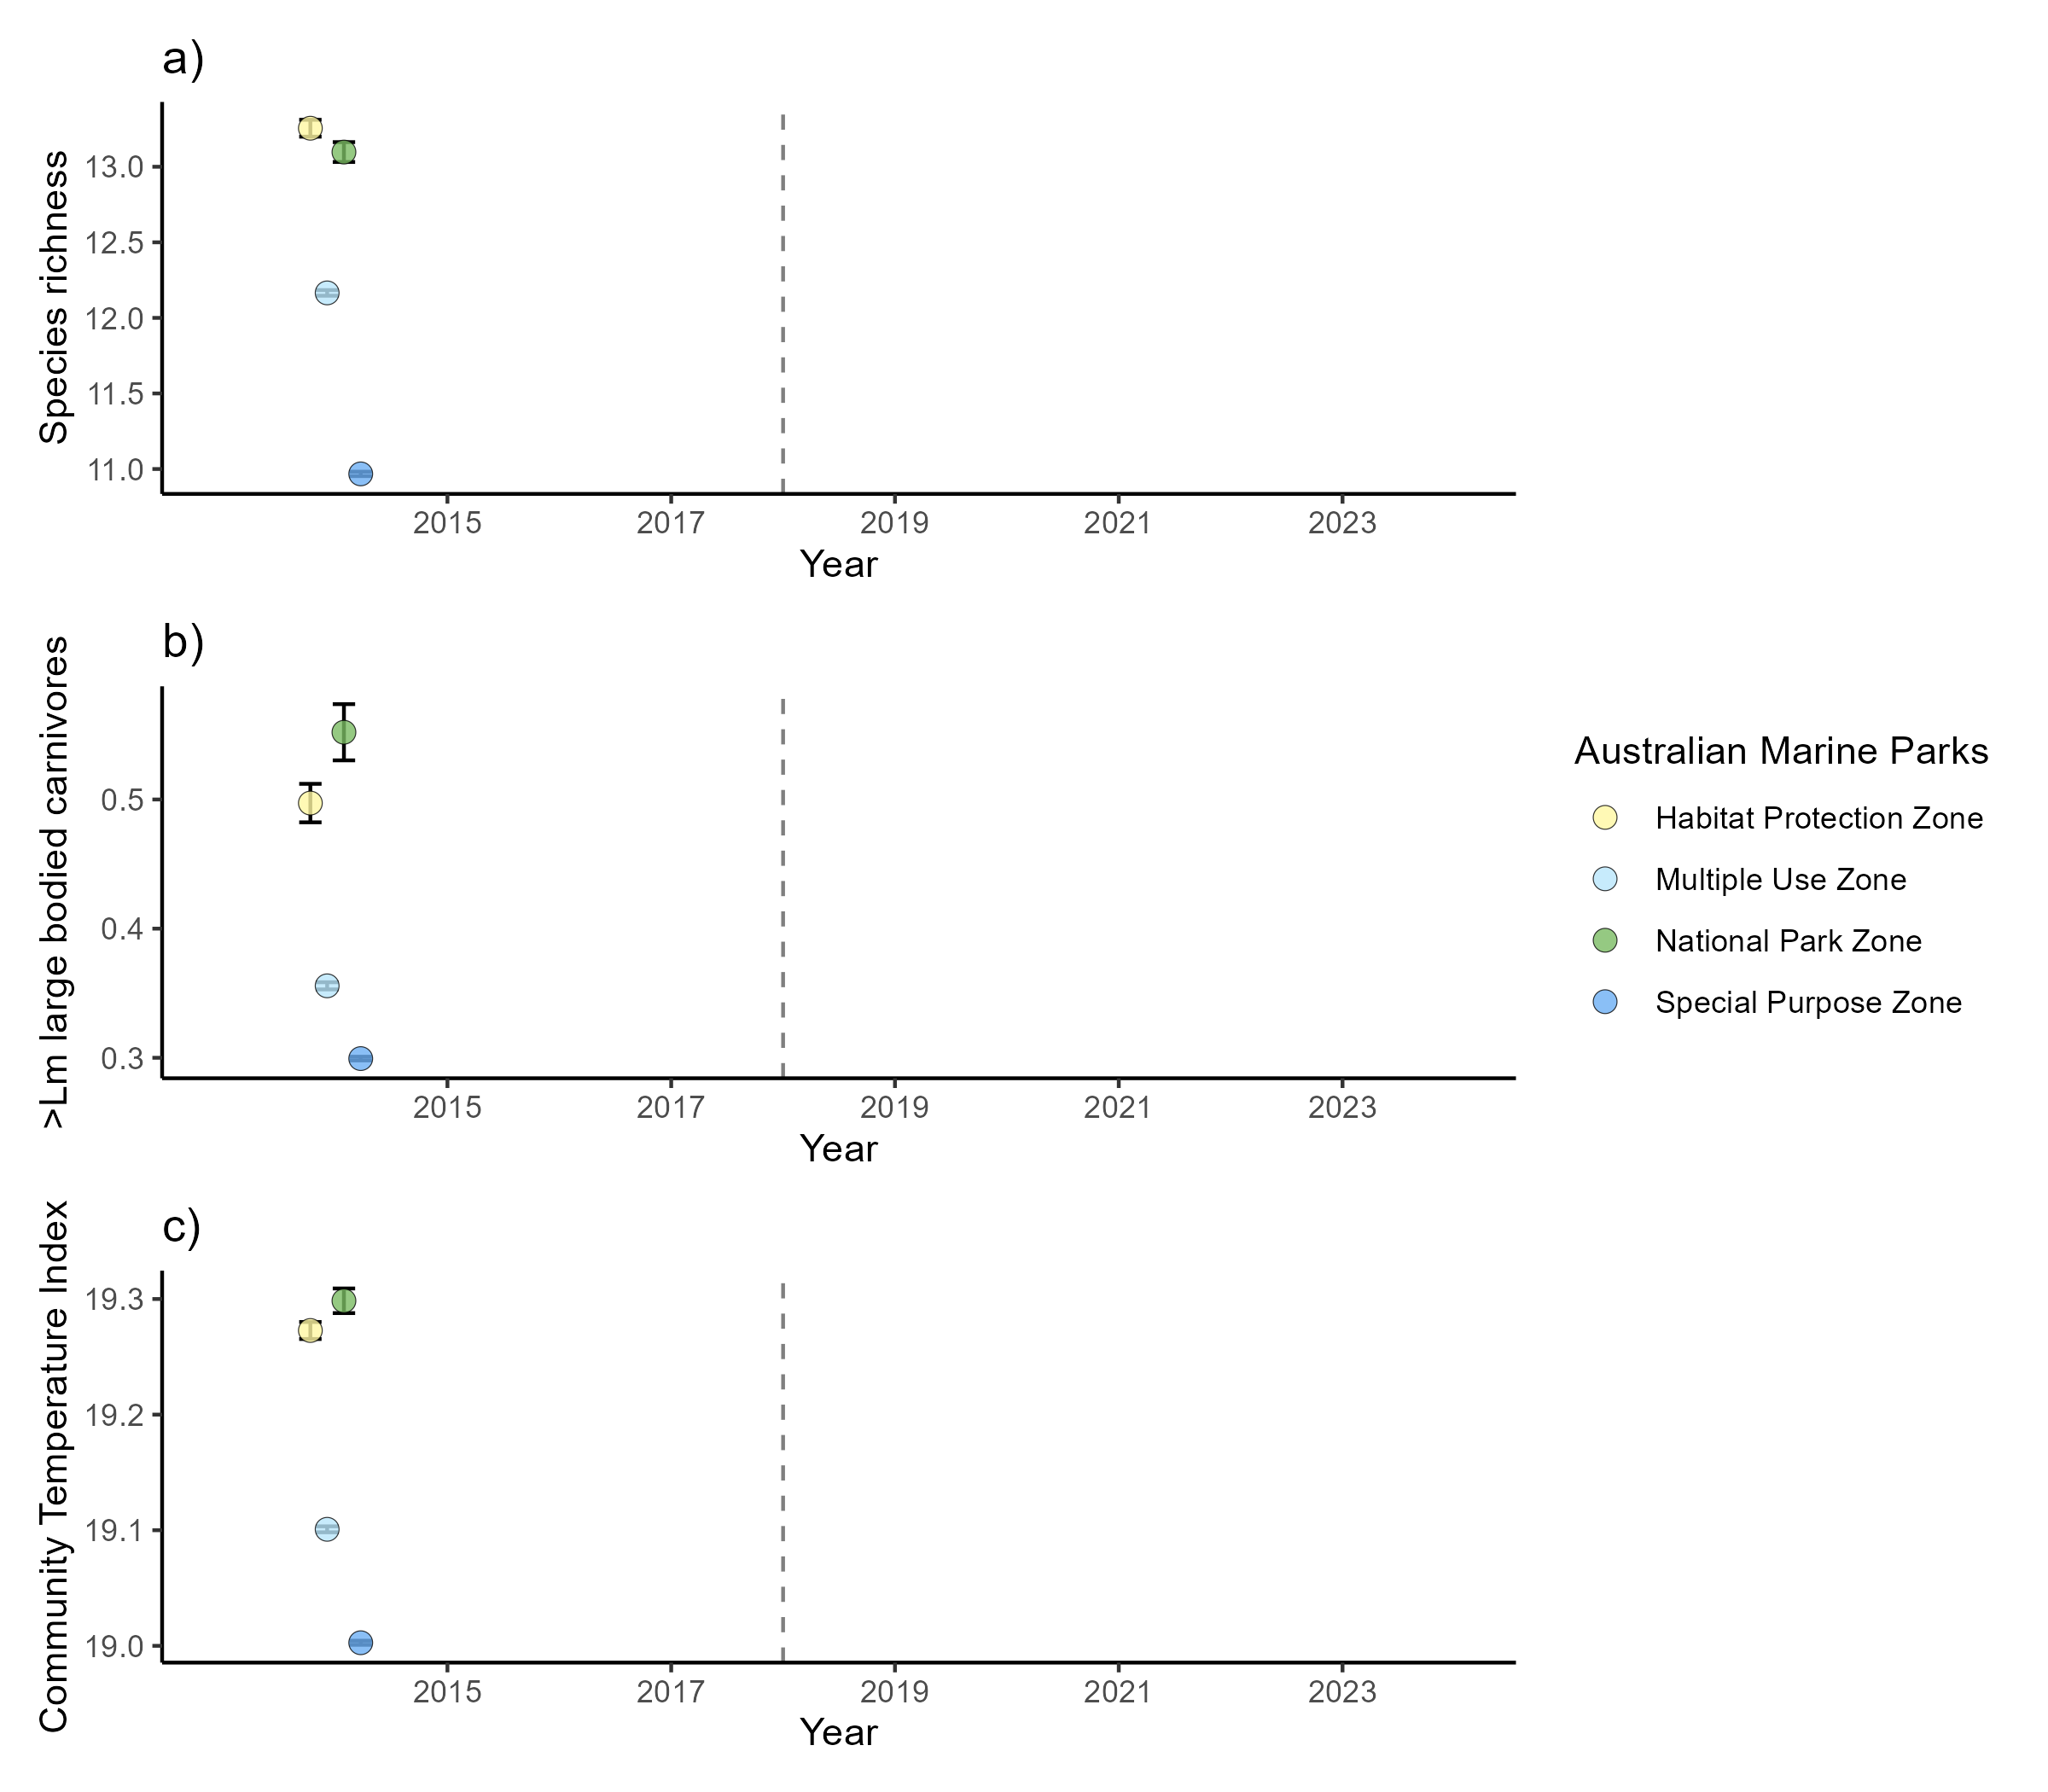
Figure 7: Temporal predictions of key fish metrics for the Geographe Marine Park.
Temporal trends of key fish metrics for the Geographe Marine Park highlight increased abundance of mature large bodied carnivorous species in the National Park Zone (Figure 7).

